***2021 Logo Pic #1

2021 Youth and Recreation Millage Funds Awarded
Youth and Recreation
- facebook
- twitter
- linkedin
- email
- pinterest
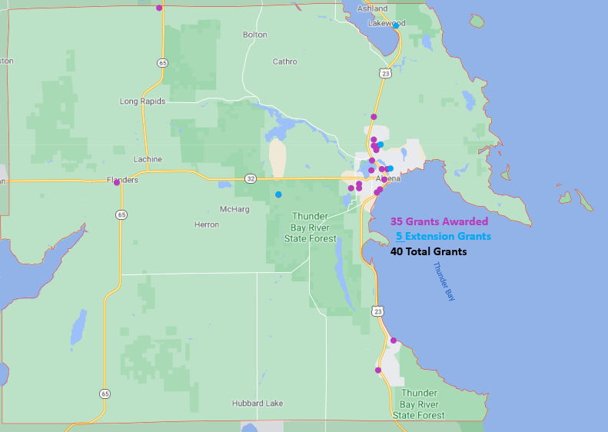***2021 Alpena County Funding #2 Pic
The Committee is trying to spread the funds throughout the County, encouraging all the Townships and non-profit organizations, schools, and governmental agencies to apply. The Alpena County Map shown on the left depicts where 29 grants have been awarded.
Budget Recommendations for 2021 are not approved until after the Full Board of Commissioners’ approval as part of the Budget held on December 22, 2020.
The total amount appropriated $648,901

Resources
2021 Award Book (Link coming soon)
2021 Youth & Recreation Meeting Dates

Township Maps
Alpena Township
City of Alpena
Green Township
Long Rapids Township
Maple Ridge Township
Ossineke Township
Sanborn Township
Wellington Township
Wilson Township
(Steve - There were no pictures taken in 2020 for the 2021 Grants)

Organization | Amount Approved | Purpose
County of Alpena – MSU Extension | $40,000.00 | Youth Programming – 4H
Park Family Foundation | $7,000.00 | Special Needs Prom
Alpena Jets Youth Football | $10,000.00 | Equipment Upgrades
MPAC | $5,400.00 | Open Skating
Friends of The Alpena Farmer’s Market | $4,000.00 | Nutrician Incentive Program
Wolf Creek Park Commission | $40,000.00 | Park Improvements
Alpena Figure Skating Club | $6,750.00 | Operating Support
Besser Museum | $75,000.00 | Exhibit Upgrade
Park Family Foundation | $10,000.00 | Ready, Set, SNAP
Alpena Public Schools – AHS KAPUT | $15,500.00 | Activities and Events
County of Alpena – Plaza Pool | $90,000.00 | Operating Support
Alpena Huron Shore Little League | $13,700.00 | Registration Assistance
Park Family Foundation | $5,000.00 | Aplex Tennis Fit Camp
Thunder Bay Schooners Swim Club | $11,500.00 | Pool Rental and Meet Fees
County of Alpena – Long Lake Park | $10,000.00 | Day Use Enhancements
Alpena Hockey Association | $7,000.00 | Tournament Experience
Alpena Huron Shore Little League | $40,000.00 | Complex Fences – Reynolds Field
County of Alpena – Plaza Pool | $7,500.00 | Ready, Set, Swim Program
Park Family Foundation | $6,000.00 | Martial Arts Women’s self-defense
Boys and Girls Club | $15,500.00 | Triple Play Program
Alpena Hockey Association | $10,000.00 | Player Cost Reduction
Alpena Figure Skating Club | $8,000.00 | First Skater Program
Friends of Plaza Pool | $7,500.00 | Free Family Fun Swim & Equipment
Alpena Community College – Cross Country | $950.00 | Summer Camp
Alpena Public Schools – AHS Robotics | $22,000.00 | Program support
Park Family Foundation | $6,000.00 | Martial Arts Scholarships
Girls Scouts of MI Shore to Shore | $45,000.00 | Camp Woodlands Renovations
Northeast MI Center for Fine Arts | $23,000.00 | Ready, Set, Create Program
MPAC | $7,500.00 | Rental Skates and Helmets
City of Alpena- Michi-e-ke-wis Park | $15,000.00 | Playground Improvements
Total: | $564,800.00

EXTENDED PROJECTS | DUE TO | COVID-19
County of Alpena – Parks and Recreation | $34,100.00 | Long Lake Park Boat Launch Project
MPAC/NLA-C | $11,987.00 | Curling
MPAC/NLA-C | $9,710.00 | Open Skate
Friends of Thunder Bay National Marine Sanctuary | $57,040.00 | Great Lakes Maritime Heritage Riverfront Recreation Area
Girl Scouts of Michigan Shore to Shore | $17,500.00 | Camp Renovations

2021 County Commissioners & Commissioners Appointees
District 1 – COMMISSIONER
Don Gilmet
220 E. Crapo Street
Alpena, MI 49707
989.916.5108
donaldgilmet@alpenacounty.org
Linda Canfield
242 S Second
Alpena, MI 49707
989.356.2742
lindacanfield1@gmail.com
District 3 – COMMISSIONER
Dave Karschnick
609 Island View Drive
Alpena, MI 49707
989.464.0722
davidkarschnick@alpenacounty.org
Dennis A. Werblow
Address: 633 Island View Dr.
Alpena, MI 49707
989.354.5560
werblow@chartermi.net
District 5 – COMMISSIONER
Brenda Fournier
2464 Diamond Drive
Alpena, MI 49707
989.358.1414
brendafournier@alpenacounty.org
Tom Heise
3376 Piper Road
Alpena, MI 49707
989.354.2447
htssllc@yahoo.com
District 7 – COMMISSIONER
Marty Thomson
2802 M 65 North
Lachine, MI 49753
989.464.6189
martythomson@alpenacounty.org
LeAnn Schultz
6838 Werth Road
Alpena, MI 49707
989.916.6622
momschultz71@gmail.com
District 2 – COMMISSIONER
Robert Adrian
227 Dawson Street
Alpena, MI 49707
989.464.6334
robertadrian@alpenacounty.org
Stephanie Gosselin
1121 N. Second Avenue
Alpena, MI 49707
989.354.4659
gosselins@alpenaschools.com
District 4 – COMMISSIONER
Bill Peterson
2379 Lake Winyah Road
Alpena, MI 49707
989.916.5351
billpeterson@alpenacounty.org
Tony Suszek
114 Kensington Court
Alpena, MI 49707
989.356.4434
tonysuszek@gmail.com
District 6 – COMMISSIONER
Kevin Osbourne
6200 Blackberry Lane
Alpena, Ml 49707
989.255.1675
kevinosbourne@alpenacounty.org
Thomas Spaulding
5925 Keating
Lachine, MI 49753
989.379.2789
tspaulding50@hotmail.com
District 8 – COMMISSIONER
John Kozlowski
1208 W. Scott Road
Ossineke, MI 49766
Phone: 989.464.2194
johnkozlowski@alpenacounty.org
Lisa Siegert
12700 Hawkins Road
Hubbard Lake, MI 49747
989.727.3089
siegertlne@gmail.com

County Contacts
Kim Ludlow
County Treasurer
989.354.9534
ludlowk@alpenacounty.org
Tammy Sumerix-Bates
Executive Manager
989.354.9502
commissionersoffice@alpenacounty.org
Lynn Bunting
Board Assistant
989.354.9501
commissionersoffice@alpenacounty.org
Kim Elkie
Board Administrative Assistant
989.354.9503
commissionersoffice@alpenacounty.org

