*** #1 2020 Logo Pic

2020 Youth and Recreation Millage Funds Awarded
Announcements Youth and Recreation
- facebook
- twitter
- linkedin
- email
- pinterest
*** #2 2020 YR Map Pic
The Committee is trying to spread the funds throughout the County, encouraging all the Townships and non-profit organizations, schools, and governmental agencies to apply.
The Alpena County Map shown on the left depicts where 31 grants have been awarded. Please click on the image for a larger view or by clicking here. (*** #3 clicking here Pic)
Budget Recommendations are not approved until after the Full Board of Commissioners approval as part of the Budget held December 17, 2019.
The total amount appropriated $550,743.00

Resources
2020 Award Book
2020 Youth & Recreation Meeting Dates
Millage Language

Township Maps
Alpena Township
City of Alpena
Green Township
Long Rapids Township
Maple Ridge Township
Ossineke Township
Sanborn Township
Wellington Township
Wilson Township

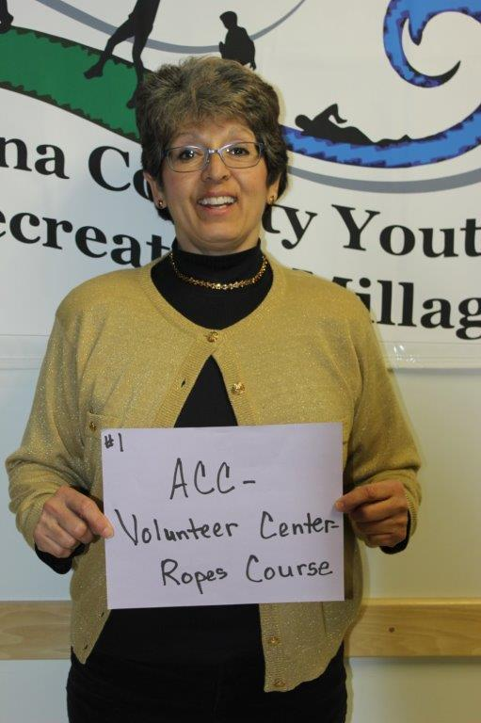
ACC Volunteer Center Ropes Course – Cathy Abraham
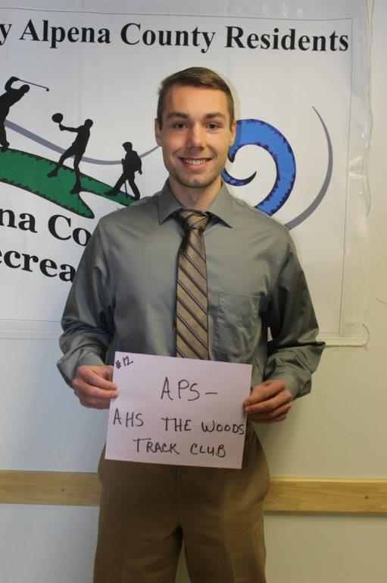
APS – AHS The Woods Track Club – John Siegert
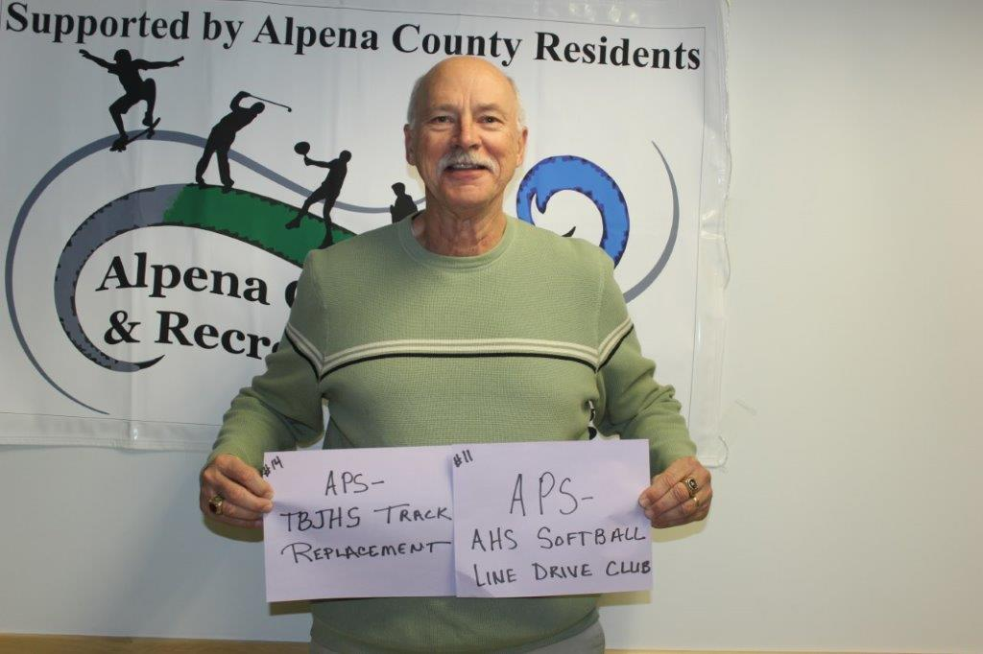
APS – TBJHS – Track Replacement -APS – AHS Softball Line Drive Club – Tim Storch

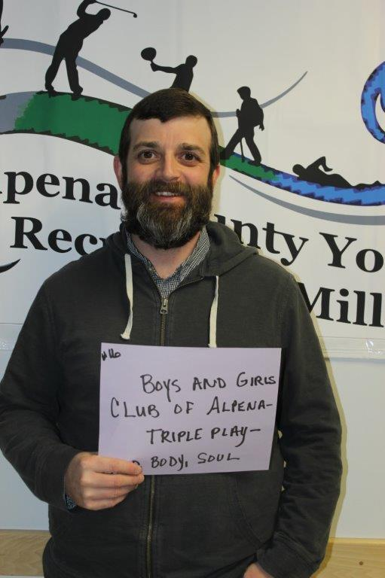
Boys & Girls Club – Brad Somers
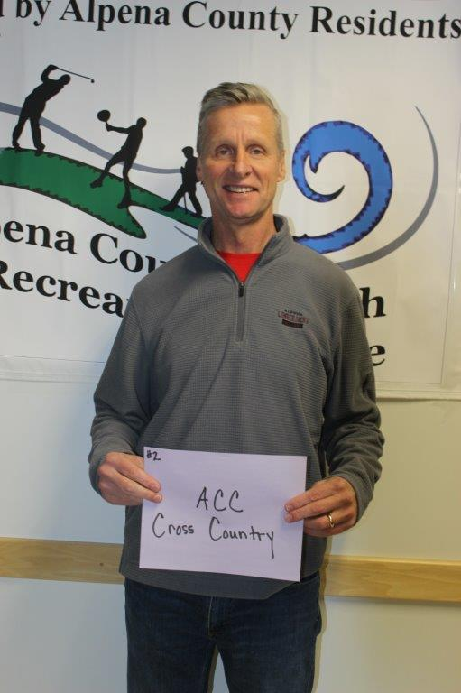
ACC – Cross Country – Mark Jacobs
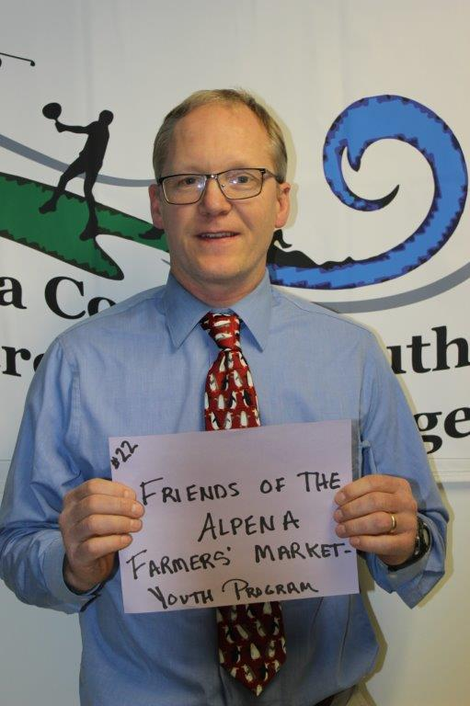
Farmers Market – JB Cook
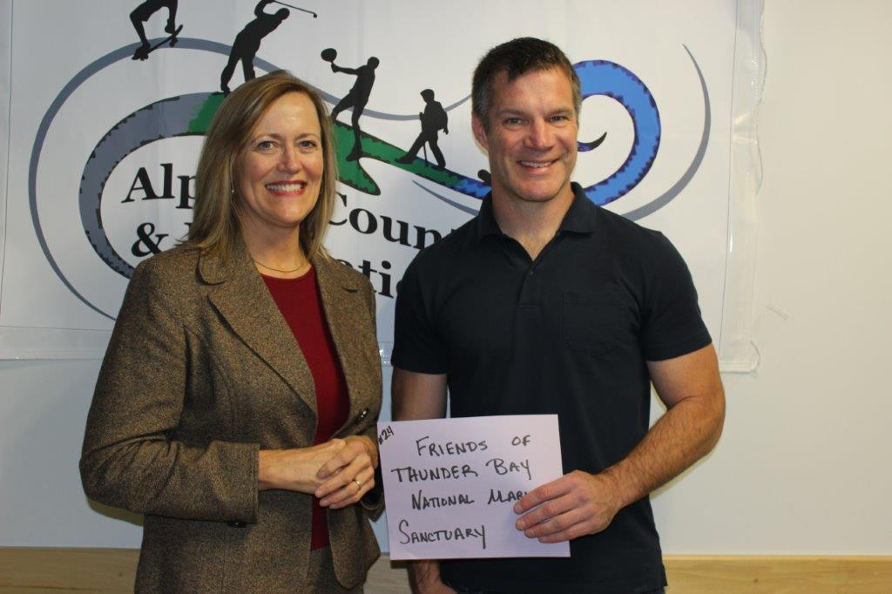Friends of Thunder Bay National Marine Sanctuary – Katie Wolf & Jeff Gray
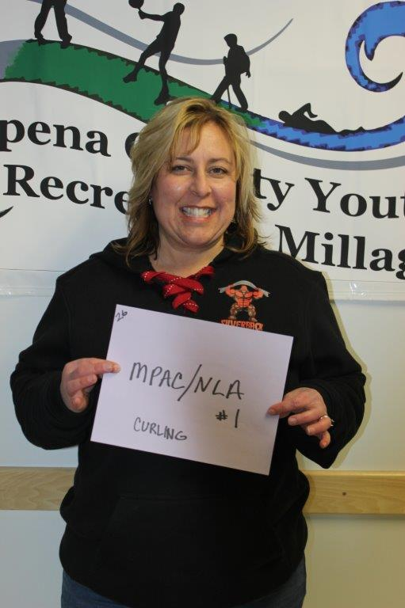
MPAC/NLA – Keli Werda
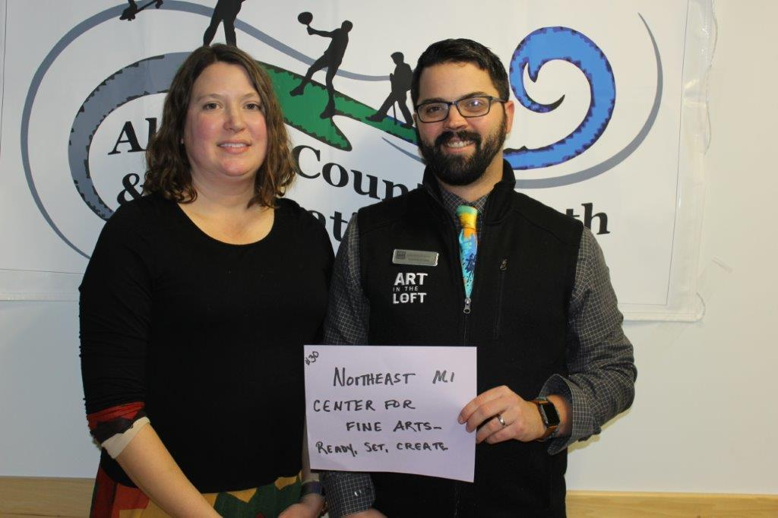Northeast MI Center For Fine Arts – Brooke Stevens & Justin Cooper
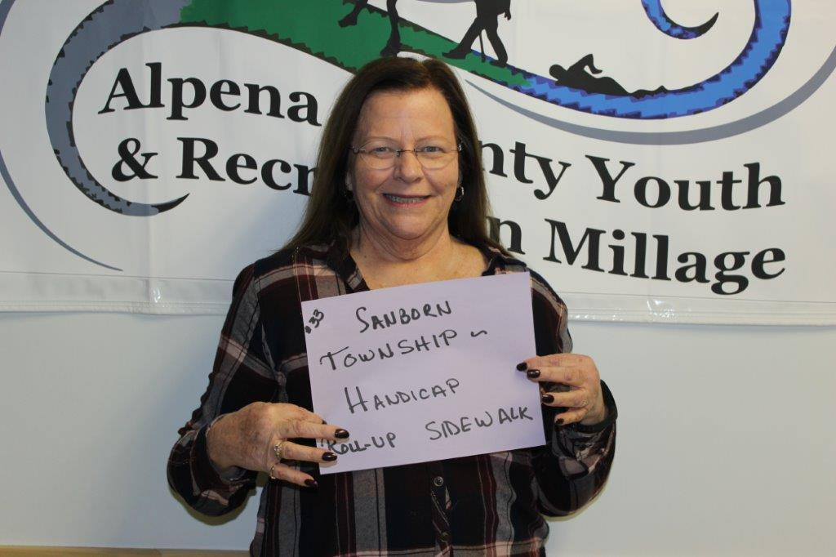Sanborn Township – Pat Sampier 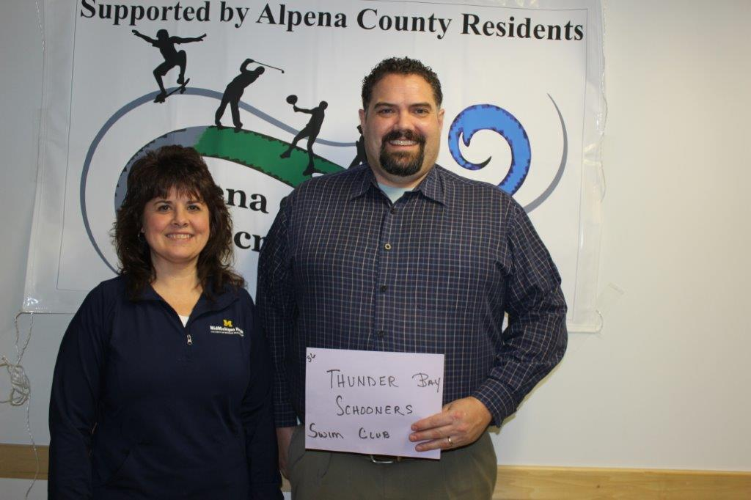Thunder Bay Schooner Swim Club – John Short & Connie Adamiak

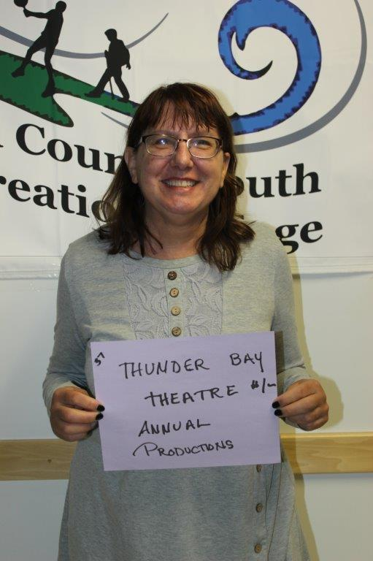
Thunder Bay Theatre – Lisa Larkin
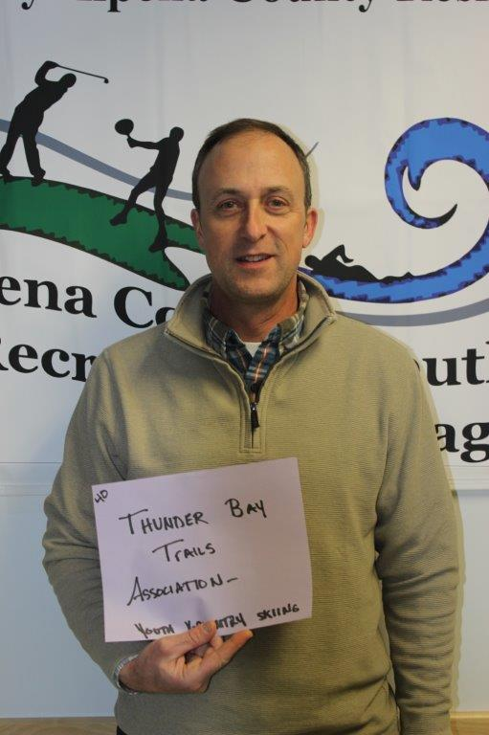
Thunder Bay Trails Association – Jeff Blumenthal
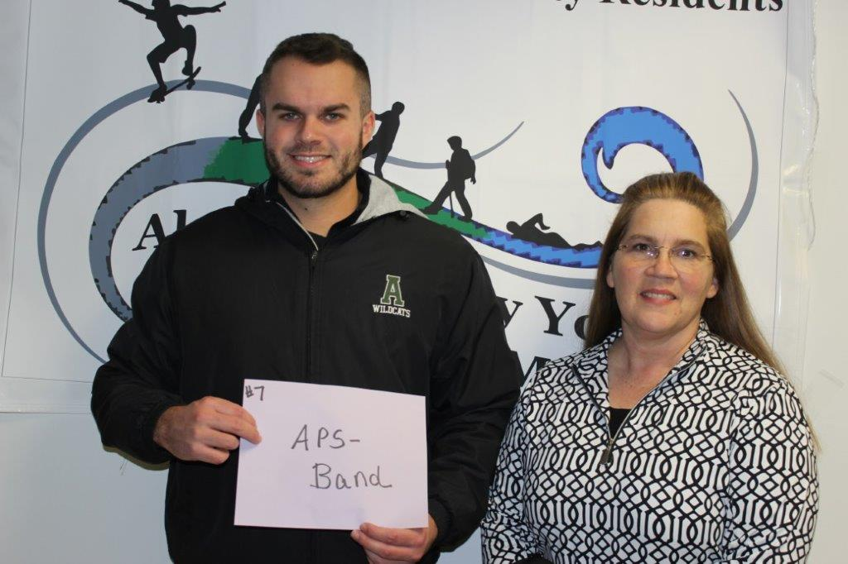APS – Band – Mike Gozzard & Lisa West
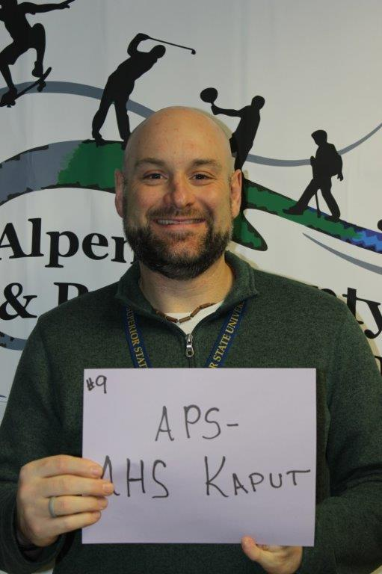
APS -AHS KAPUT – Tom Berriman
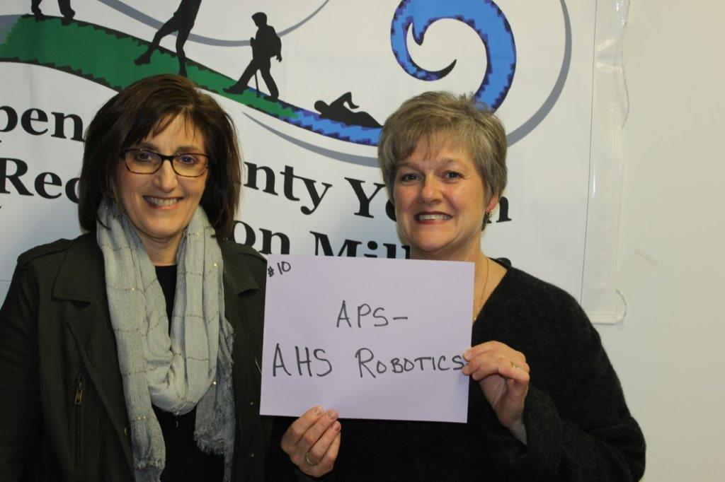APS-AHS Robotics – Elly Diamond & Nancy Jones

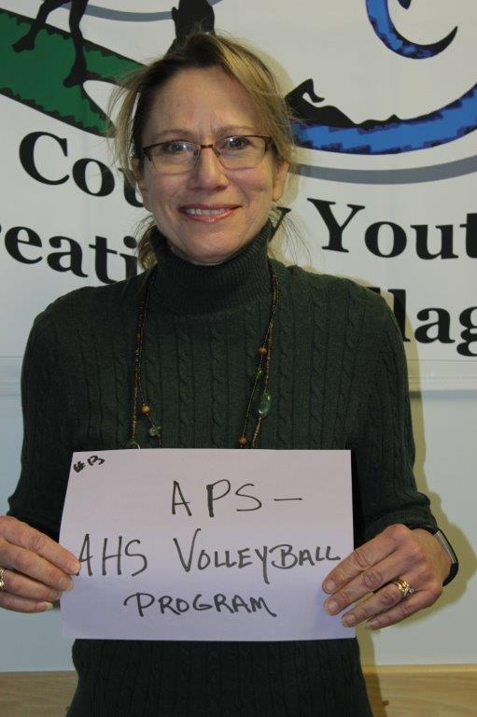
APS – AHS Volleyball Program – Melissa Doubek

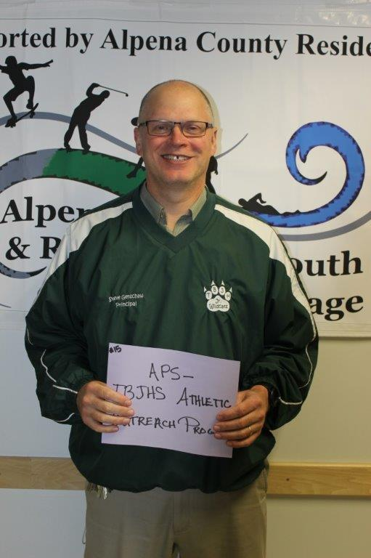
APS – TBJHS Athletic Outreach – Steve Genschaw
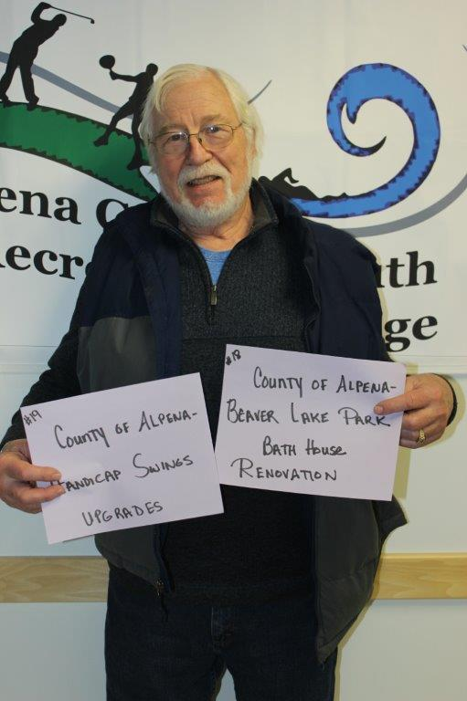
COA – Parks Commission – Chuck LeFebvre
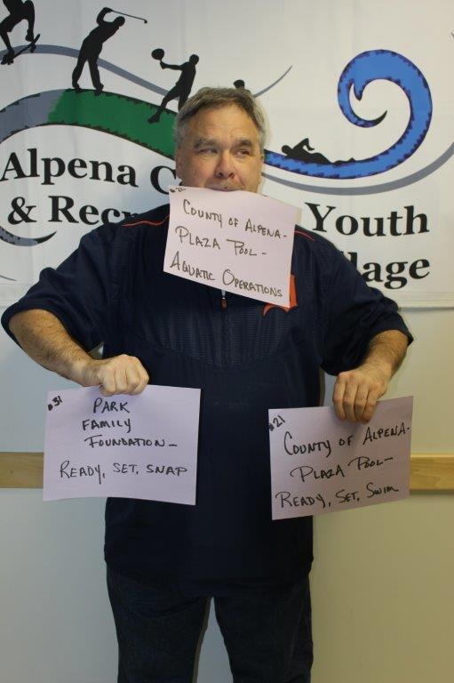
COA – Plaza Pool & Park Family Foundation – Norm Sommerfeld
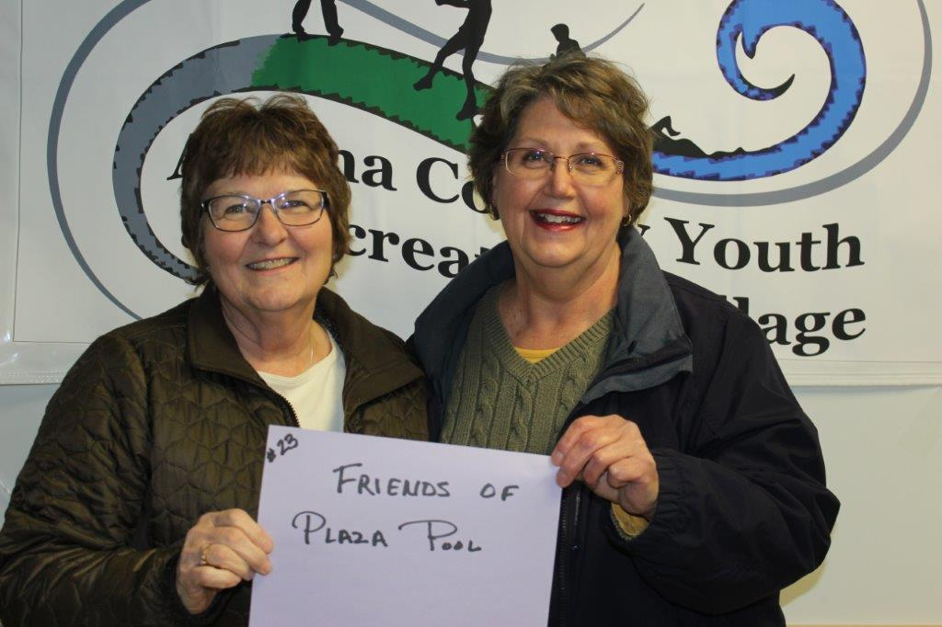Friends of the Plaza Pool – Ann Skiba & Carolyn Szatkowski
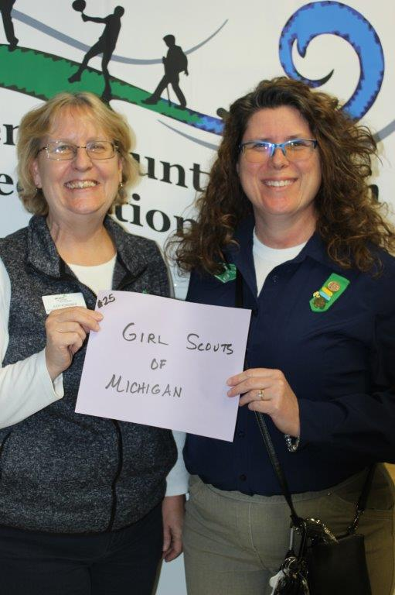
Girl Scouts of Michigan – Evonne Jasman & Judy Koronka
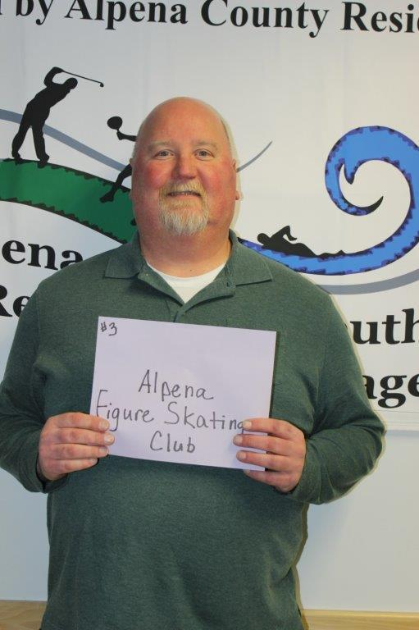
Alpena Figure Skating Club – Chris Ruby
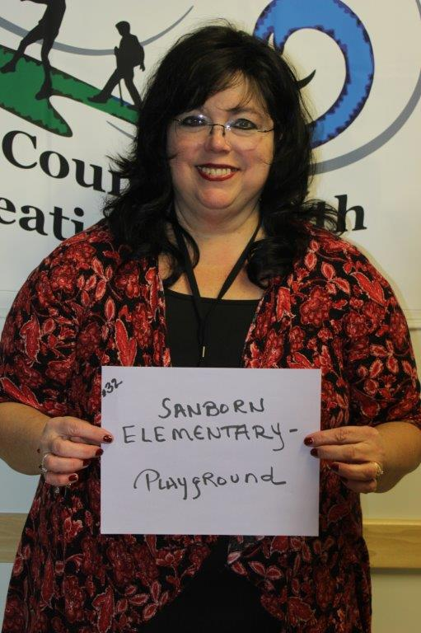
Sanborn Elementary – Pauline Burnham

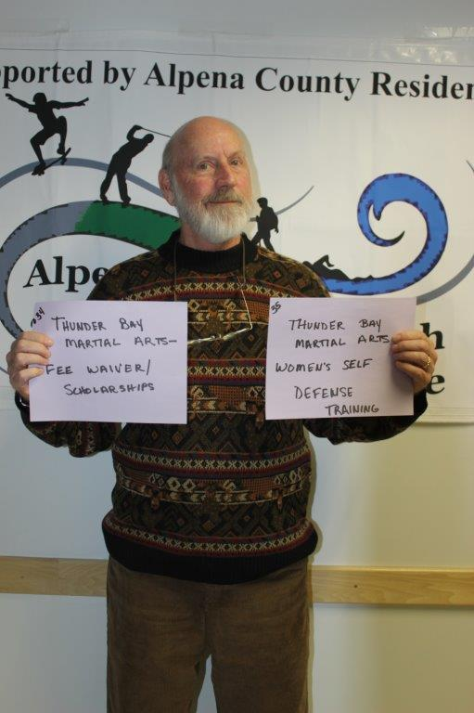
Thunder Bay Martial Arts – Dan Schackmann

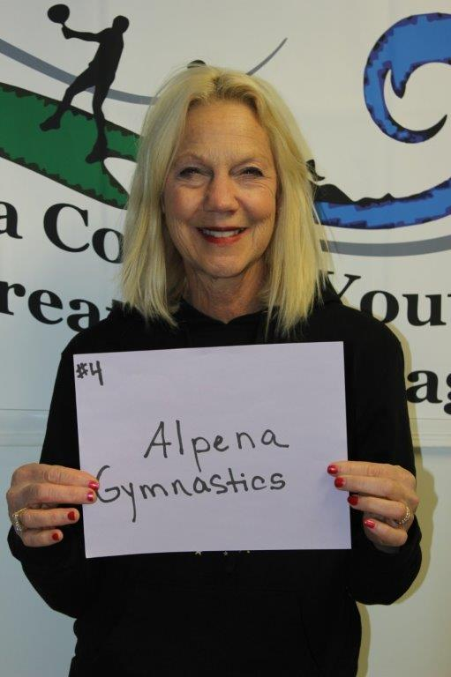
Alpena Gymnastics – Buffy Story
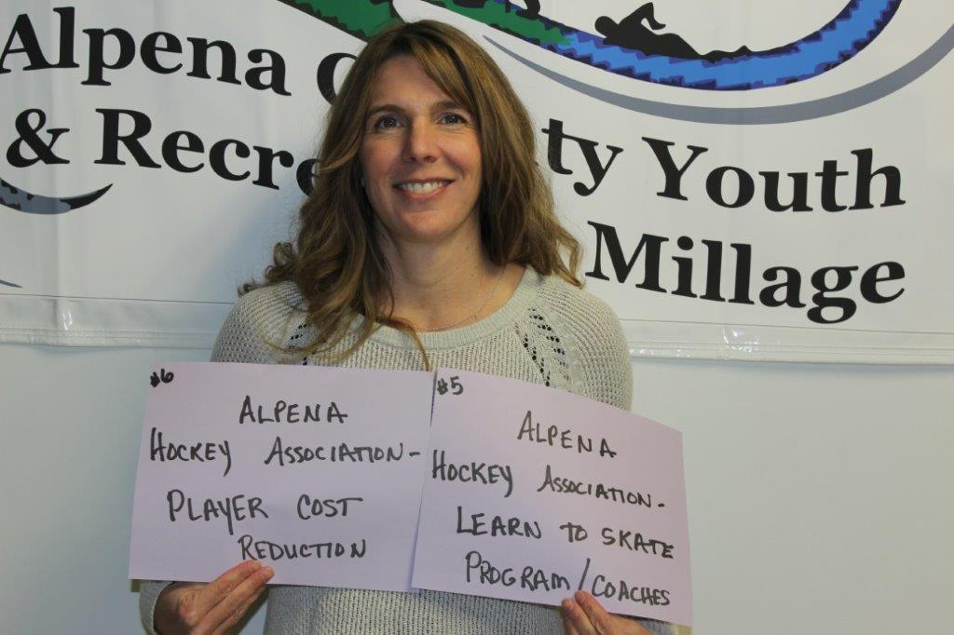Alpena Hockey Association – Julie VanDusen
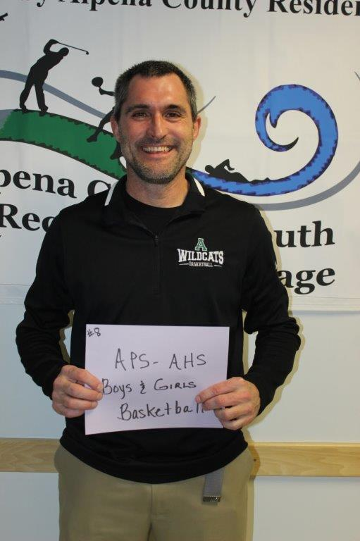
APS – AHS Boys & Girls Basketball – John Pintar

Organization | Project | Awarded
ACC Volunteer Center | Ropes Course | $2,071.00
ACC Cross-Country Team | Operating Support | $2,500.00
Alpena Figure Skating Club | Operating Support | $5,000.00
Alpena Gymnastics Inc | Safety Landing Mat | $1,810.00
Alpena Hockey Association | Learn to Skate  Program & Coaches | $1,798.00
Alpena Hockey Association | Player Cost Reduction | $6,300.00
APS – AHS Band | Band Equipment  (instruments only) | $10,000.00
APS – AHS Boys & Girls Basketball | Operating Support | $7,500.00
APS – AHS KAPUT | Activity Nights  (no gifts) | $18,375.00
APS – AHS Robotics Team | Operating Support | $30,750.00
APS – AHS Softball Line Drive Club | Reduce Transportation & Contribution Fees | $2,000.00
APS – The Woods Track Club | Hats & Shirts | $1,058.00
APS – AHS Volleyball Program | Transportation &  Contribution Fees | $2,550.00
APS – TBJHS Track Replacement | Running Track  Replacement | $35,000.00
APS – TBJHS Athletic Outreach Program | Athletic Outreach  Program | $13,280.00
Boys & Girls Club of Alpena | Triple Play  Mind, Body, Soul | $12,500.00
County of Alpena – MSU Extension | Youth Programming | $40,000.00
County of Alpena – Parks Commission | Beaver Lake Park Bathhouse Renovation | $15,970.00
County of Alpena – Parks Commission | Long Lake Park Boat Launch Project (2019 award, carry over  to 2020) | $34,100.00
County of Alpena – Parks Commission | Handicap Swings | $5,000.00
County of Alpena – Plaza Pool | Aquatic Operations | $86,313.00
County of Alpena – Plaza Pool | Ready, Set, Swim | $8,500.00
Friends of the Alpena Farmers Market | Youth Program | $3,000.00
Friends of the Plaza Pool | Programming & Support –  Family Fridays | $5,075.00
Friends of the TBNMS | Recreation Area | $57,040.00
Girl Scouts of Michigan | Camp Renovations | $17,500.00
MPAC dba Northern Lights Arena | Curling | $23,000.00
MPAC dba Northern Lights Arena | Maintenance Support | $19,300.00
MPAC dba Northern Lights Arena | Open Skating Support | $12,650.00
Northeast MI Center for Fine Arts | Ready, Set, Create | $21,250.00
Park Family Foundation | Ready, Set, SNAP | $9,500.00
APS – Sanborn Elementary School | Playground Equipment | $10,000.00
Sanborn Township Planning Commission | Handicap Roll-up Sidewalk | $10,528.00
Thunder Bay Martial Arts | Fee Waiver/Scholarships | $7,500.00
Thunder Bay Martial Arts | Women’s Self Defense  Training | $3,000.00
Thunder Bay Schooners Swim Club | Pool Time & Meet Fees | $11,000.00
Thunder Bay Theatre | Annual Productions | $8,125.00
Thunder Bay Theatre | Educational Tour | $18,500.00
Thunder Bay Trails Association | Youth Cross-Country  Ski Club | $5,500.00
Total |  | $550,743.00

County Commissioners & Commissioners Appointees
District 1 – COMMISSIONER
Brad McRoberts
221 Potter Street
Alpena, MI 49707
989.255.0208
bradmcroberts@alpenacounty.org
Linda Canfield
242 S Second
Alpena, MI 49707
989.356.2742
lindacanfield1@frontier.com
District 3 – COMMISSIONER
Dave Karschnick
609 Island View Drive
Alpena, MI 49707
989.464.0722
davidkarschnick@alpenacounty.org
Dennis A. Werblow
Address: 633 Island View Dr.
Alpena, MI 49707
989.354.5560
werblow@chartermi.net
District 5 – COMMISSIONER
Brenda Fournier
2464 Diamond Drive
Alpena, MI 49707
989.358.1414
brendafournier@alpenacounty.org
Tom Heise
3376 Piper Road
Alpena, MI 49707
989.354.2447
htssllc@yahoo.com
District 7 – COMMISSIONER
Marty Thomson
2802 M 65 North
Lachine, MI 49753
989.464.6189
martythomson@alpenacounty.org
Fred Wegmeyer
10599 Napper Rd.
Herron, MI 49744
989.379.4034
District 2 – COMMISSIONER
Robert Adrian
227 Dawson Street
Alpena, MI 49707
989.464.6334
robertadrian@alpenacounty.org
Brett Miller
1121 River Street
Alpena, MI 49707
989.354.3328
bam3623@gmail.com
District 4 – COMMISSIONER
Bill Peterson
2379 Lake Winyah Road
Alpena, MI 49707
989.916.5351
billpeterson@alpenacounty.org
Tony Suszek
114 Kensington Court
Alpena, MI 49707
989.356.4434
tonysuszek@gmail.com
District 6 – COMMISSIONER
Ronald McDonald
6594 Orchard Hill Road
Alpena, Ml 49707
989.379.4848
ronaldmcdonald@alpenacounty.org
Thomas Spaulding
5925 Keating
Lachine, MI 49753
989.379.2789
tspaulding50@hotmail.com
District 8 – COMMISSIONER
John Kozlowski
1208 W. Scott Road
Ossineke, MI 49766
Phone: 989.464.2194
johnkozlowski@alpenacounty.org
Lisa Siegert
12700 Hawkins Road
Hubbard Lake, MI 49747
989.727.3089
siegertlne@gmail.com

County Contacts
Lynn Bunting
Board Assistant
989.354.9501
commissionersoffice@alpenacounty.org
Kim Elkie
Board Administrative Assistant
Alpena County Commissioners
989.354.9503
commissionersoffice@alpenacounty.org
Tammy Sumerix-Bates
Executive Manager
989.354.9502
commissionersoffice@alpenacounty.org
Kim Ludlow
County Treasurer
989.354.9534
ludlowk@alpenacounty.org

Share this article
- facebook
- twitter
- linkedin
- email
- pinterest

