*** #1 2019 Logo

2019 Youth and Recreation Millage Funds Awarded
Youth and Recreation
- facebook
- twitter
- linkedin
- email
- pinterest
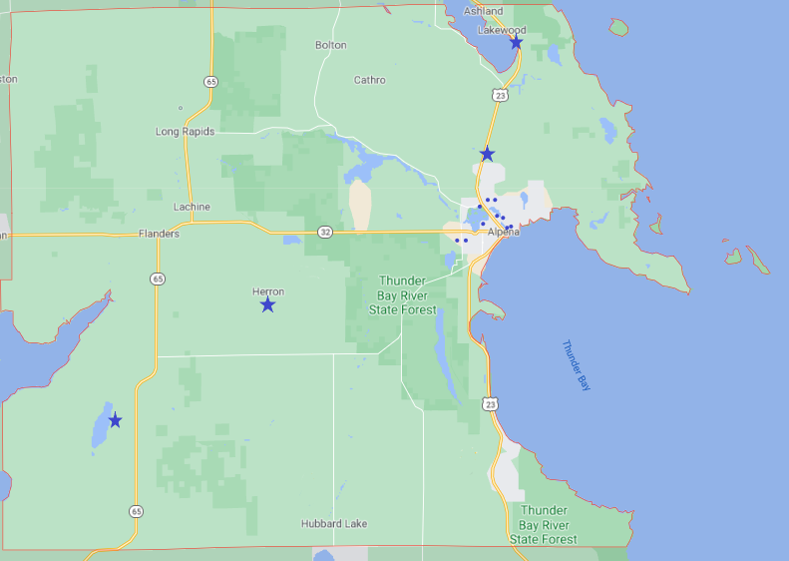2019 Alpena County Funding #2 Pic
The Committee is trying to spread the funds throughout the County, encouraging all the Townships and non-profit organizations, schools, and governmental agencies to apply. The Alpena County Map shown on the left depicts where 29 grants have been awarded. Please click on the image for a larger view or by clicking here.
Budget Recommendations for 2019 recommendations are not approved until after the Full Board of Commissioners approval as part of the Budget held December 18, 2018.
The total amount appropriated $545,223.00

Resources
2019 Award Book
Meeting Dates
Millage Language
Funding Report

Township Maps
Alpena Township
City of Alpena
Green Township
Long Rapids Township
Maple Ridge Township
Ossineke Township
Sanborn Township
Wellington Township
Wilson Township

