*** 2018 Logo Pic #1

2018 Youth and Recreation Millage Funds Awarded
Youth and Recreation
- facebook
- twitter
- linkedin
- email
- pinterest
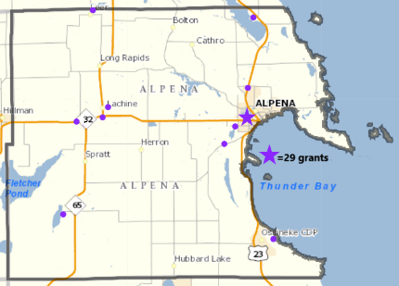2018 YR Map #2 Pic
The Committee is spreading the funds throughout the County, encouraging all the Townships and non-profit organizations, schools, and governmental agencies to apply. The Alpena County Map shown on the left, depicts where 29 grants have been awarded. Please click on the image for a larger view or by clicking here. (clicking here #3 Pic)
Budget recommendations are not approved until after the Full Board of Commissioners approval as part of the Budget held December 19, 2017.
Total amount appropriated $541,756.00

Resources
2018 Award Book
Funding Report
Meeting Dates

Maps
Alpena Township
City of Alpena
Green Township
Long Rapids Township
Maple Ridge Township
Ossineke Township
Sanborn Township
Wellington Township
Wilson Township

Listed below, you can view the organization, the amount awarded and the name of the project. 2018 Award book can be view by clicking here. (clicking here #4 Pic)
Park Family Foundation
$11,000.00 Ready, Set, Snap funding for special needs recreational activities. 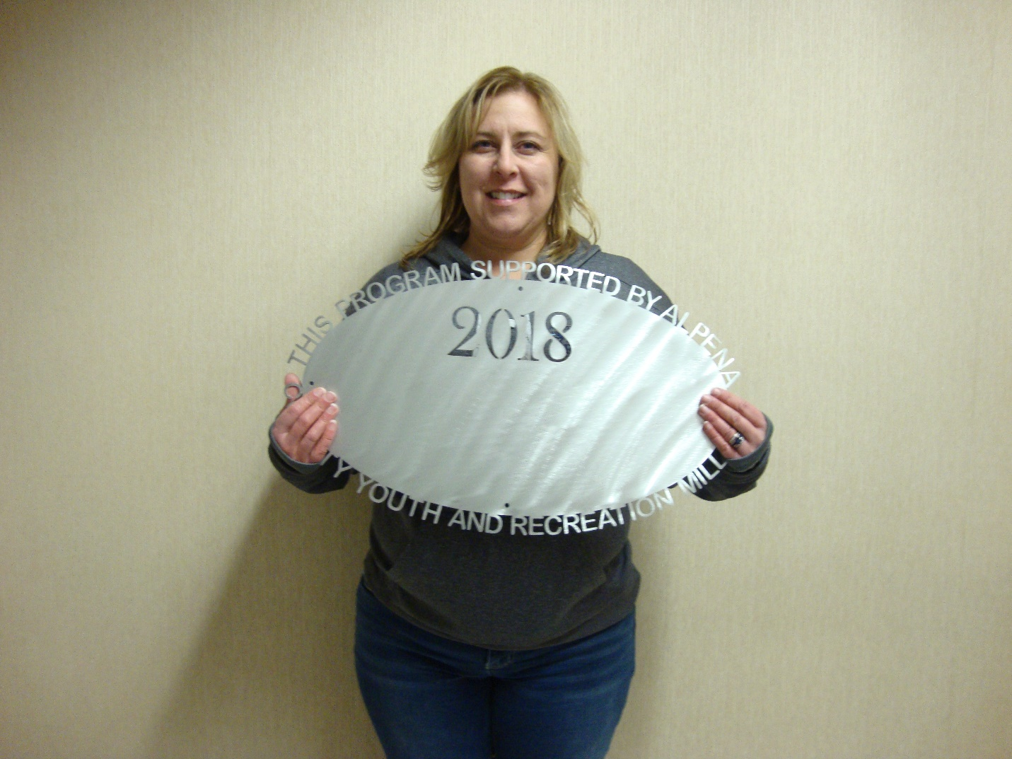MPAC-Northern Lights Arena Community #1 $13,120.00
Free open ice skating and skate rental, 23 Sundays. 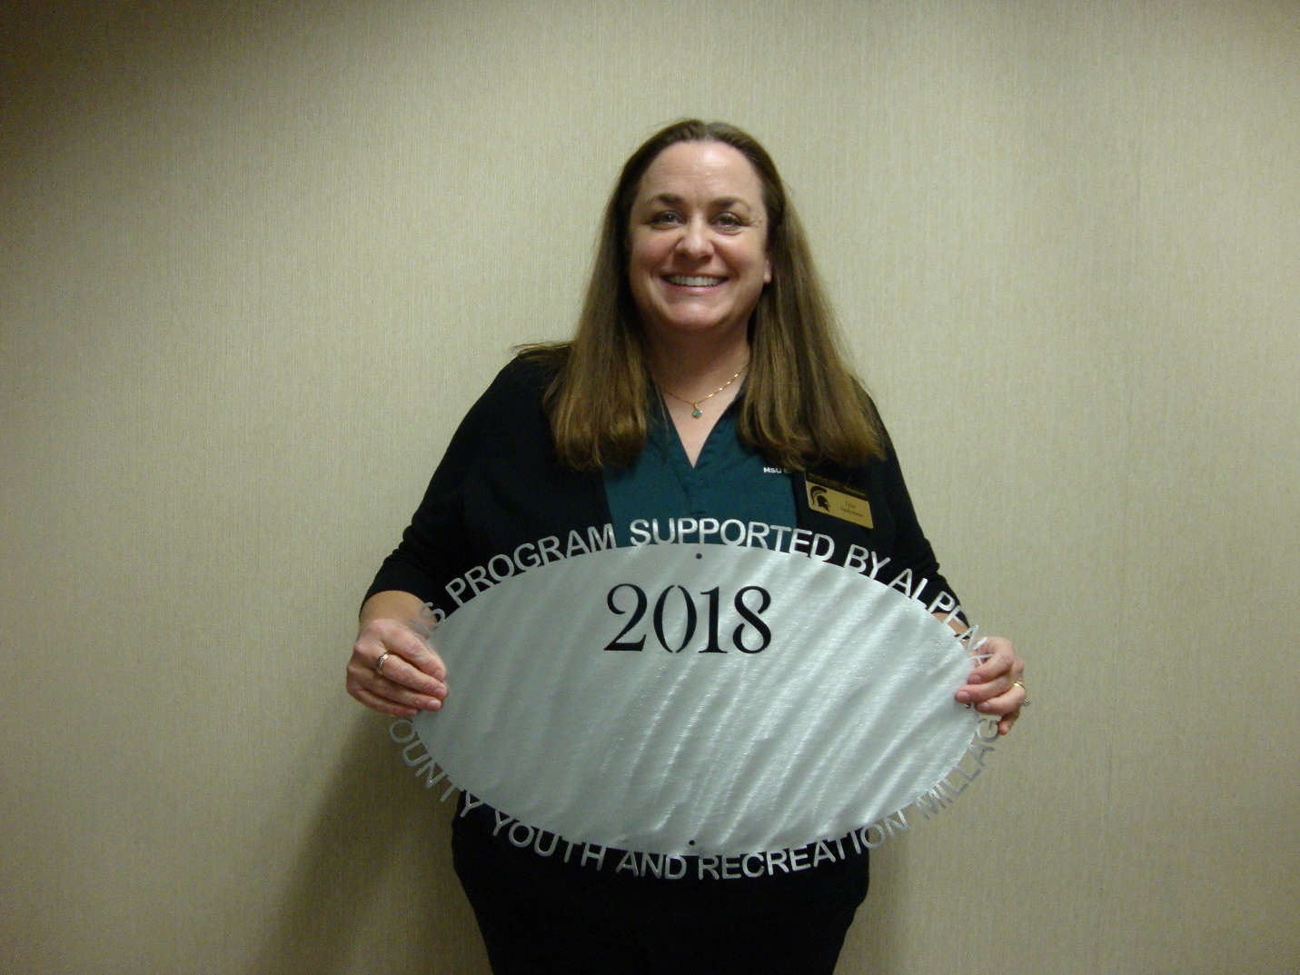County of Alpena – MSU Extension
$40,000.00 Youth Programming (4-H) 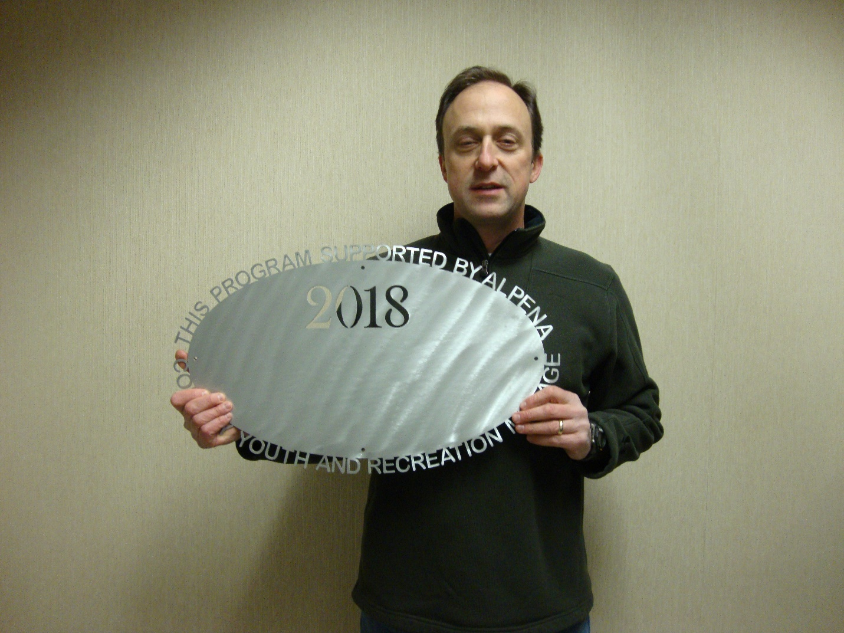Thunder bay Trails Association
$5,500.00 Youth Cross Country Ski Club County of Alpena – Plaza Pool
$8,500.00 Ready, set, swim program 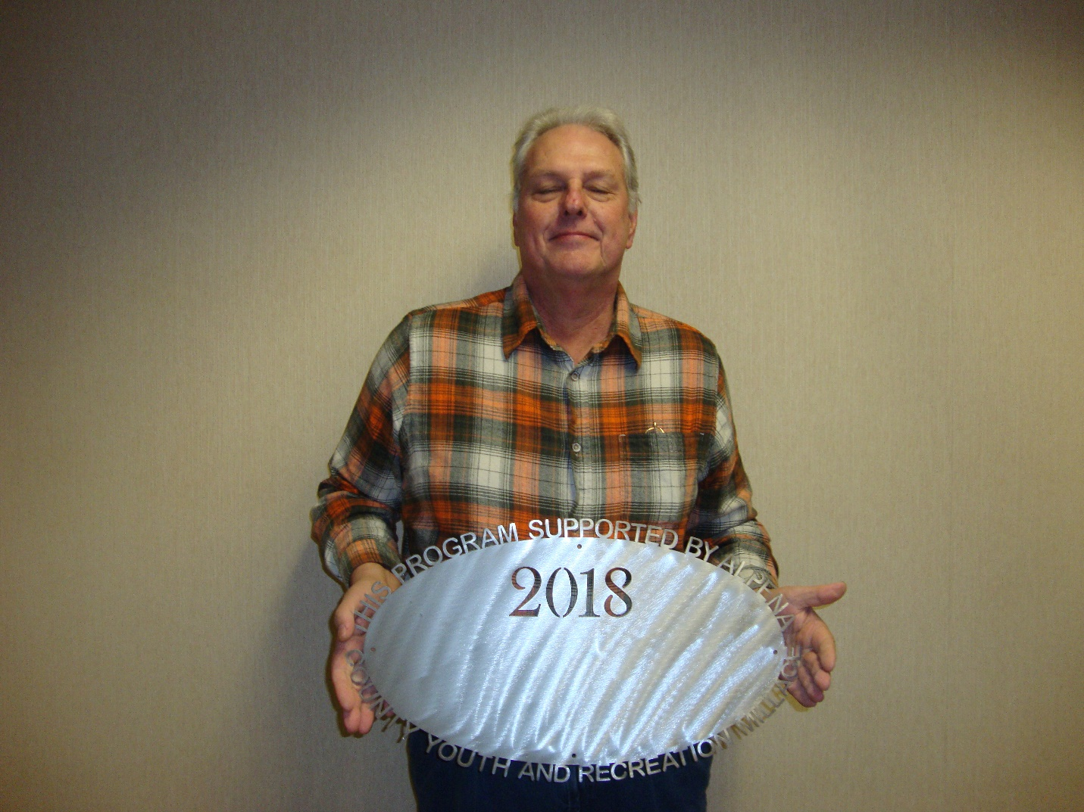Green Township
$7,583.00 Recreational Area Upgrades (volleyball, picnic tables, slide). 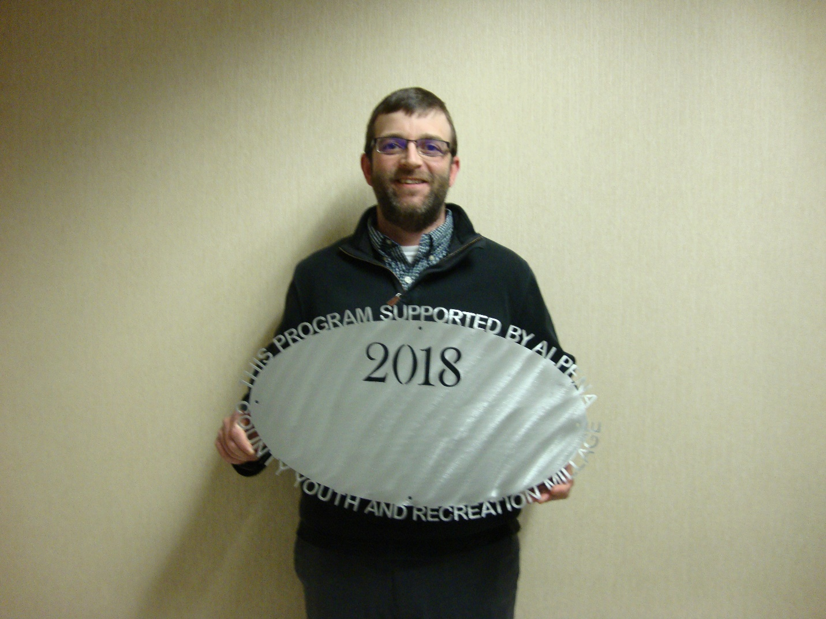Boys and Girls Club
$3,570.00 Carpet upgrade in game room 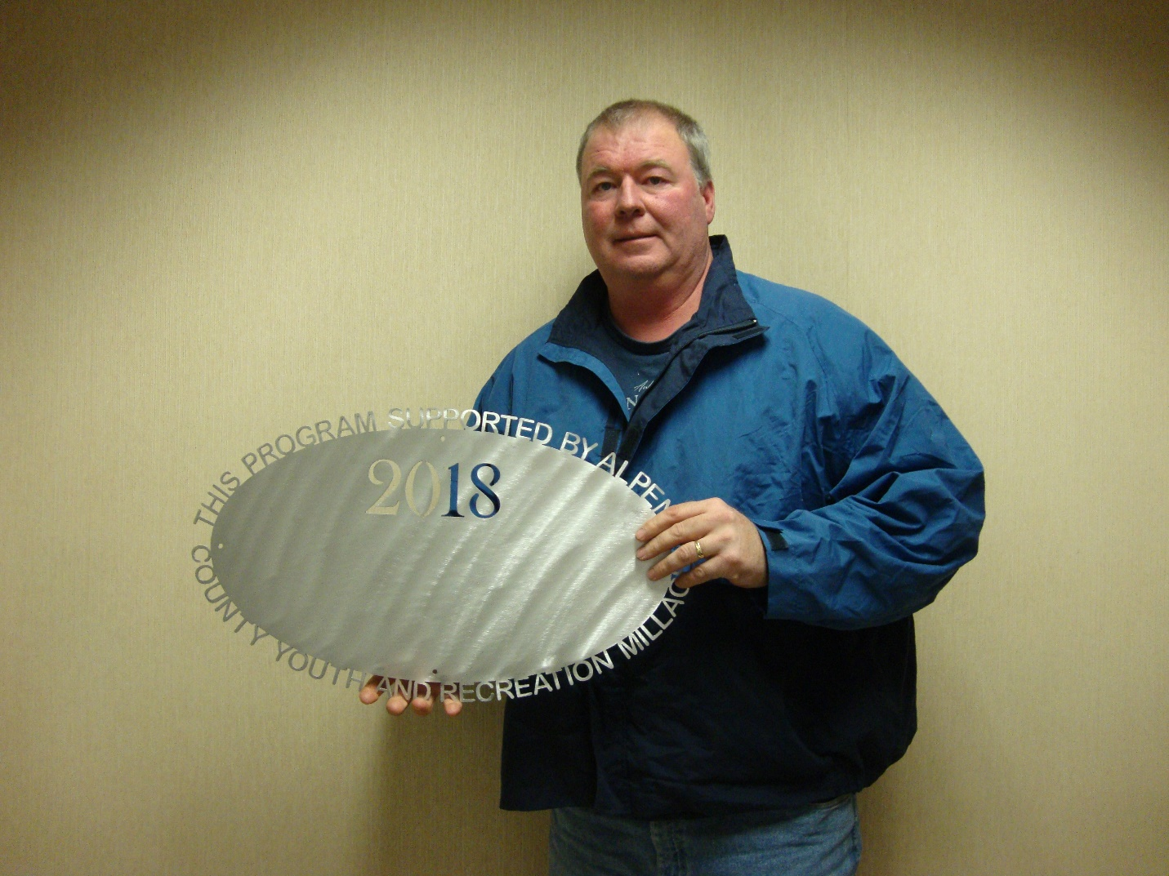Alpena Public Schools – TBJHS
$19,000.00 Athletic Outreach programs for 6th graders, admissions support for grades 7-8 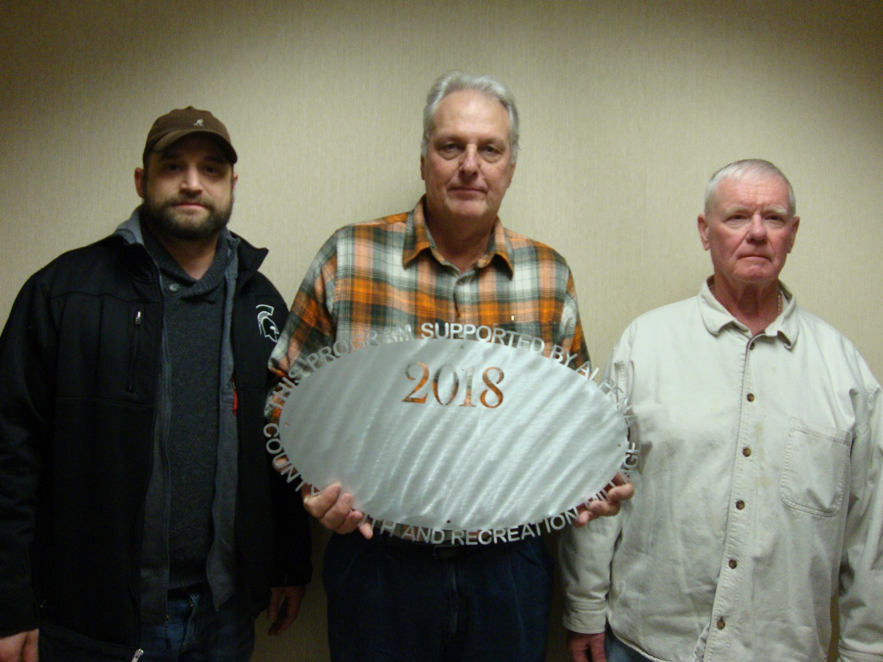County of Alpena – Parks Commission – Green Township $10,000.00
Upgrades at Manning Hill Park County of Alpena – Plaza Pool
$80,000.00 Pool Operations 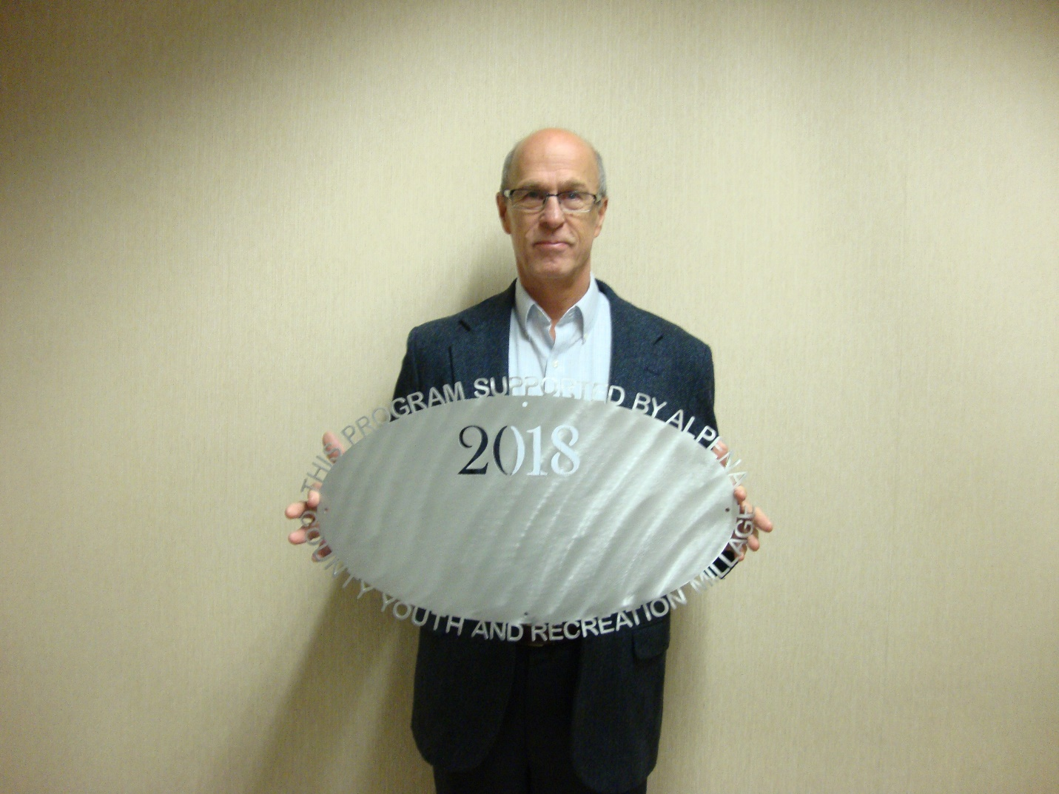Community Foundation – Rotory Club
$60,000.00 Splash Park at Starlite Beach 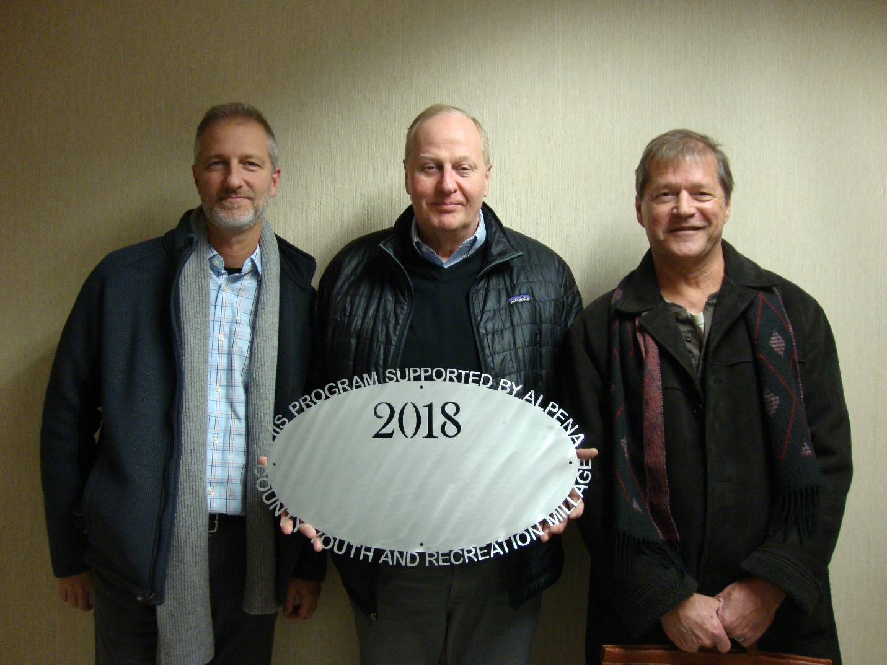City of Alpena/Alpena Mixed Vollyball League $13,950.00
Mich-e-ke-wis Volleyball Courts Lighting 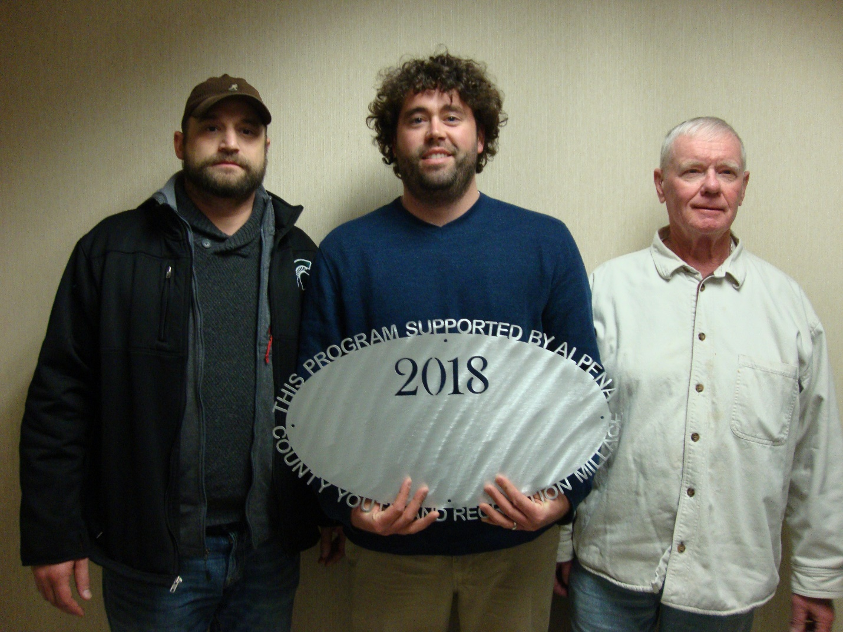County of Alpena – Parks Commission
$15,000.00 Playground at Long Lake Park 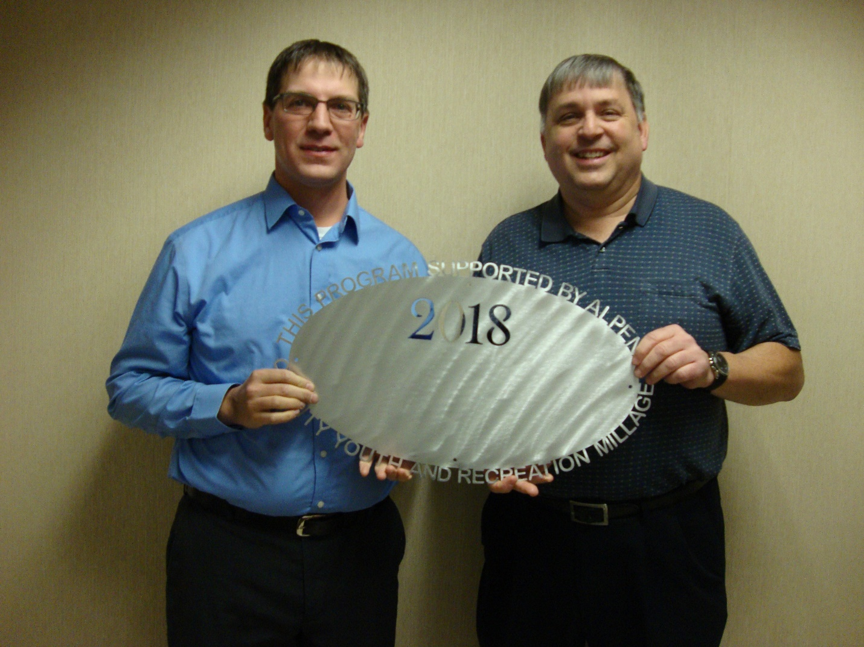Alpena City Band
$2,000.00 Centennial (100 year) Project 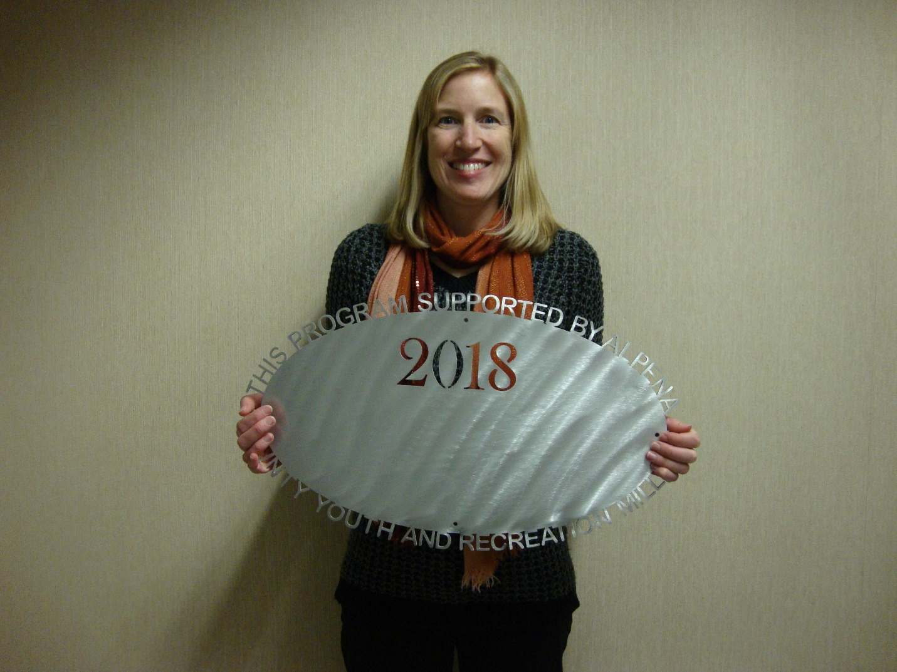Thunder bay Schooners Swim Club
$9,500.00 Operating Support – Pool Rental 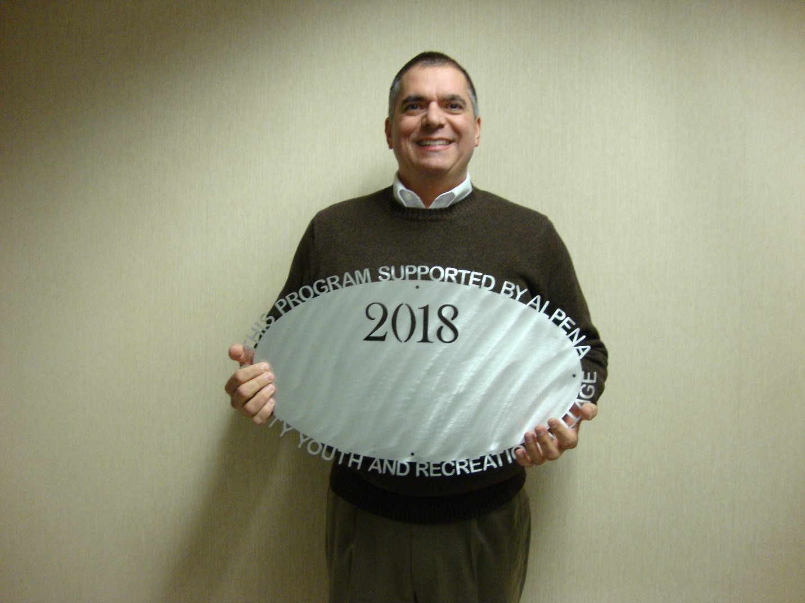Alpena Public Schools – AHS KAPUT
$18,350.00 Support of activety nights, Freshman bash, Prom and Senior lock-in 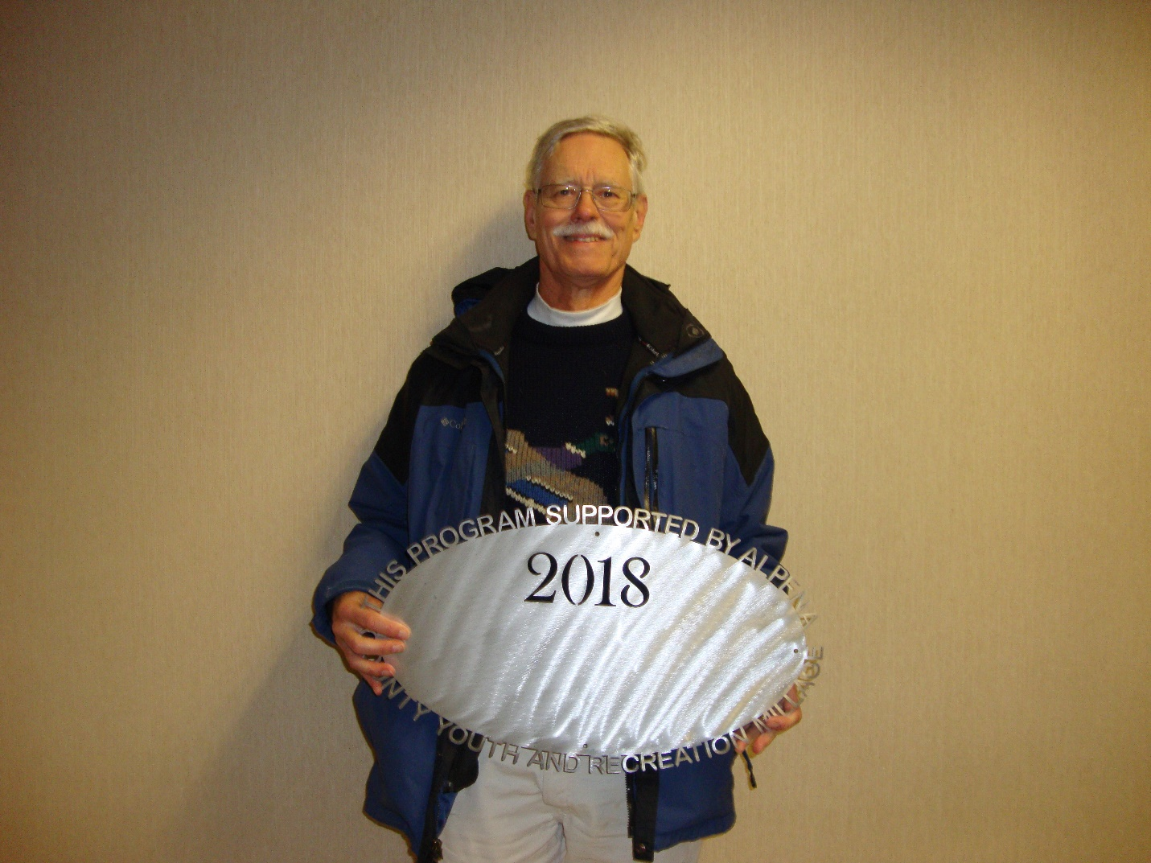Friends of Plaza Pool
$3,200.00 New User Activities Alpena Public Schools – AHS Softball Line Drive Club $2,500.00
Operating cost to reduce fees to players 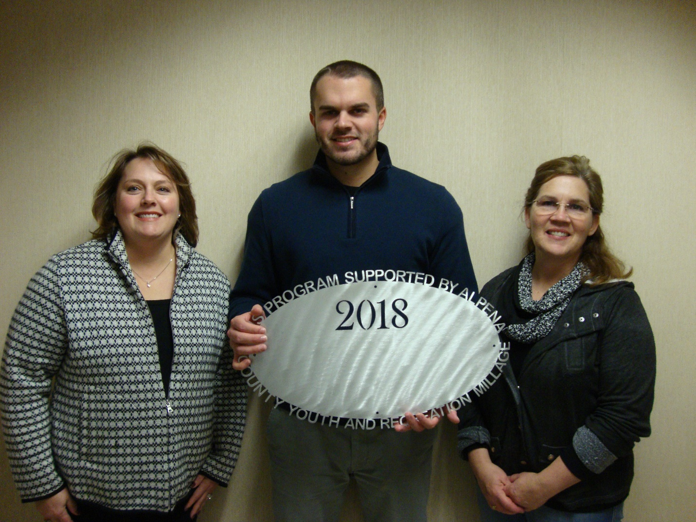Alpena Public Schools – AHS Band
$16,522.00 Band Instruments (Baritone sax, 4 piccolos, trombone, tuba) 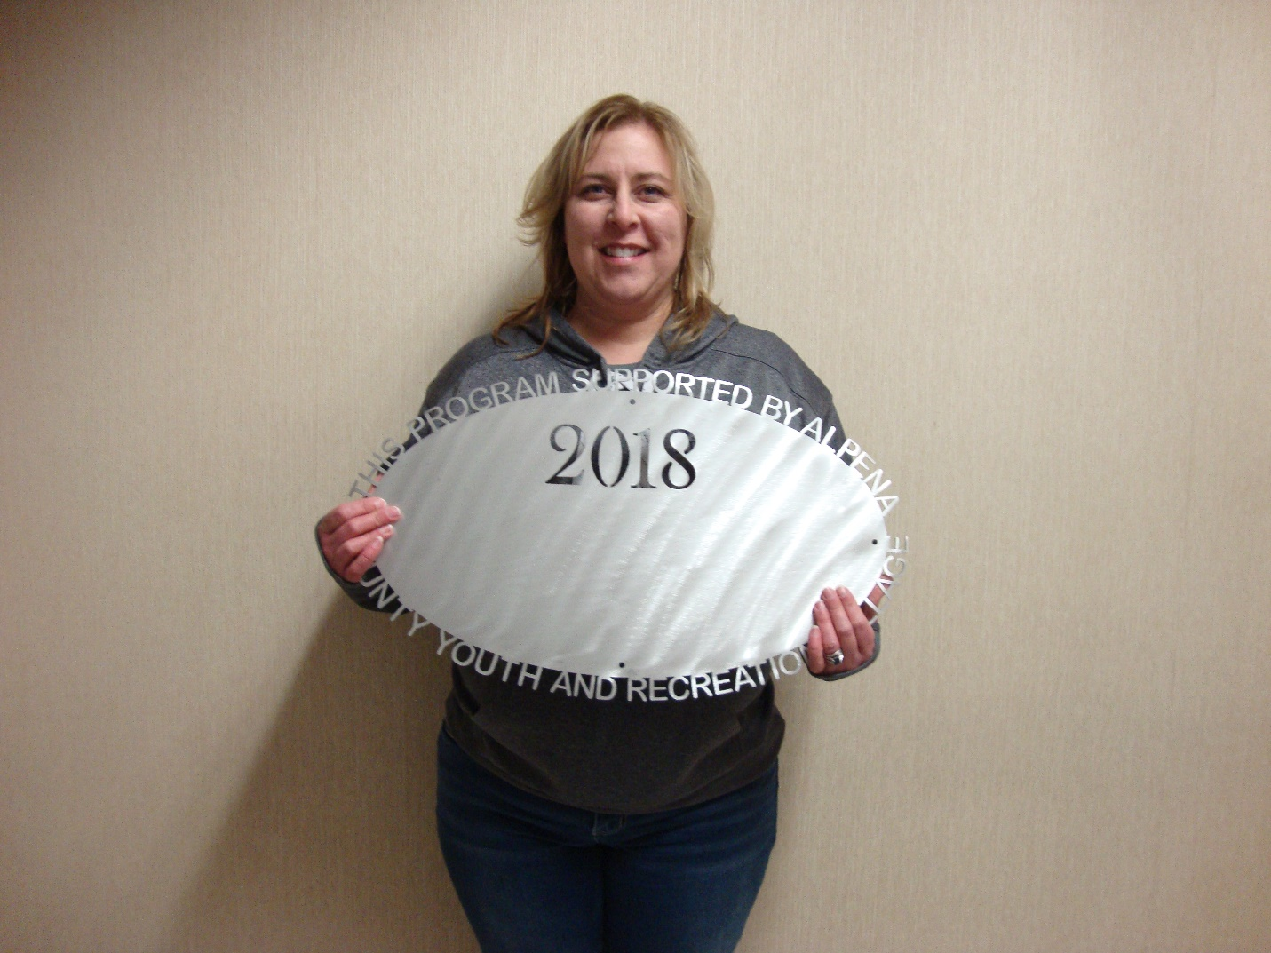MPAC – Northern Lights Arena#3
$10,000.00 Operating Support (Ameresco Reimbursement)
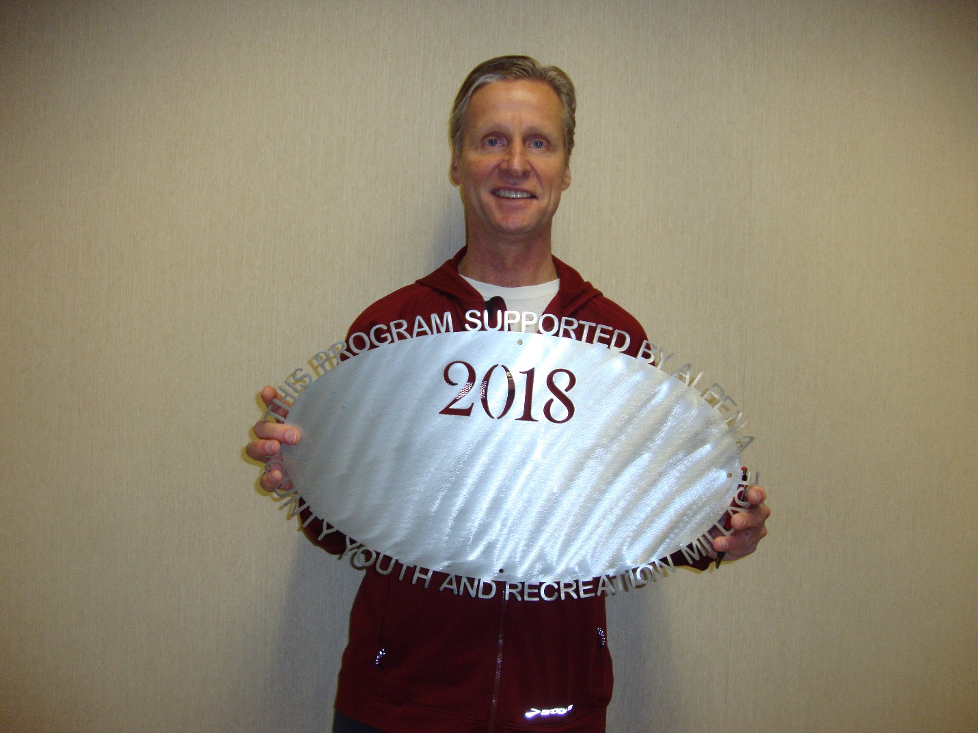Alpena Community College
$2,400.00 Cross Country Team support (camp and running jackets) 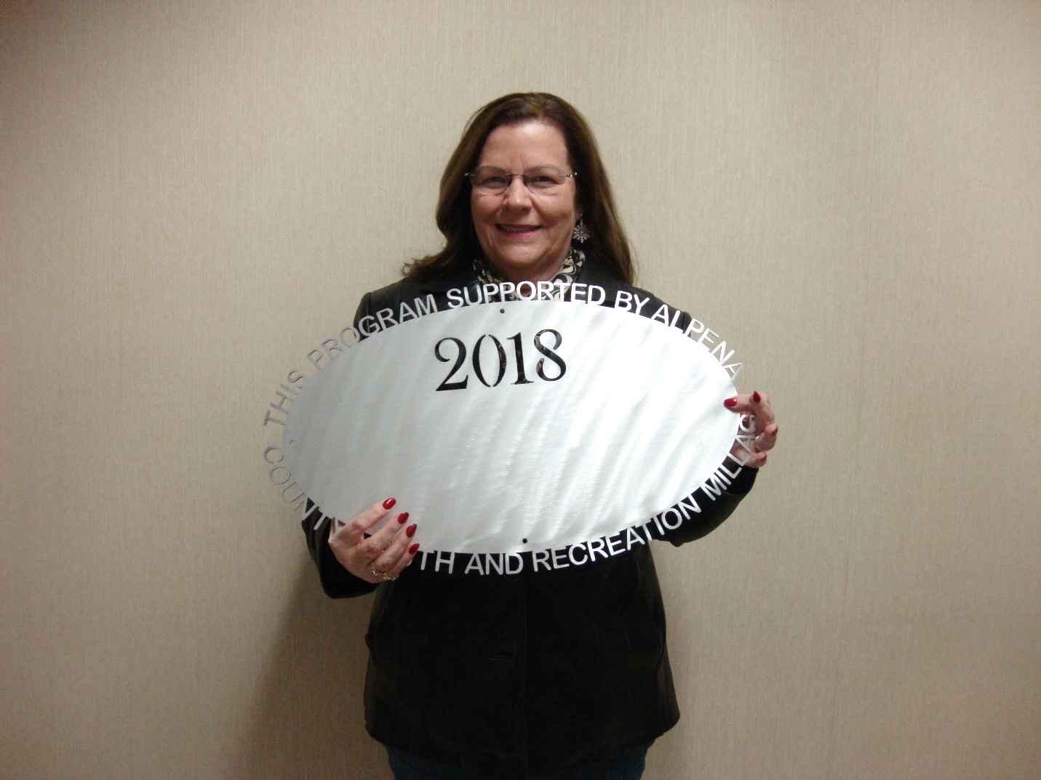Sanborn Township
$16,000.00 Huron/Ossineke beach improvement (climbing wall). County of Alpena – Sunken Lake Park
$13,014.00 Electrical Upgrades 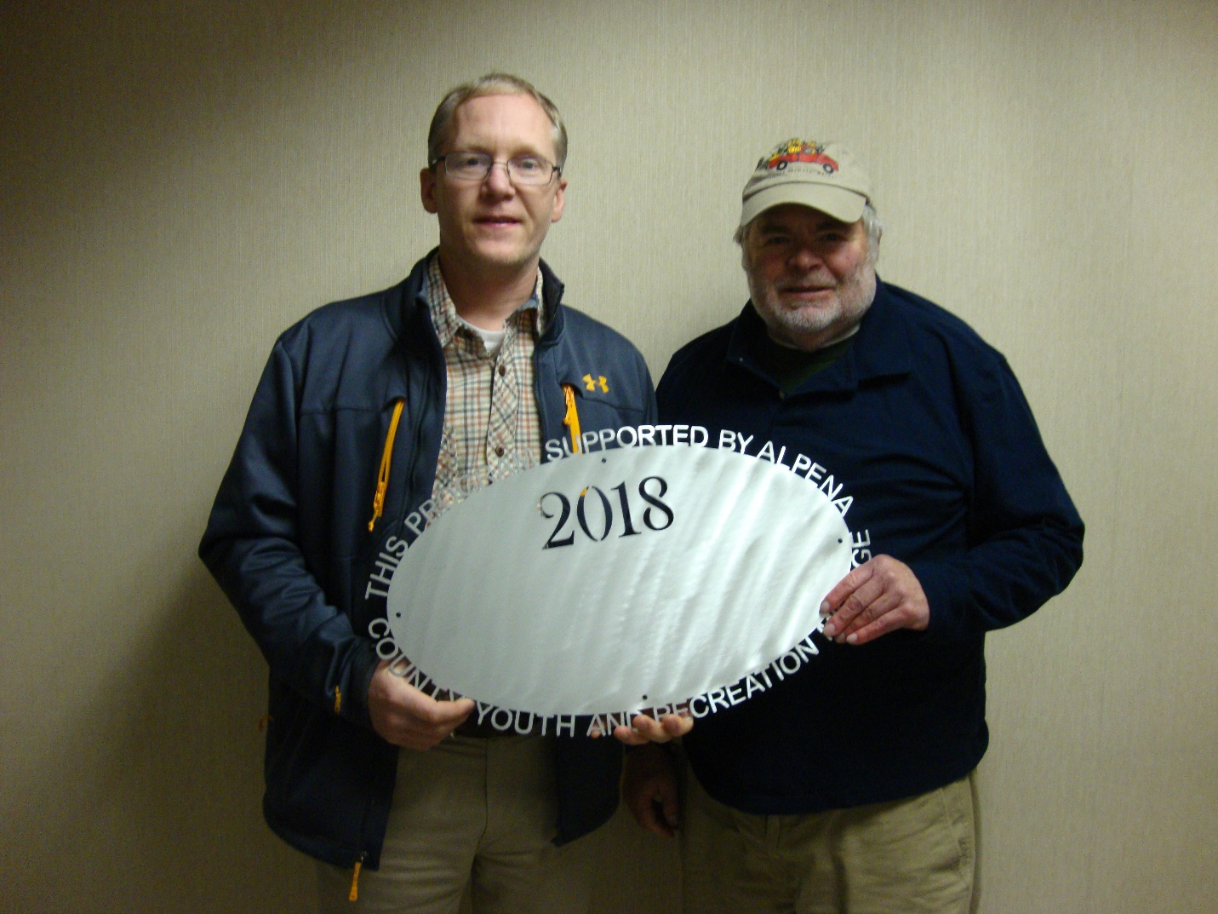Friends of the Alpena Farmers Market
$3,000.00 Support of kid’s day 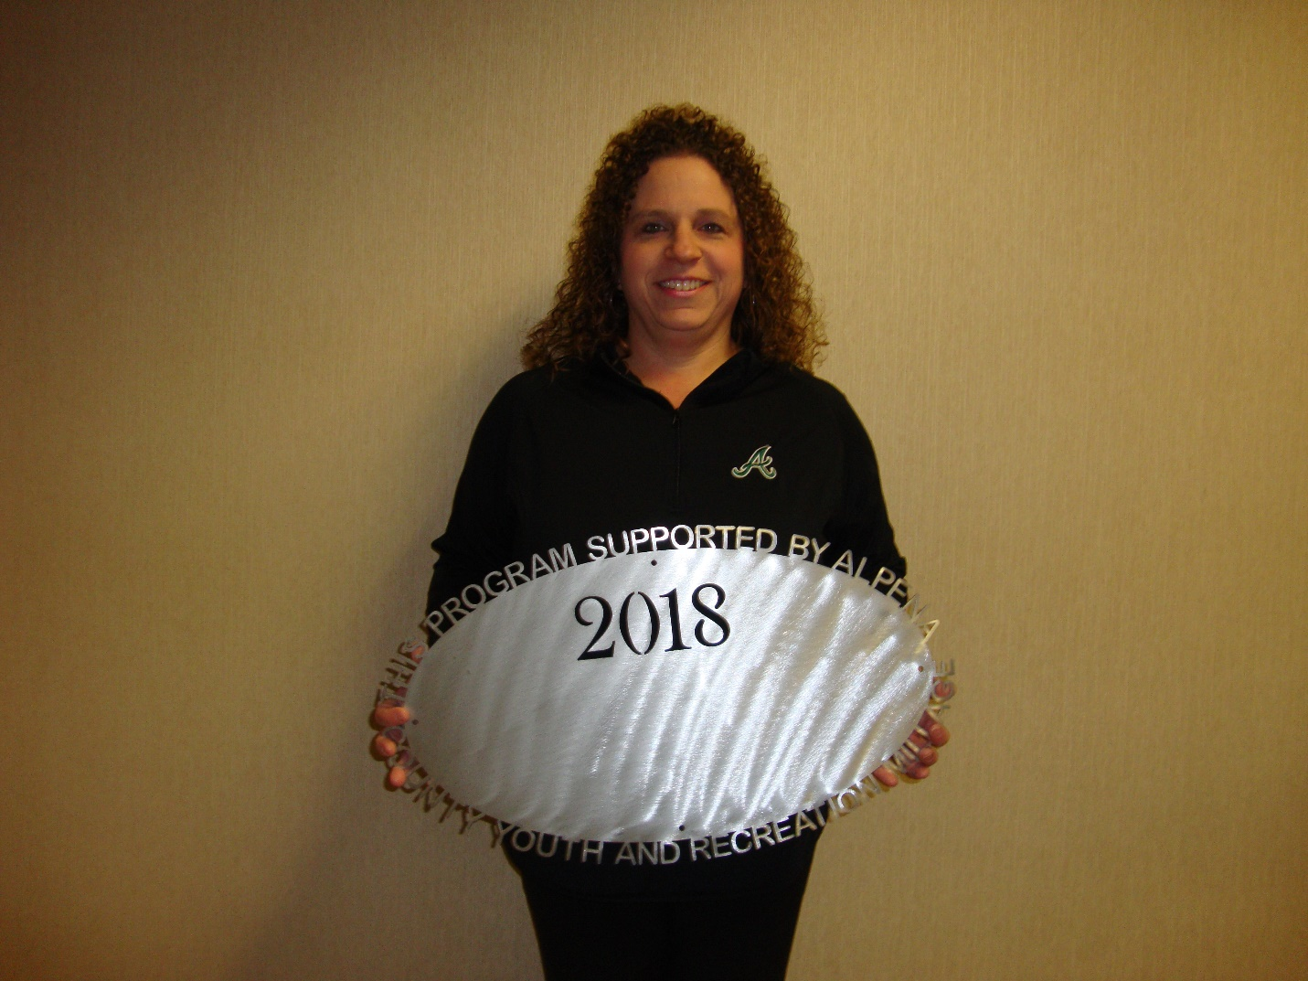Alpena Public Schools – AHS Vollyball Program $3,525.00
Support to reduce cost to players 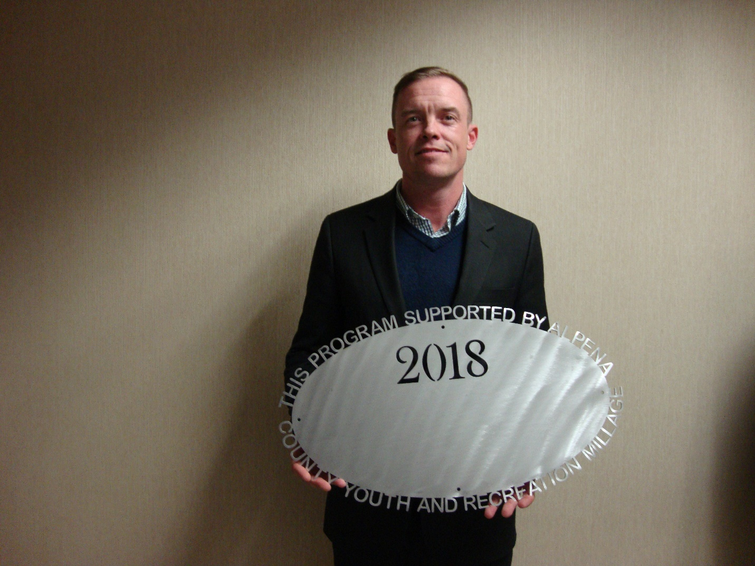Thunder bay River Restoration
$10,362.00 Funds to support river improvement and cleaning project 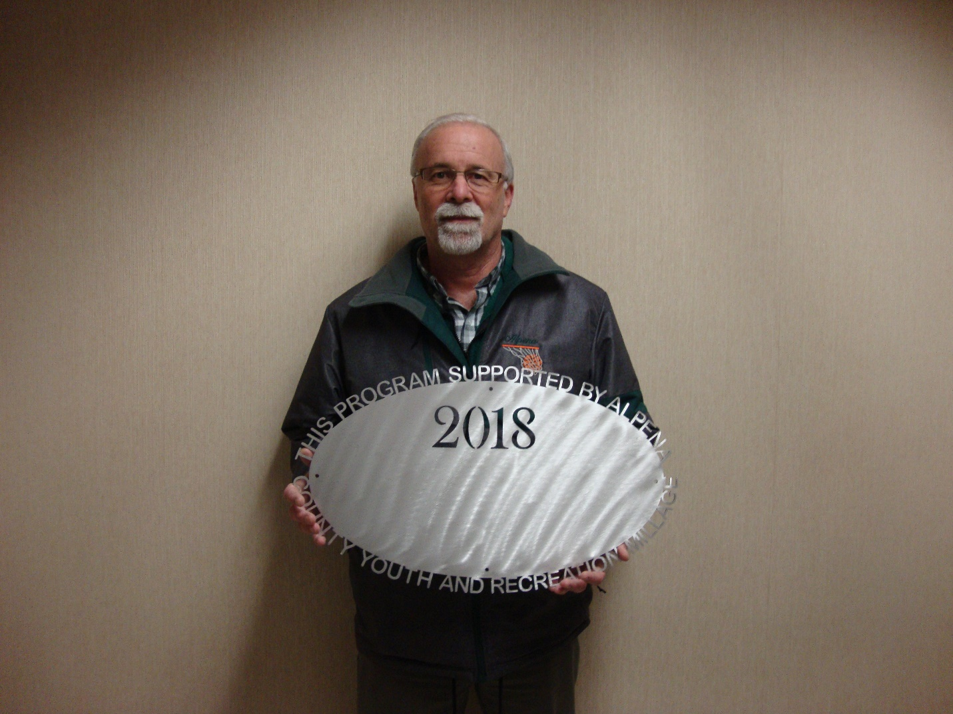Alpena Public Schools – AHS Boys and Girls Basketball $8,500 Support to reduce cost to players (transportation, uniforms, Freshman team) 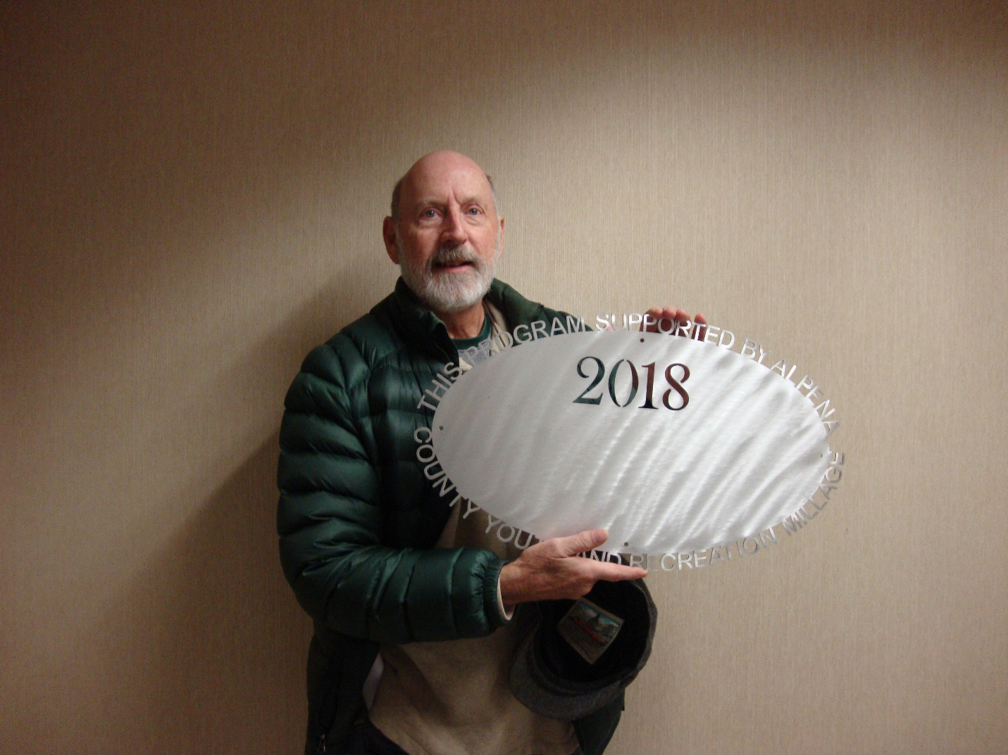Thunder bay Martial Arts
$7,500.00 Scholarships for Martial Art classes 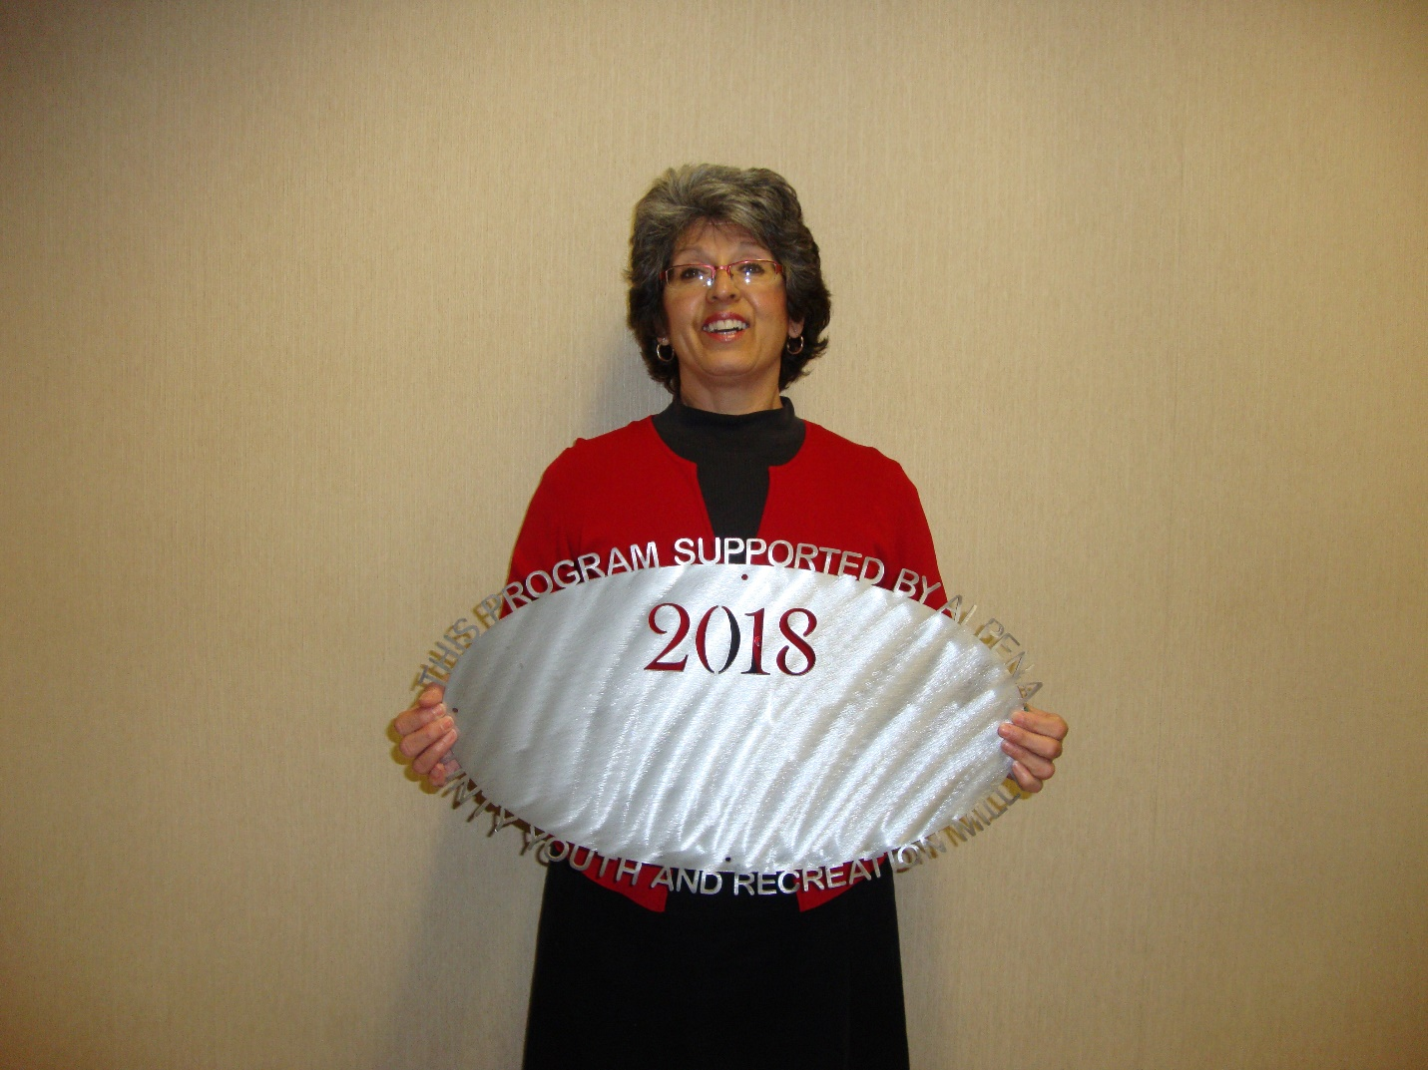ACC Volunteer Center
$4,500.00 Ropes Course 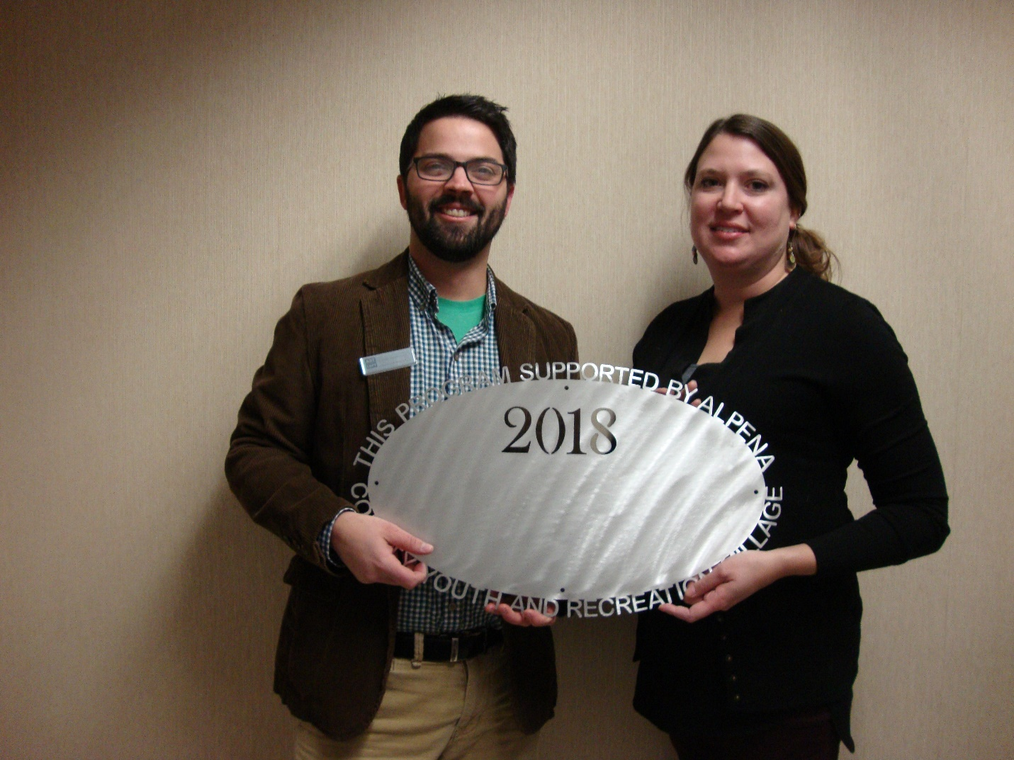Northeast MI for Fine Arts, Inc.
$22,285.00 Ready, Set, Create Program 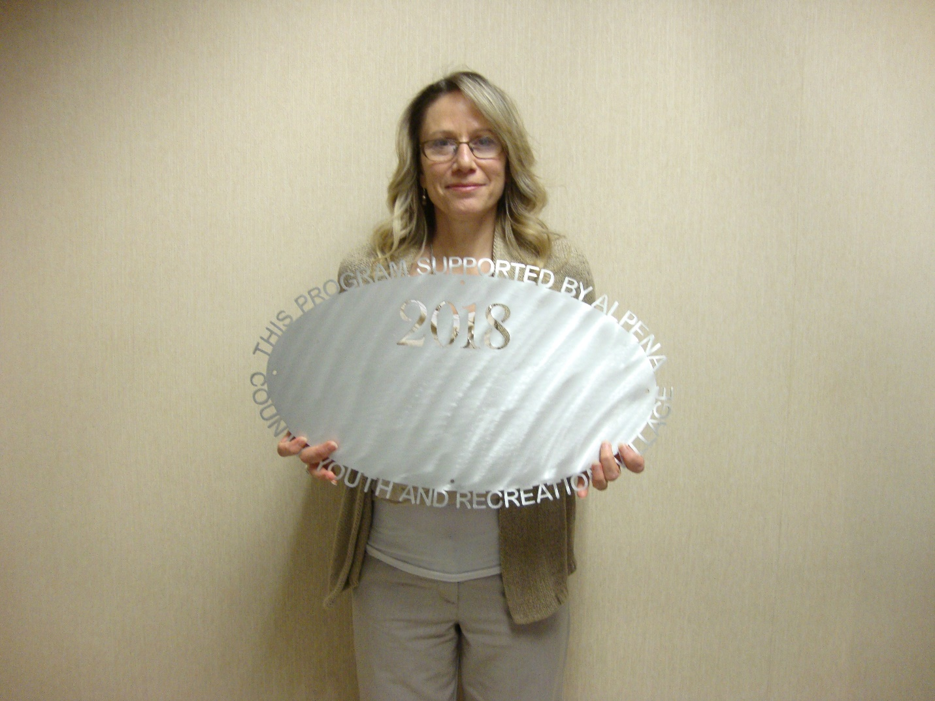Alpena Public Schools – AHS Robotics
$33,250.00 Support for AHS Robotic Teams 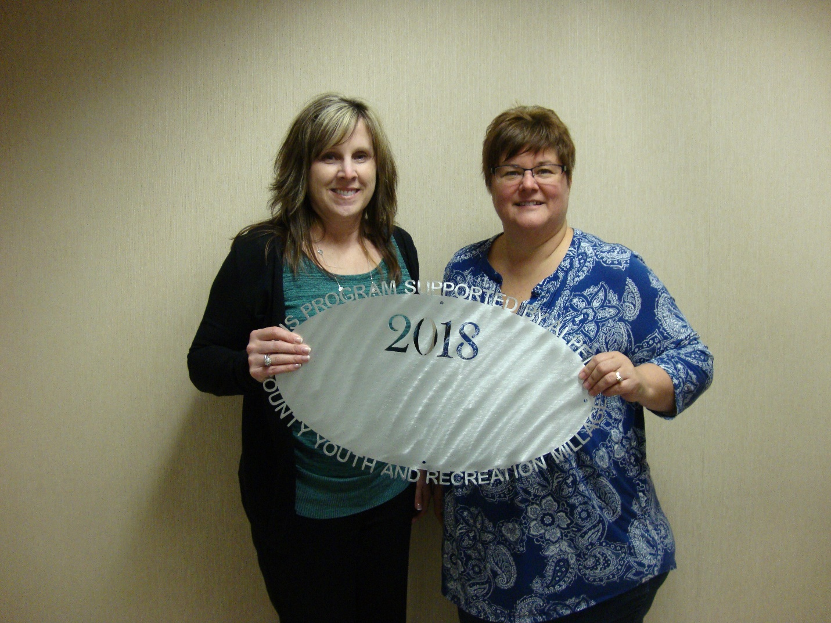Alpena Figure Skating Club
$4,500.00 Operating support, ice fees 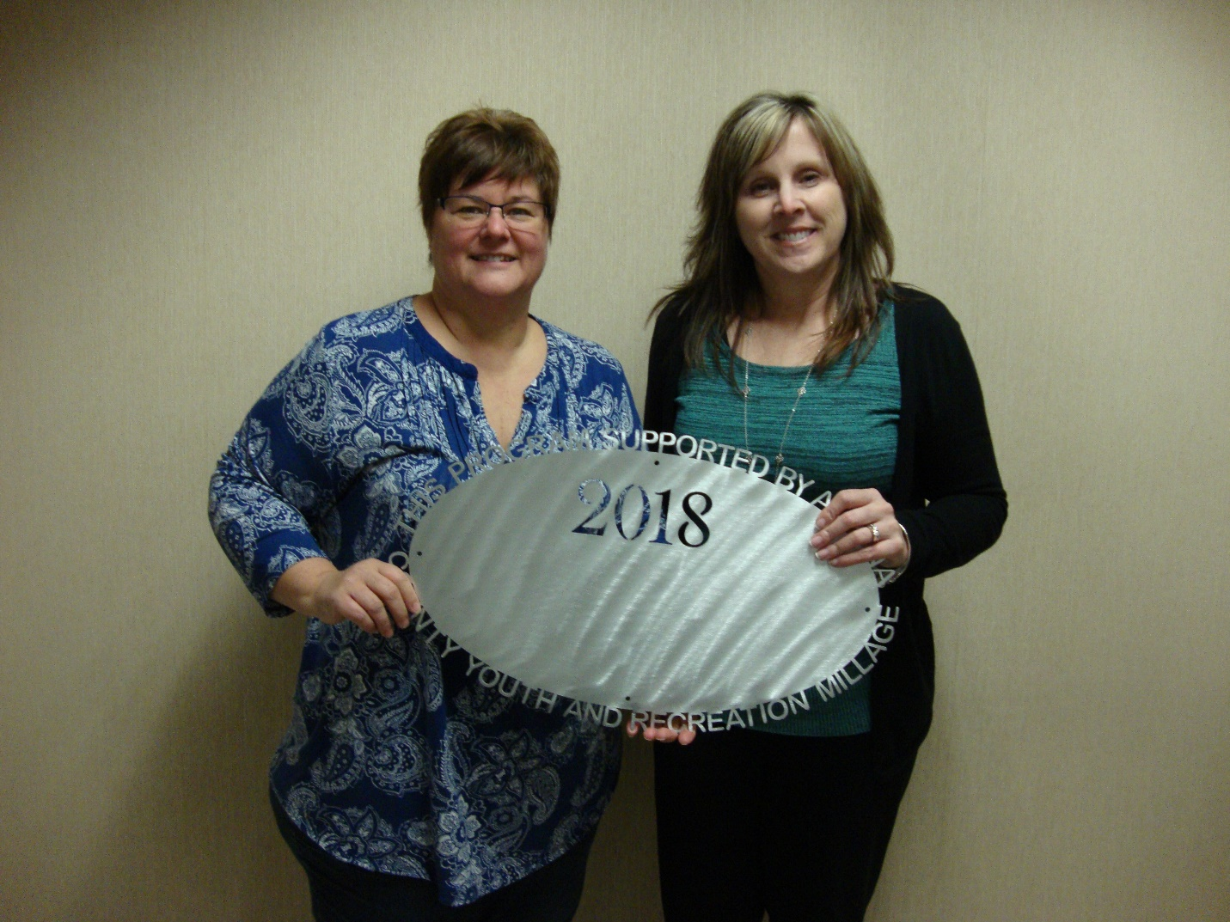Alpena Public Schools – AHS Figure Skating Club $3,525.00 Operating Support – Transportion, ice fees ACC Basketball
$3,475.00 Scoring Table County of Alpena – Parks Commission
$35,000.00 Beaver Lake Park Bathroom Renovations 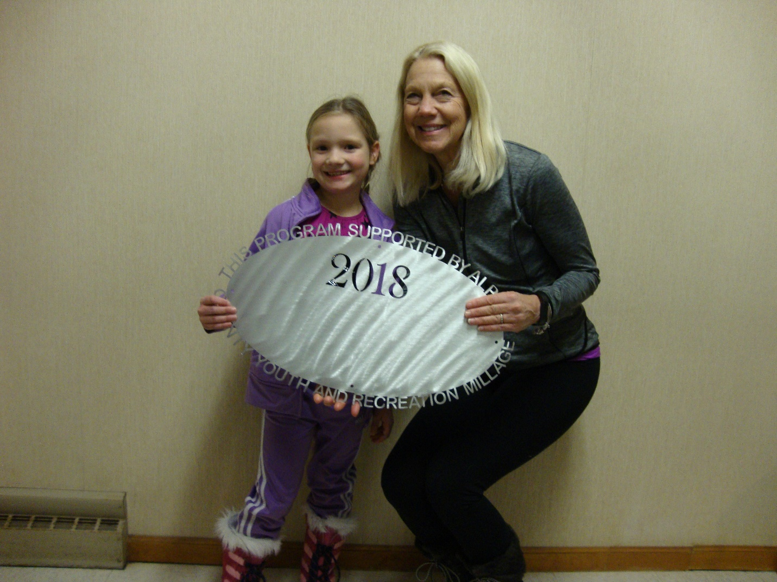Alpena Gymnastics
$3,000.00 Landing Mats 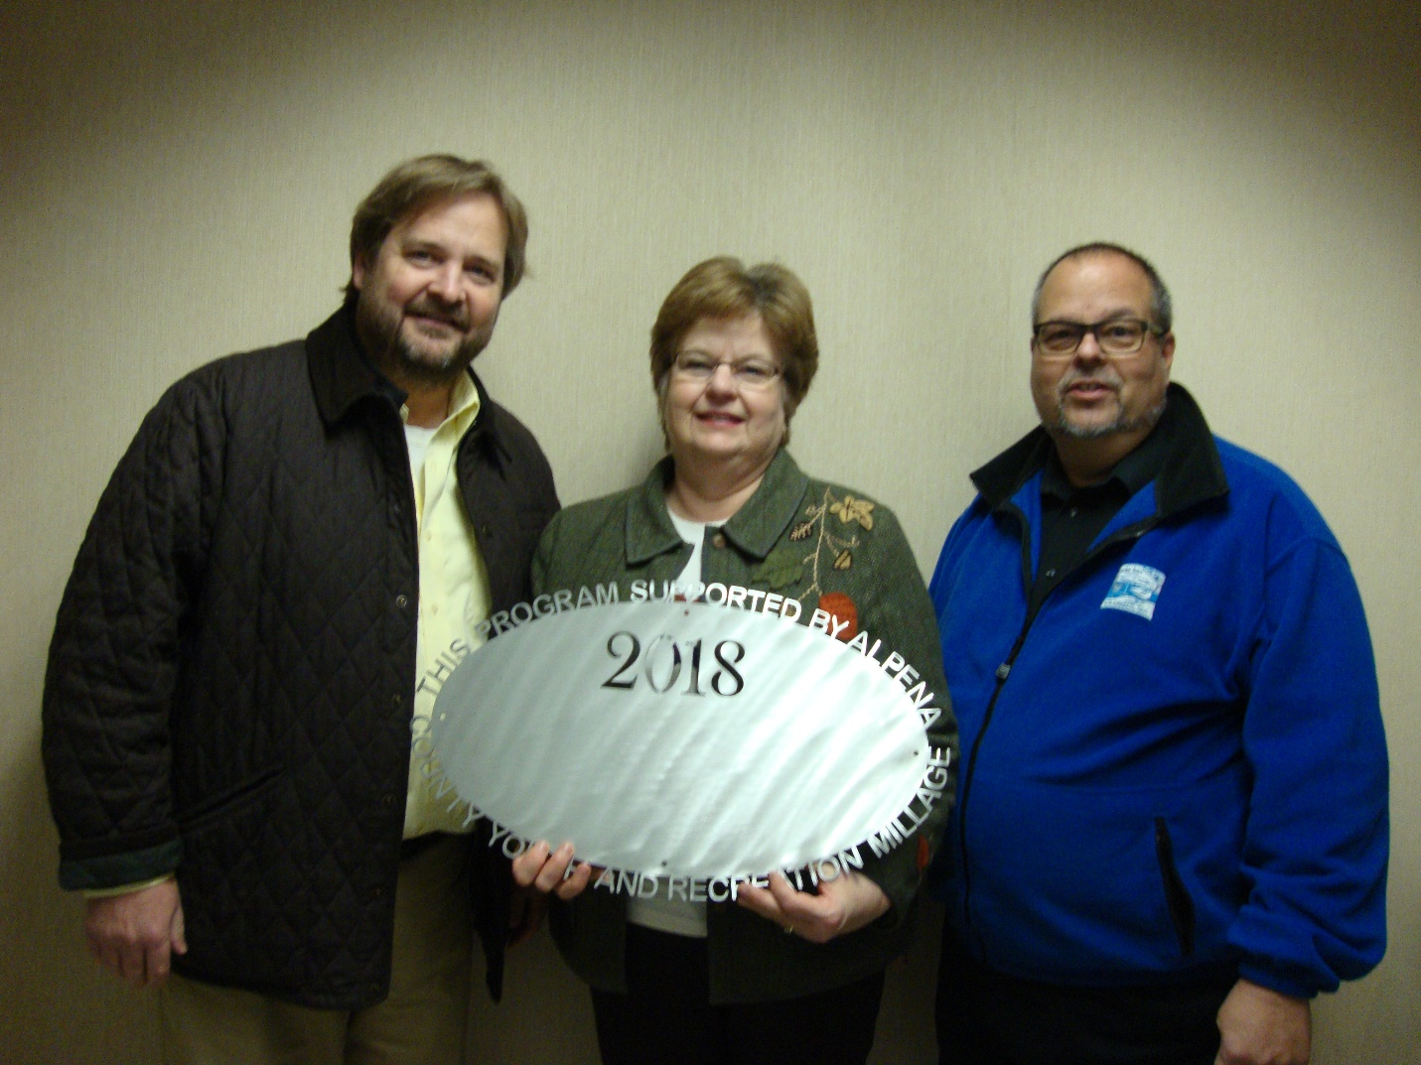Thunder bay Arts Council
$7,500.00 Bi-Path Sculpture Project 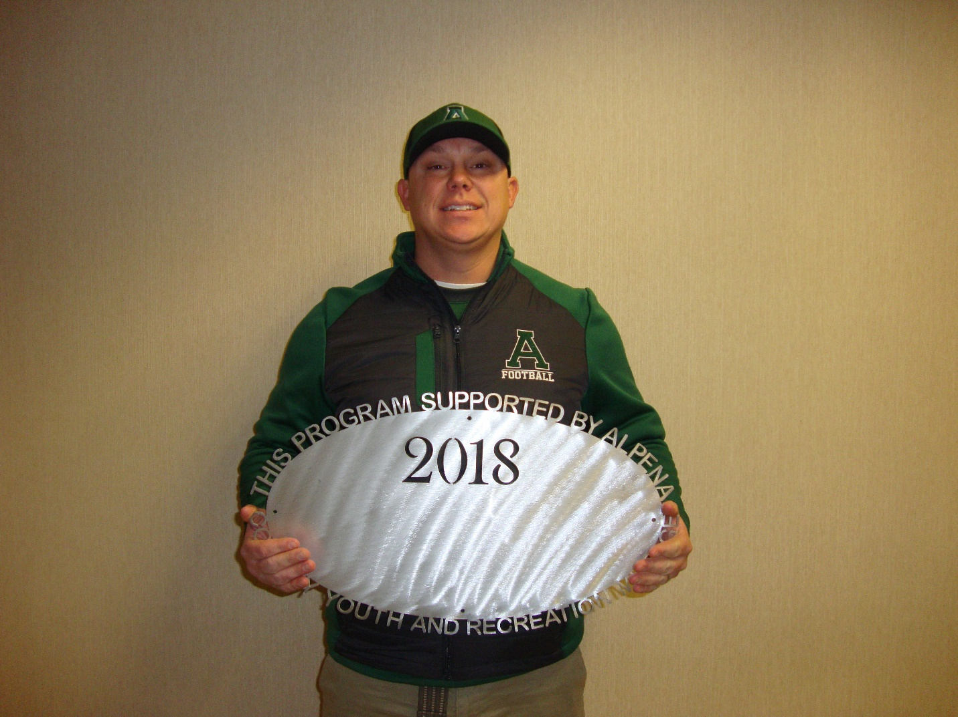Alpena Public Schools – AHS Football
$10,000.00 $6,200 transportation, weight match $3,800

Commissioners & Commissioners Appointees
District 1 – COMMISSIONER
Brad McRoberts
221 Potter Street
Alpena, MI 49707
989.255.4188
bradmcroberts@alpenacounty.org
Linda Canfield
117 Hitchcock Street
Alpena, MI 49707
989.356.2742
lindacanfield1@frontier.com
District 3 – COMMISSIONER
Nick Modrzynski
596 Northwood Drive
Alpena, MI 49707
989.255.6095
nickmodrzynski@alpenacounty.org
Darlene Wilmot
150 S. North Street
Alpena, MI 49707
989.356.9770
darlenewilmot@hotmail.com
District 5 – COMMISSIONER
Brenda Fournier
2464 Diamond Drive
Alpena, MI 49707
989.358.1414
brendafournier@alpenacounty.org
Tom Heise
3376 Piper Road
Alpena, MI 49707
989.354.2447
htssllc@yahoo.com
District 7- COMMISSIONER
Cameron Habermehl
14510 M-32 West
Lachine, MI 49753
989.766.3455
camhabermehl@alpenacounty.org
Fred Wegmeyer
10599 Napper Rd.
Herron, MI 49744
989.379.4034
District 2 – COMMISSIONER
Robert Adrian
227 Dawson Street
Alpena, MI 49707
989.464.6334
robertadrian@alpenacounty.org
Brett Miller
1121 River Street
Alpena, MI 49707
989.354.3328
bam3623@gmail.com
District 4 – COMMISSIONER
Bill Peterson
2379 Lake Winyah Road
Alpena, MI 49707
989.916.5351
billpeterson@alpenacounty.org
Tony Suszek
114 Kensington Court
Alpena, MI 49707
989.356.4434
suszektj@charter.net
District 6 – COMMISSIONER
Ronald McDonald
6594 Orchard Hill Road
Alpena, Ml 49707
989.379.4848
ronaldmcdonald@alpenacounty.org
Thomas Spaulding
5925 Keating
Lachine, MI 49753
989.379.2789
jeanntom71@hotmail.com
District 8 – COMMISSIONER
John Kozlowski
1028 W. Scott Road
Ossineke, MI 49766
Phone: 989.471.8349
johnkozlowski@alpenacounty.org
Lisa Siegert
12700 Hawkins Road
Hubbard Lake, MI 49747
989.727.3089
siegertlne@gmail.com

County Contacts
Kim Ludlow
County Treasurer
989.354.9534
ludlowk@alpenacounty.org
Lynn Bunting
Administrative Assistant
Alpena County Commissioners
989.354.9501
commissionersoffice@alpenacounty.org
Tammy Sumerix-Bates
Executive Manager
Alpena County Commissioners
989.354.9502
commissionersoffice@alpenacounty.org
Share this article
- facebook
- twitter
- linkedin
- email
- pinterest

