***2017 Pic #1

2017 Youth and Recreation Millage Funds Awarded
Youth and Recreation
- facebook
- twitter
- linkedin
- email
- pinterest
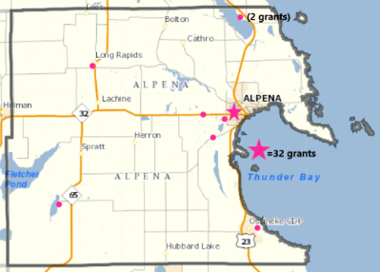2017 YR Map #2 Grants
The Committee is spreading the funds throughout the County, encouraging all the Townships and non-profit organizations, schools, and governmental agencies to apply. The Alpena County Map shown on the left, depicts where 32 grants have been awarded. Please click on the image for a larger view or by clicking here. (***clicking here #2 Pic)
Budget recommendations are not approved until after the Full Board of Commissioners approval as part of the Budget held December 20, 2016.
Total amount appropriated $651,149.00

Resources
2017 Award Book
Funding Report
Meeting Dates

Maps
Alpena Township
City of Alpena
Green Township
Long Rapids Township
Maple Ridge Township
Ossineke Township
Sanborn Township
Wellington Township
Wilson Township

Listed below, you can view the organization, amount awarded and the name of project. 2017 Award book can be view by clicking here.
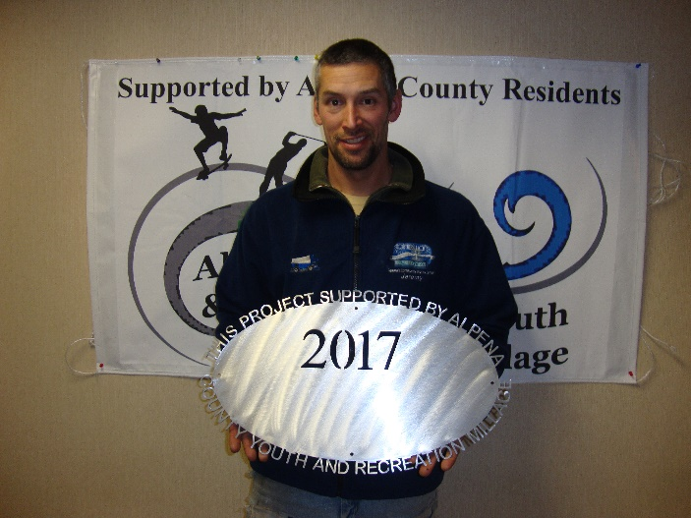

MPAC-NLA $10,080.00 Free Open Skating

***2017 logo pic

County of Alpena – Long Lake Park
$45,000.00 Boat Launch Improvement – MDNR match NOT FUNDED

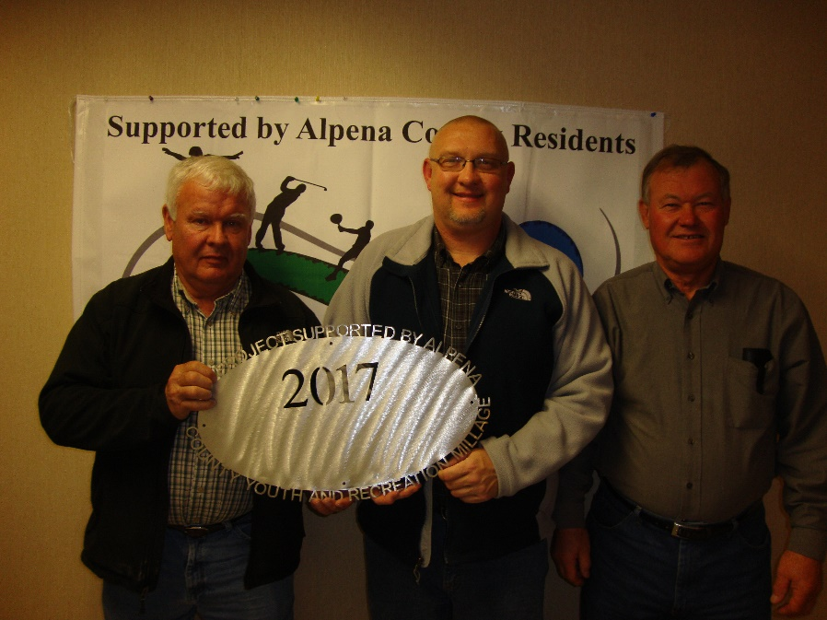

Long Rapids Township
$40,000.00 Park Improvement – MDNR match (project carried over to 2018)

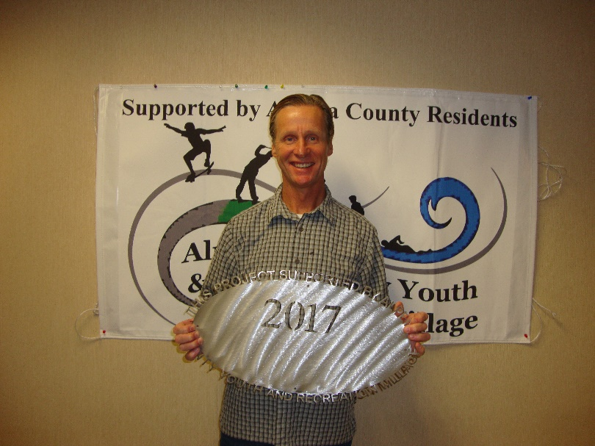

Alpena Community College
$2,478.00 Cross Country Team support

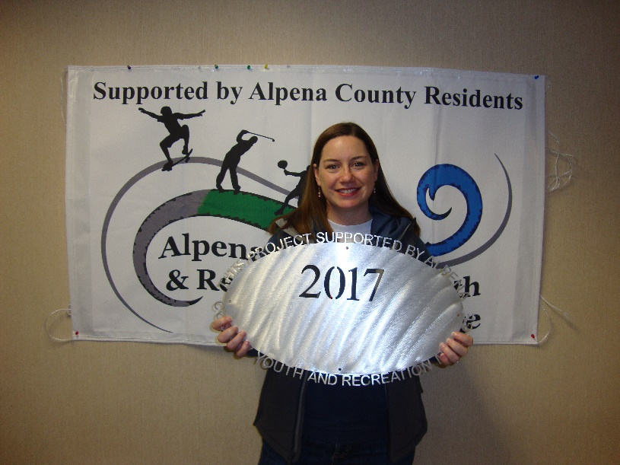
Alpena Public Schools
$2,816.00 AHS Volleyball Team Support 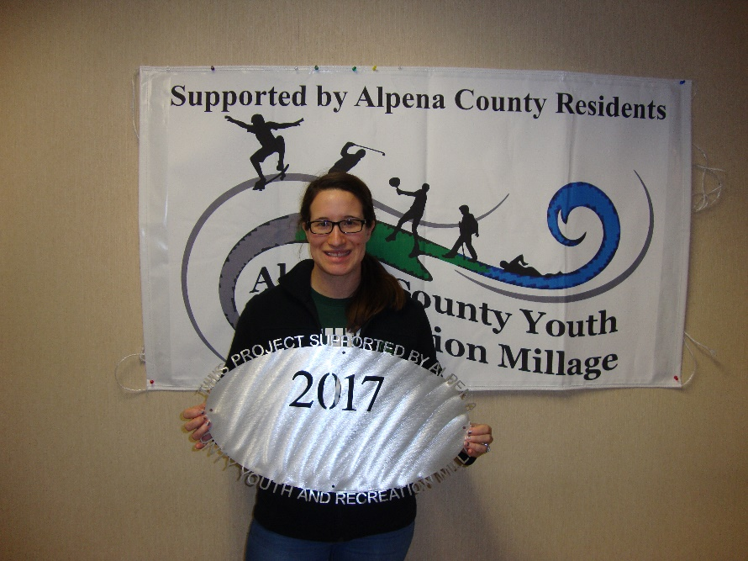
County of Alpena – MSU Extension
$40,000.00 Youth Programming (4-H)

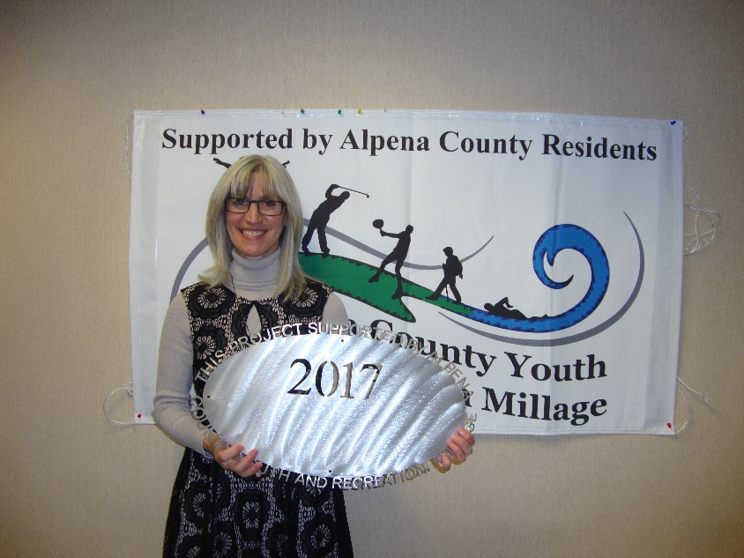

Besser Museum
$11,000.00 Shout “Eureka” Science Saturday and plananetarium/museum visit

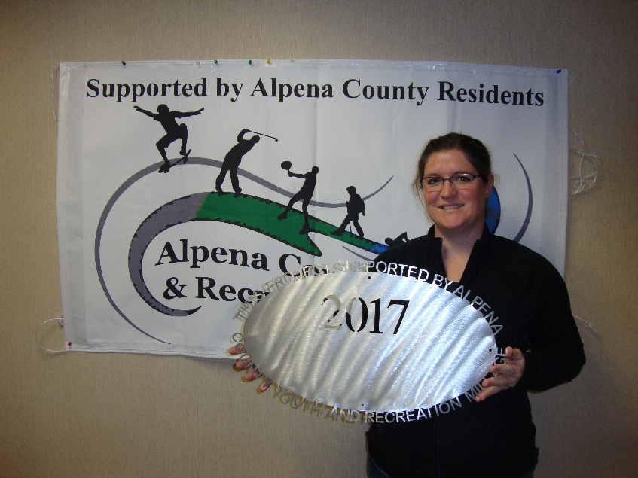

Alpena Public Schools
$18,345.00 TBJHS Outreach Program

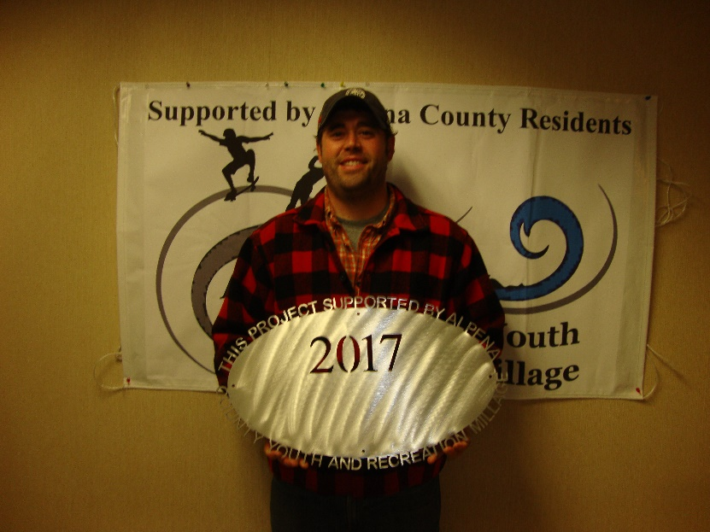

County of Alpena – Long Lake Park
$135,000.00 Bath House Contingency Plan
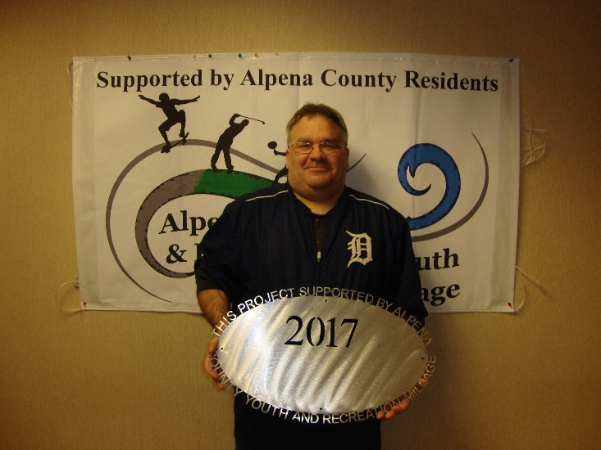

County of Alpena – Plaza Pool
$8,000.00 Ready, Set, Swim

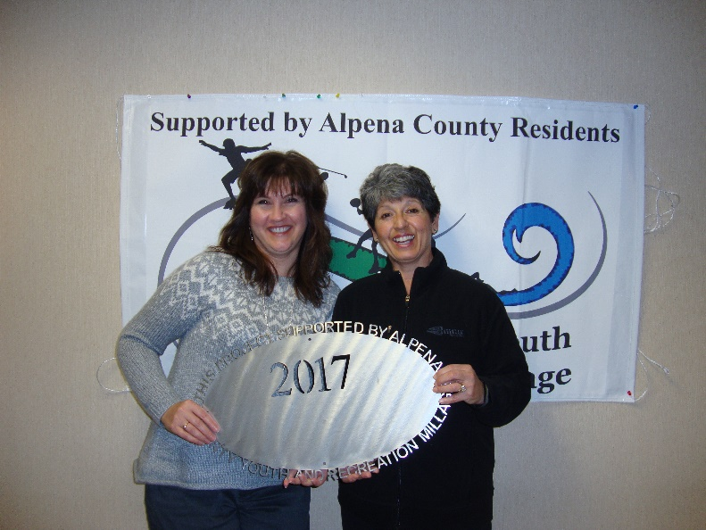

ACC Volunteer Center
$3,608.00 Ropes Course

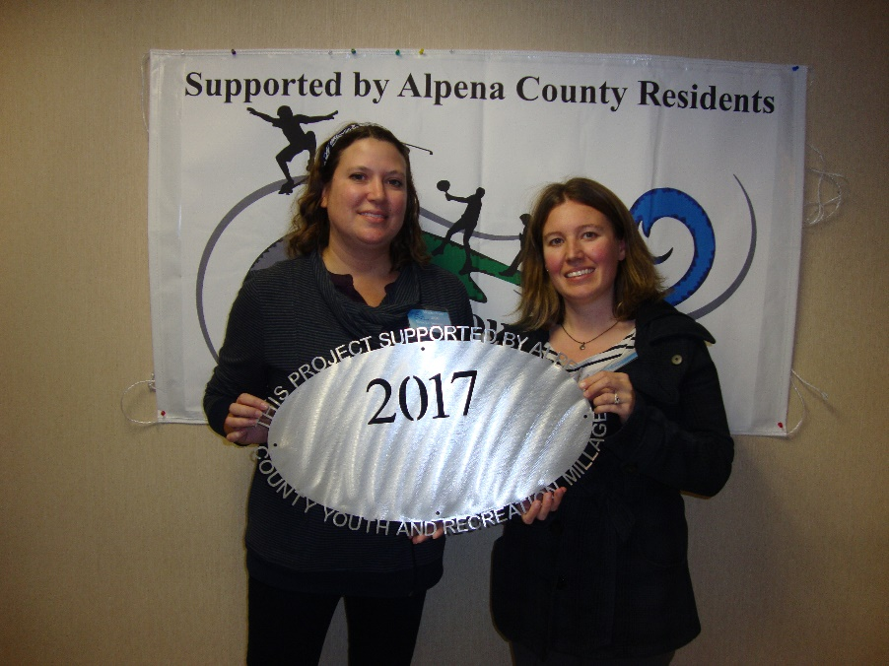
NEMI Center for Fine Arts
$20,225.00 Ready, Set, Create

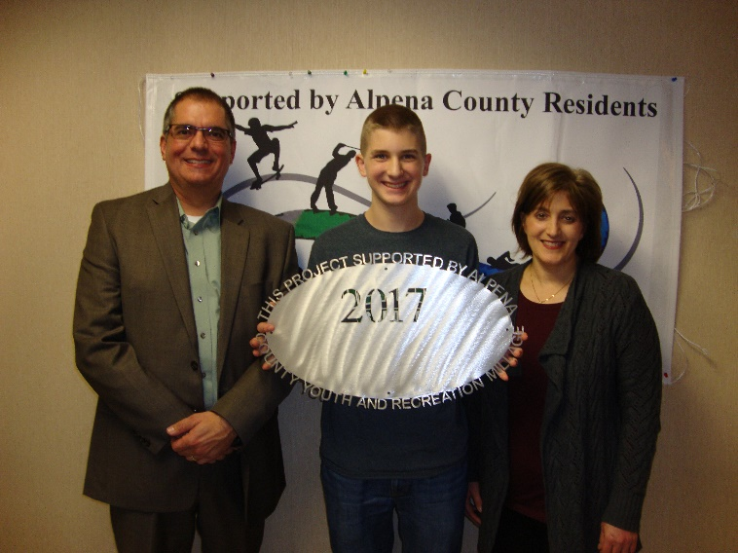

Alpena Public Schools
$33,500.00 AHS Robotics

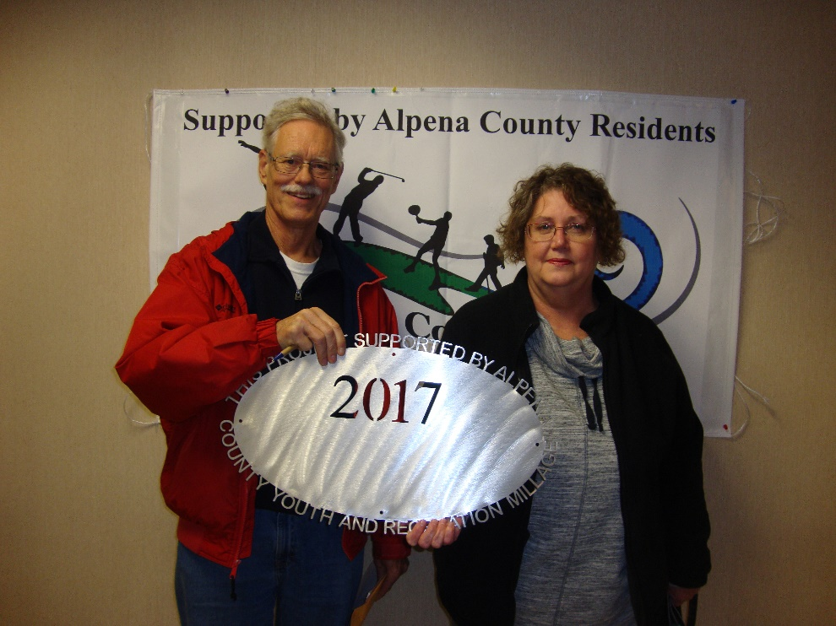

Friends of Plaza Pool
$2,180.00 Support

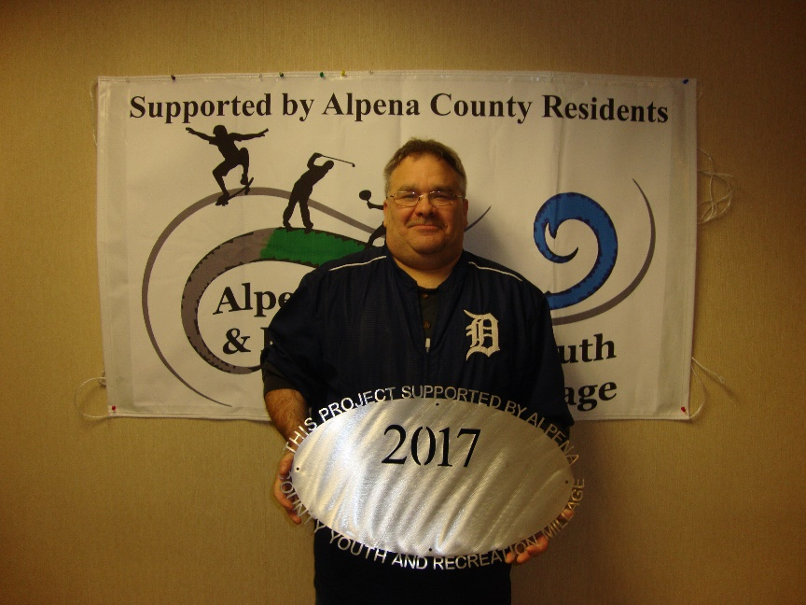

Park Family Foundation
$10,000.00 Ready, Set, Snap
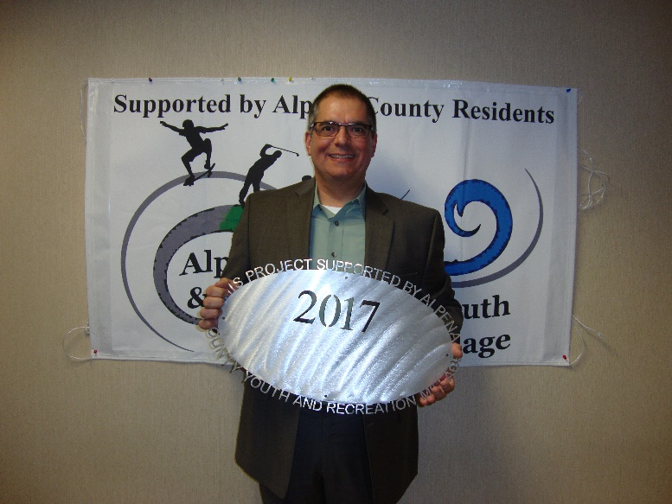

Alpena Public Schools
$19,275.00 KAPUT

***2017 Y&R pic

Thunder Bay Soccer Association
$2,500.00 Benches

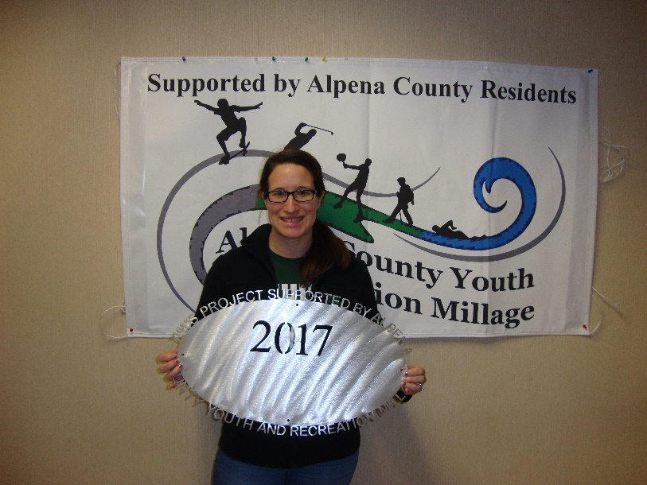

Taking Pride in Alpena
$30,000.00 Bi-Path extension – Match grant only (did not use funds)
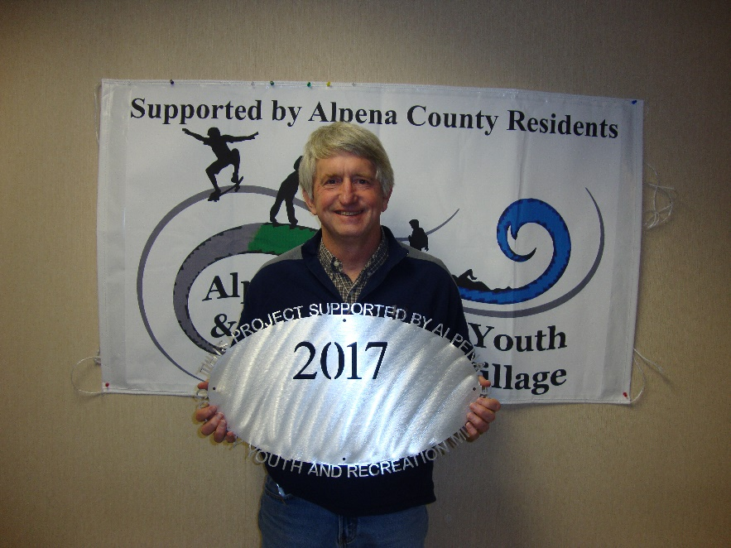

Top of MI Trails Council
$30,000.00 Signage – Alpena County Company must be used

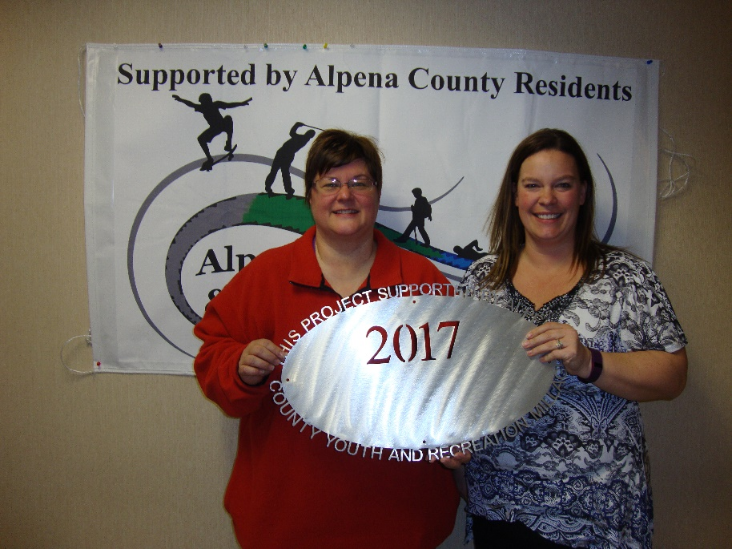

Alpena Figure Skating
$1,000.00 “Try it Days” – (ice fees, skate rental, raffle, membership)

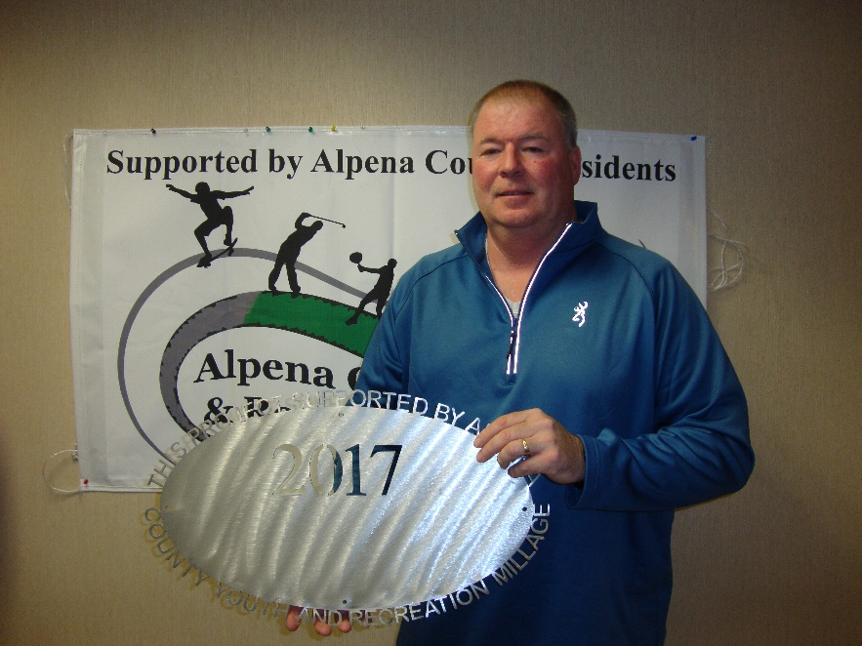

Alpena Public Schools
$4,000.00 Softball Line Drive Club Fence

***2017 logo pic

County of Alpena – Long Lake Park
$45,000.00 Bath House – MDNR Grant match NOT FUNDED

***2017 logo pic

County of Alpena – Beaver Lake Park
$45,000.00 Bath House – MDNR Grant match NOT FUNDED

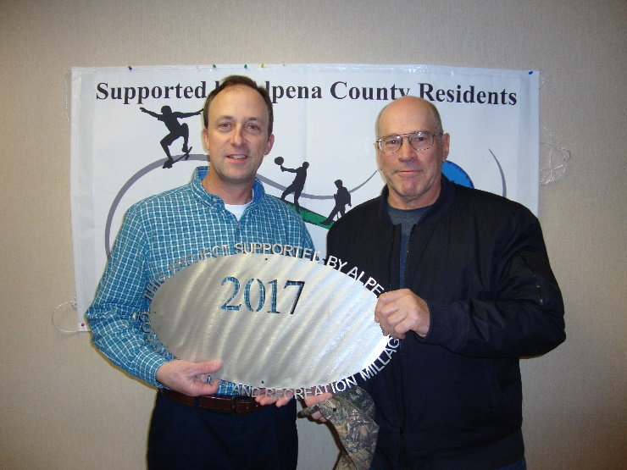
Thunder Bay Trails Association
$5,500.00 Youth Ski Club 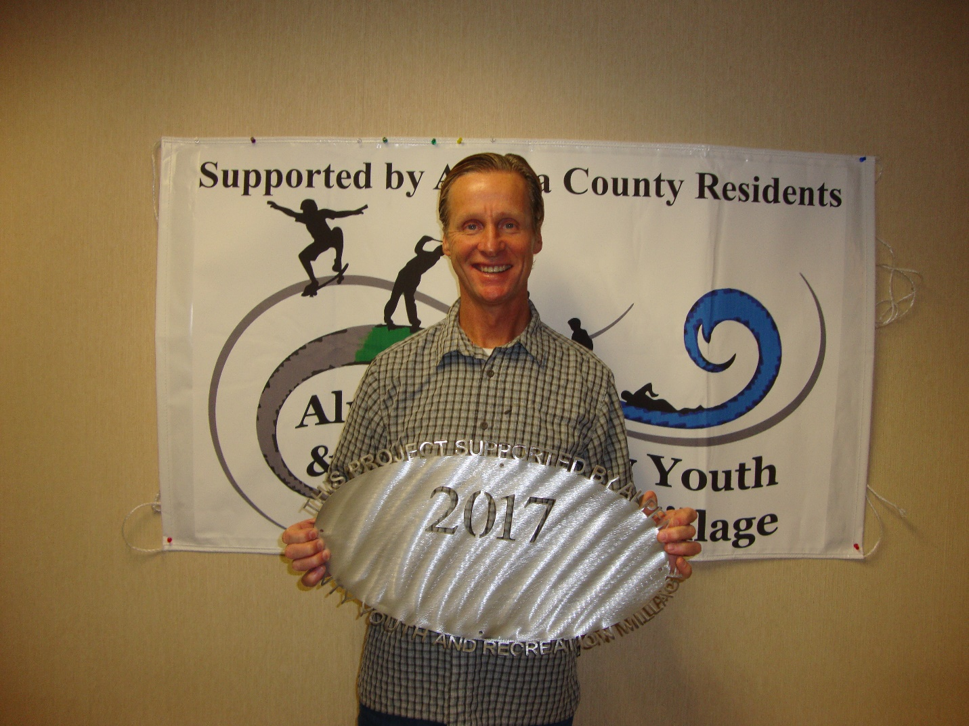Alpena Public Schools
$1,645.00 AHS Woods Track Club 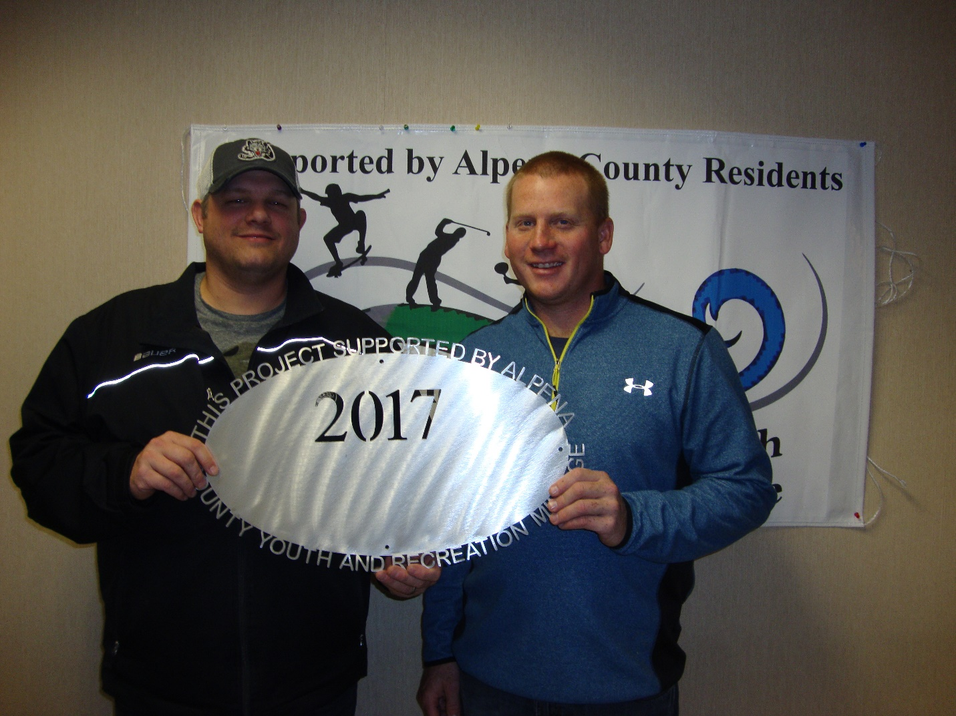Alpena Hockey Association
$5,000.00 Tournament Support Alpena Hockey Association
$5,000.00 Equipment 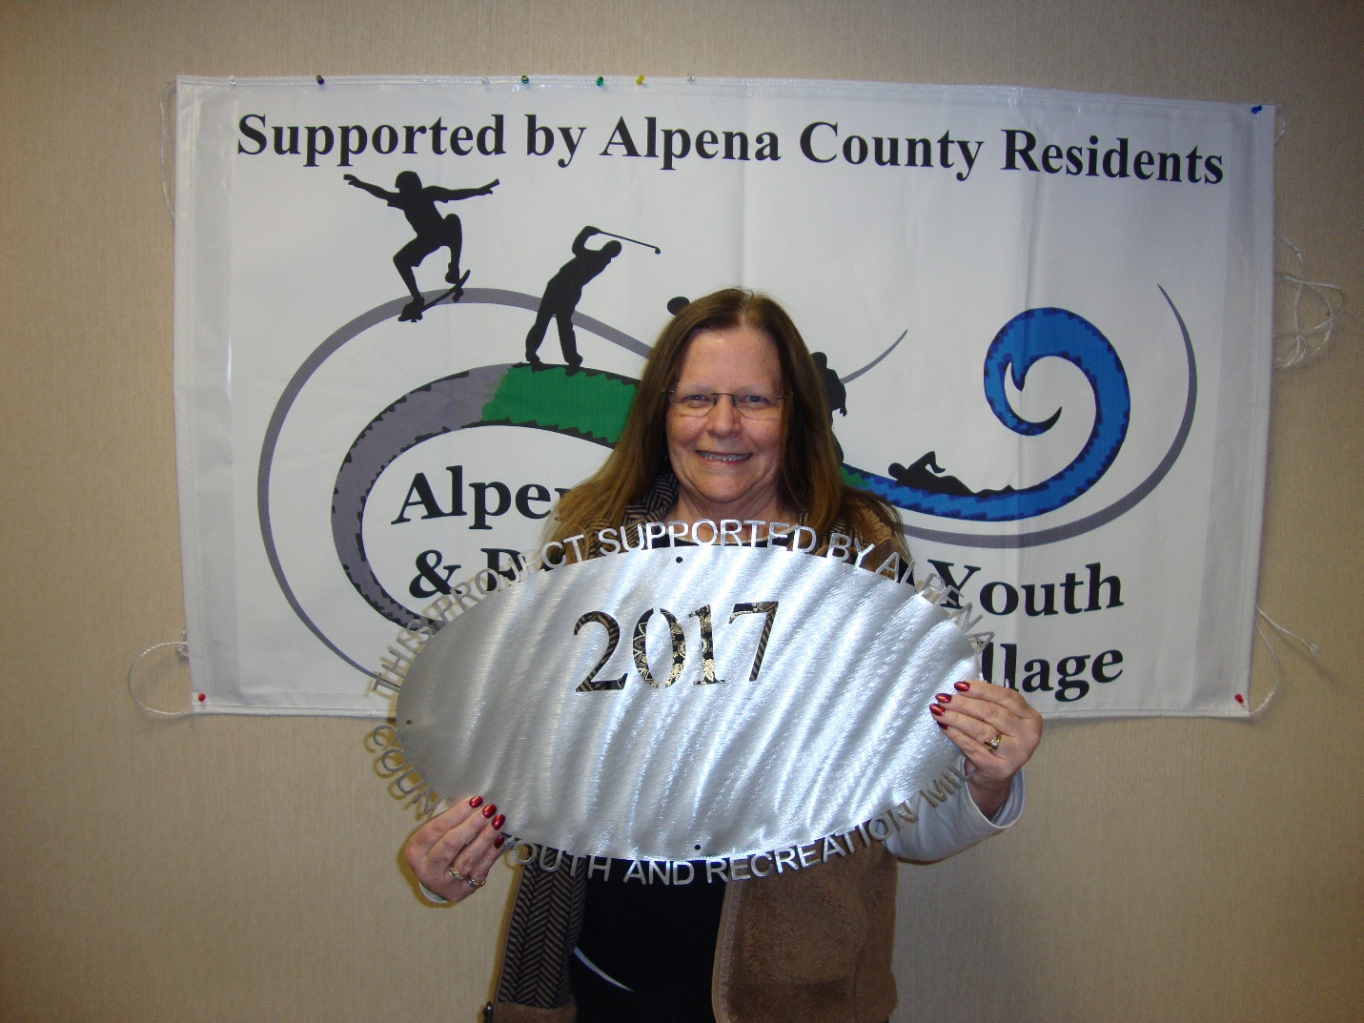Sanborn Townships
$10,379.00 Slide and Basketball Court at Lake Huron Park (Ossineke Beach) 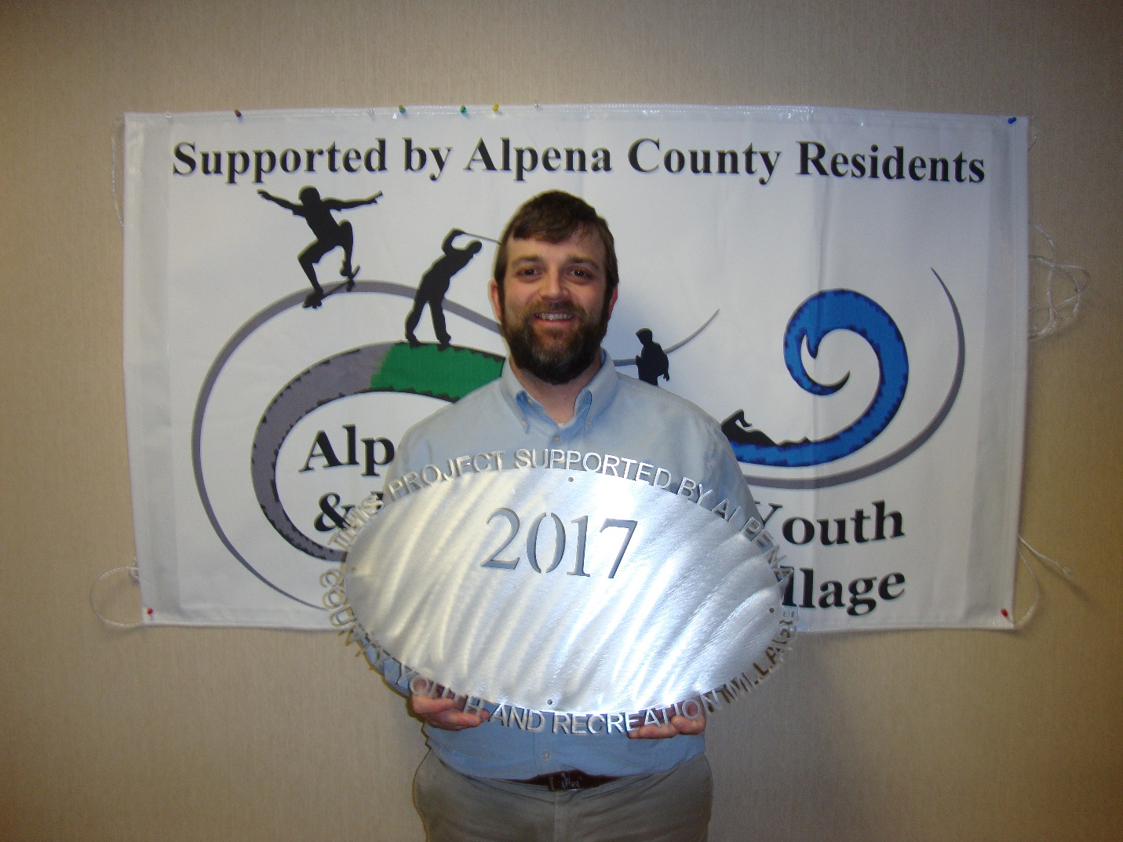Boys and Girls Club
$5,000 Basketball Hoops 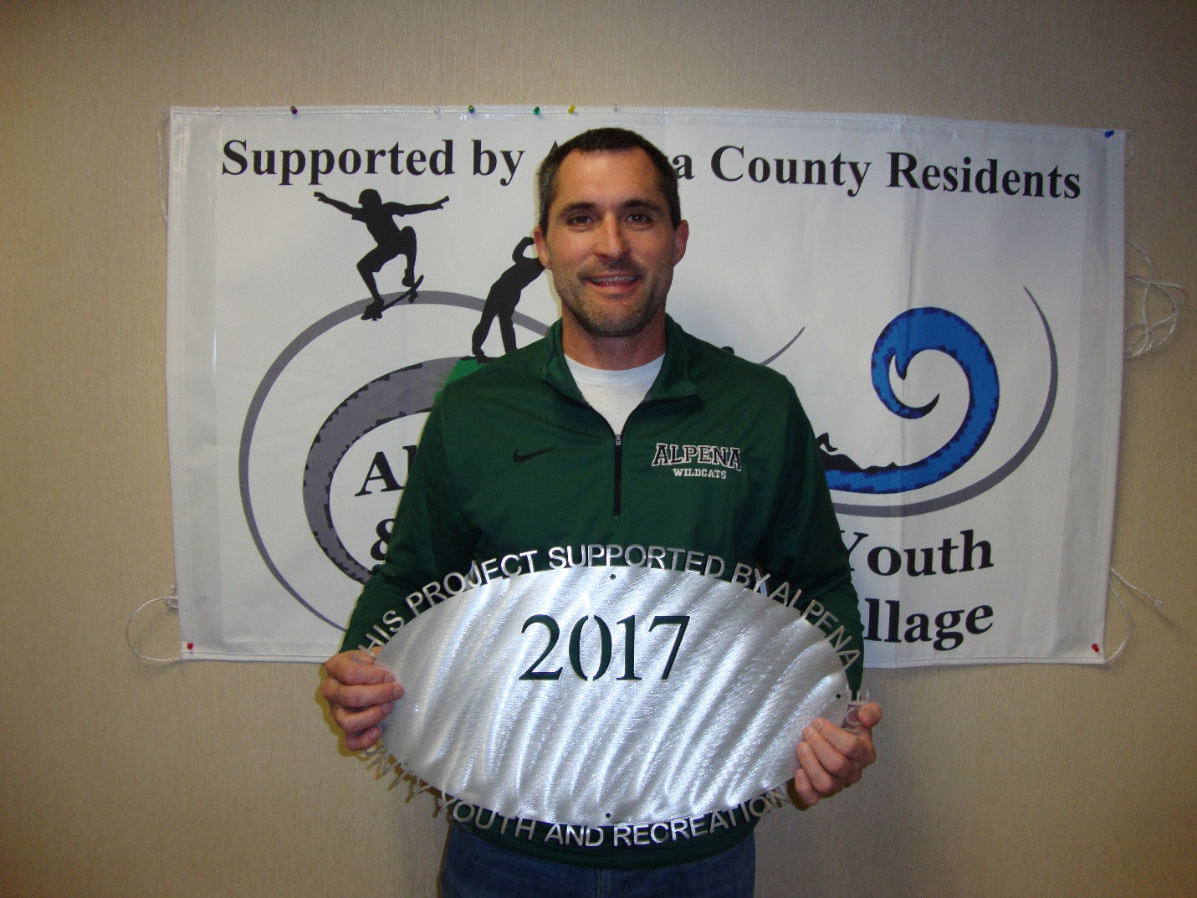Alpena Public Schools
$8,238.00 AHS Boys and Girls Basketball support 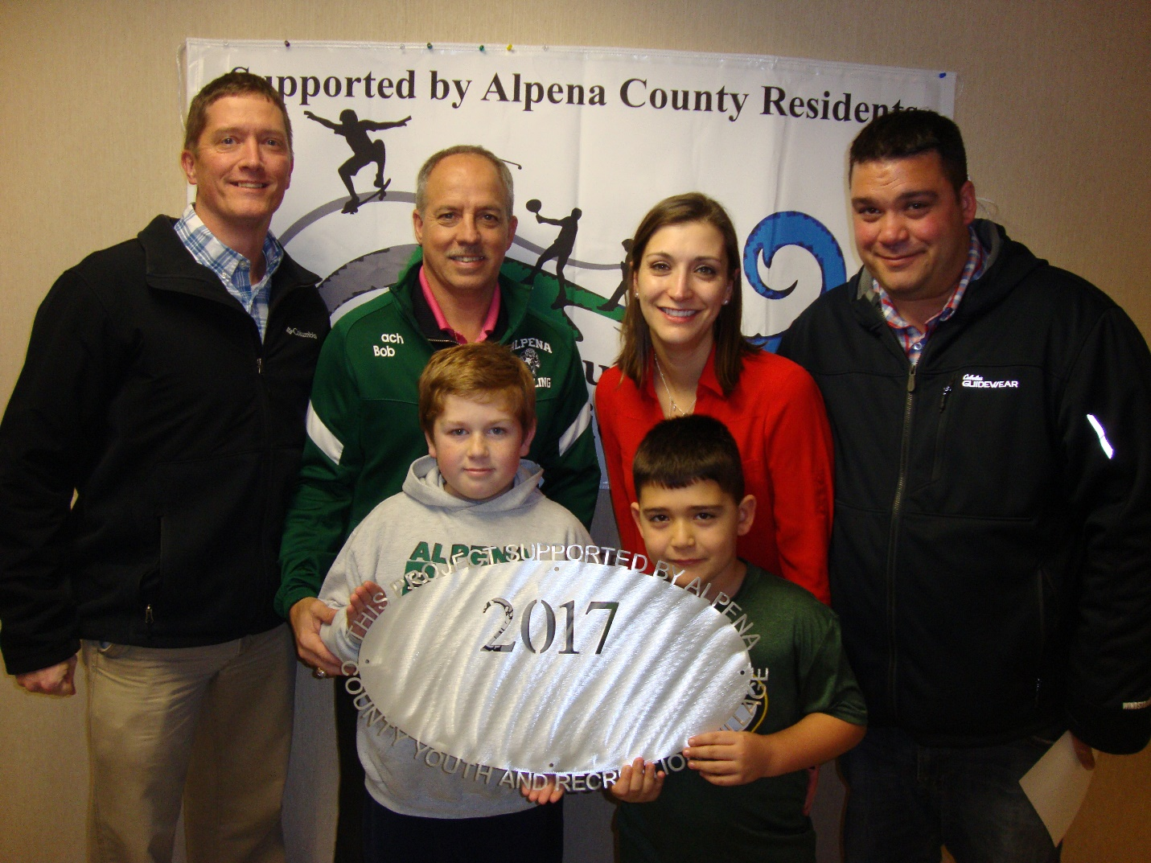Alpena Public Schools
$25,000.00 AHS Wrestling Boosters – Equipment and supplies (mats, uniforms, headgear) Alpena Hockey Association
$3,000.00 Jersey & socks 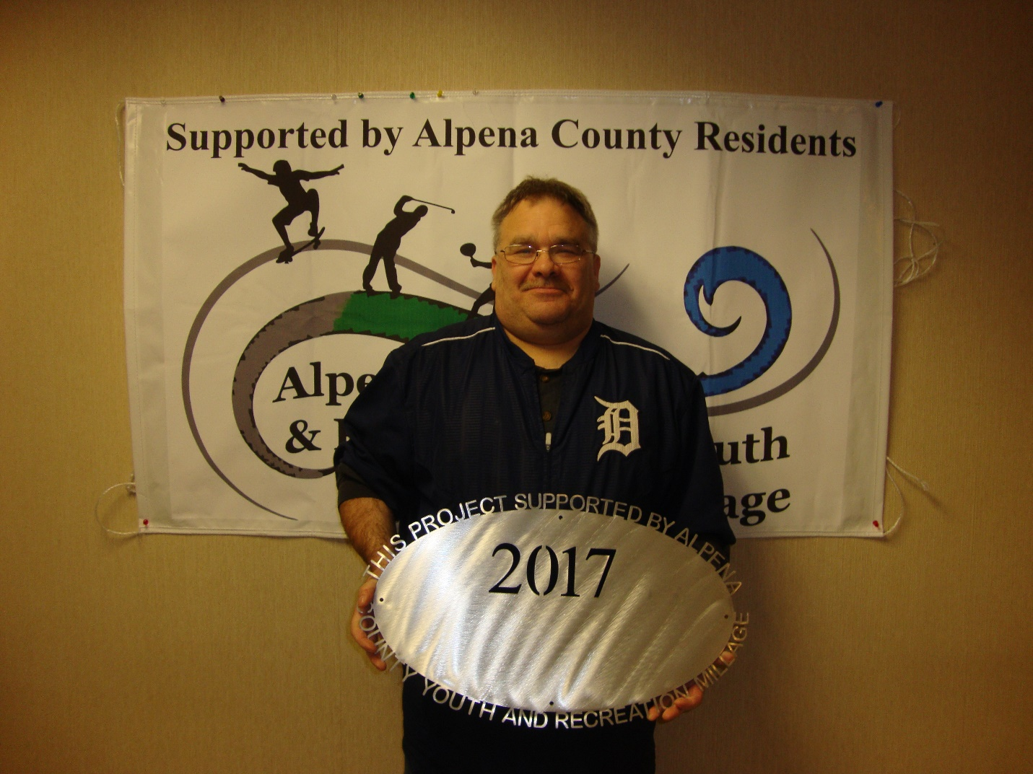County of Alpena
$80,000.00 Plaza Pool – Operations 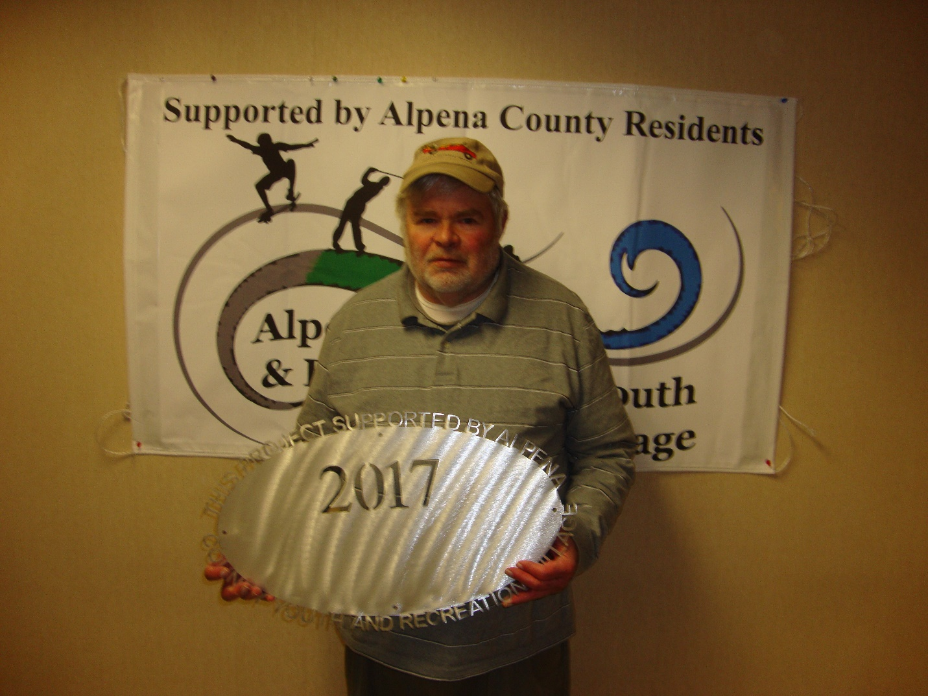Friends of Farmers Market
$3,000.00 Children’s day Thunder Bay Schooners
$9,000.00 Support Park Family Foundation
$8,000.00 Ready, Set, Serve 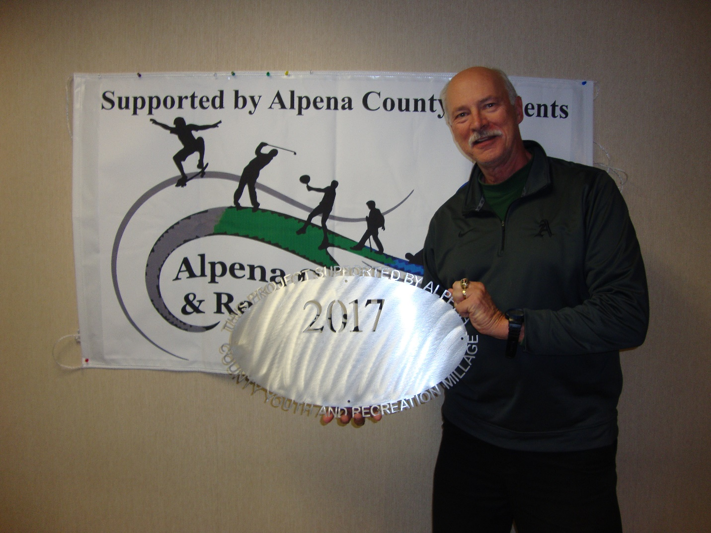Alpena Public Schools
$3,000.00 AHS Girls and Boys Soccer Park Family Foundation
$4,000.00 Ready, Set, Flip 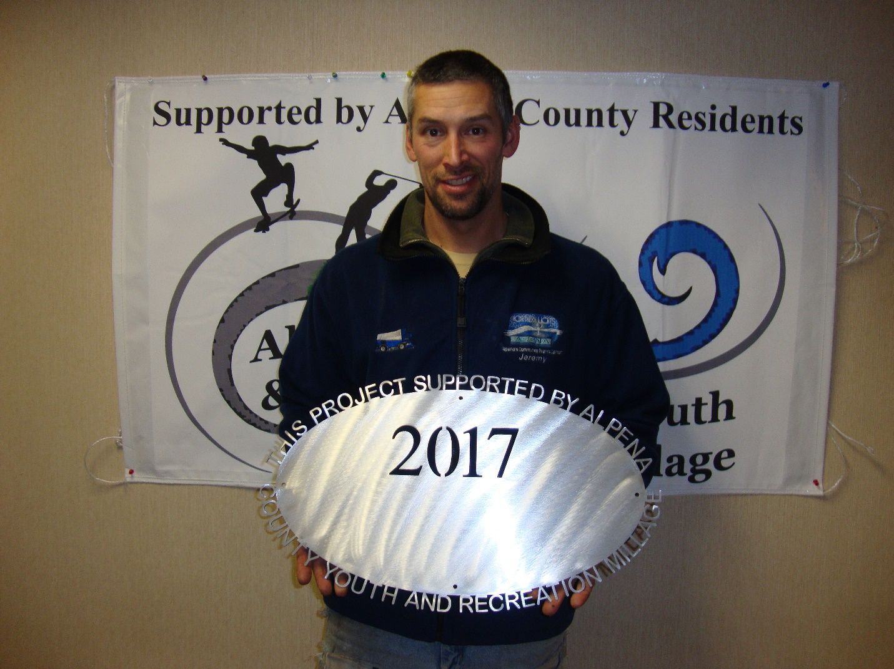MPAC-NLA
$7,000.00 Ready, Set, Skate MPAC-NLA
$10,000.00 Water Reclaim Project (project carried over to 2018) Alpena Public Schools
$10,000.00 AHS Wildcat Stadium Lighting

Commissioners & Commissioners Appointees
District 1 – COMMISSIONER
Jeff Kowalski
717 S. First Ave.
Alpena, MI 49707
989.356.0427
jeffkowalski@alpenacounty.org
Linda Canfield
117 Hitchcock Street
Alpena, MI 49707
989.356.2742
lindacanfield1@frontier.com
District 3 – COMMISSIONER
Nick Modrzynski
596 Northwood Drive
Alpena, MI 49707
989.255.6095
nickmodrzynski@alpenacounty.org
Darlene Wilmot
150 S. North Street
Alpena, MI 49707
989.356.9770
darlenewilmot@hotmail.com
District 5 – COMMISSIONER
Brenda Fournier
2464 Diamond Drive
Alpena, MI 49707
989.358.1414
brendafournier@alpenacounty.org
Tom Heise
3376 Piper Road
Alpena, MI 49707
989.354.2447
htssllc@yahoo.com
District 7 – COMMISSIONER
Cameron Habermehl
14510 M-32 West
Lachine, MI 49753
989.766.3455
camhabermehl@alpenacounty.org
Fred Wegmeyer
10599 Napper Rd.
Herron, MI 49744
989.379.4034
District 2 – COMMISSIONER
Robert Adrian
227 Dawson Street
Alpena, MI 49707
989.464.6334
robertadrian@alpenacounty.org
Brett Miller
1121 River Street
Alpena, MI 49707
989.354.3328
bam3623@gmail.com
District 4 – COMMISSIONER
Bill Peterson
2379 Lake Winyah Road
Alpena, MI 49707
989.916.5351
billpeterson@alpenacounty.org
Tony Suszek
114 Kensington Court
Alpena, MI 49707
989.356.4434
suszektj@charter.net
District 6 – COMMISSIONER
Ronald McDonald
6594 Orchard Hill Road
Alpena, Ml 49707
989.379.4848
ronaldmcdonald@alpenacounty.org
Thomas Spaulding
5925 Keating
Lachine, MI 49753
989.379.2789
jeanntom71@hotmail.com
District 8 – COMMISSIONER
John Kozlowski
1028 W. Scott Road
Ossineke, MI 49766
Phone: 989.471.8349
johnkozlowski@alpenacounty.org
Lisa Siegert
12700 Hawkins Road
Hubbard Lake, MI 49747
989.727.3089
siegertlne@gmail.com

County Contacts
Kim Ludlow
County Treasurer
989.354.9534
ludlowk@alpenacounty.org
Lynn Bunting
Administrative Assistant
Alpena County Commissioners
989.354.9501
commissionersoffice@alpenacounty.org
Tammy Sumerix-Bates
Executive Manager
Alpena County Commissioners
989.354.9502
commissionersoffice@alpenacounty.org
Share this article
- facebook
- twitter
- linkedin
- email
- pinterest

