***2016 Logo Pic #1

2016 Youth and Recreation Millage Funds Awarded
Youth and Recreation
- facebook
- twitter
- linkedin
- email
- pinterest
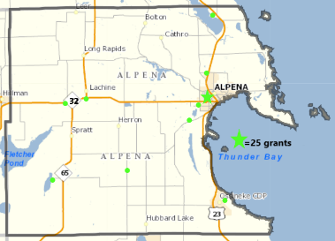***2016 YR Map #2 Pic
The Committee is spreading the funds throughout the County, encouraging all the Townships and non-profit organizations, schools, and governmental agencies to apply.
The Alpena County Map shown on the left, depicts where 25 grants have been awarded. Please click on the image for a larger view or by clicking here. (***clicking here #3 Pic)
Budget Recommendations for 2019 recommendations are not approved until after the Full Board of Commissioners approval as part of the Budget held December 30, 2015.
Total amount appropriated $572,230.00

Resources
Funding Report
2016 Award Book
Meeting Dates

Maps
Alpena Township
City of Alpena
Green Township
Long Rapids Township
Maple Ridge Township
Ossineke Township
Sanborn Township
Wellington Township
Wilson Township

Listed below, you can view the organization, amount awarded and the name of project. You can also view the 2016 Award Book by clicking here (***clicking here #4 Pic)
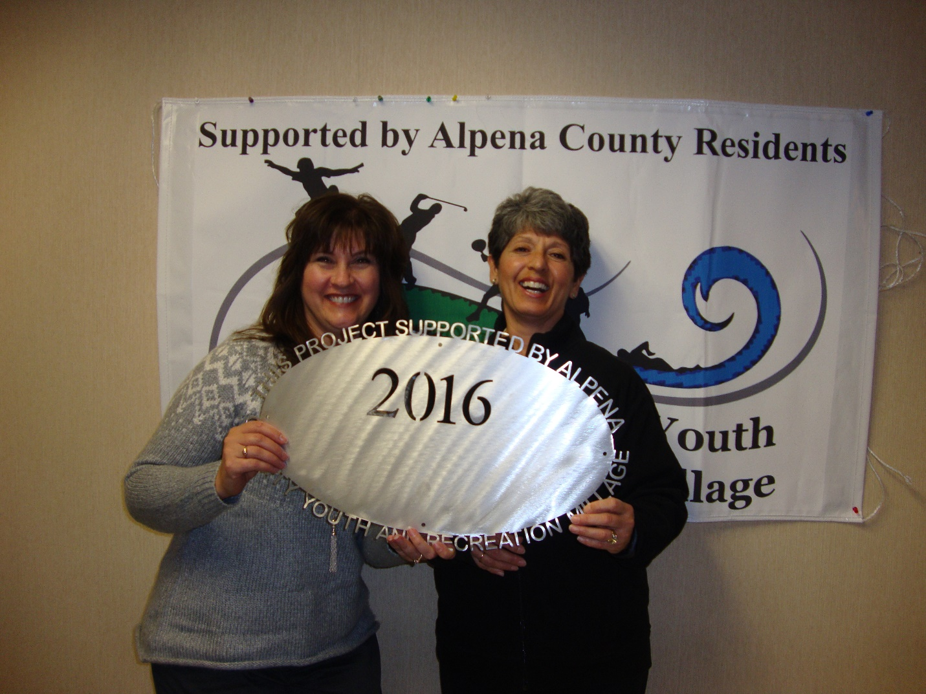ACC – Volunteer Center
$4000.00 Ropes Course

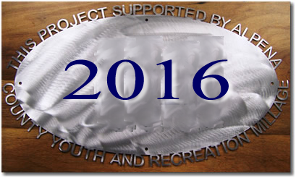

Alpena Figure Skating Club
$3000.00 Try It Days.
Did not get funding

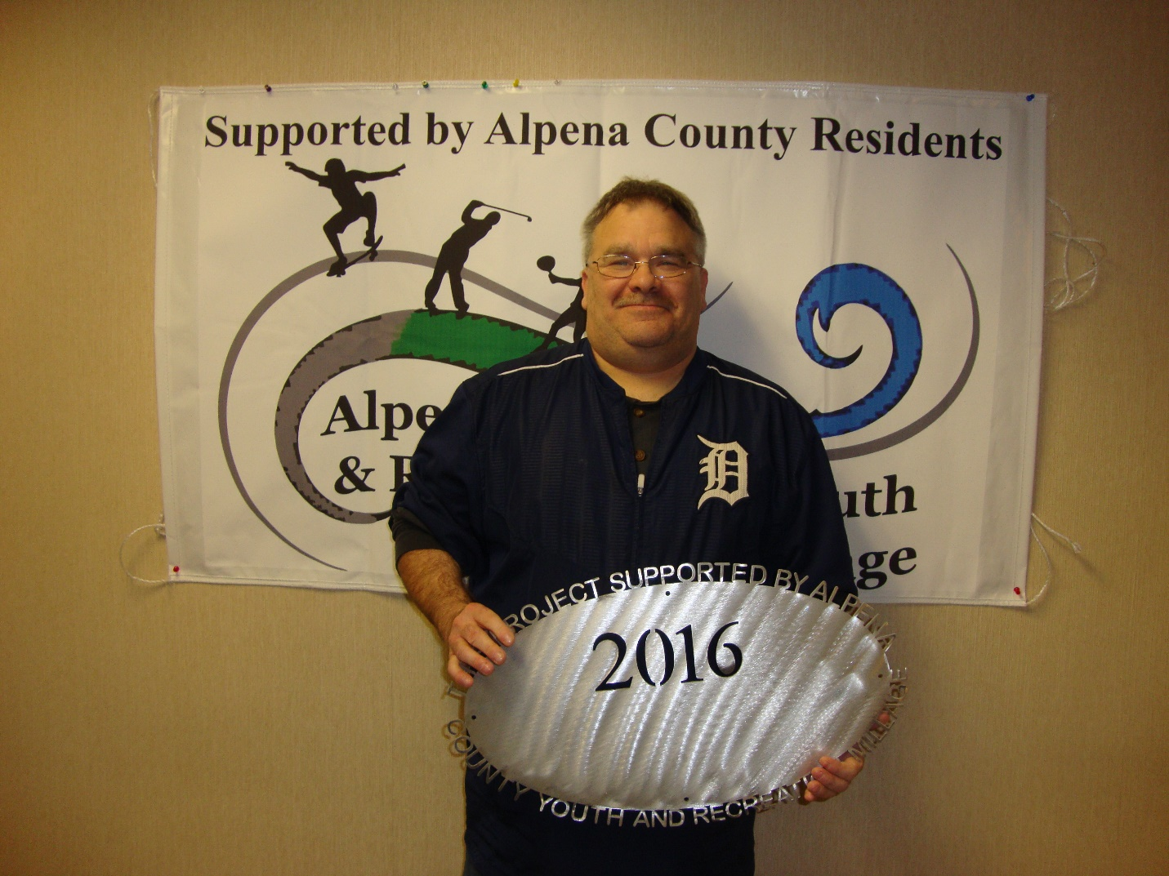Alpena Gymnastics (Ready Set Flip)
$6,310 Ready, Set, Flip Program 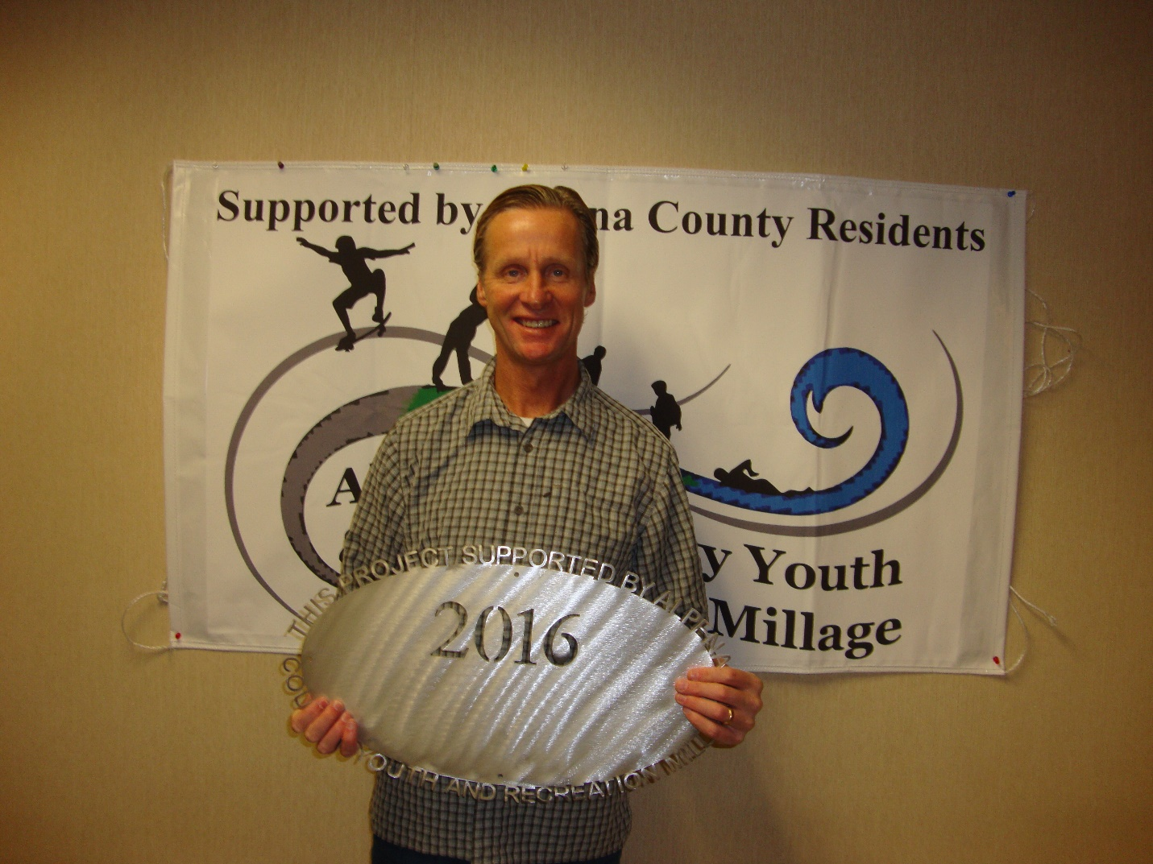Alpena Public Schools – AHS – The Woods Track Club $1,715 Support 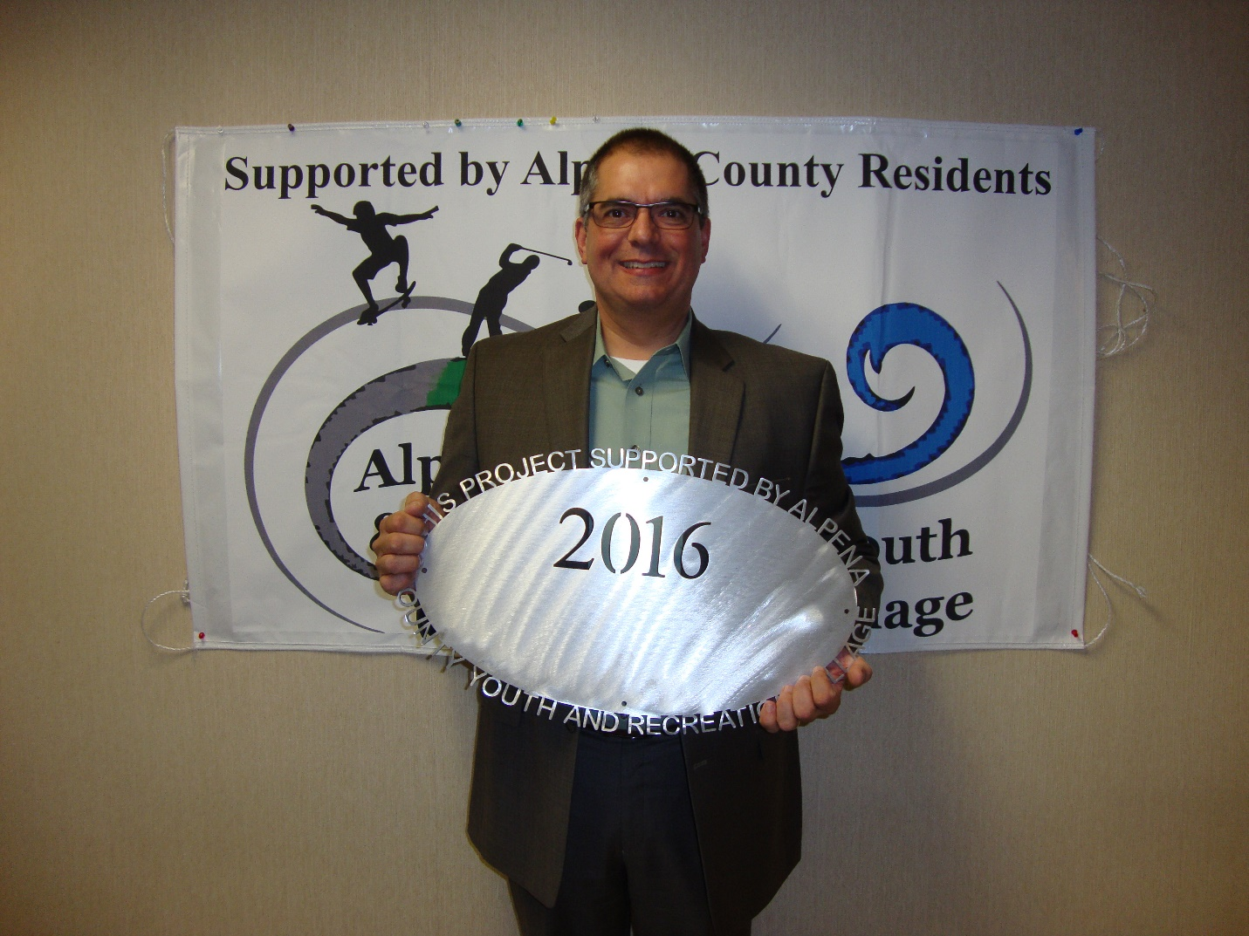Alpena Public Schools – AHS KAPUT
$19,200 Operating Support 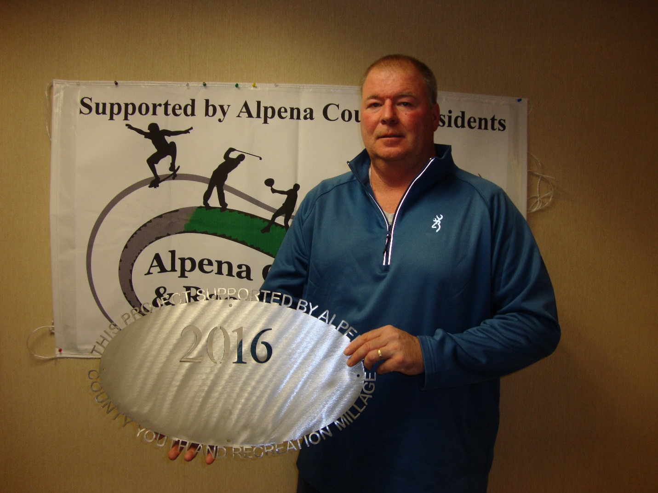Alpena Public Schools – AHS Softball Line Drive Club $5,000 Fencing for Field 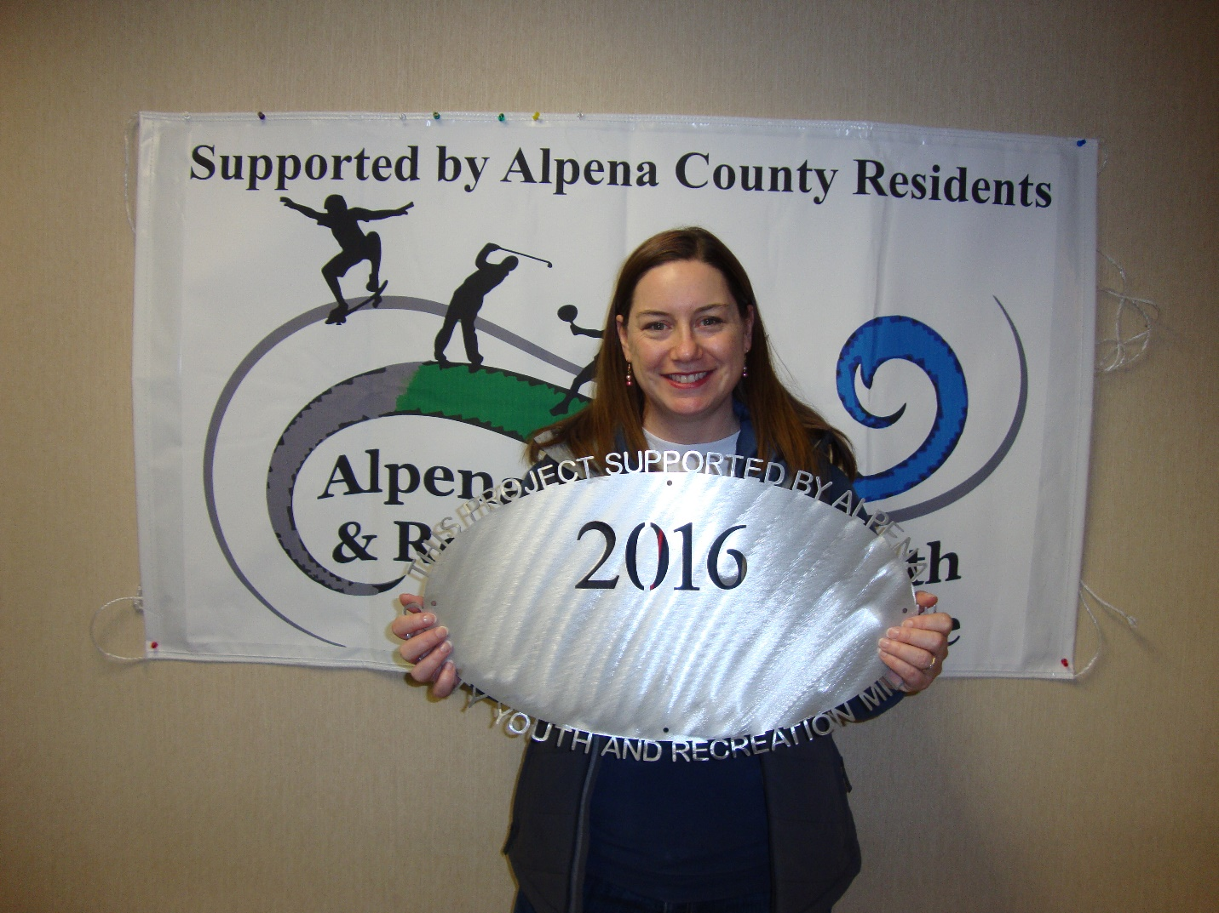Alpena Public Schools – AHS Volleyball Program $2,916 Operating Support 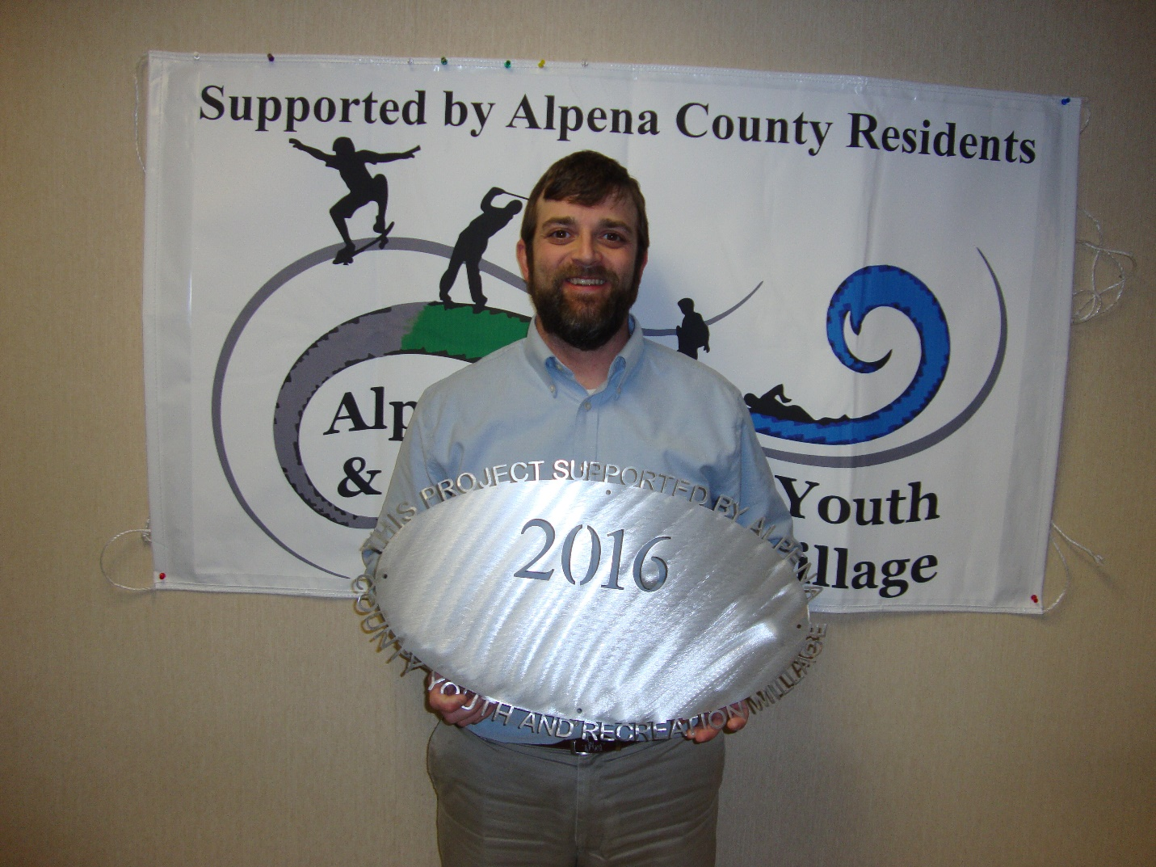Boys and Girls Club of Alpena
$13,000 Gym Improvements

County of Alpena – Long Lake Park Bath House $45,000 Local Match for MDNR Grant. Did not get funding 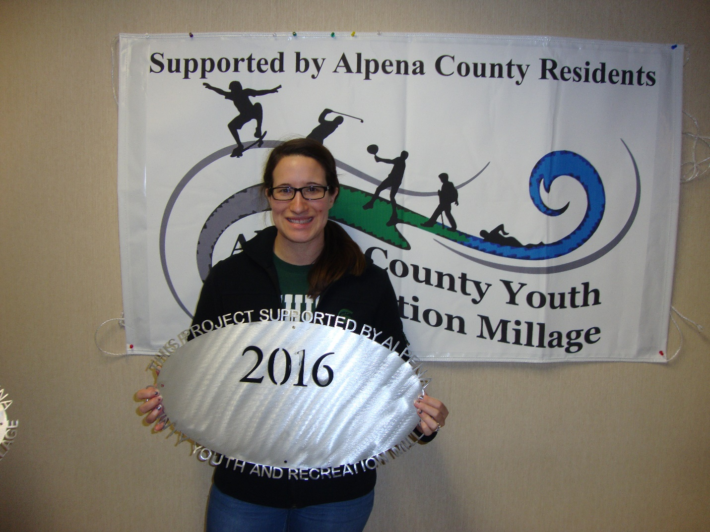County of Alpena – MSU Programming
$40,000 4-H and Youth programs 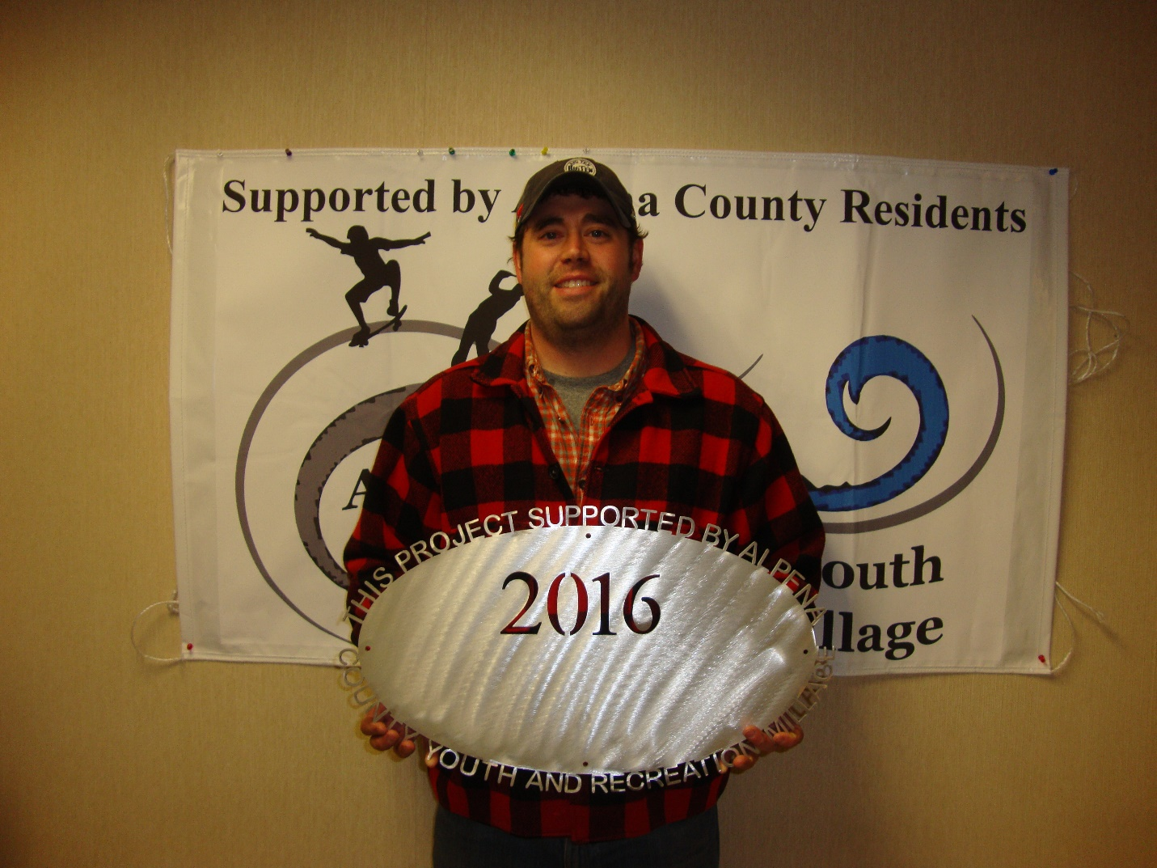County of Alpena – Parks # 3 Long Lake Park Restroom Renovation
$15,000 Long Lake Restroom Renovation County of Alpena – Plaza Pool (Ready, Set, Swim) $8,500 Ready, Set, Swim Program 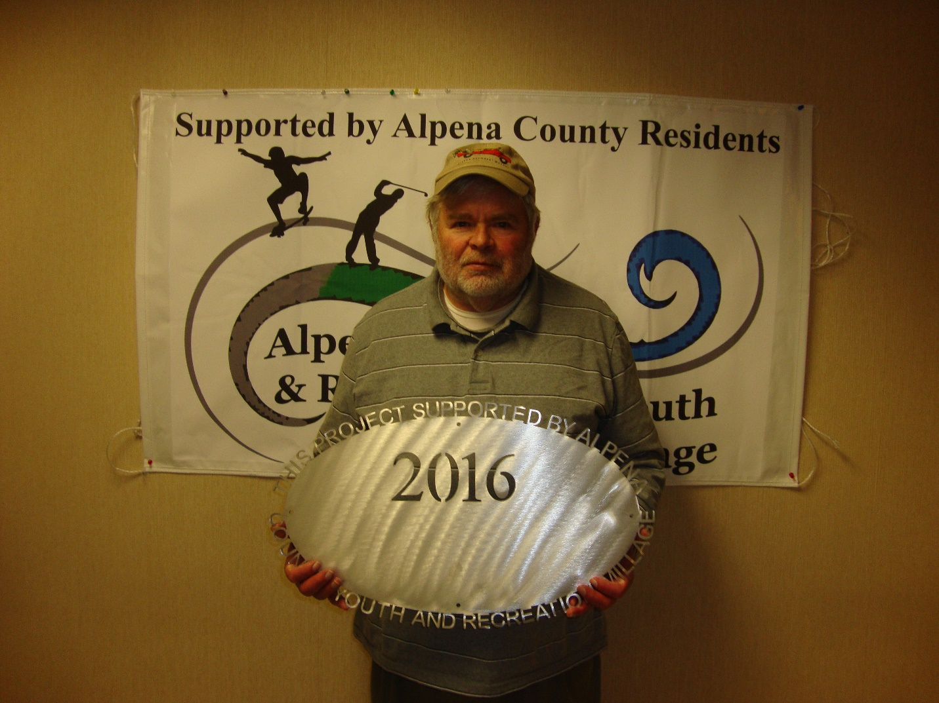Friends of Farmers Market
$2,250 Support for Youth Programs

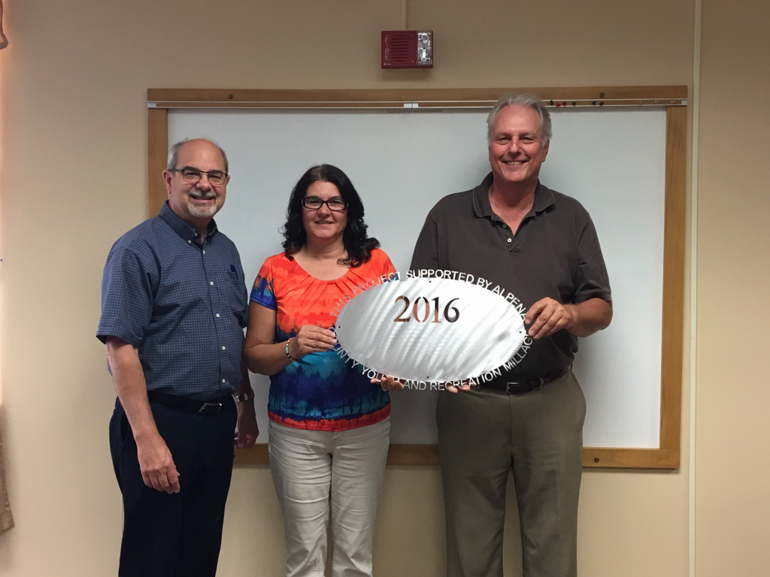

Green Township
$8,200 Recreational Facilities 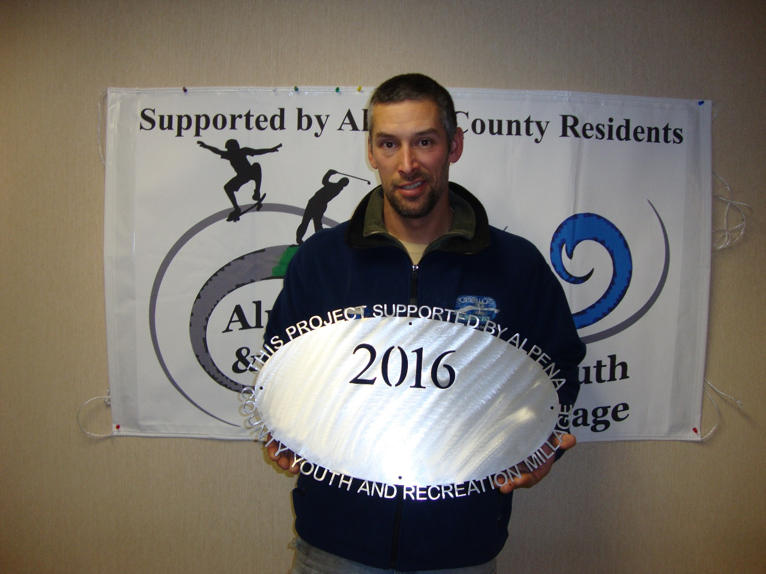MPAC – NLA # 2 (Free Open Skating)
$8,000 Free Open Skating 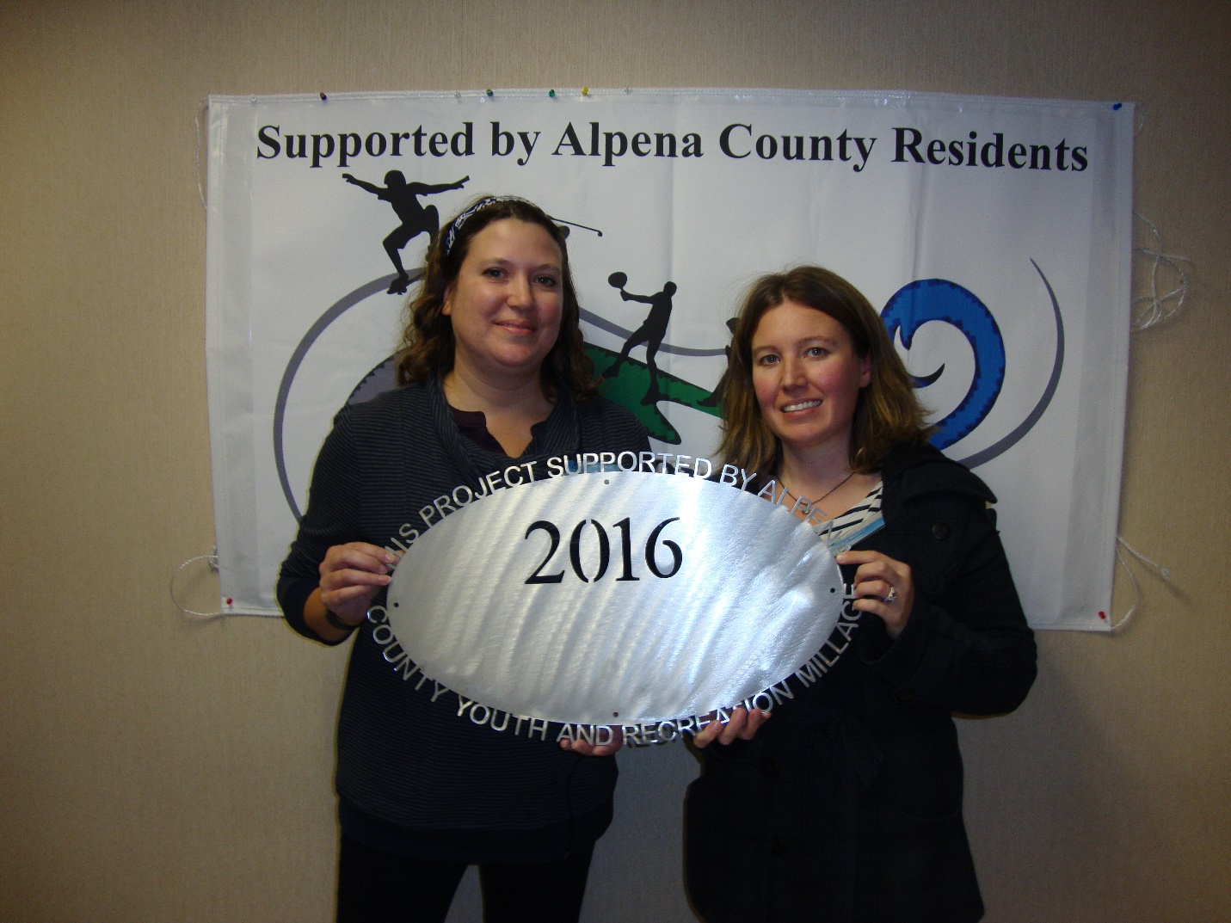NE MI Center for Fine Arts, Inc.
$20,000 Ready, Set, Create Program Park Family Foundation # 2 (Ready Set Snap) $7,500
Ready, Set, Snap Program

Senior Citizens # 1
$750 Bicycle Project.
Did not get funding

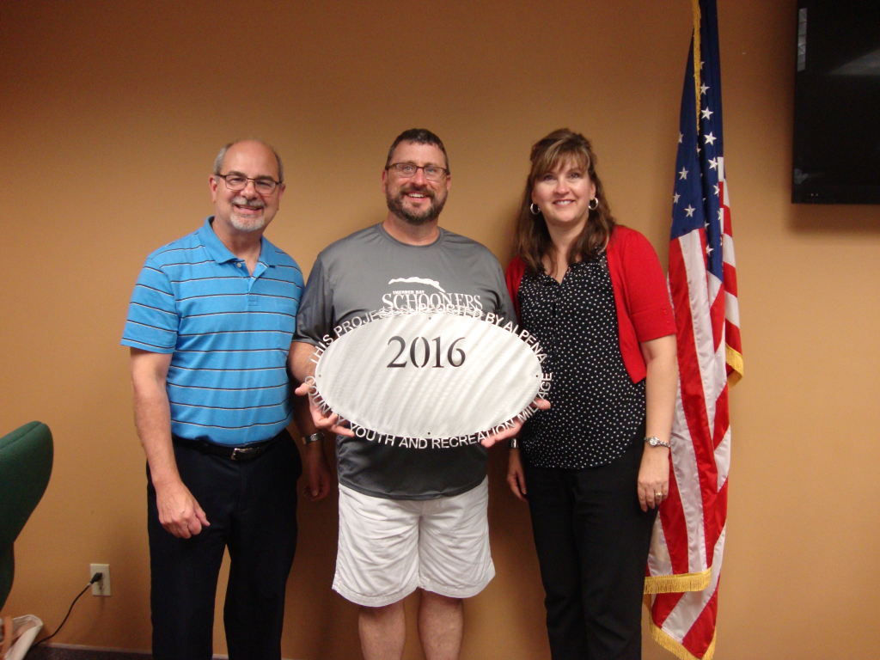

Thunder Bay Schooners Club
$9,000 Program Support

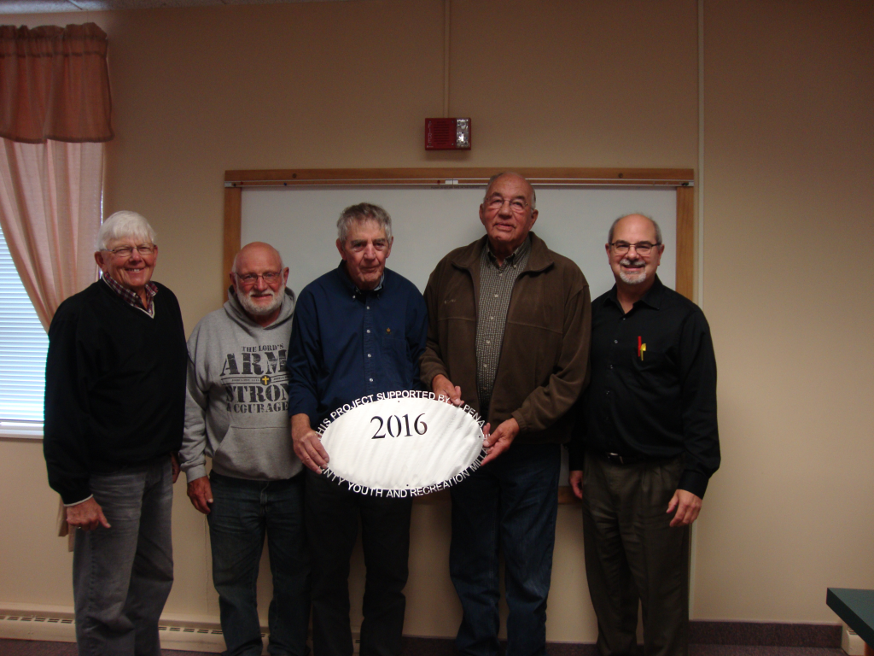
Wilson Township – Wolf Creek Park
$15,000 Site Improvements
Alpena Community College
$1200.00 Cross Country Boosters

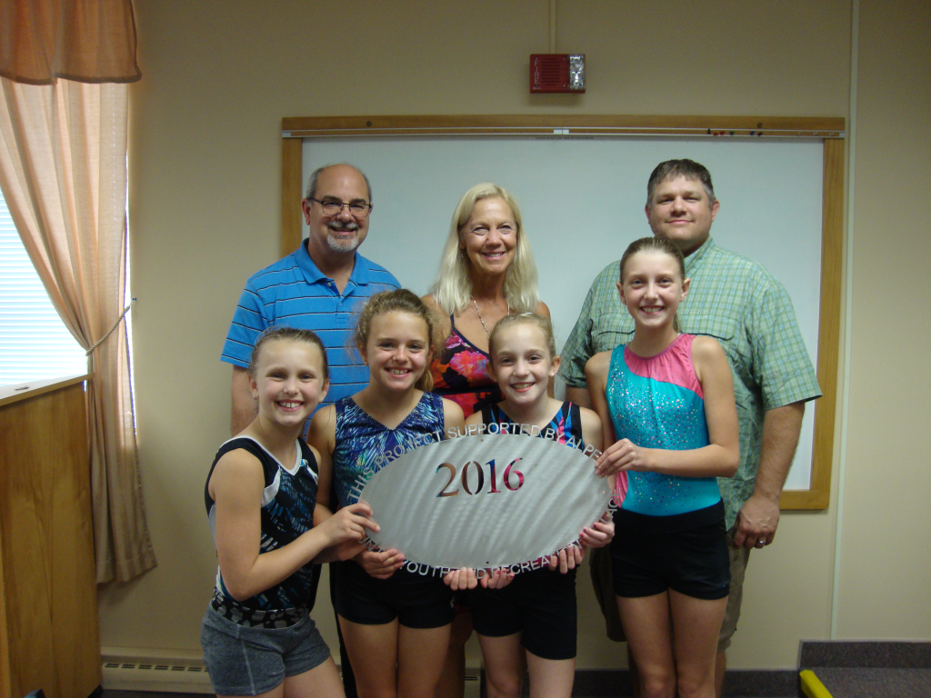
Alpena Gymnastics (Mats)
$3,000 Mats 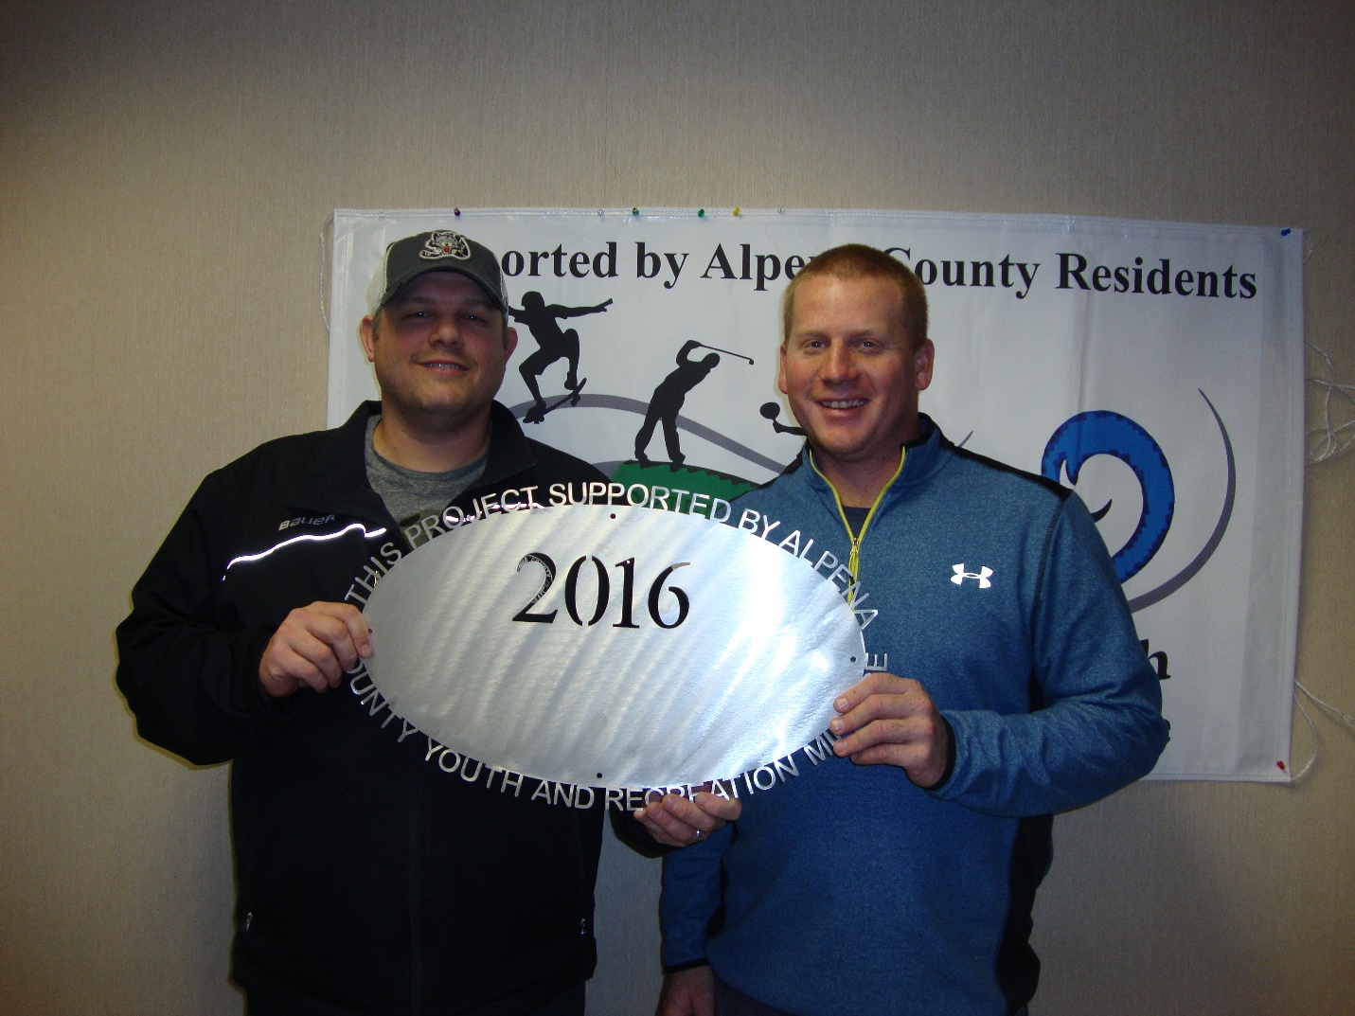Alpena Hockey Association
$10,500 Tournament Support 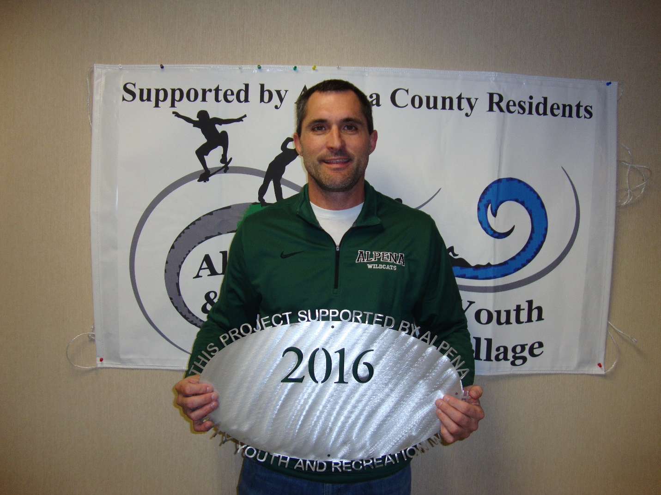Alpena Public Schools – AHS Boys and Girls Basketball $9,000 Operating Support 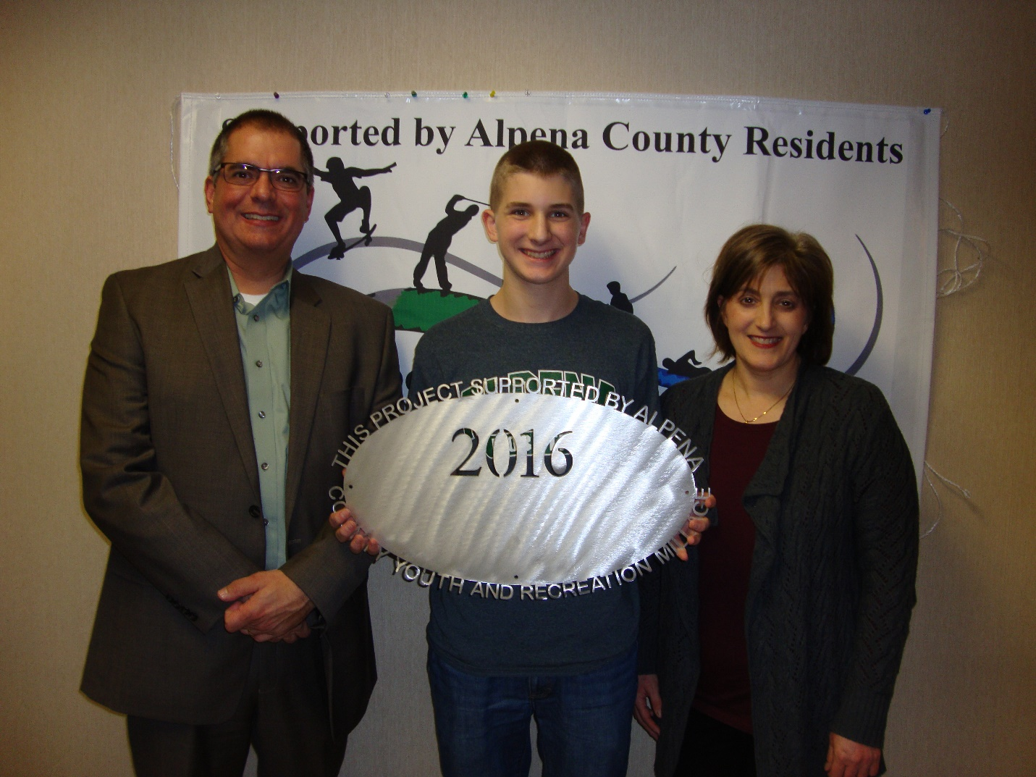Alpena Public Schools – AHS Robotics
$25,000 Support 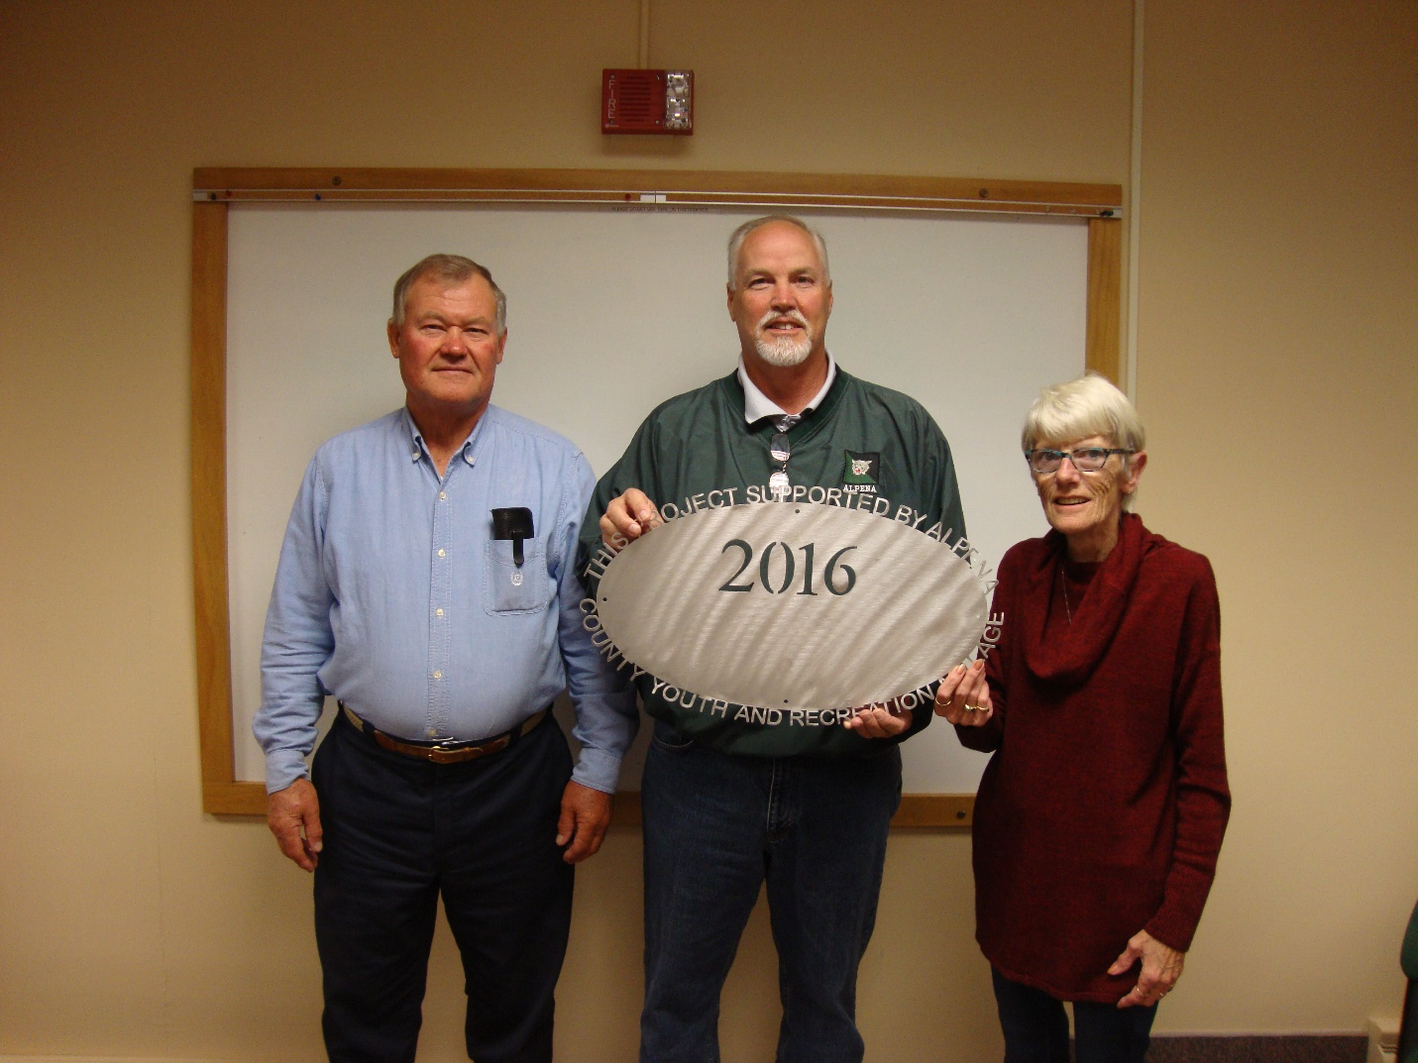Alpena Public Schools – AHS Track and Field $3,895 Hurdles 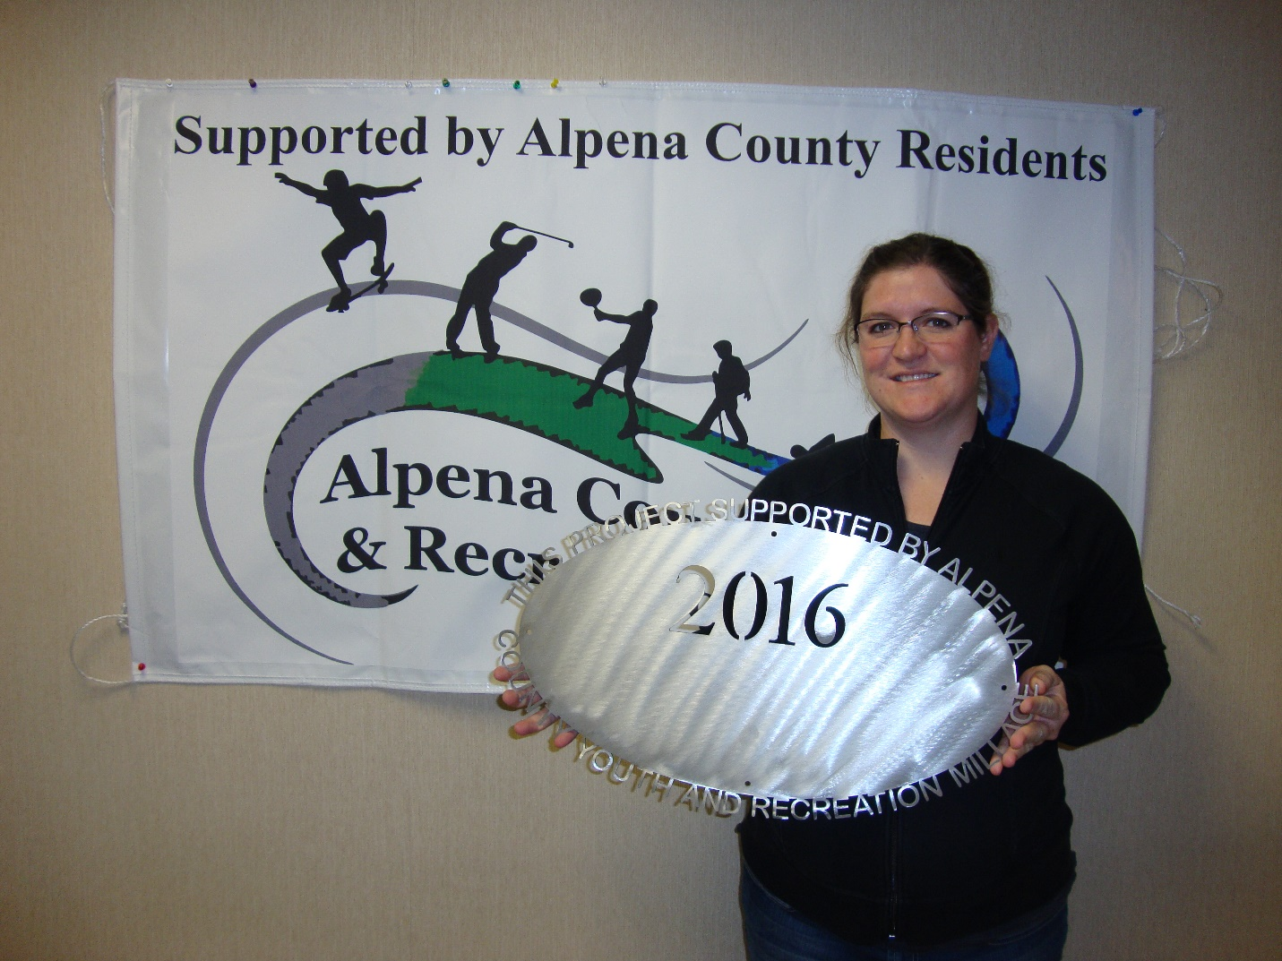Alpena Public Schools – TBJHS Athletic Outreach $19,140 Operating Support

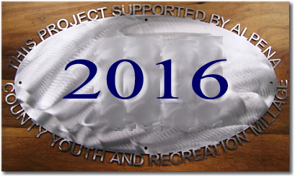
County of Alpena – Beaver Lake Park Bath House $45,000 Local Match for MDNR Grant. Did not get funding

County of Alpena – Long Lake Park Boat Launch $45,000 Local Match for MDNR Grant. Did not get funding
County of Alpena – Parks # 1 – Beaver Lake Park Pavilion $10,000 Pavilion County of Alpena – Plaza Pool (Operating Support) $76,500 Pool Operations County of Alpena Parks # 6 – Green Township $10,000
Manning Hill Improvements 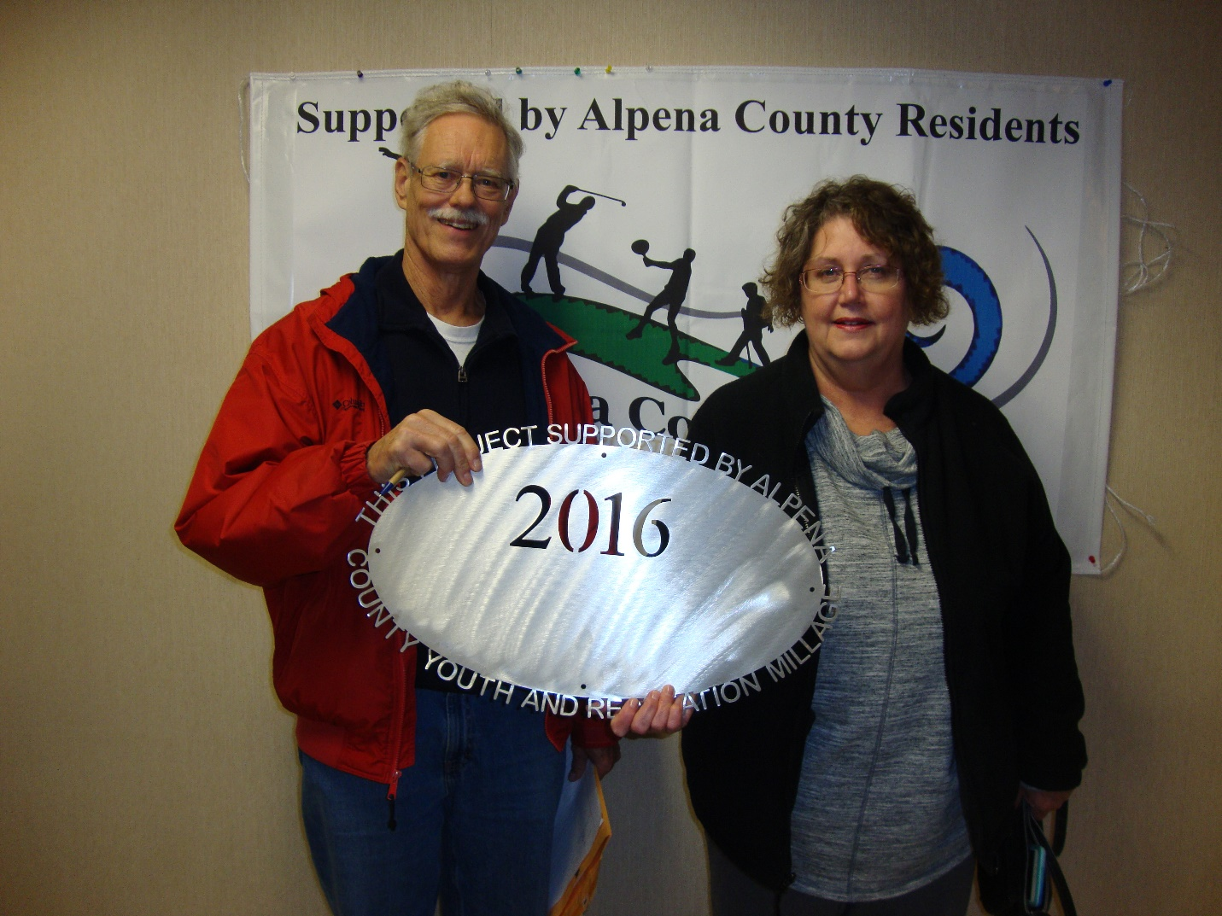Friends of Plaza Pool
$1,700 Pool Support MPAC – NLA # 1 (Tournament Support)
$10,000 Tournament Support MPAC – NLA # 3 (Ready Set Skate)
$9,215 Ready, Set, Skate Program Park Family Foundation # 1 (Ready Set Serve) $7,500
Ready, Set, Serve Program 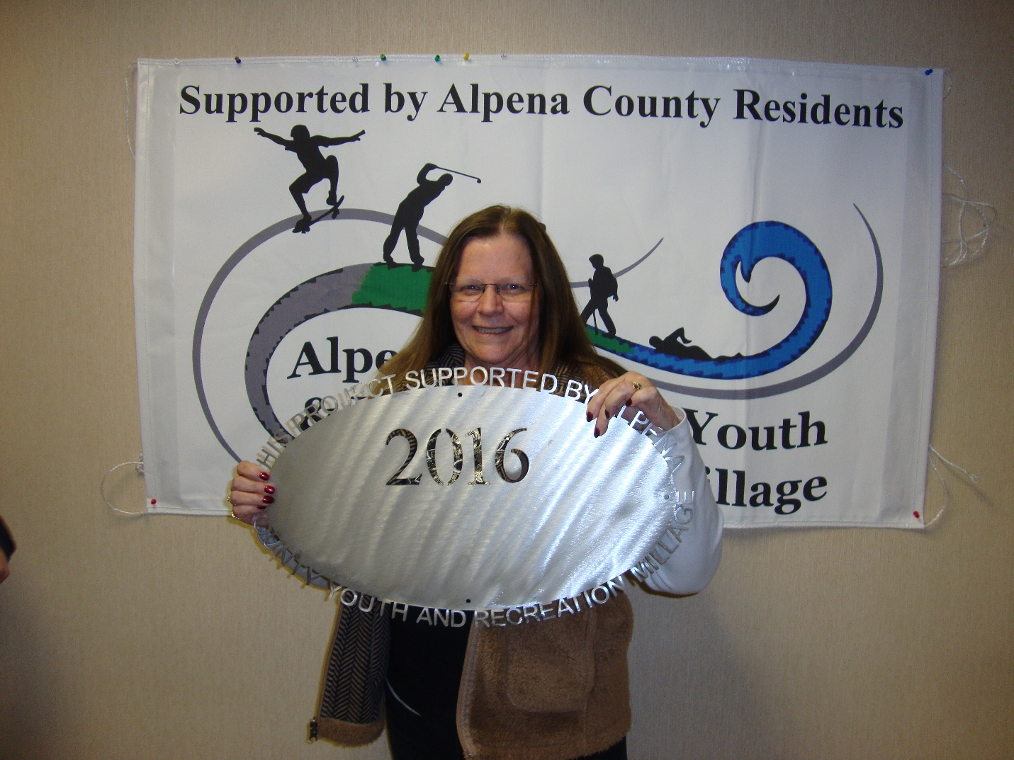Sanborn Township – Park on Lake Huron
$7,000 Swings 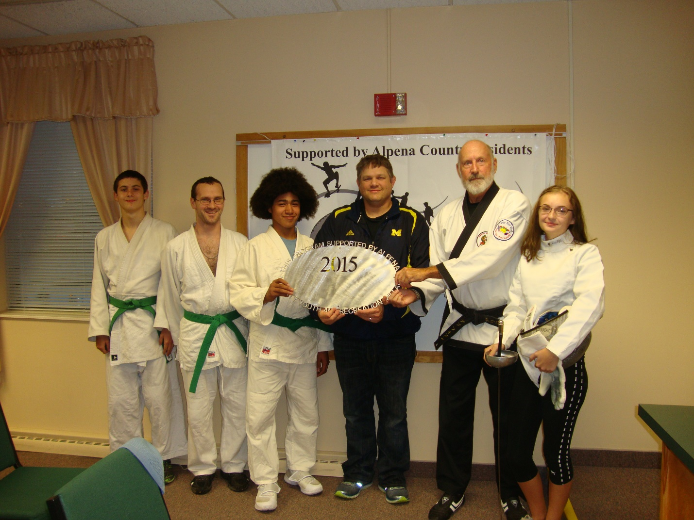Thunder Bay Martial Arts
$4,000 Scholarships 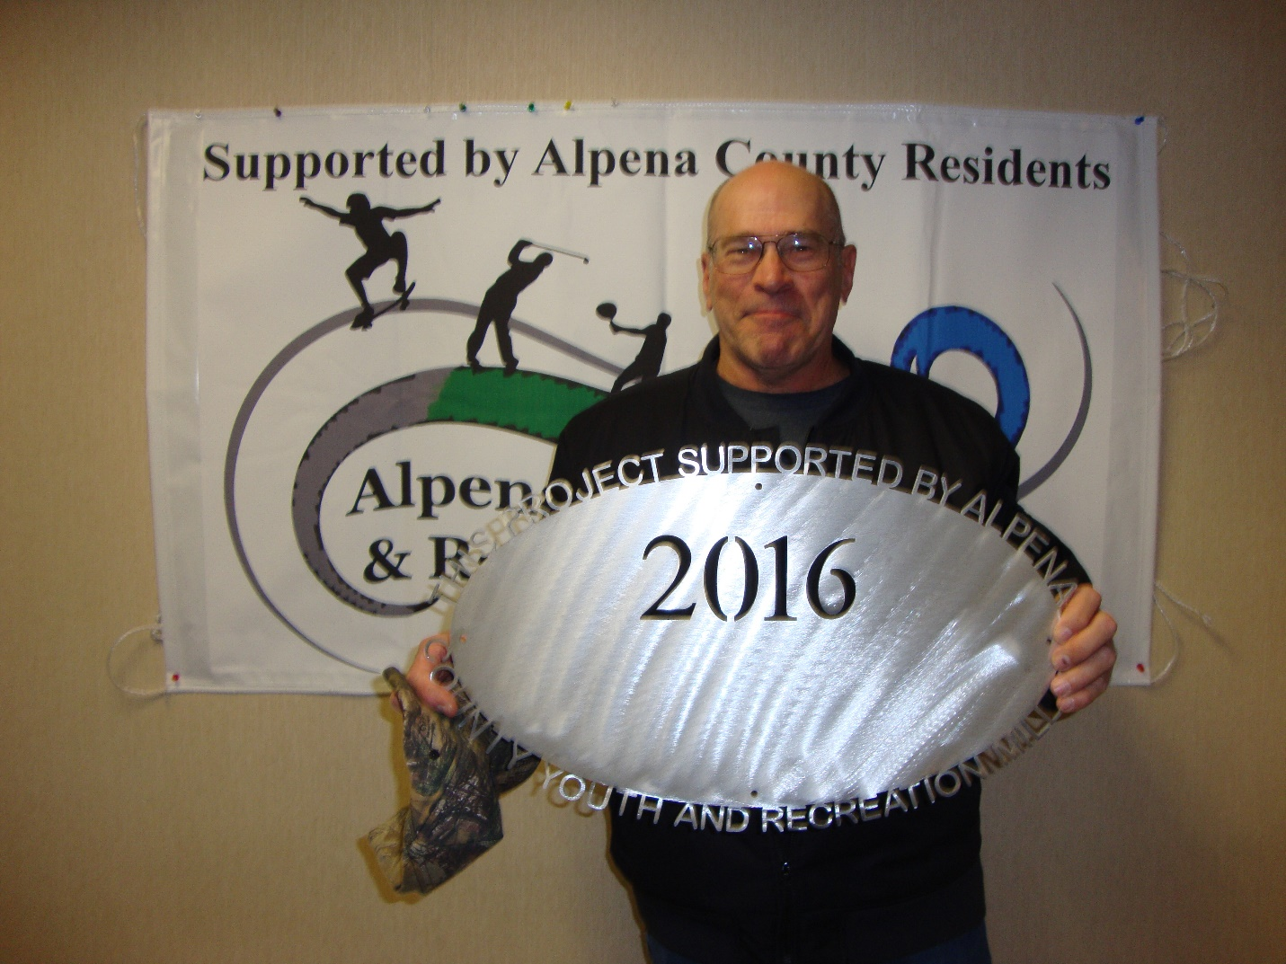Thunder Bay Trails Association
$8,000 Chippewa Hills Expansion

Administration $25,230.00

Commissioners & Commissioners Appointees
District 1 – COMMISSIONER
Jeff Kowalski
717 S. First Ave.
Alpena, MI 49707
989.356.0427
jeffkowalski@alpenacounty.org
Linda Canfield
117 Hitchcock Street
Alpena, MI 49707
989.356.2742
lindacanfield1@frontier.com
District 3 – COMMISSIONER
Camille Nerkowski
3210 S. Third Avenue
Alpena, MI 49707
989.356.2909
camillenerkowski@alpenacounty.org
Darlene Wilmot
150 S. North Street
Alpena, MI 49707
989.356.9770
darlenewilmot@hotmail.com
District 5 – COMMISSIONER
Mary Hess
8793 US-23 South
Ossineke, MI 49766
989.471.2103
maryhess@alpenacounty.org
Tom Heise
3376 Piper Road
Alpena, MI 49707
989.354.2447
htssllc@yahoo.com
District 7- COMMISSIONER
Cameron Habermehl
14510 M-32 West
Lachine, MI 49753
989.766.3455
camhabermehl@alpenacounty.org
Fred Wegmeyer
10599 Napper Rd.
Herron, MI 49744
989.379.4034
District 2 – COMMISSIONER
Robert Adrian
227 Dawson Street
Alpena, MI 49707
989.464.6334
robertadrian@alpenacounty.org
Brett Miller
1121 River Street
Alpena, MI 49707
989.354.3328
bam3623@gmail.com
District 4 – COMMISSIONER
Lyle VanWormer
4665 Kirchoff Road
Alpena, MI 49707
989.255.5896
lylevanwormer@alpenacounty.org
Tony Suszek
114 Kensington Court
Alpena, MI 49707
989.356.4434
suszektj@charter.net
District 6 – COMMISSIONER
Ronald McDonald
6594 Orchard Hill Road
Alpena, Ml 49707
989.379.4848
ronaldmcdonald@alpenacounty.org
Thomas Spaulding
5925 Keating
Lachine, MI 49753
989.379.2789
jeanntom71@hotmail.com
District 8 – COMMISSIONER
Eric Lawson
P.O. Box 73
Ossineke, MI 49766
Phone: 989.255.3762
ericlawson@alpenacounty.org
Lisa Siegert
12700 Hawkins Road
Hubbard Lake, MI 49747
989.727.3089
siegertlne@gmail.com

County Contacts
Kim Ludlow
County Treasurer
989.354.9534
ludlowk@alpenacounty.org
Jamie Siess
Board Secretary
Alpena County Commissioners
989.354.9504
commissionersoffice@alpenacounty.org
Tammy Sumerix-Bates
Executive Manager
Alpena County Commissioners
989.354.9502
commissionersoffice@alpenacounty.org
Share this article
- facebook
- twitter
- linkedin
- email
- pinterest

