***2015 Logo Pic #1

2015 Youth and Recreation Millage Funds Awarded
Youth and Recreation
- facebook
- twitter
- linkedin
- email
- pinterest
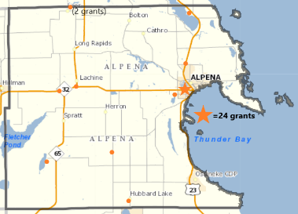***
The Committee is trying to spread the funds throughout the County, encouraging all the Townships and non-profit organizations, schools, and governmental agencies to apply. The Alpena County Map shown on the left, depicts where 24 grants have been awarded. Please click on the image for a larger view or by clicking here. (clicking here #2)
Budget Recommendations for 2015 recommendations are not approved until after the Full Board of Commissioners approval as part of the Budget for 2014 held December 30, 2014 meeting.
Total amount appropriated $393,680

Resources
2015 Millage Award Book
Meeting Dates
2015 Funding Report

Maps
Alpena Township
City of Alpena
Green Township
Long Rapids Township
Maple Ridge Township
Ossineke Township
Sanborn Township
Wellington Township
Wilson Township

Listed below, you can view the organization, amount awarded and the name of project. Additionally, you can view or download the 2015 Youth and Recreation Awards Book by clicking here. (***clicking here #3 Pic)
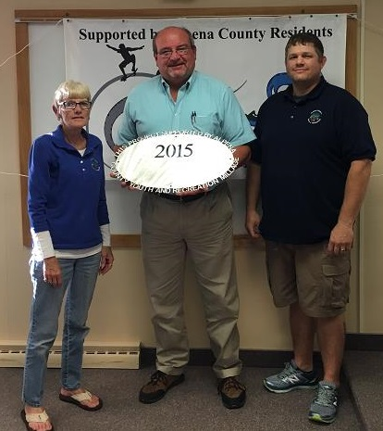
City of Alpena- Carryover Trailhead
$40,000 Local Match for $245,000 MDNR Grant 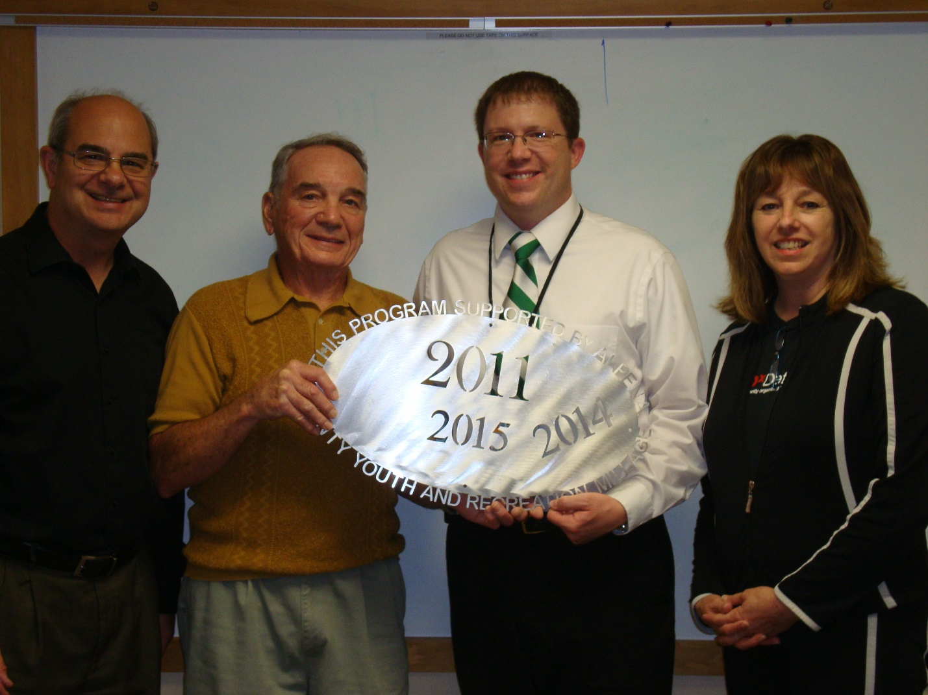Association of Lifelong Learners at ACC
$5,780.00
Shipwrieck Alley Class 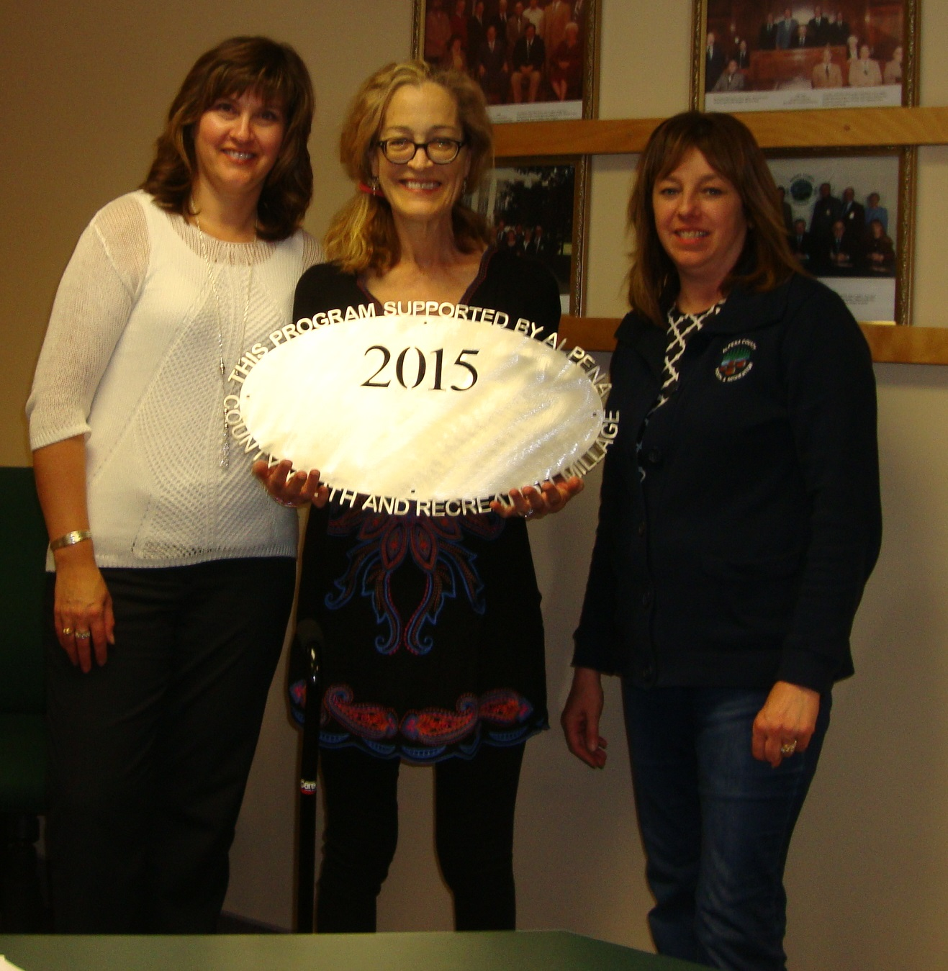ACC Volunteer Center
$4000.00 Ropes Course 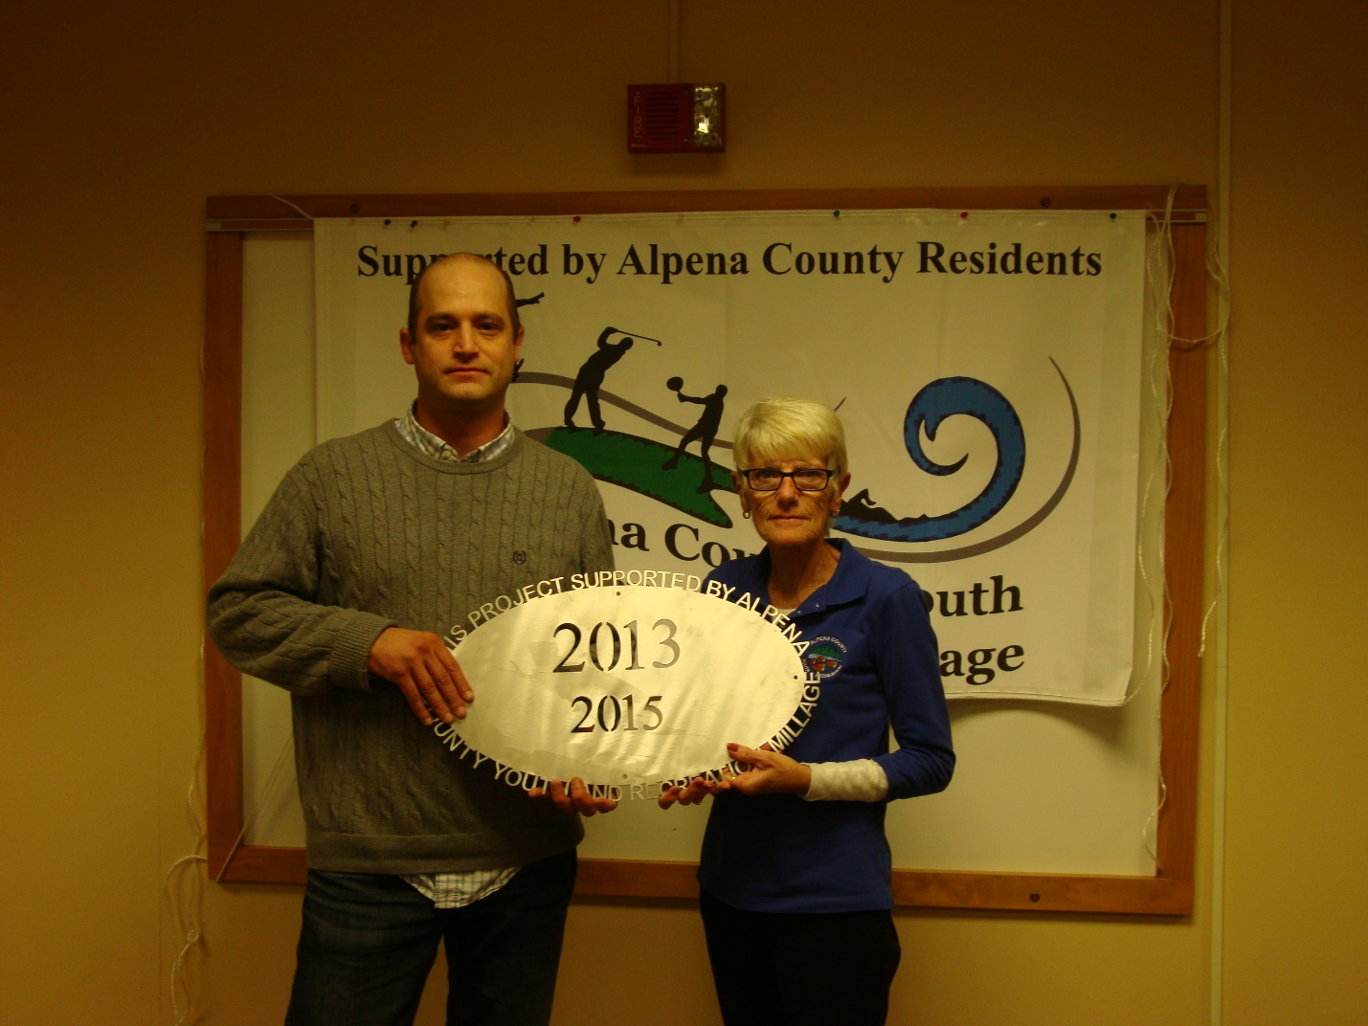County of Alpena – Sunken Lake Park # 1
$4625.00 Covered Bridge Roof Project 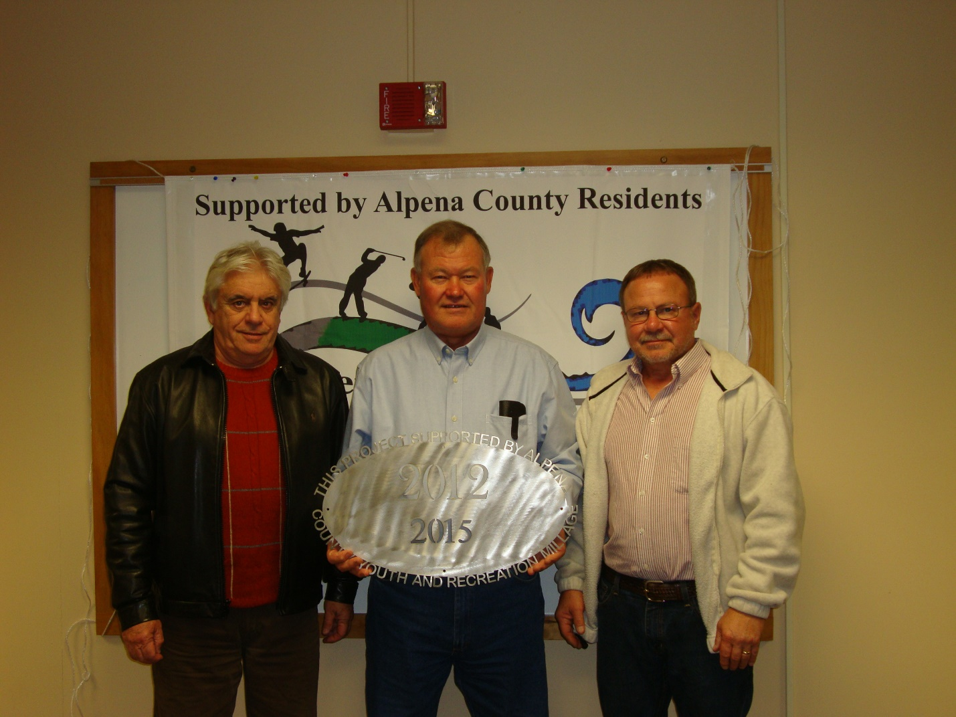Hubbard Lake Lions
$9500.00 Fencing at Park 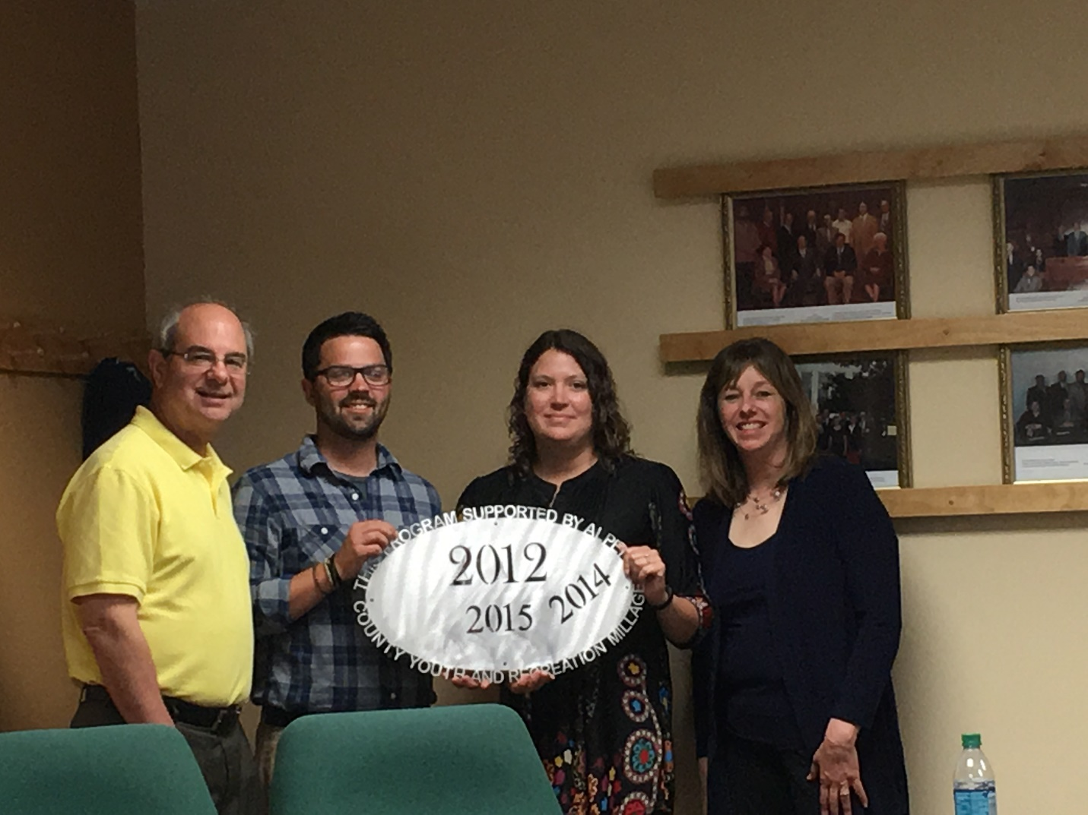Northeast MI Center for Fine Arts
$22,000.00 Ready, Set, Create 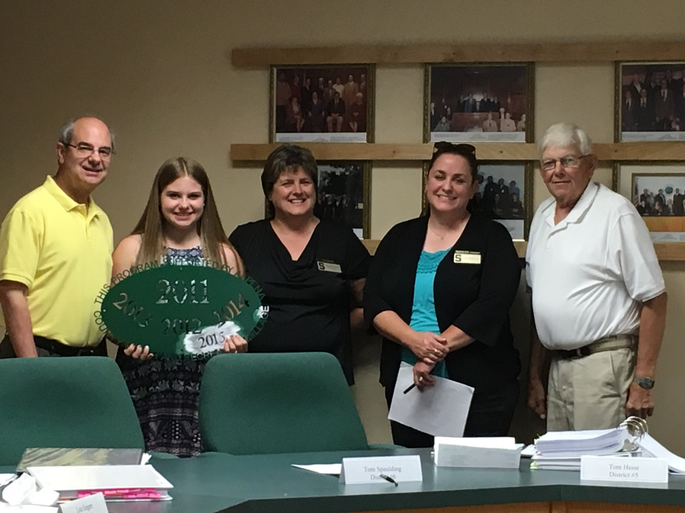MSU Extension
$41,474.00 Youth Programming 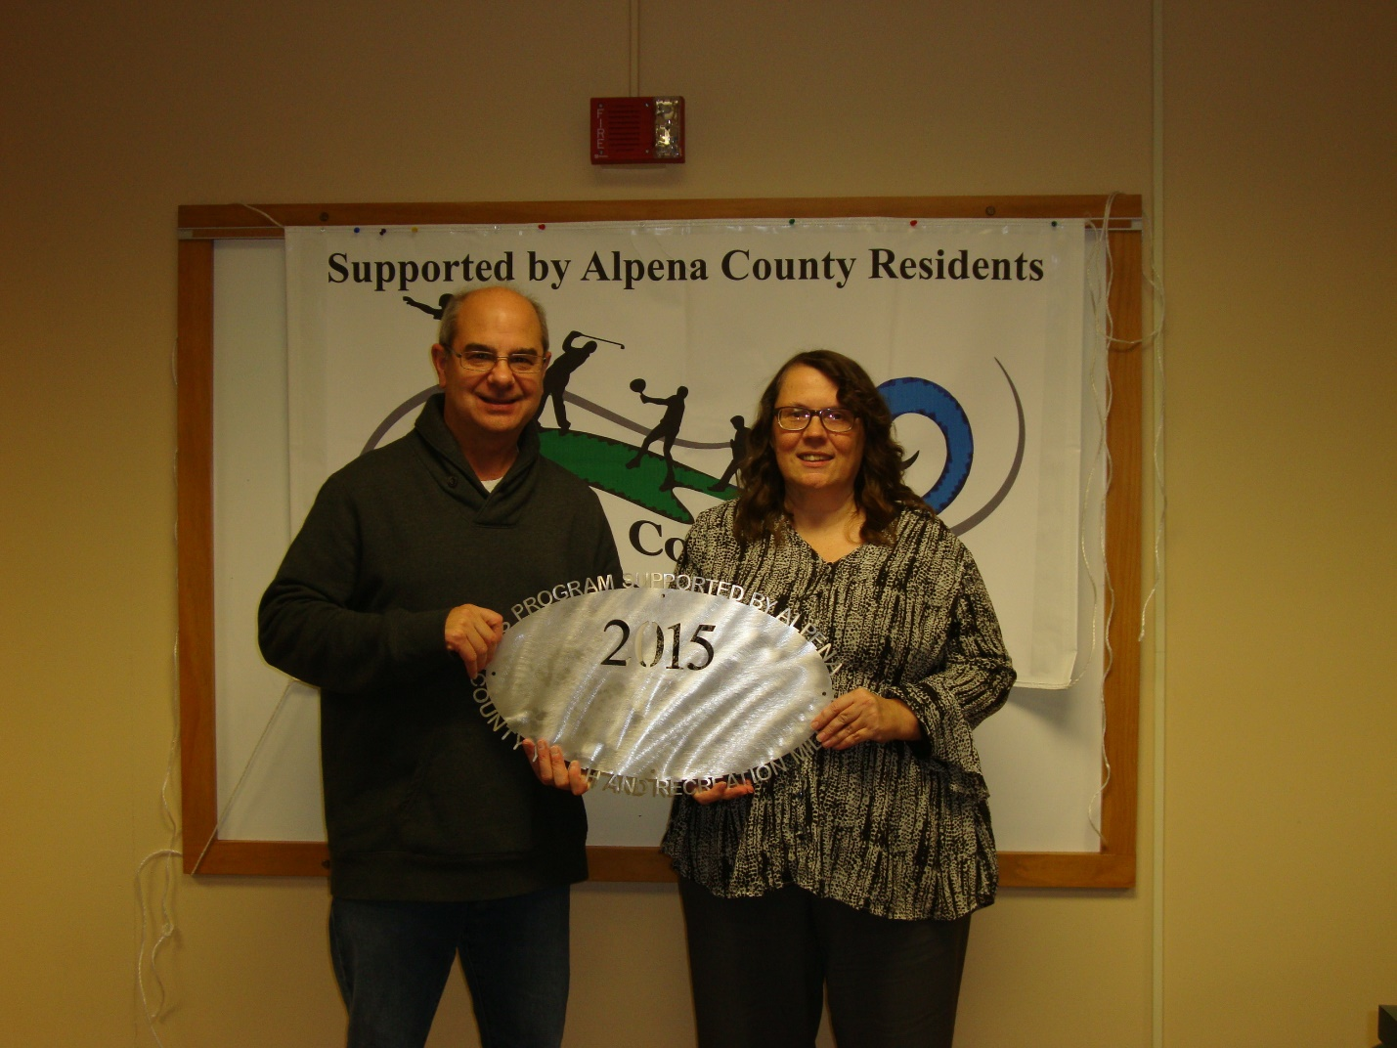Alpena High School Band Boosters
$9000.00 Band Instruments 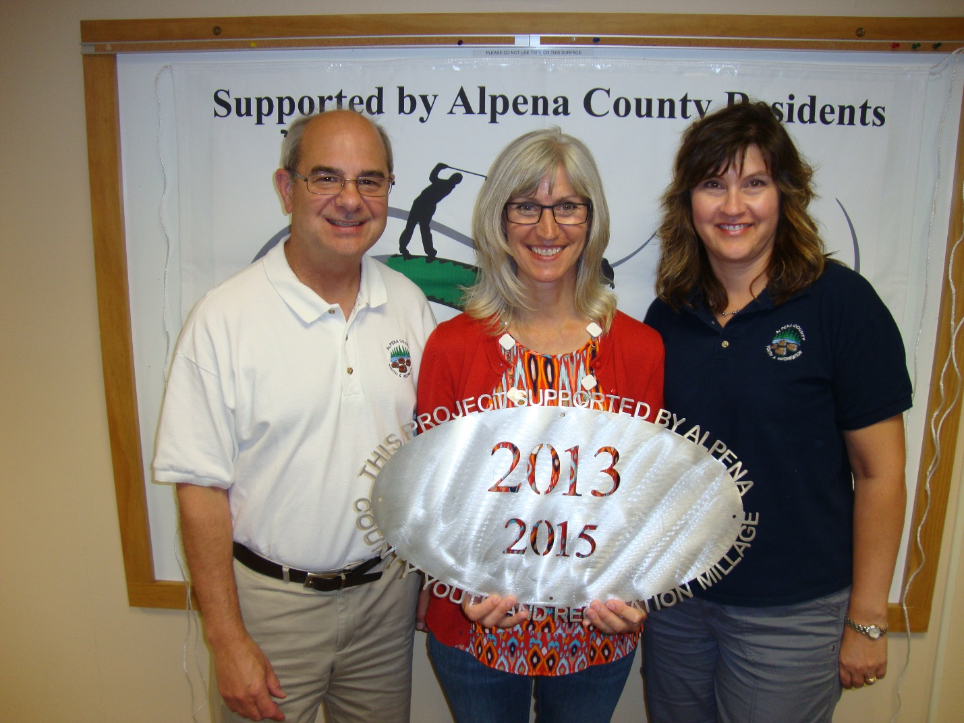Besser Museum
$7000.00 Shout “Eureka” Science 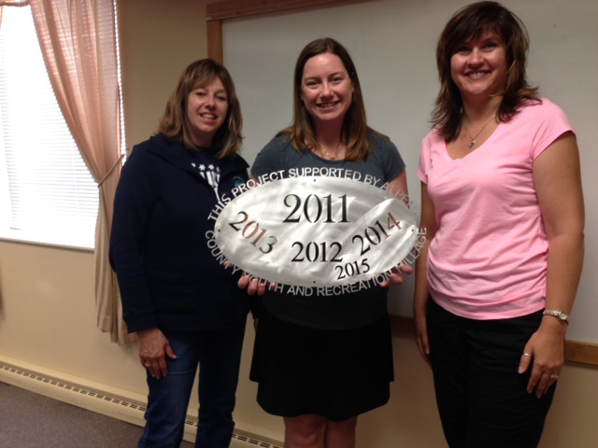ALPENA PUBLIC SCHOOLS – VOLLEYBALL CLUB $6555.00 Support to reduce the cost of player/jerseys 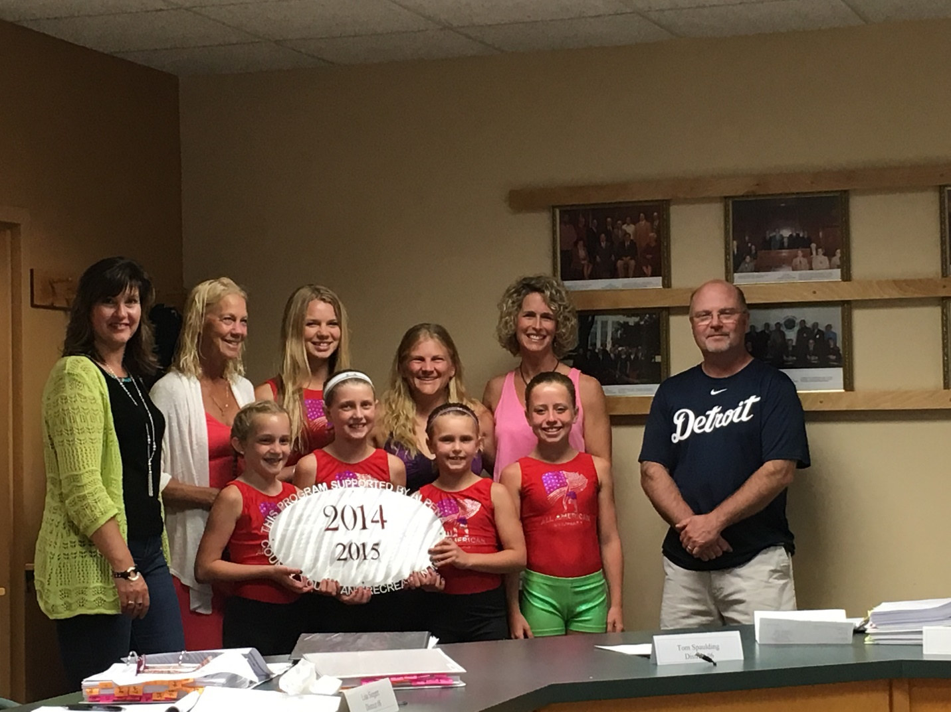Wildkitten Tumbling, Inc. # 1
$3000.00 Ready, Set, Flip 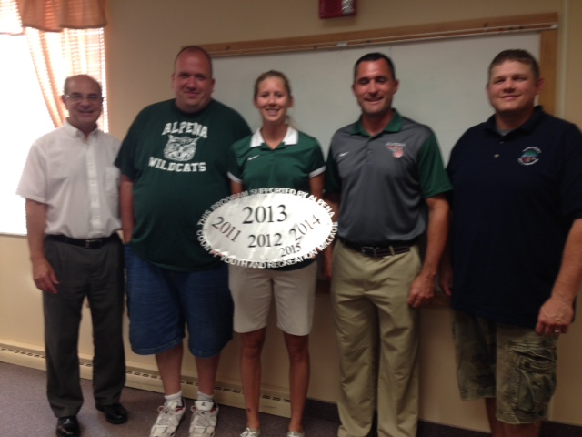Alpena Public Schools – AHS Boys and Girls Basketball $9,000.00
Support to reduce the cost of player/uniforms 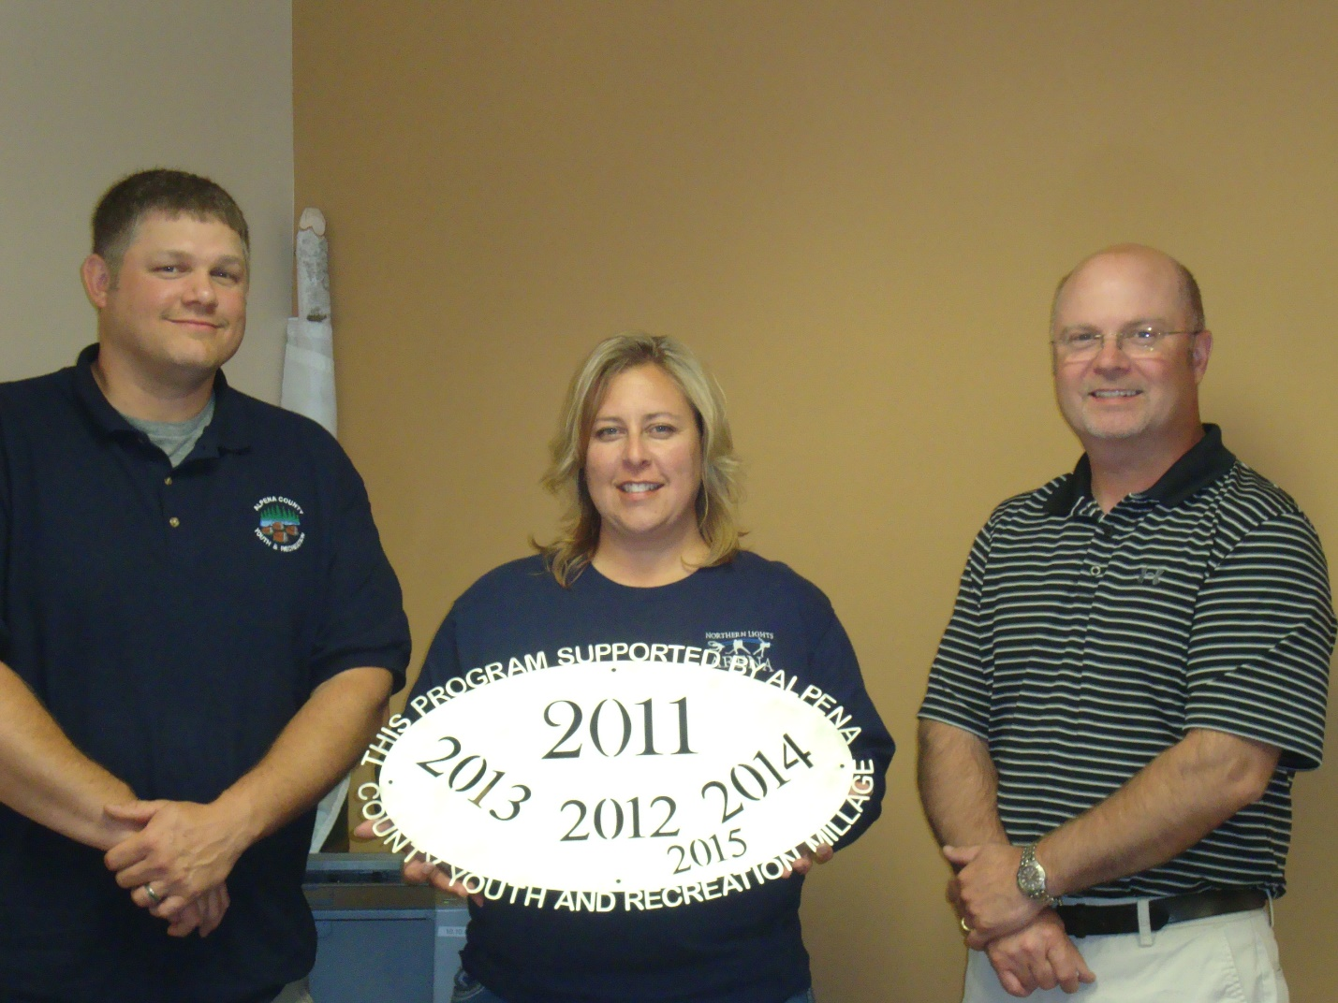Northern Lights Arena Community/MPAC
$3815.00 Ready, Set, Skate 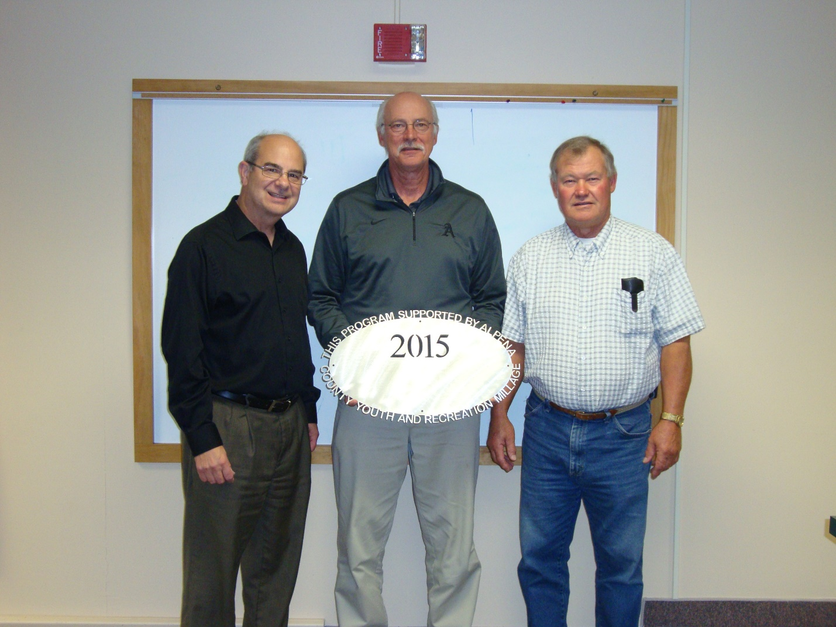Alpena Public Schools – AHS Boys and Girls Soccer $6135.00 Uniforms and partial travel
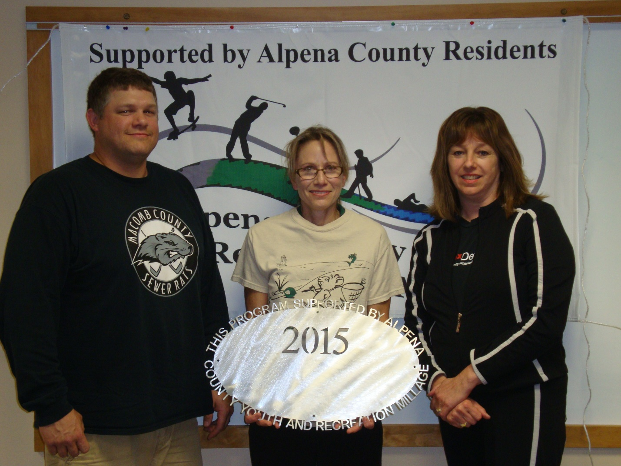City of Alpena/Wildlife Sanctuary
$500.00 River Rats Summer Science 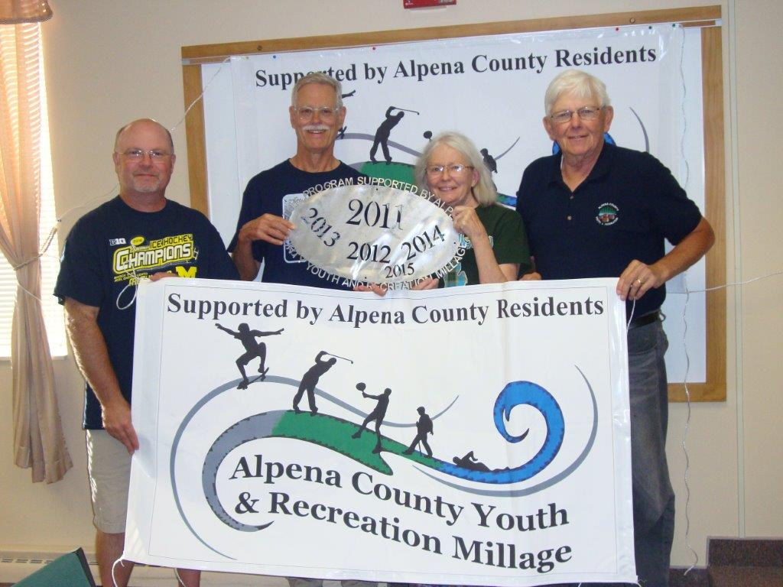Friends of Plaza Pool
$1700.00 Aquatic Programming 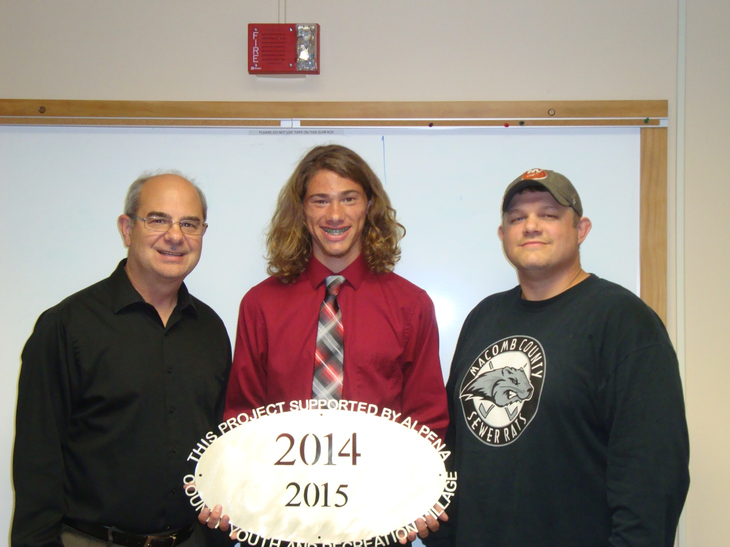ACC Cross Country Boosters
$5178.00 Time-clock, accessories, travel 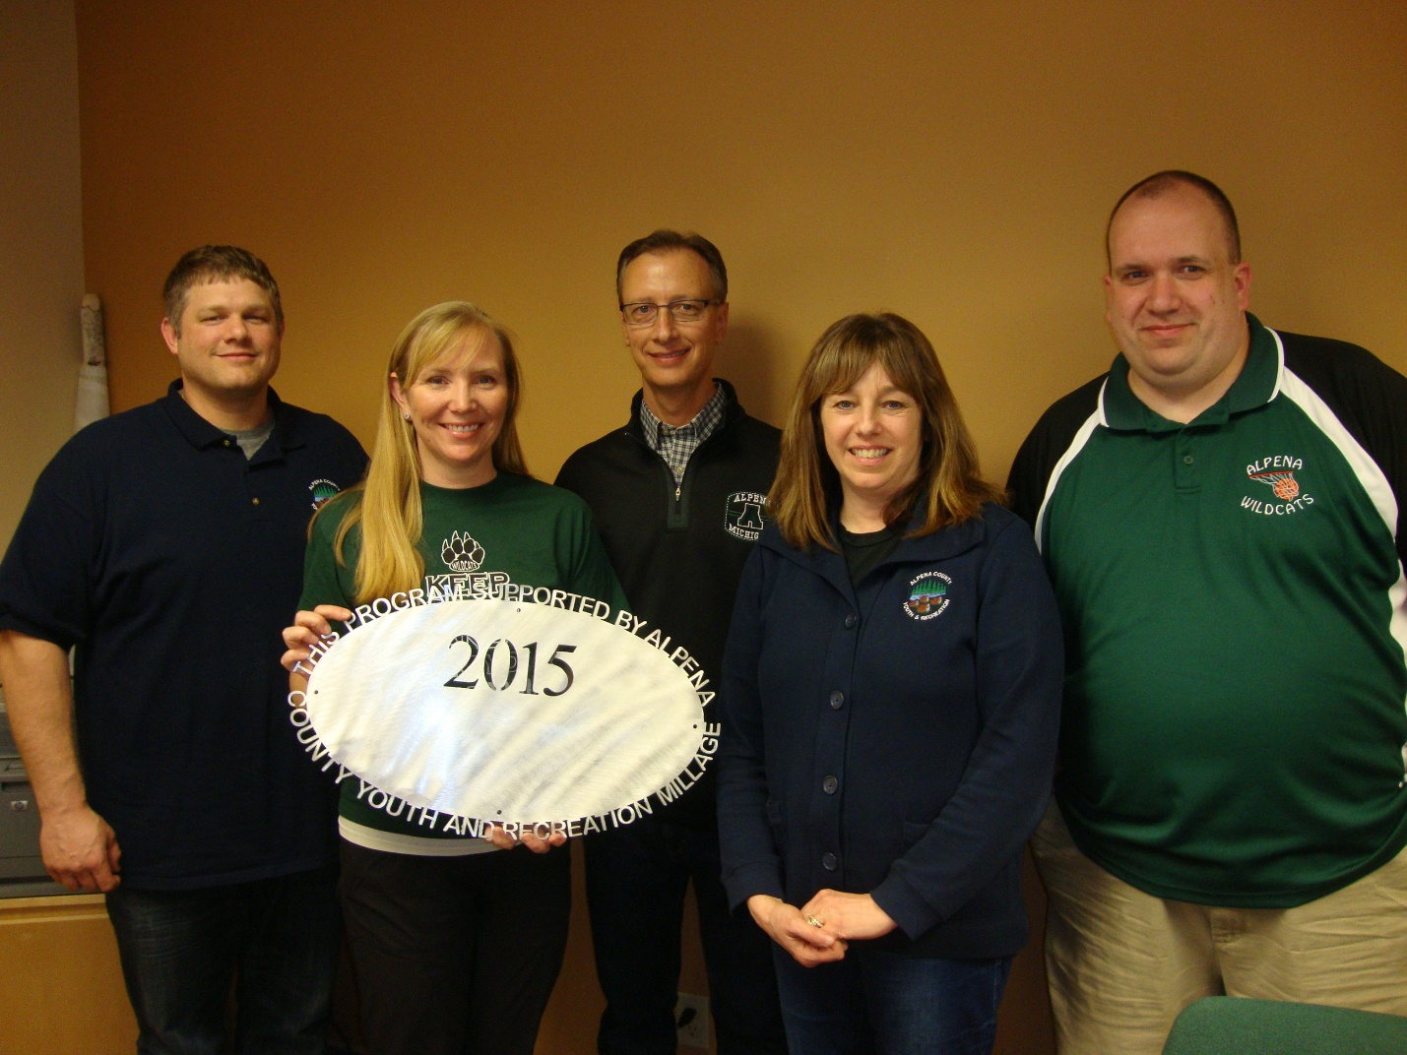ALPENA PUBLIC SCHOOLS – TBJHS
$19,982.00 Athletic Outreach 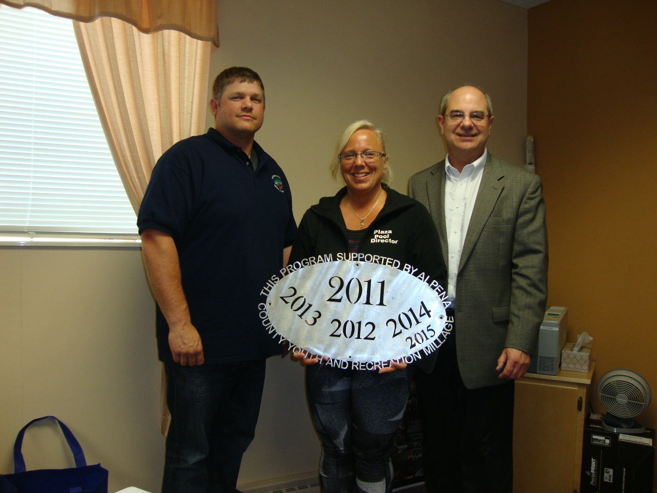County of Alpena – Plaza Pool # 2
$8500.00 Ready, Set, Swim County of Alpena – Plaza Pool # 1
$85,000.00 Operating Support 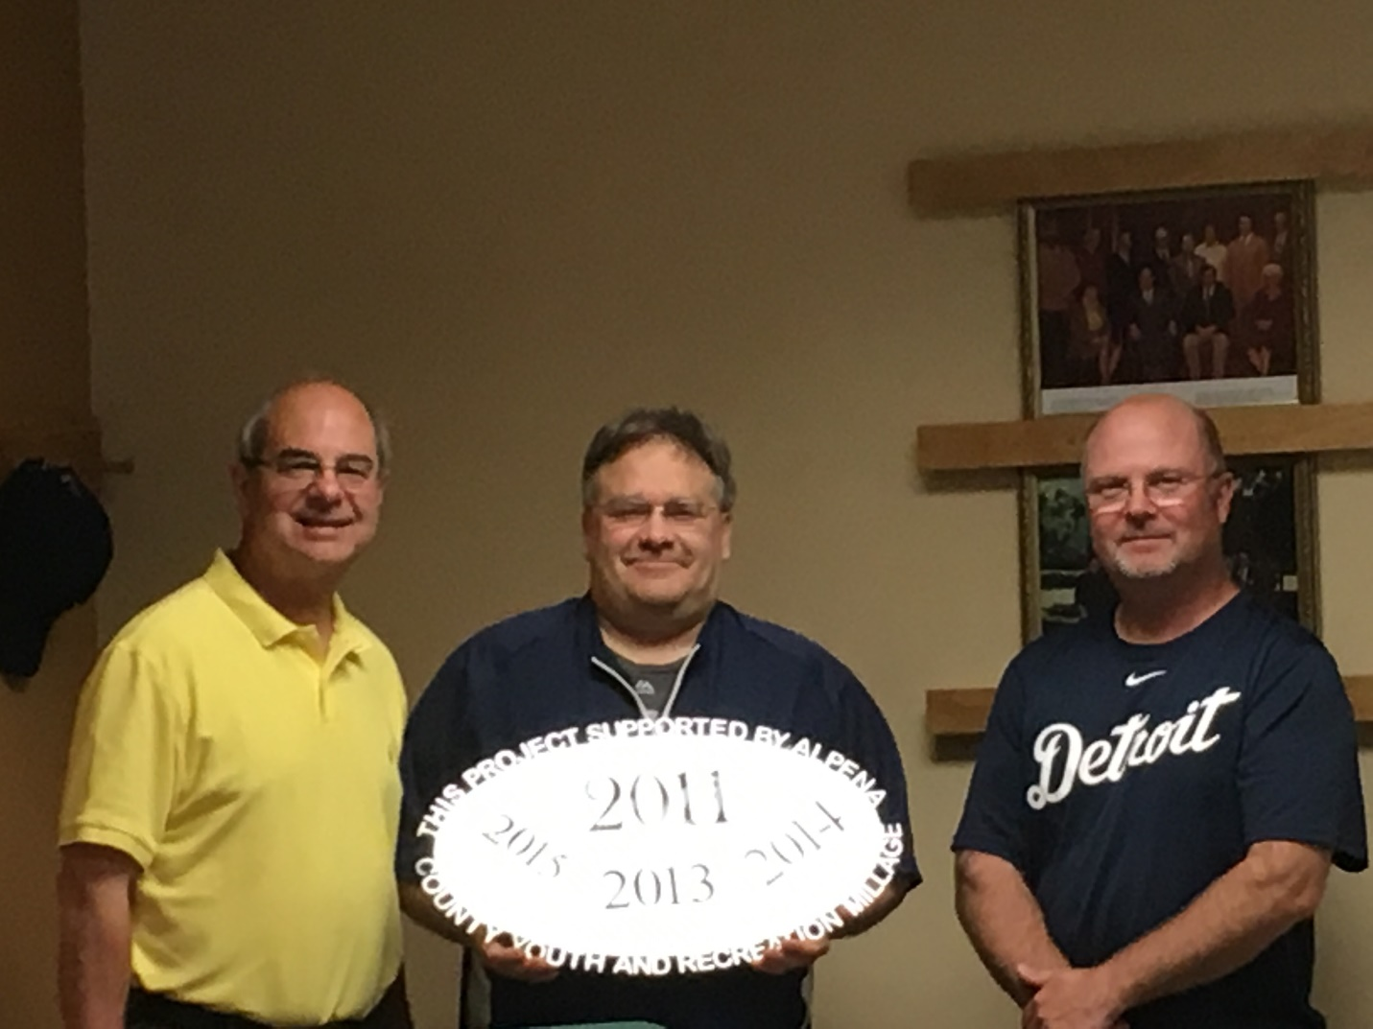Alpena Tennis Association
$8275.00 Ready, Set, Serve County of Alpena – Sunken Lake Park # 2
$5100.00 Pavillion Roof Project 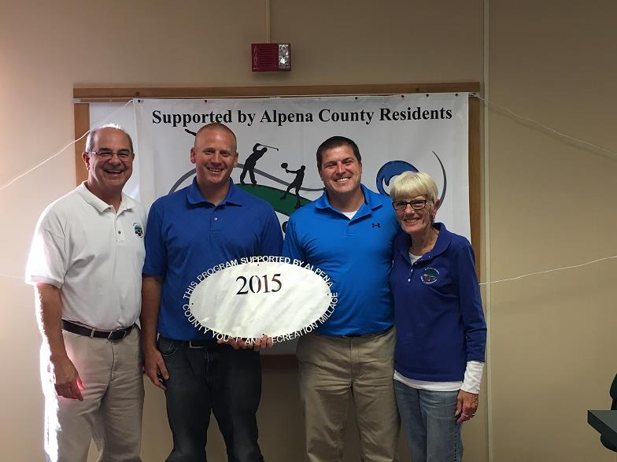Alpena Hockey Association
$7000.00 Tournament Support 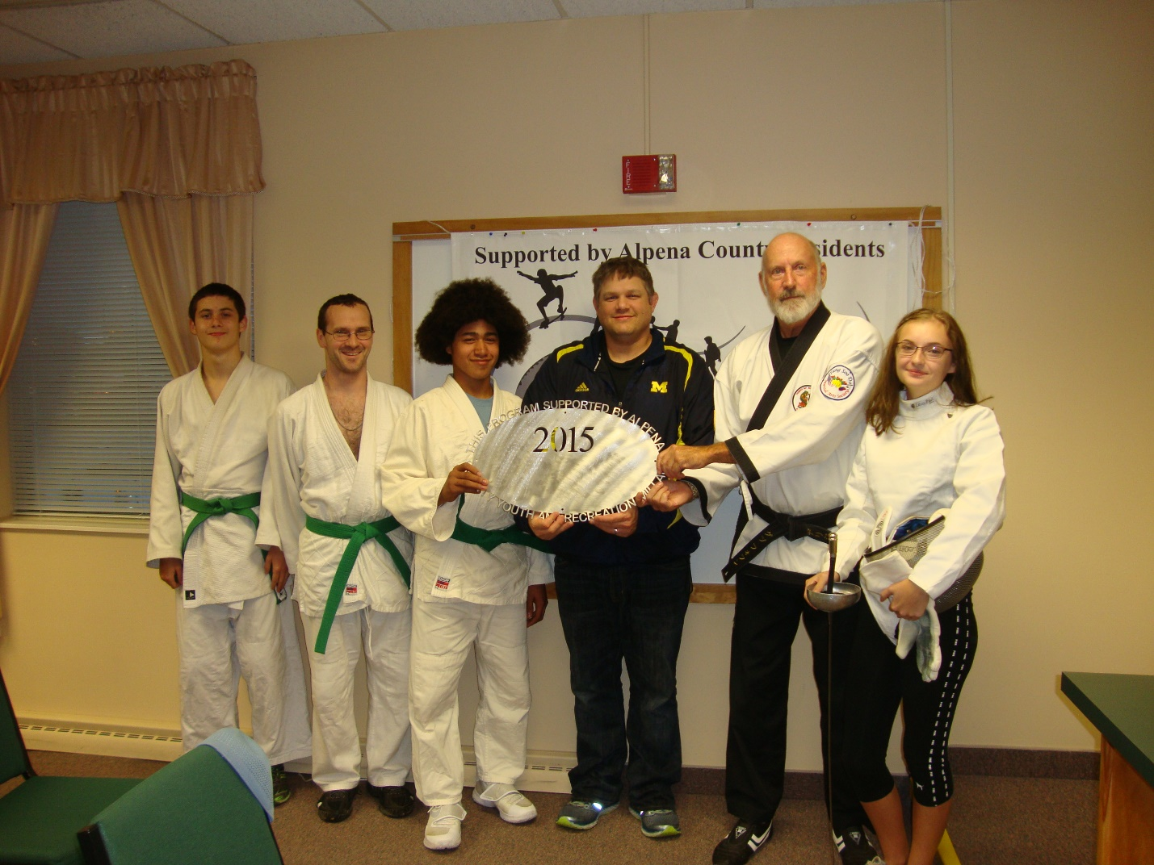Thunder Bay Martial Arts
$10,000.00 Mats, fencing, scholarships – partial 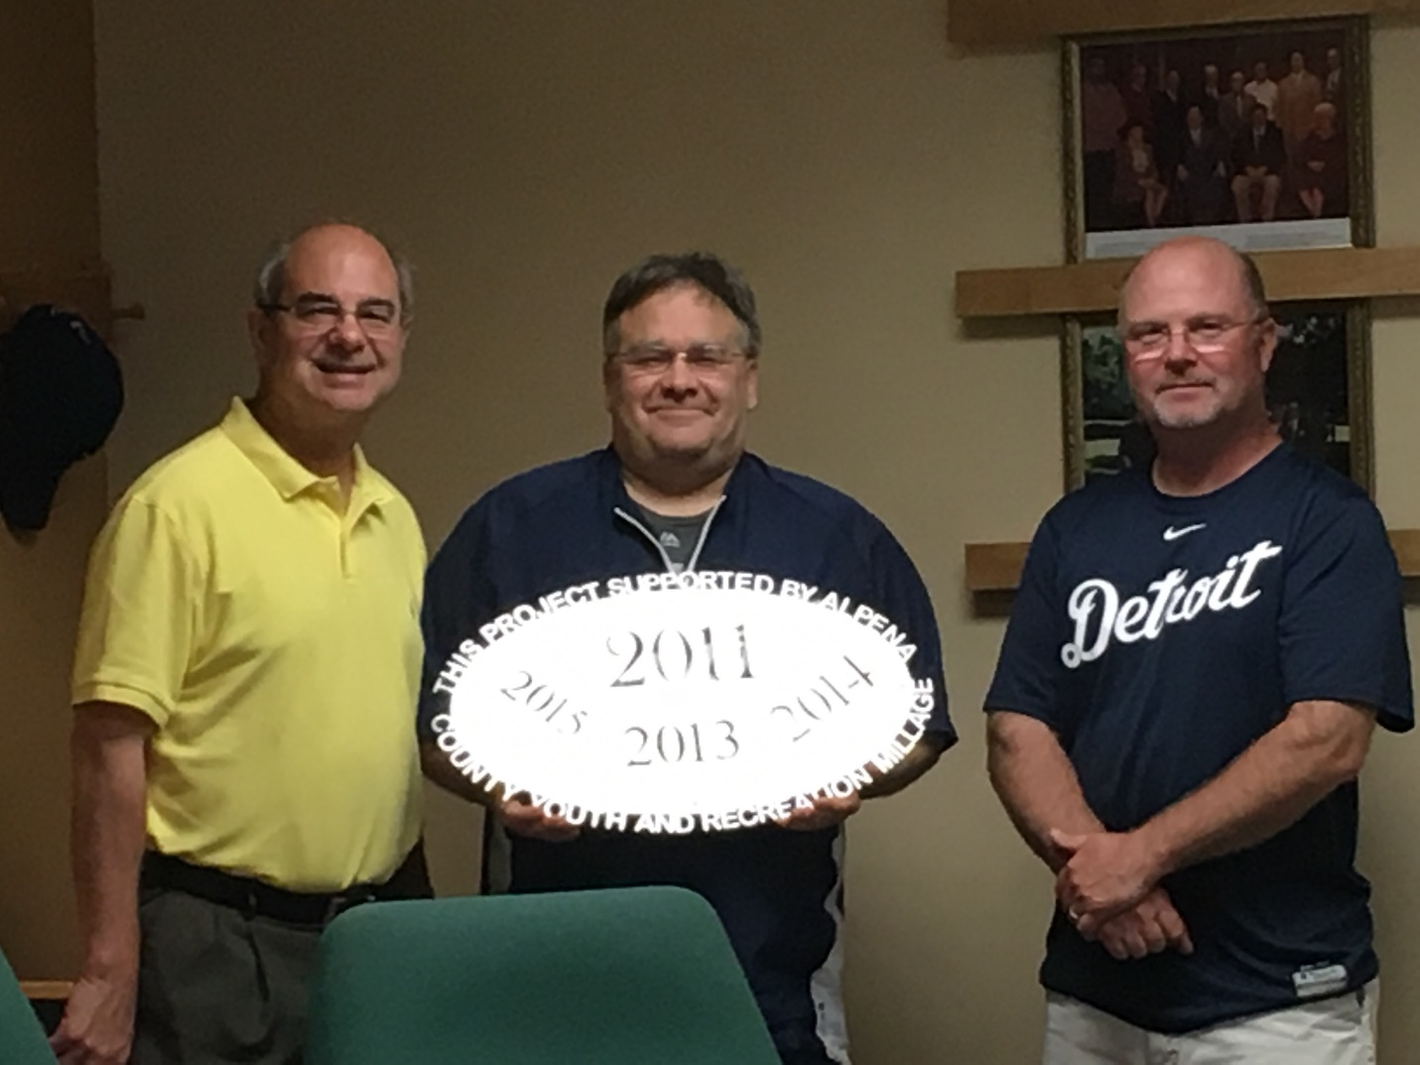Park Family Foundation
$8000.00 Ready, Set, Snap 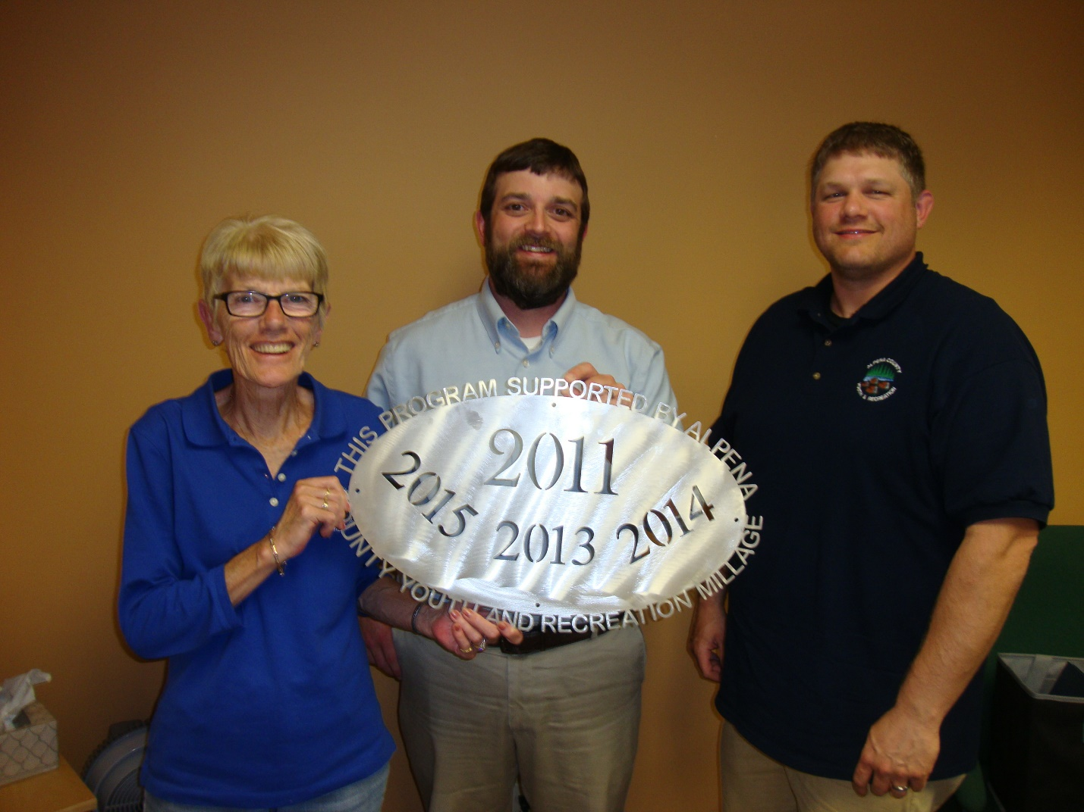Boys and Girls Club
$13,000.00 Triple Play/Wanna Play Program 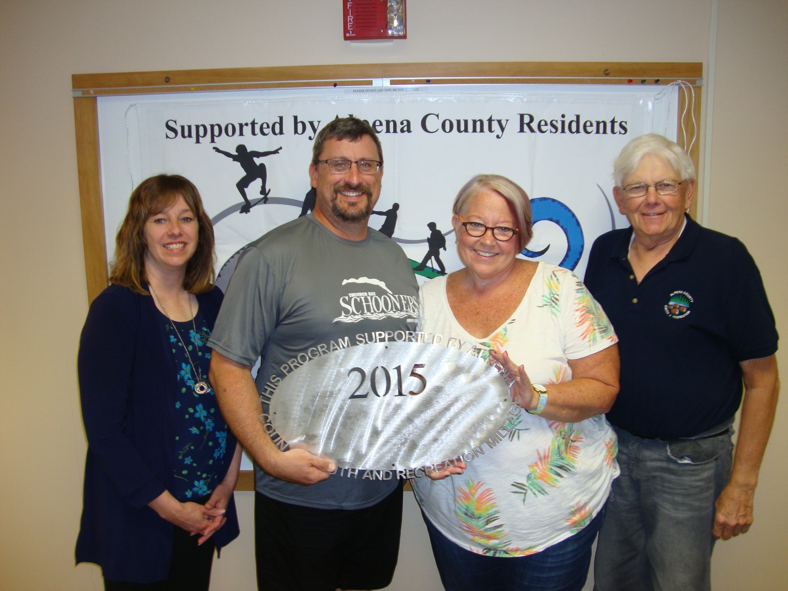Thunder Bay Schooners Swim Club
$7500.00 Pool time Wildkitten Tumbling, Inc. # 2
$2000.00 Gymnastic lesson support 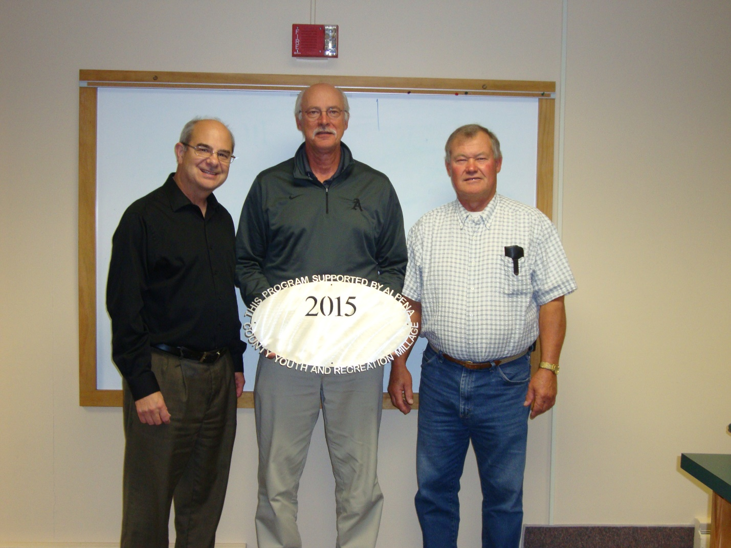Alpena Public Schools – Wildcat Stadium upgrades $10,000.00 Scoreboard

Commissioners & Commissioners Appointees
District 1-COMMISSIONER
Jeff Kowalski
717 S. First Ave.
Alpena, MI 49707
989.356.0427
jeffkowalski@alpenacounty.org
Linda Canfield
117 Hitchcock Street
Alpena, MI 49707
989.356.2742
lindacanfield1@frontier.com
District 3- COMMISSIONER
Camille Nerkowski
3210 S. Third Avenue
Alpena, MI 49707
989.356.2909
camillenerkowski@alpenacounty.org
Darlene Wilmot
150 S. North Street
Alpena, MI 49707
989.356.9770
darlenewilmot@hotmail.com
District 5- COMMISSIONER
Mary Hess
8793 US-23 South
Ossineke, MI 49766
989.471.2103
maryhess@alpenacounty.org
Tom Heise
3376 Piper Road
Alpena, MI 49707
989.354.2447
htssllc@yahoo.com
District 7- COMMISSIONER
Cameron Habermehl
14510 M-32 West
Lachine, MI 49753
989.766.3455
camhabermehl@alpenacounty.org
Fred Wegmeyer
10599 Napper Rd.
Herron, MI 49744
989.379.4034
District 2-COMMISSIONER
Robert Adrian
227 Dawson Street
Alpena, MI 49707
989.464.6334
robertadrian@alpenacounty.org
Brett Miller
1121 River Street
Alpena, MI 49707
989.354.3328
bam3623@gmail.com
District 4- COMMISSIONER
Lyle VanWormer
4665 Kirchoff Road
Alpena, MI 49707
989.255.5896
lylevanwormer@alpenacounty.org
Tony Suszek
114 Kensington Court
Alpena, MI 49707
989.356.4434
suszektj@charter.net
District 6-COMMISSIONER
Ronald McDonald
6594 Orchard Hill Road
Alpena, Ml 49707
989.379.4848
ronaldmcdonald@alpenacounty.org
Thomas Spaulding
5925 Keating
Lachine, MI 49753
989.379.2789
jeanntom71@hotmail.com
District 8- COMMISSIONER
Eric Lawson
P.O. Box 73
Ossineke, MI 49766
989.255.3762
ericlawson@alpenacounty.org
Lisa Siegert
12700 Hawkins Road
Hubbard Lake, MI 49747
989.727.3089
siegertlne@gmail.com

County Contacts
Kim Ludlow
County Treasurer
989.354.9534
ludlowk@alpenacounty.org
Laura Ellery
Board Secretary
Alpena County Commissioners
989.354.9504
commissionersoffice@alpenacounty.org
Tammy Sumerix-Bates
Executive Manager
Alpena County Commissioners
989.354.9502
commissionersoffice@alpenacounty.org
Share this article
- facebook
- twitter
- linkedin
- email
- pinterest

