***2014 Logo Pic #1

2014 Youth and Recreation Millage Funds Awarded
Youth and Recreation
- facebook
- twitter
- linkedin
- email
- pinterest
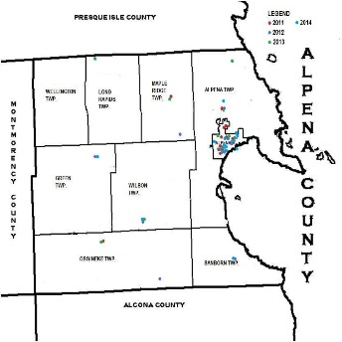2014 Map
The Committee is trying to spread the funds throughout the County, encouraging all the Townships and non-profit organizations, schools, and governmental agencies to apply. The Alpena County Map shown on the left, depicts where the grants were awarded by the red dots for 2011 and the blue dots for 2012 green dots for 2013, and turquoise blue dots for 2014. Please click on the image for a larger view or by clicking here. (clicking here #2 Pic)
Budget Recommendations for 2014 where made on October 3, 2013. These recommendations are not approved until after the Full Board of Commissioners approval as part of the Budget for 2014 held on December 27, 2013.
Total amount appropriated $467,613.00

Resources
2014 Millage Award Book
Ballot Language
Funding Report
Meeting Dates

Maps
Alpena Township
City of Alpena
Green Township
Long Rapids Township
Maple Ridge Township
Ossineke Township
Sanborn Township
Wellington Township
Wilson Township

Listed below, you can view the organization, amount awarded and the name of project. Additionally, you can view or download the 2014 Youth and Recreation Awards Book by clicking here. (clicking here #3 Pic)

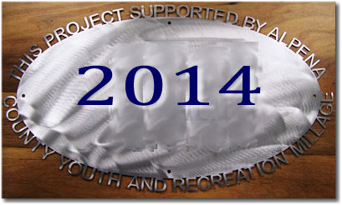
City of Alpena- Carryover Trailhead
$40,000 Local Match for $245,000 MDNR Grant Carried over to 2015 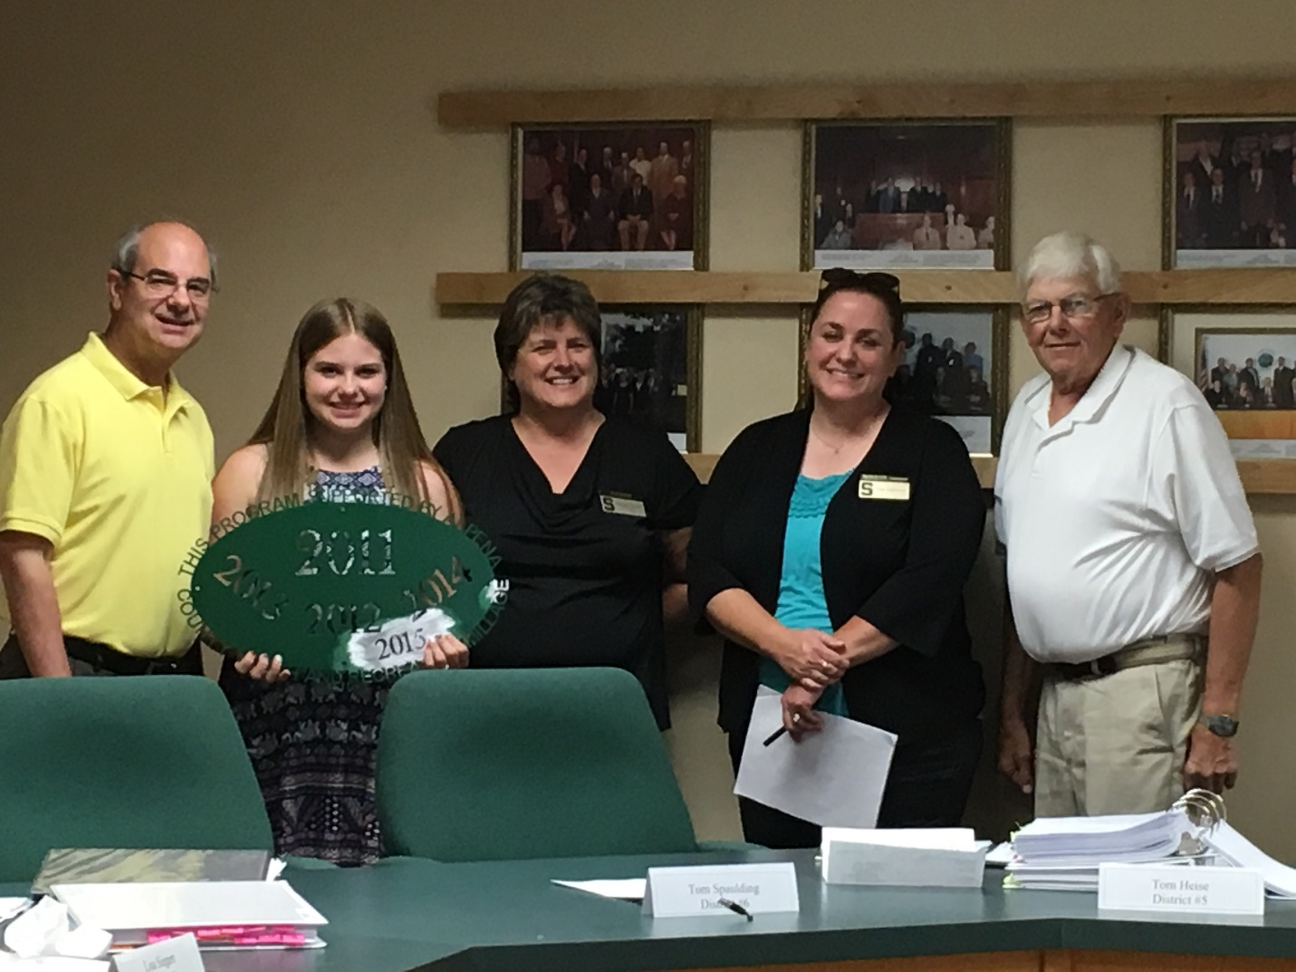County of Alpena MSU Extension – 4H
$30,500 4-H Youth Development Program
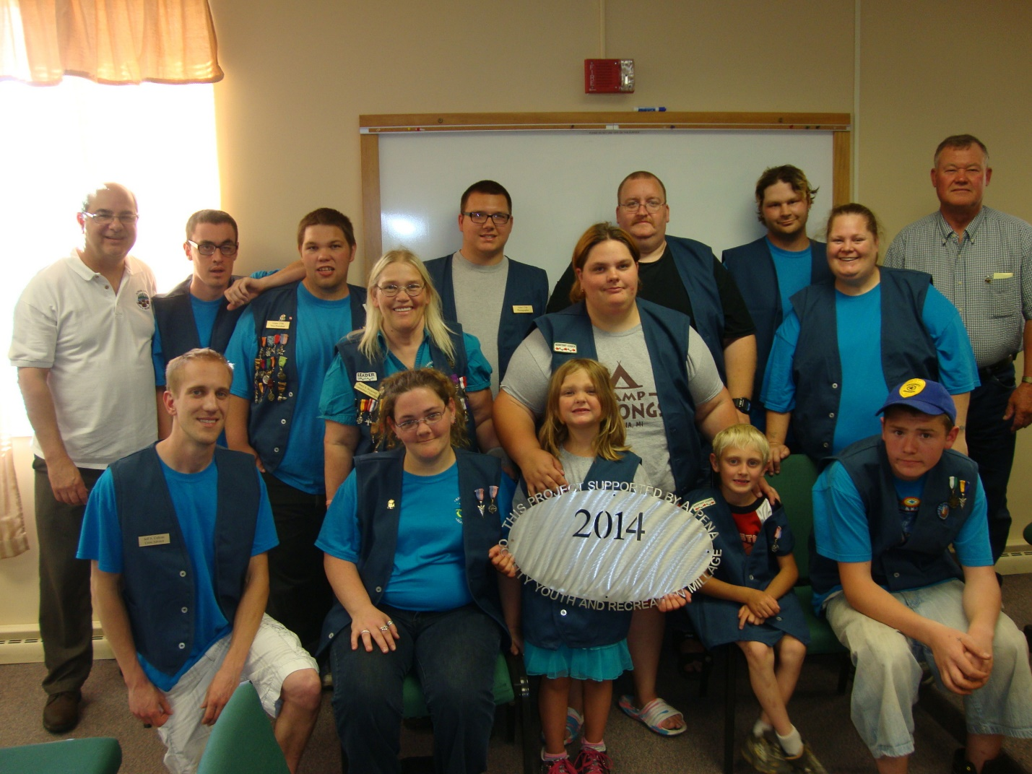Navigators Crew
$4,000 Scouting supplies 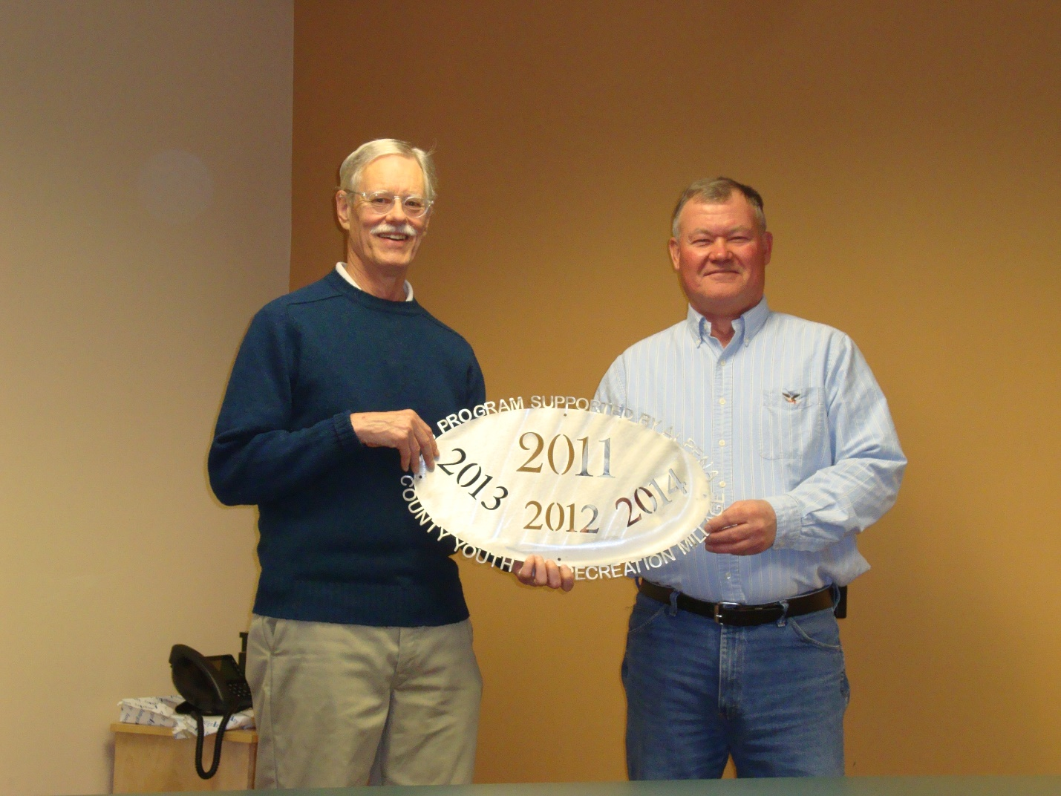Friends of Plaza Pool
$2,755 Community Programs Support 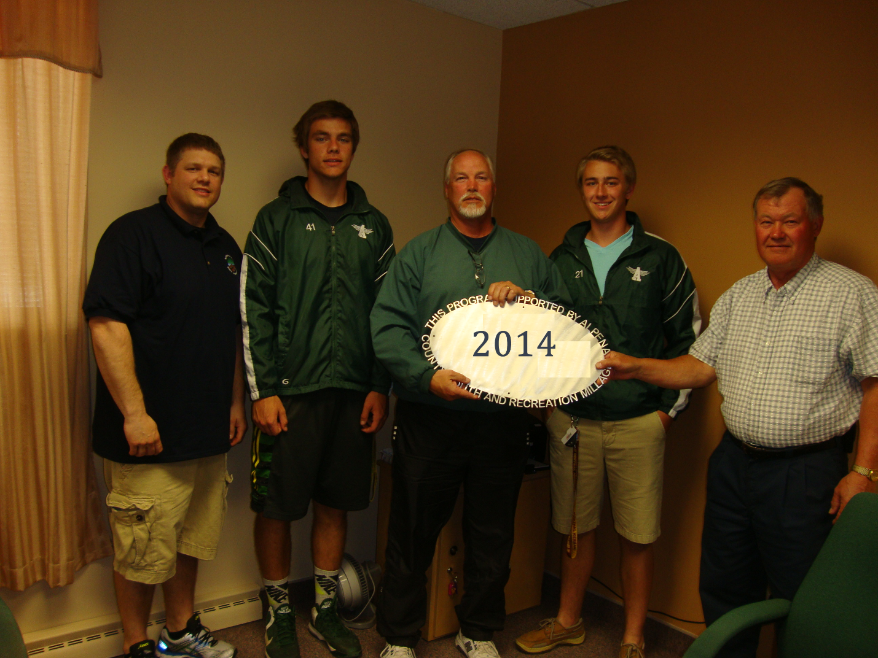Alpena Public Schools – AHS Boys Track & Field $8,000 New Uniforms 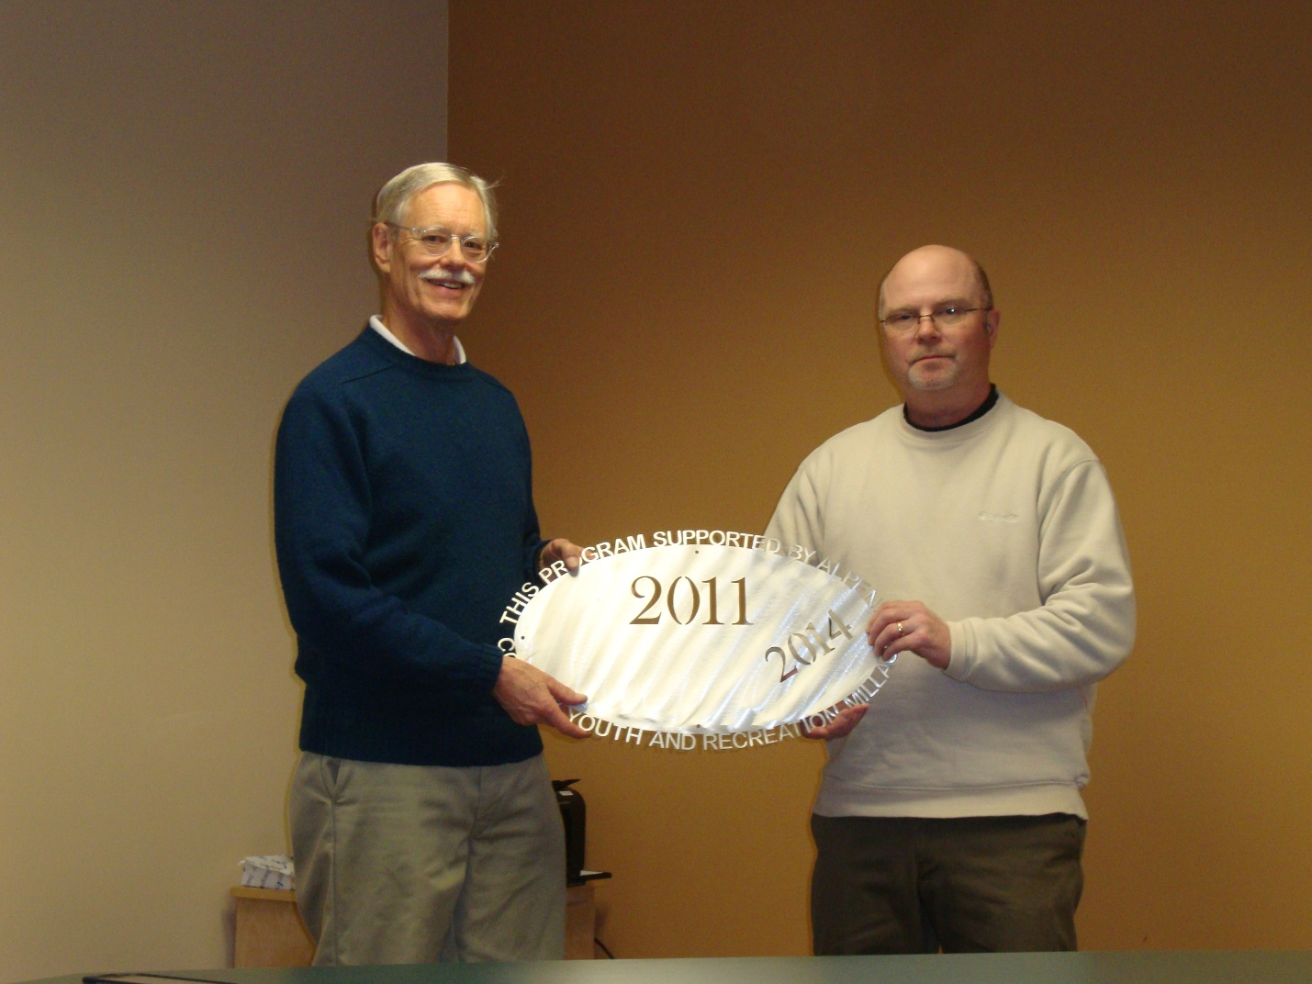ACC – Association of Lifelong Learners
$6,000 Shipwreck Ally class support/ROV support

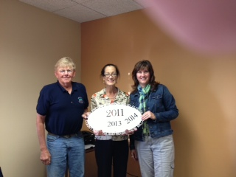
ACC – Volunteer Center
$3,500 Ropes Course 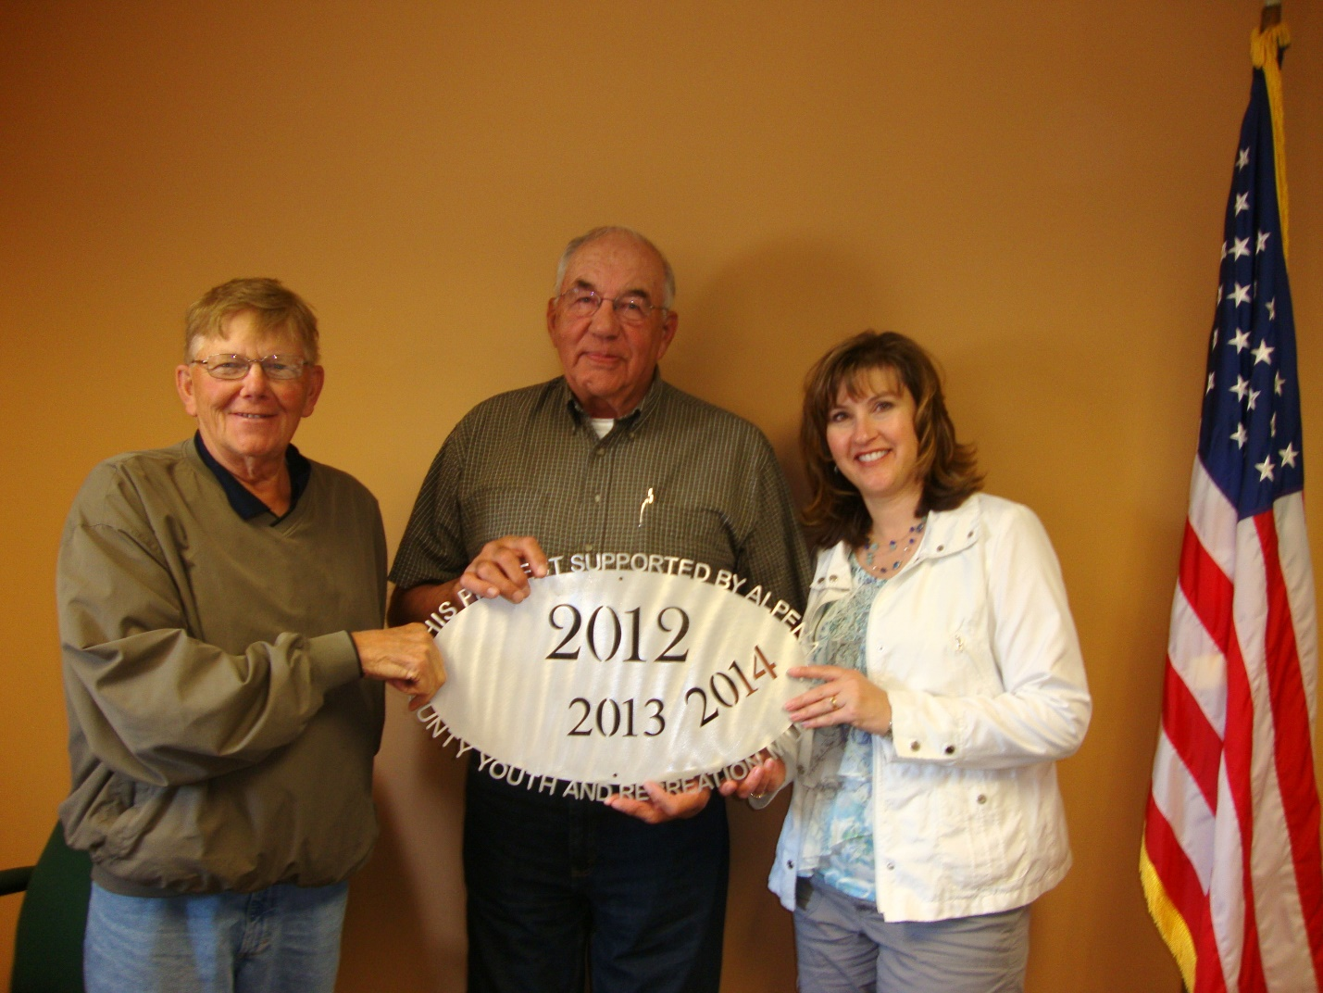Wilson Township
$25,000 Wolf Creek Park Pedestrian Bridge 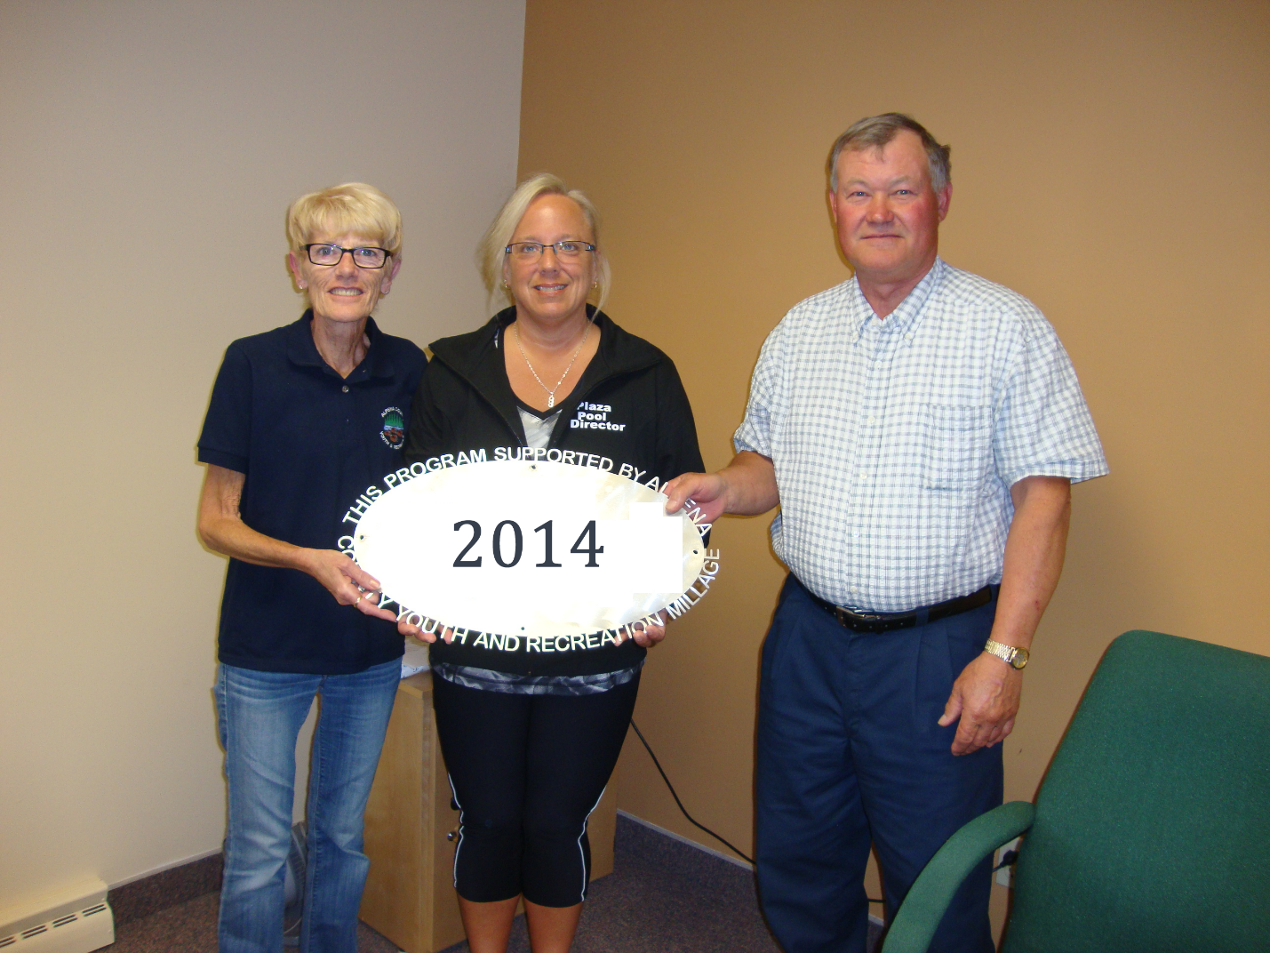County of Alpena – Plaza Pool # 2
$2,500 Pool Supplies 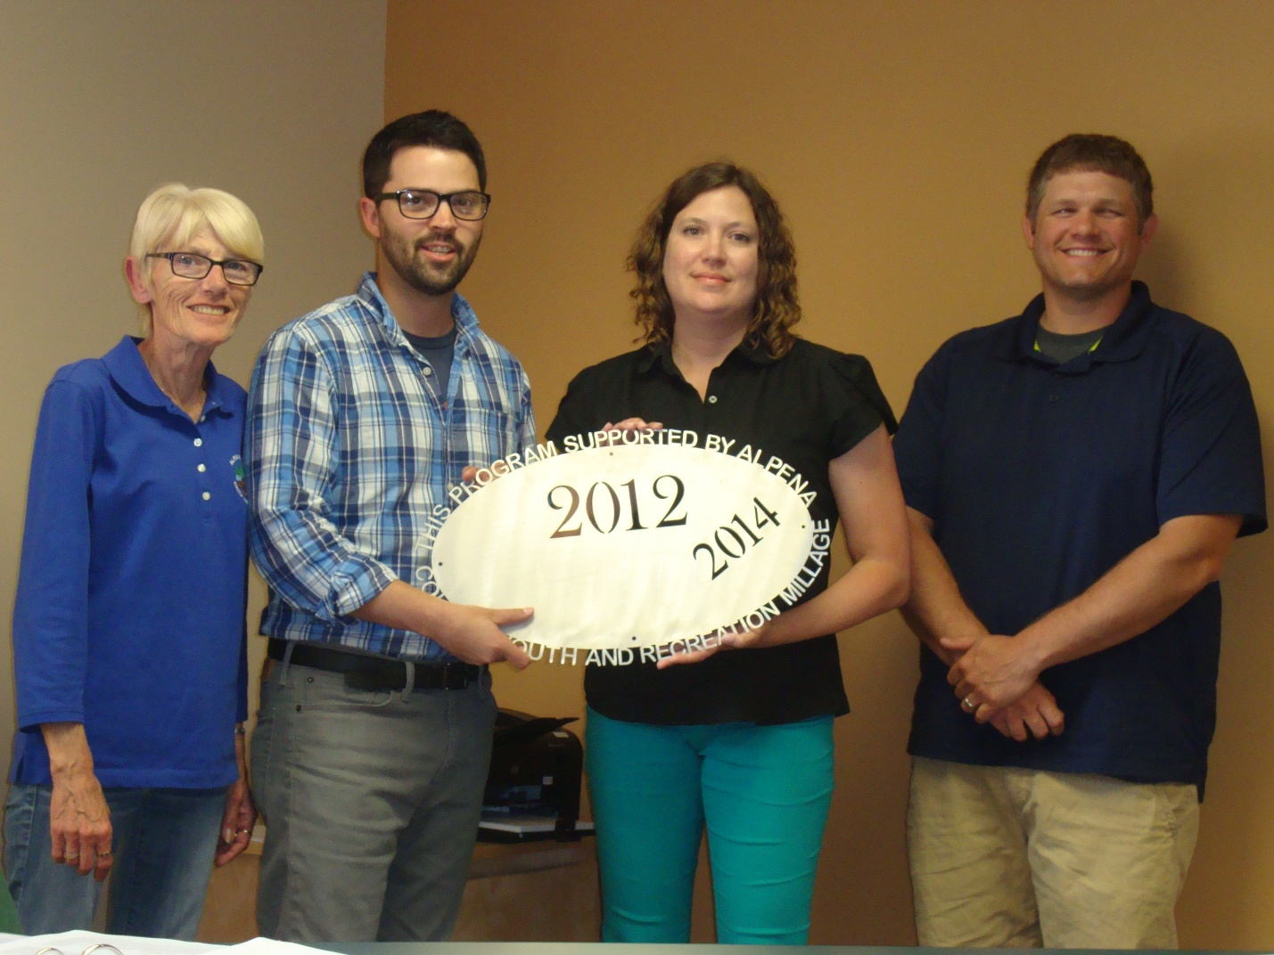Northeast MI Center for Fine Arts
$20,000 Ready, Set, Create 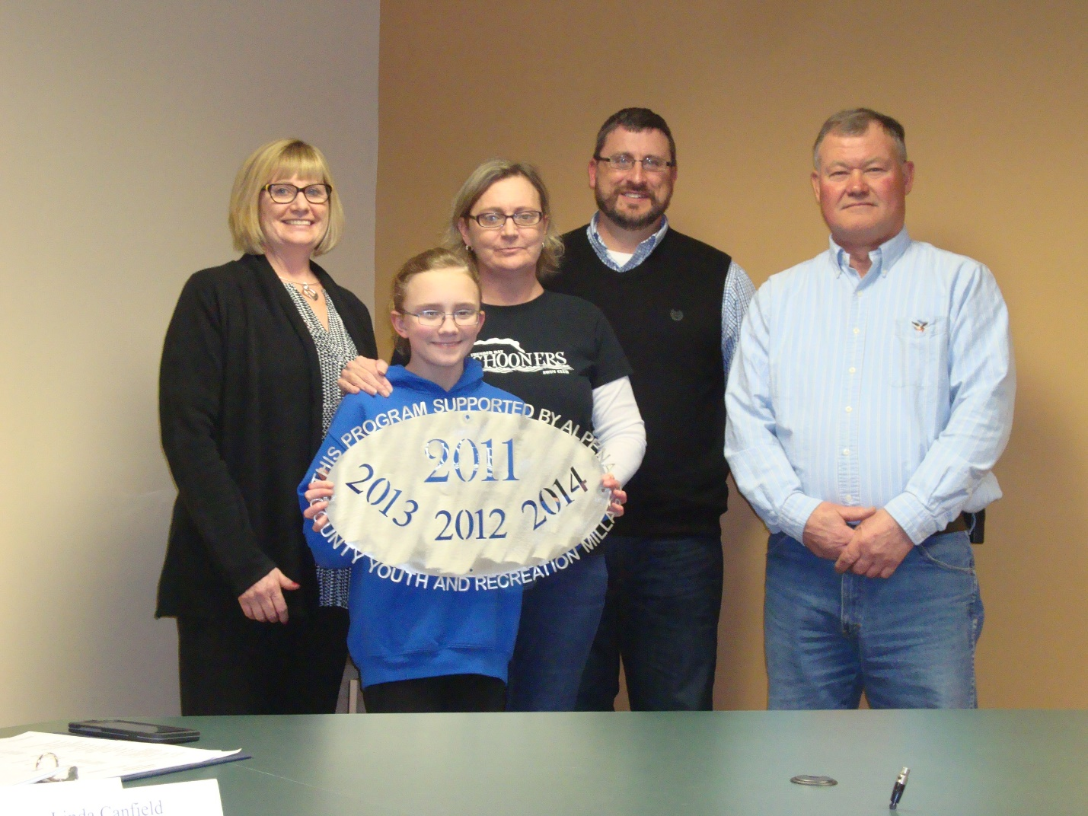Alpena Swim Club – Thunder Bay Schooners $6,000 Operating Support to reduce the cost to players 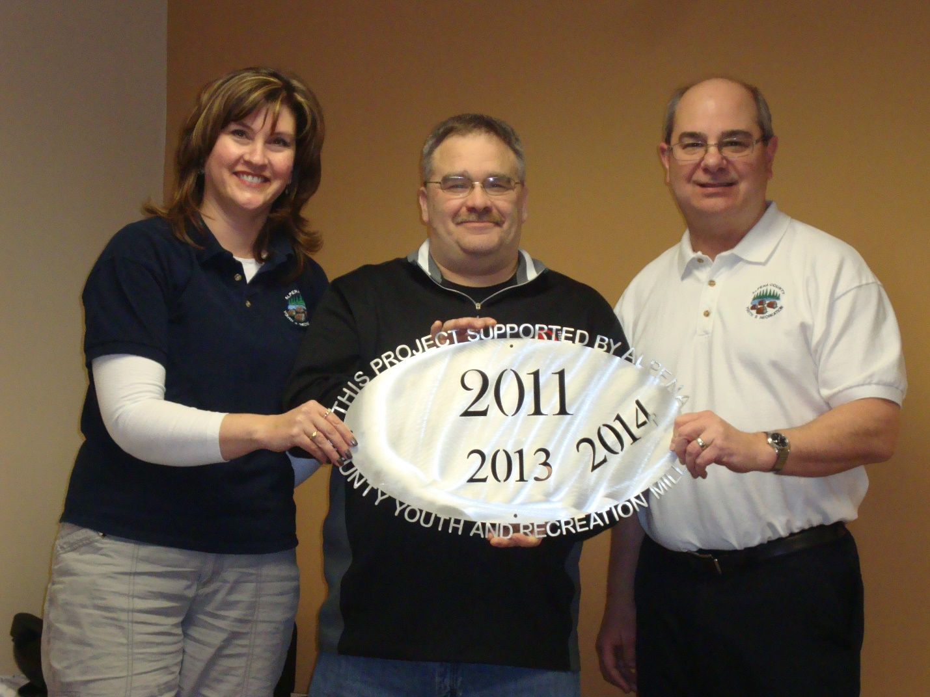Alpena Tennis Association
# 2– AHS Tennis Teams
$7,500 Ready, Set, Serve 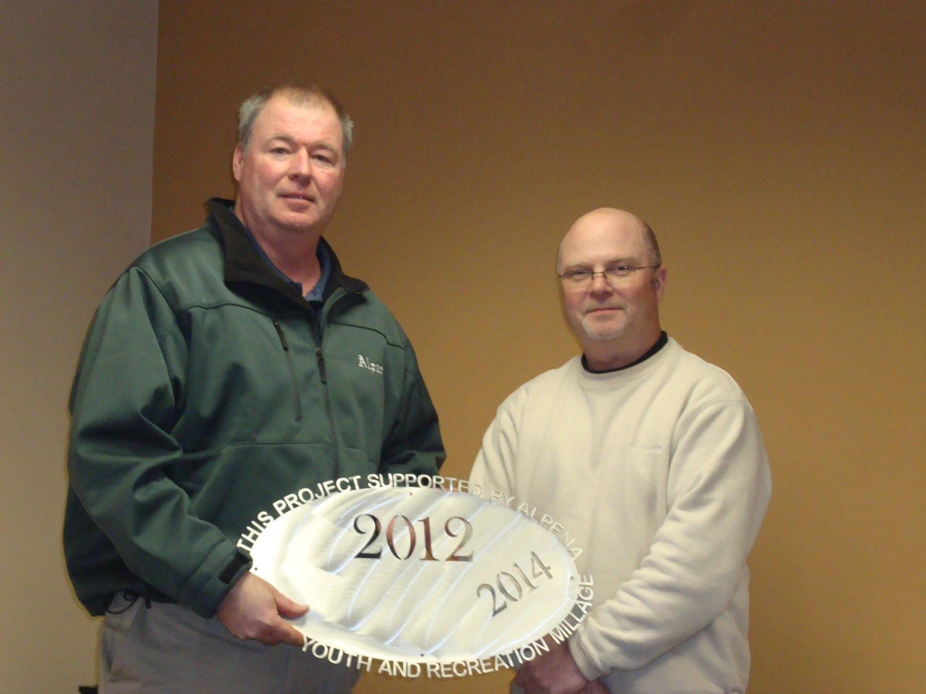Alpena Public Schools – Carryover – Softball Line Drive Club $4,319 Backstop 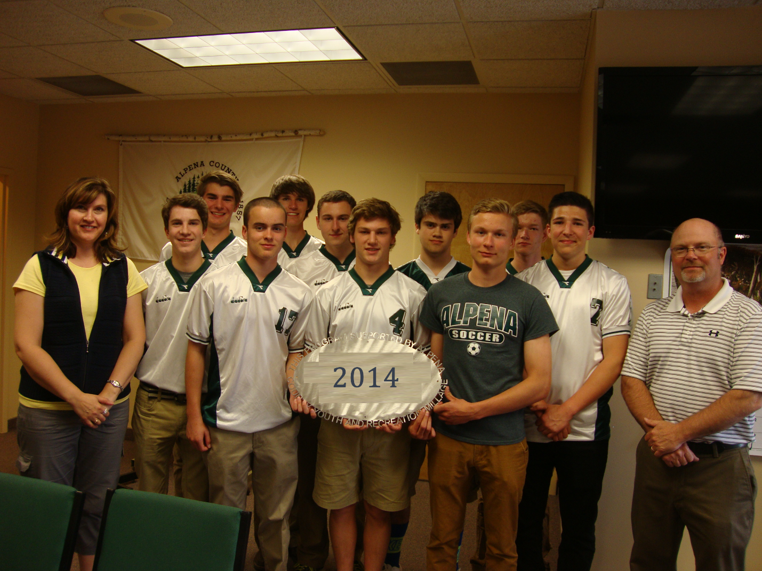Alpena Public Schools-
AHS Boys and Girls Soccer
$6,800 Operating Support, transportation support, nets 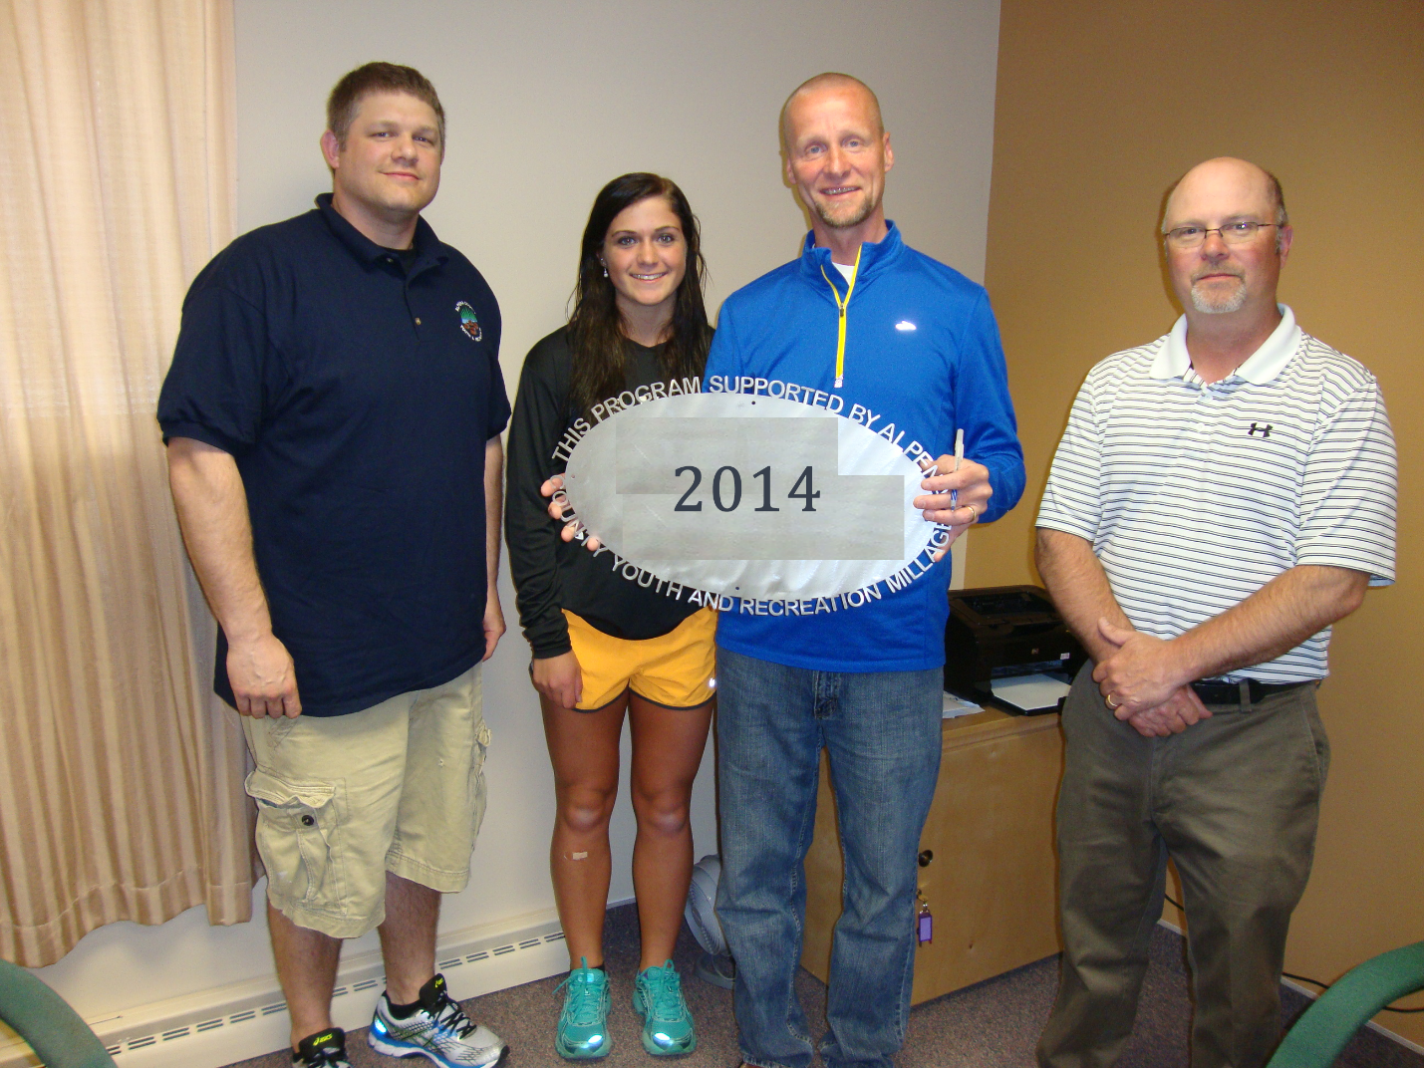ACC – Lumberjack Cross Country – Boosters
$2,700 Operating Support -supplies

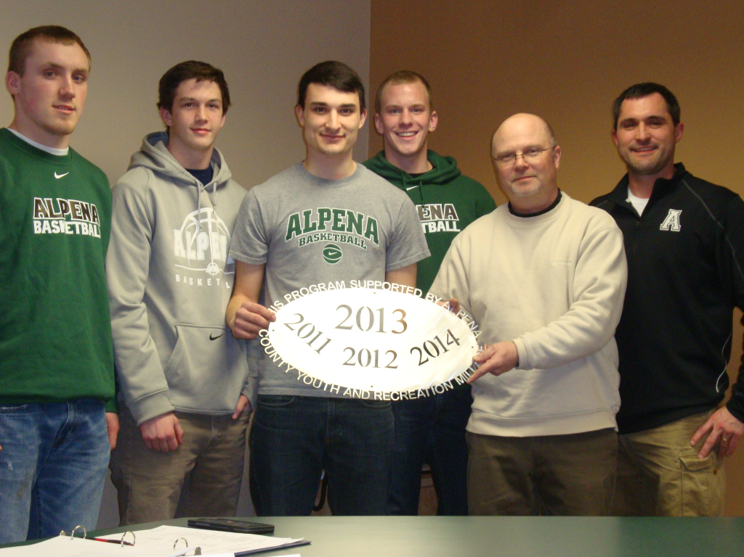
Alpena Public Schools – Boys Basketball
$6,000 Operating support for Boys and Girls Teams 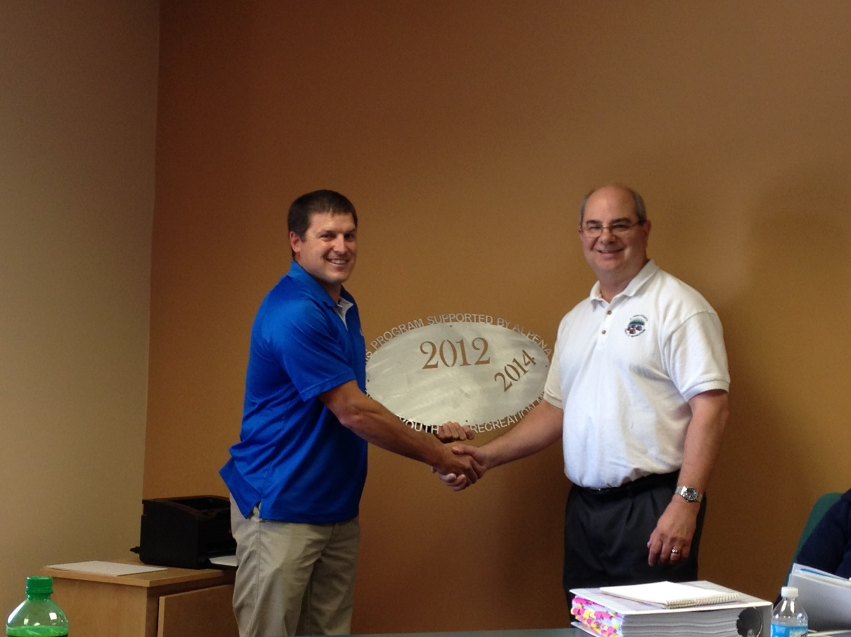Alpena Huron Shore Babe Ruth
$19,000 Field Improvement – Veteran’s Field – Ossineke 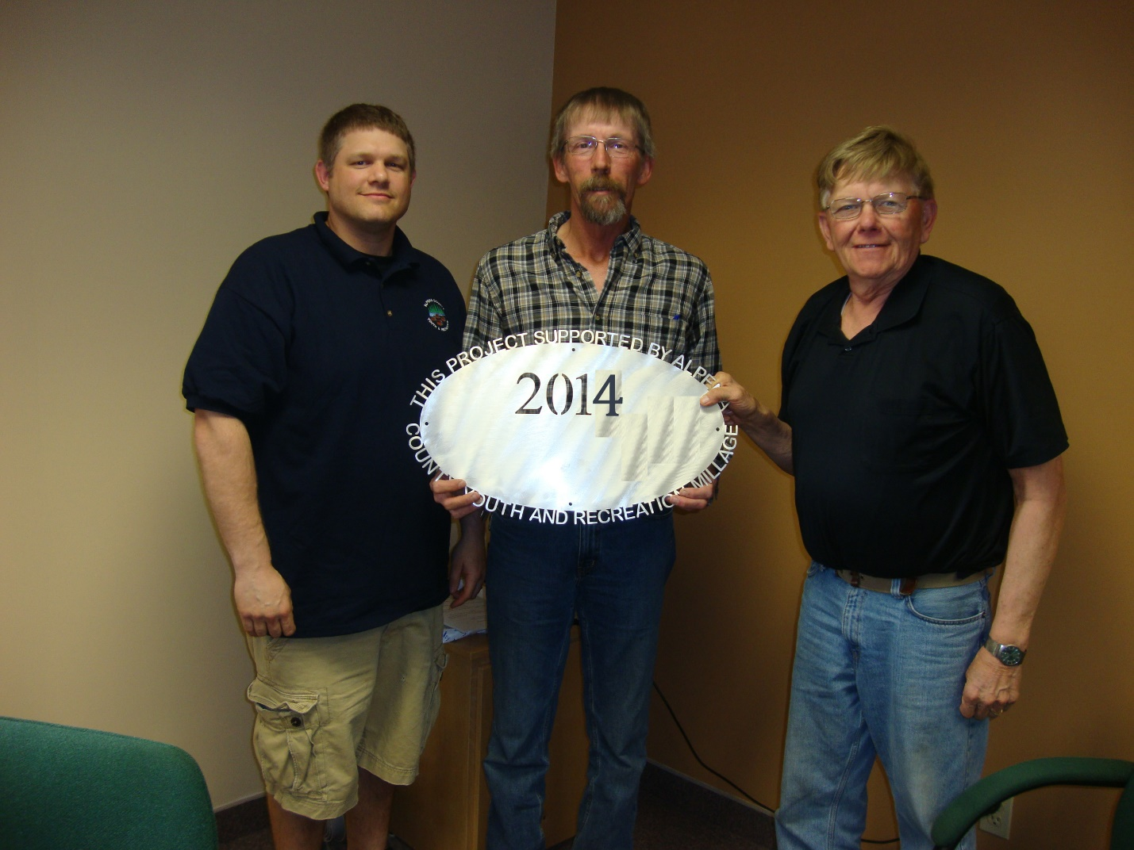County of Alpena Tennis Courts
$17,839 Tennis Court Reconstruction
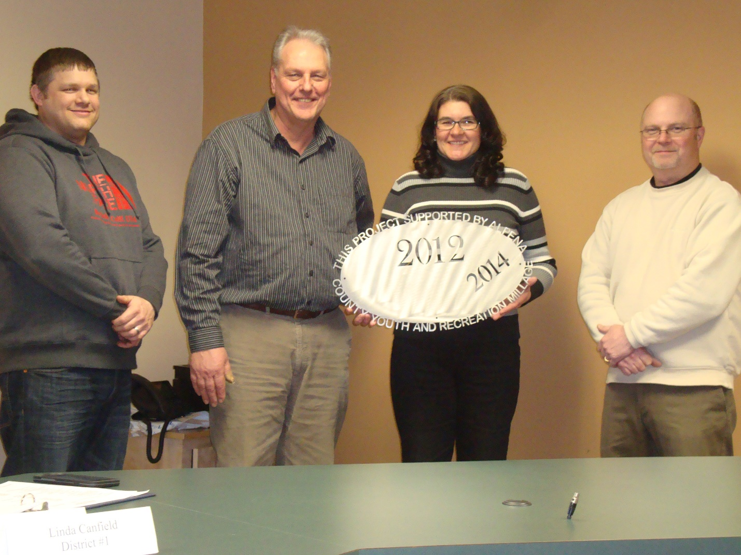Green Township
$10,200 Pavillion at Township 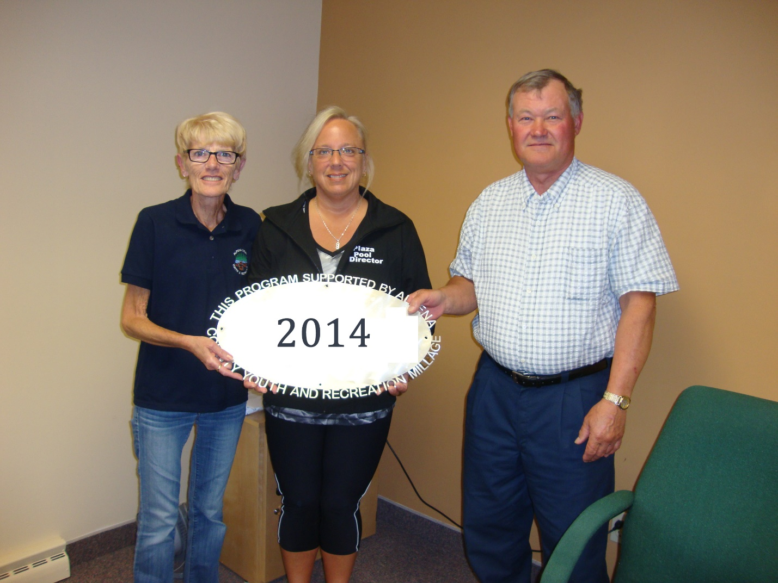Alpena County- Plaza Pool – Operating
$85,000 Aquatic Programming 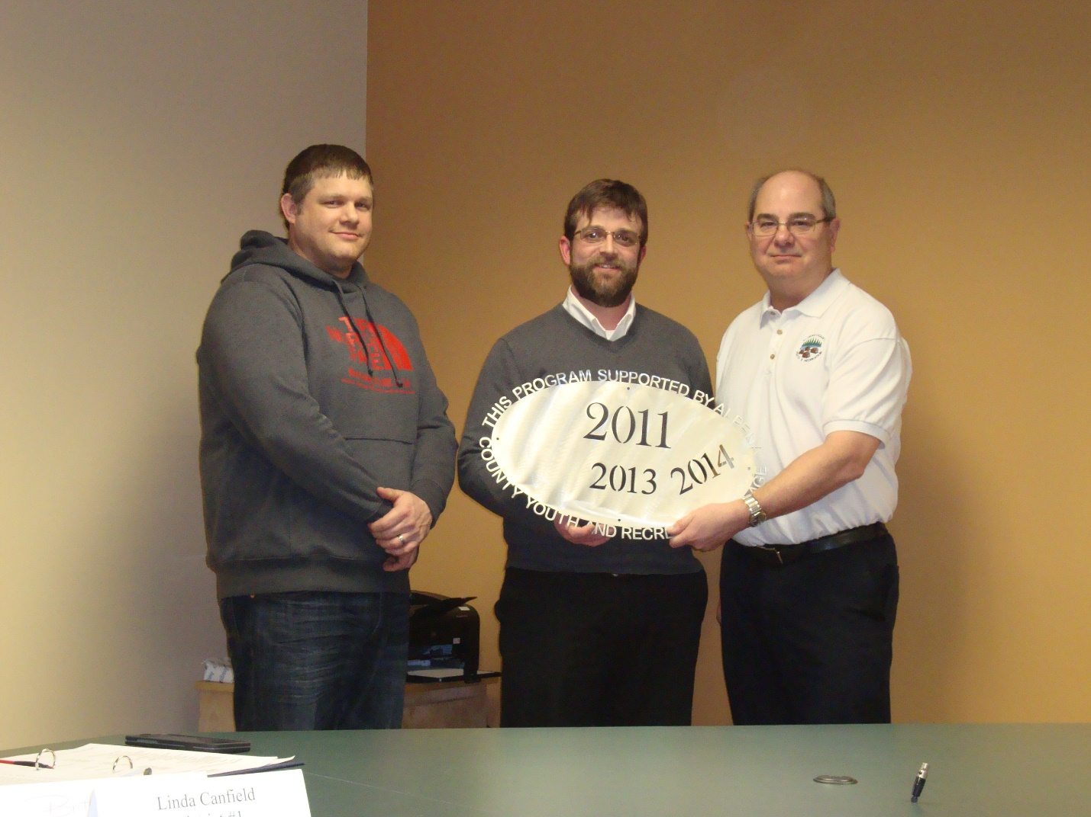Boys and Girls Club
$3,300 Ceiling tile replacement and painting 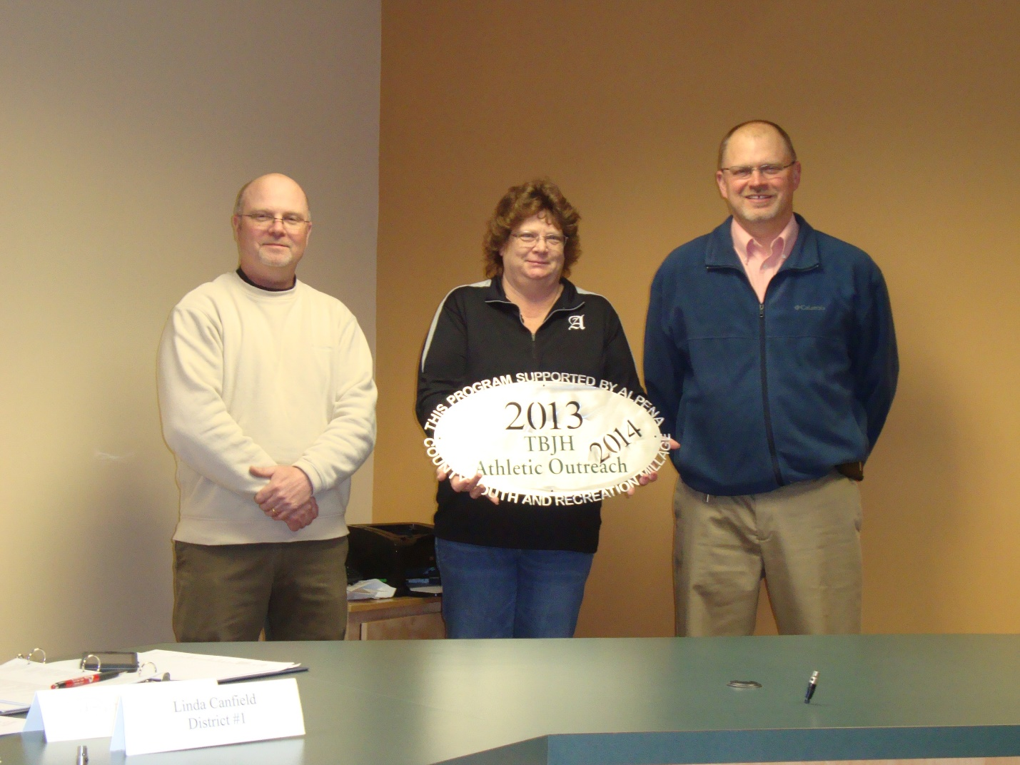Alpena Public Schools- TBJHS
$19,000 6th grade programming, gate admissions 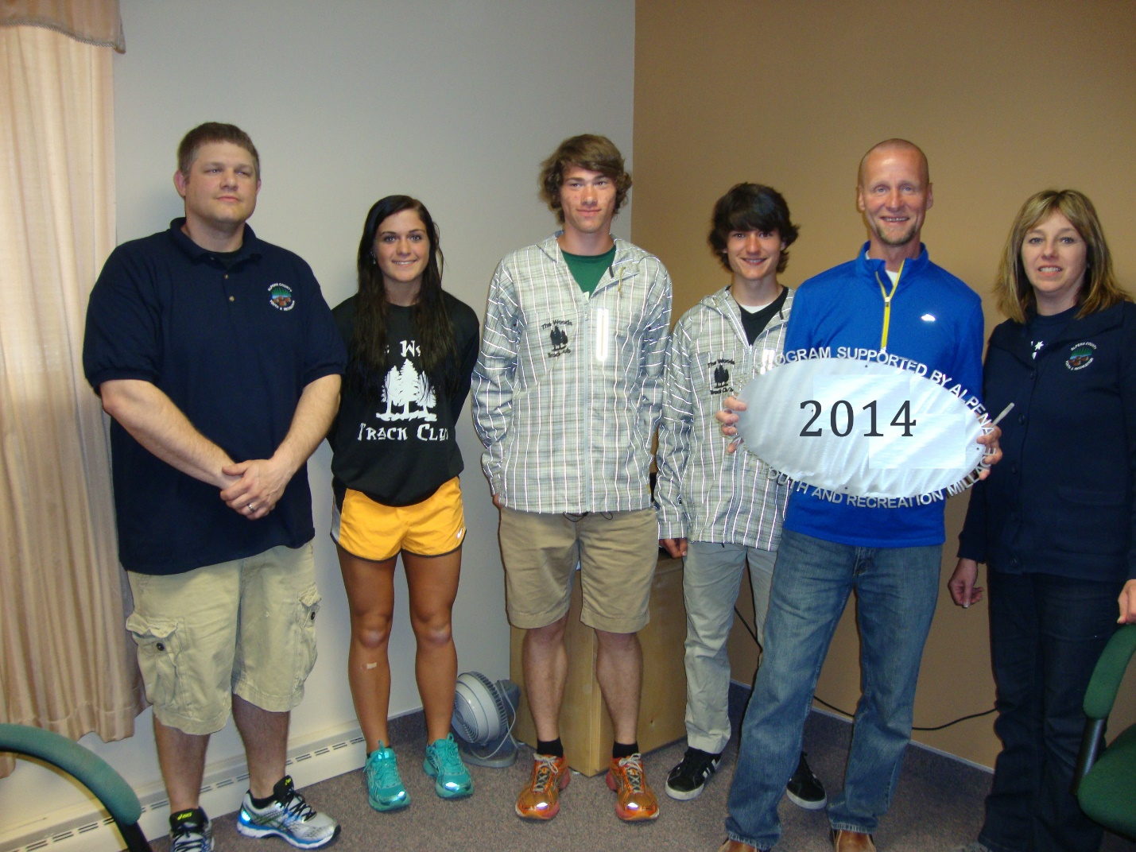Alpena Public Schools/ACC – Cross Country
$4,600 Trail Project at Besser Company 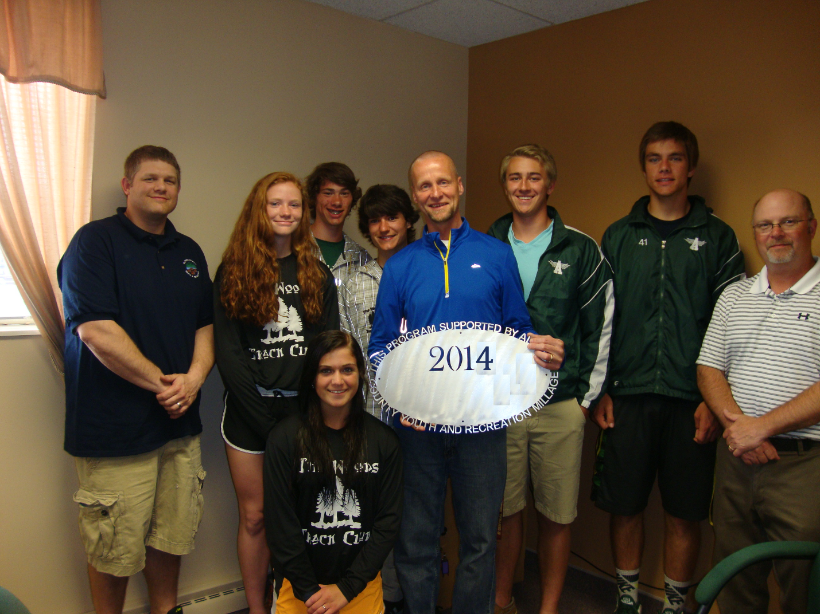Alpena Public Schools – The Woods Track Club $4,100 Operating Support for indoor track team 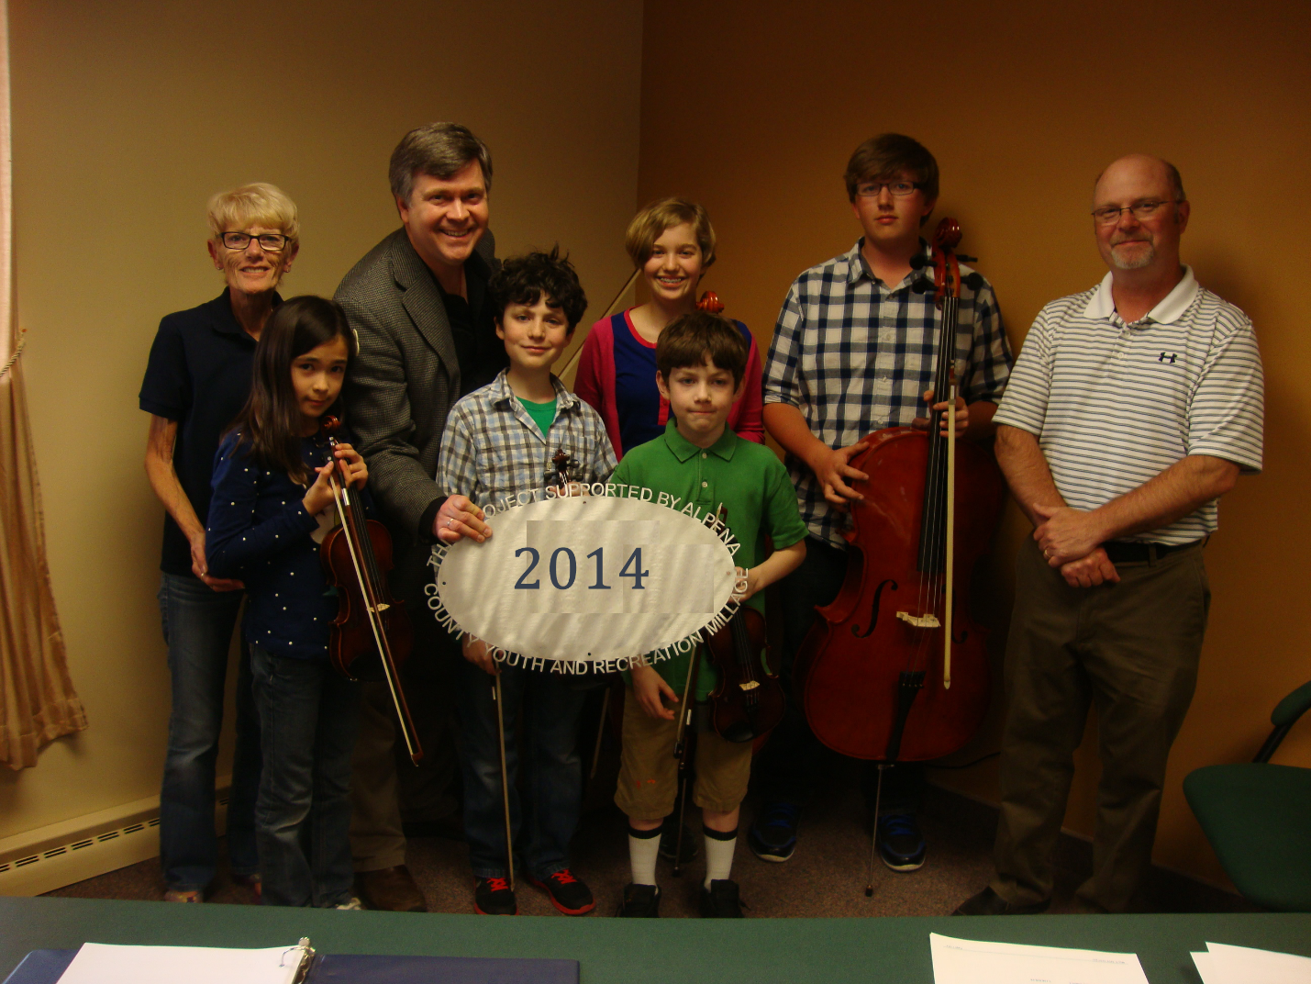Alpena Symphony Orchestra
$8,000 Operating Support & Equip

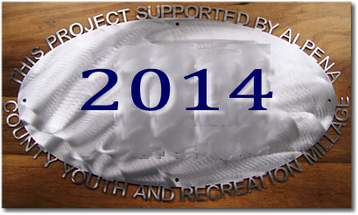
Alpena Boosters Club
$10,000 Wings Over Alpena

County of Alpena Plaza Pool # 3
$7,500 Ready, Set, Swim 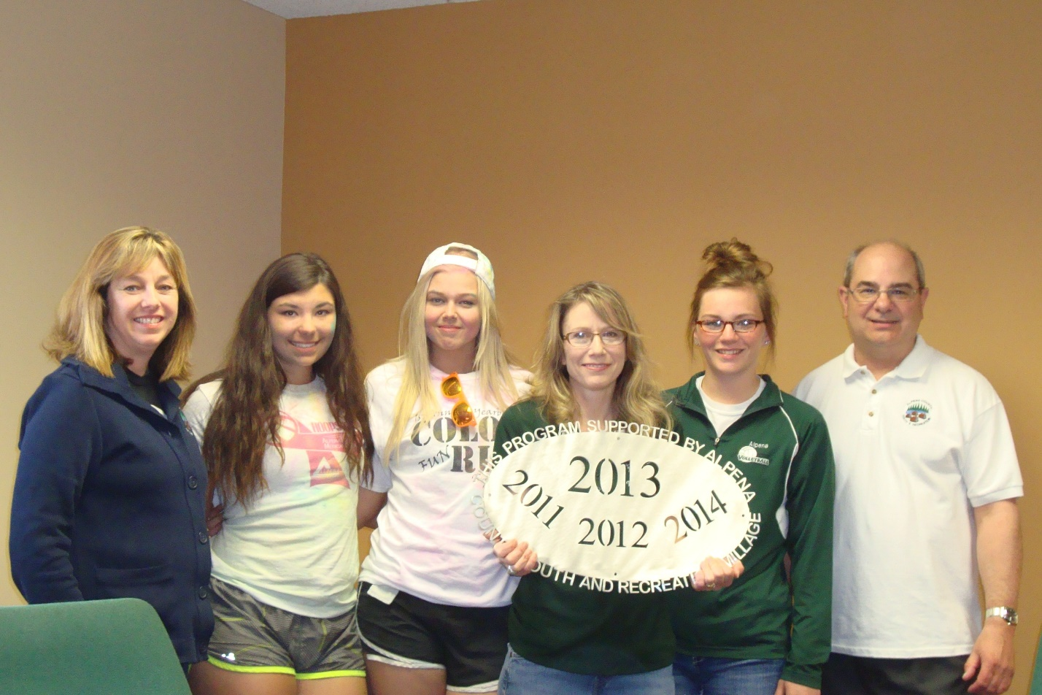Alpena Public Schools – Volleyball Club
$7,500 Operating Support to reduce the cost to players Alpena Tennis Association
# 1 — AHS Tennis Teams
$9,000 Operating Support 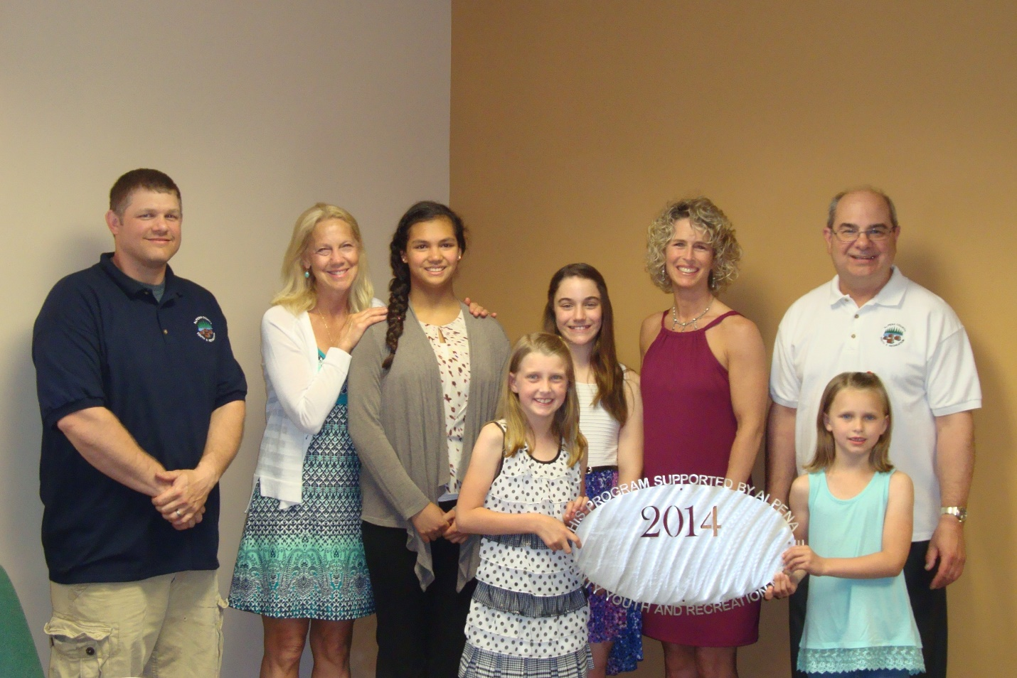Wildkitten Tumbling, Inc.
$18,000 Spring Floor Alpena Public Schools – Softball Line Drive Club $20,000 Backstop/Bleachers and Grand Stands at AHS Varsity field 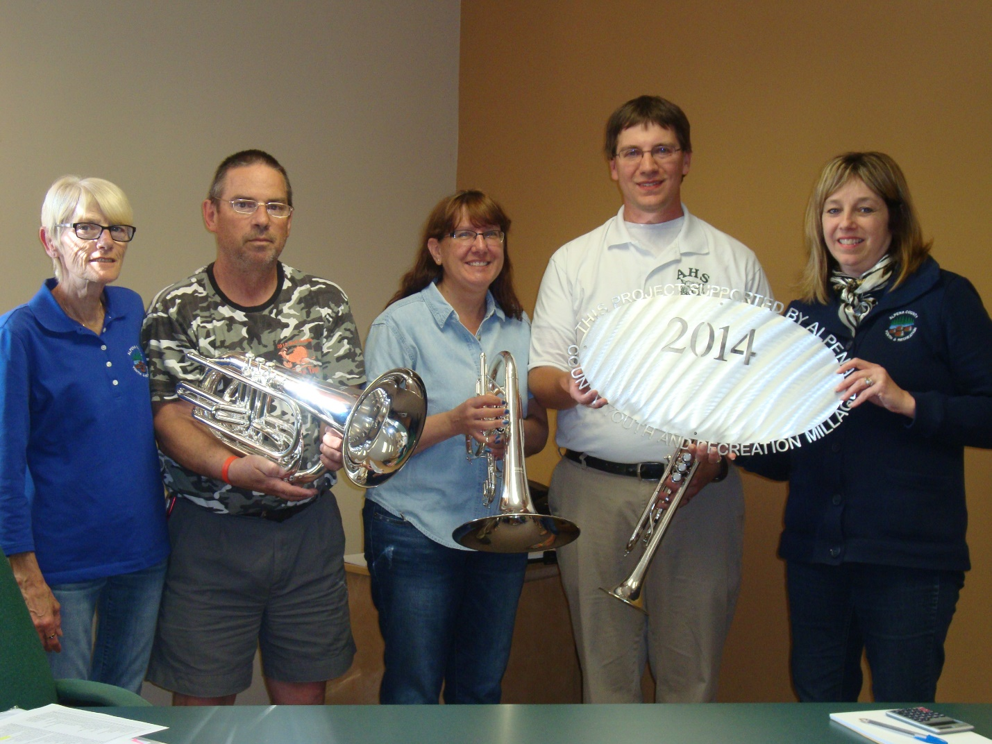Alpena High School Band Boosters
$20,000 Symphony Band uniforms, instruments 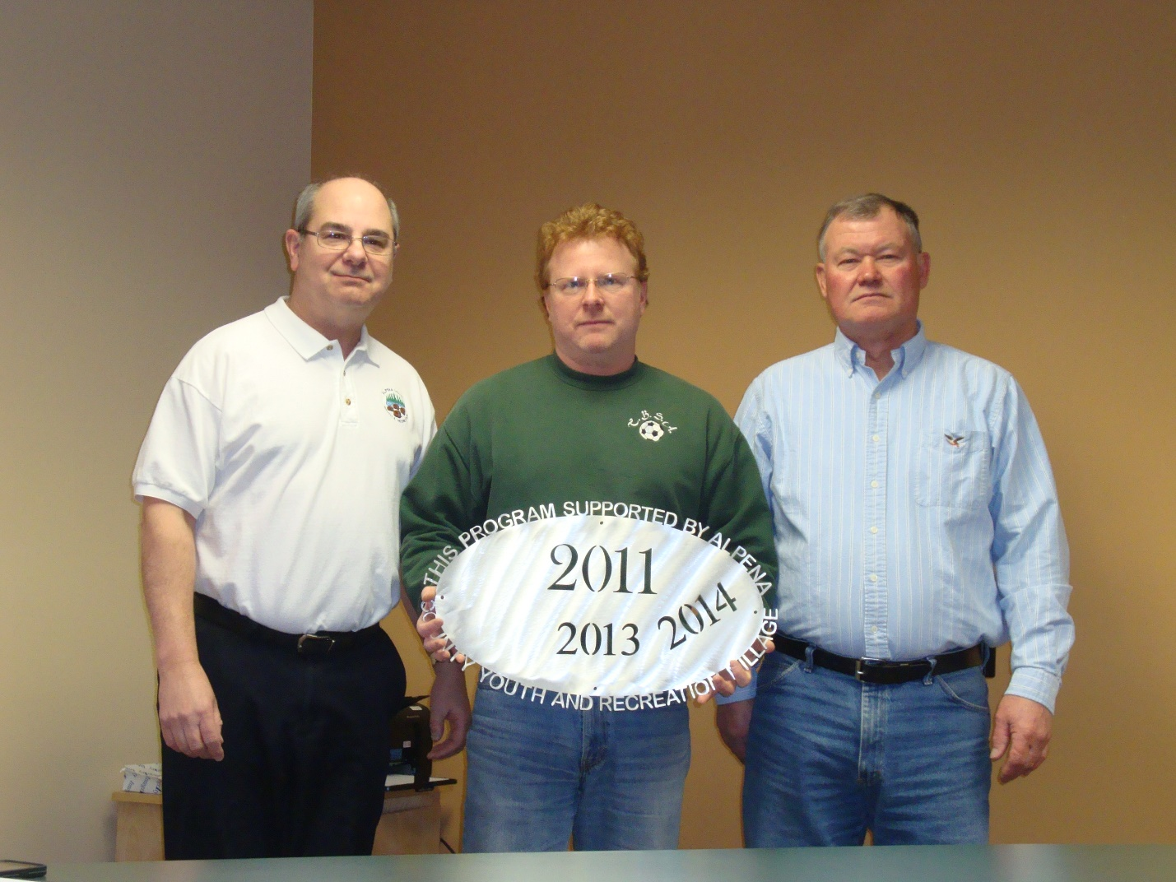Thunder Bay Soccer Association
$20,000 Field Improvement at Woodward – New well 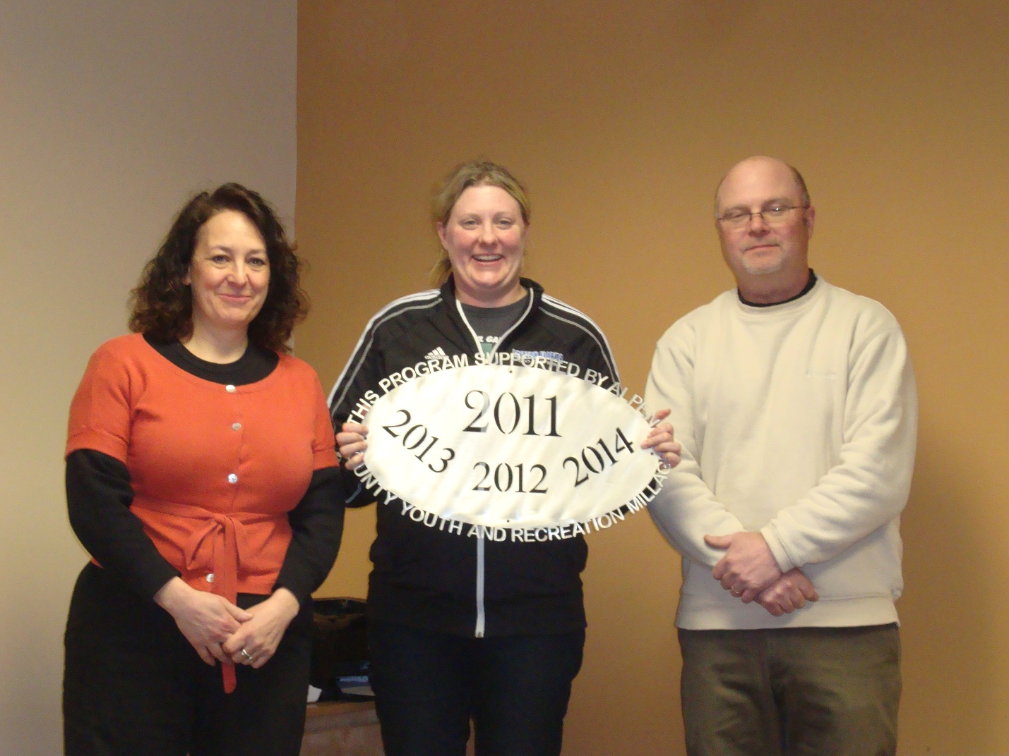Alpena Hockey Association
$6,000 Tournament Support – House Teams Alpena Huron Shore Babe Ruth
$3,000 Operating Support – to reduce player fees

Commissioners & Commissioners Appointees
District 1-COMMISSIONER
Jeff Kowalski
717 S. First Ave.
Alpena, MI 49707
989.356.0427
jeffkowalski@alpenacounty.org
Linda Canfield
117 Hitchcock Street
Alpena, MI 49707
989.356.2742
lindacanfield1@frontier.com
District 3- COMMISSIONER
Tom Mullaney
285 Island View Drive
Alpena, MI 49707
989.356.9781
tommullaney@alpenacounty.org
Darlene Wilmot
150 S. North Street
Alpena, MI 49707
989.356.9770
darlenewilmot@hotmail.com
District 5- COMMISSIONER
Scot McKenzie
2762 Werth Road
Alpena, MI 49707
989.354.3552
scotmckenzie@alpenacounty.org
Tom Heise
3376 Piper Road
Alpena, MI 49707
989.354.2447
htssllc@yahoo.com
District 7- COMMISSIONER
Cameron Habermehl
14510 M-32 West
Lachine, MI 49753
989.766.3455
camhabermehl@alpenacounty.org
Fred Wegmeyer
10599 Napper Rd.
Herron, MI 49744
989.379.4034
District 2-COMMISSIONER
Robert Adrian
227 Dawson Street
Alpena, MI 49707
989.464.6334
robertadrian@alpenacounty.org
Calvin L. Howard
329 W. Miller St.
Alpena, MI 49707
989.916.6221
cherokee5eagle@frontier.com
District 4- COMMISSIONER
Lyle VanWormer
4665 Kirchoff Road
Alpena, MI 49707
989.255.5896
lylevanwormer@alpenacounty.org
Tony Suszek
114 Kensington Court
Alpena, MI 49707
989.356.4434
suszektj@charter.net
District 6-COMMISSIONER
Mark Hall
5005 Long Rapids Road
Alpena, MI 49707
989.354.6023
Kamila Robillard
7361 Haken Road
Alpena, MI 49707
989.657.0600
Kam9431@gmail.com
District 8- COMMISSIONER
Eric Lawson
P.O. Box 73
Ossineke, MI 49766
Phone: 989.255.3762
ericlawson@alpenacounty.org
Lisa Siegert
12700 Hawkins Road
Hubbard Lake, MI 49747
989.727.3089
siegertlne@gmail.com

County Contacts
Kim Ludlow
County Treasurer
989.354.9534
ludlowk@alpenacounty.org
Laura Ellery
Board Secretary
Alpena County Commissioners
989.354.9504
commissionersoffice@alpenacounty.org
Tammy Sumerix-Bates
Executive Manager
Alpena County Commissioners
989.354.9502
commissionersoffice@alpenacounty.org
Share this article
- facebook
- twitter
- linkedin
- email
- pinterest

