2013 Youth and Recreation Millage Funds Awarded

(2013 Y&R sign)

Youth & Recreation
- facebook
- twitter
- linkedin
- email
- pinterest
(2013 Map)

The Committee is trying to spread the funds throughout the County, encouraging all the Townships and non-profit organizations, schools, and governmental agencies to apply. The Alpena County Map shown on the left, depicts where the grants were awarded by the red dots for 2011 and the blue dots for 2012 and green dots for 2013. Please click on the image for a larger view.
Total amount appropriated $629,960.00

Listed below, you can view the organization, amount awarded and the name of project. You can also view or download the 2013 Youth and Recreation Awards Book by clicking here

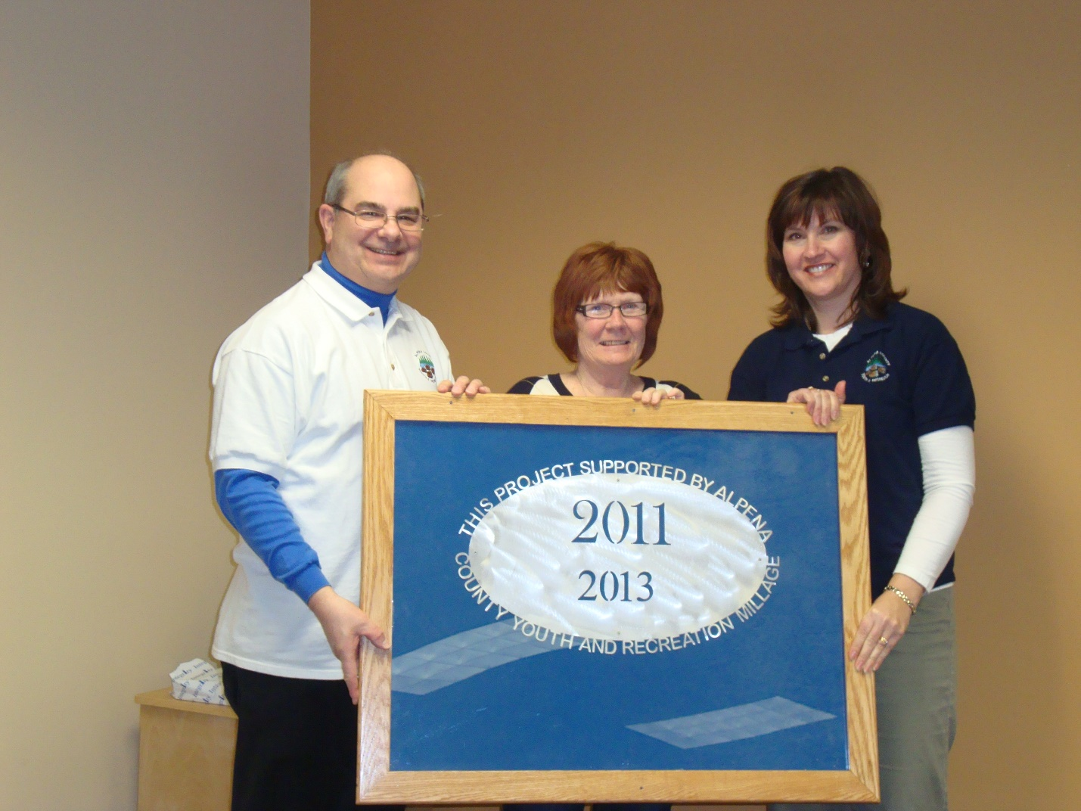
Alpena County Parks Docks $15,000
New docking systems at Long Lake, Sunken Lake, and Beaver Lake Parks

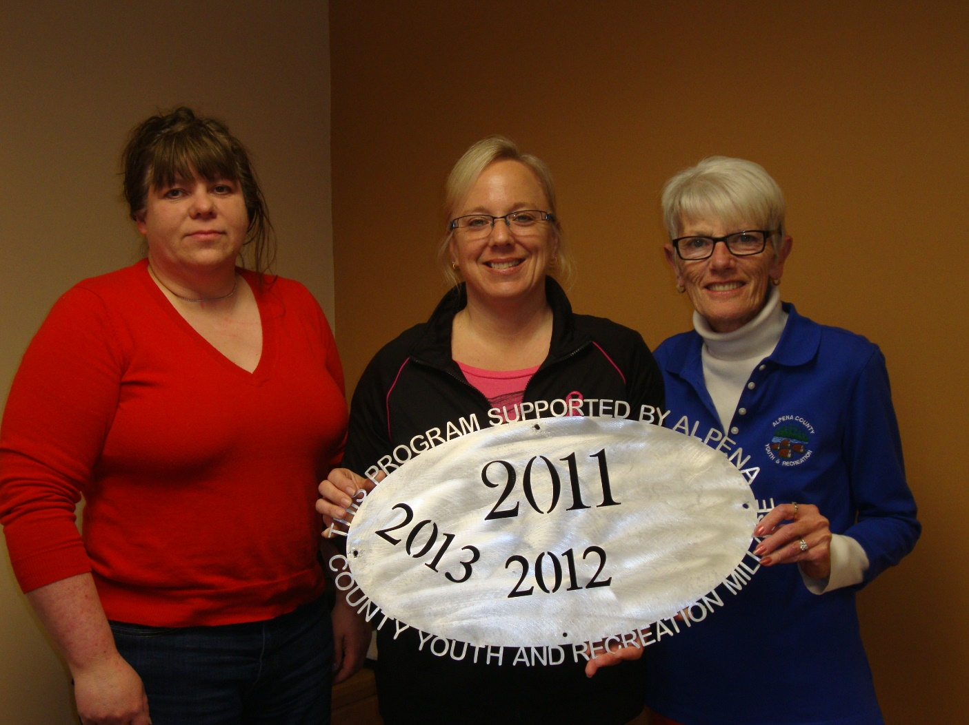
Alpena County Plaza Pool Operating $85,000
Aquatic Programming

Alpena County Plaza Pool: Make a Splash
$5,000 Water Safety – 2nd grade students

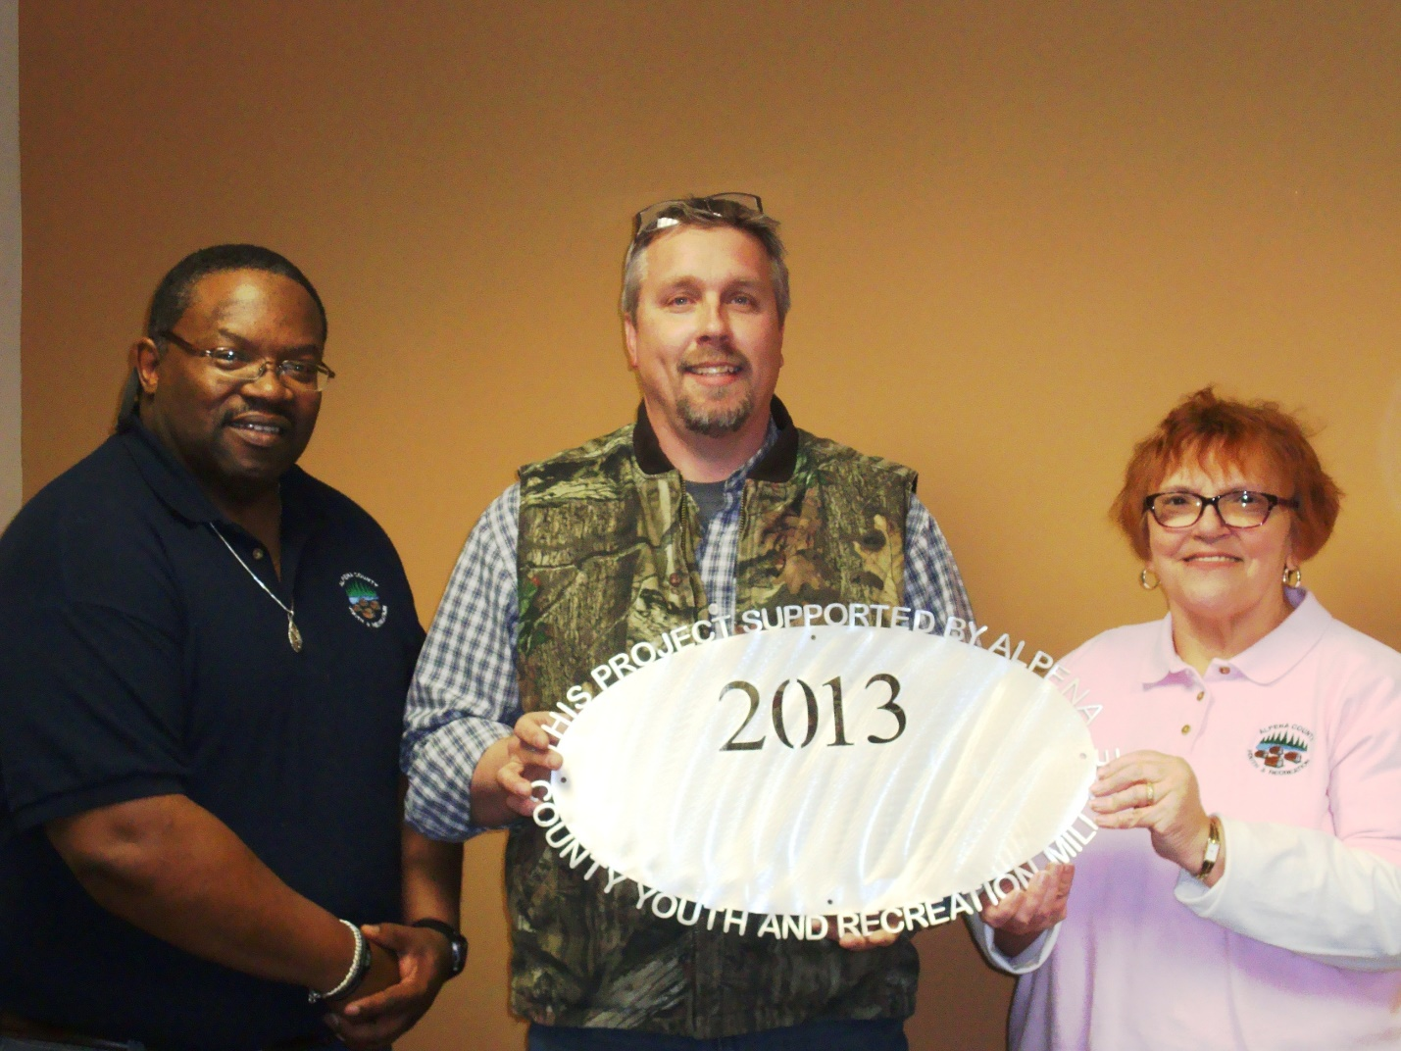
Alpena Huron Shore Little League $26,465
Field Improvements/Capital Projects

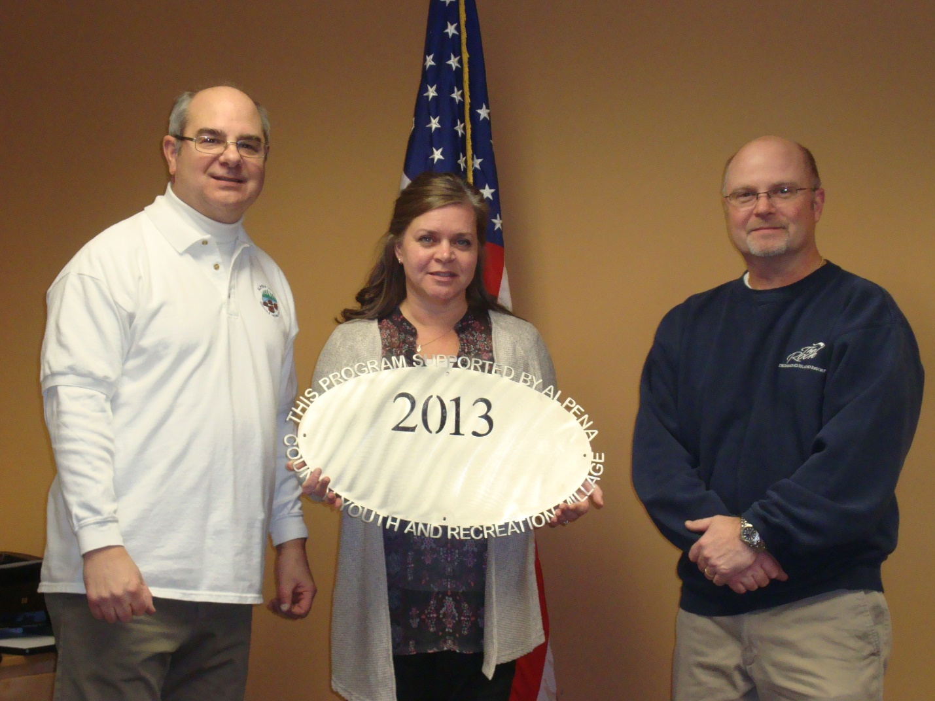
APS: Cheering leading Club $4,000
Cheer & Tumble Mats

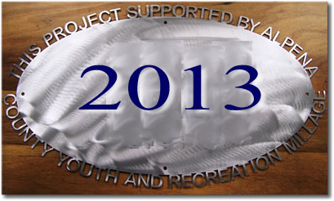
APS-Softball Linedrive Club $4,319 (Carried over to 2014)
AHS Field Improvements
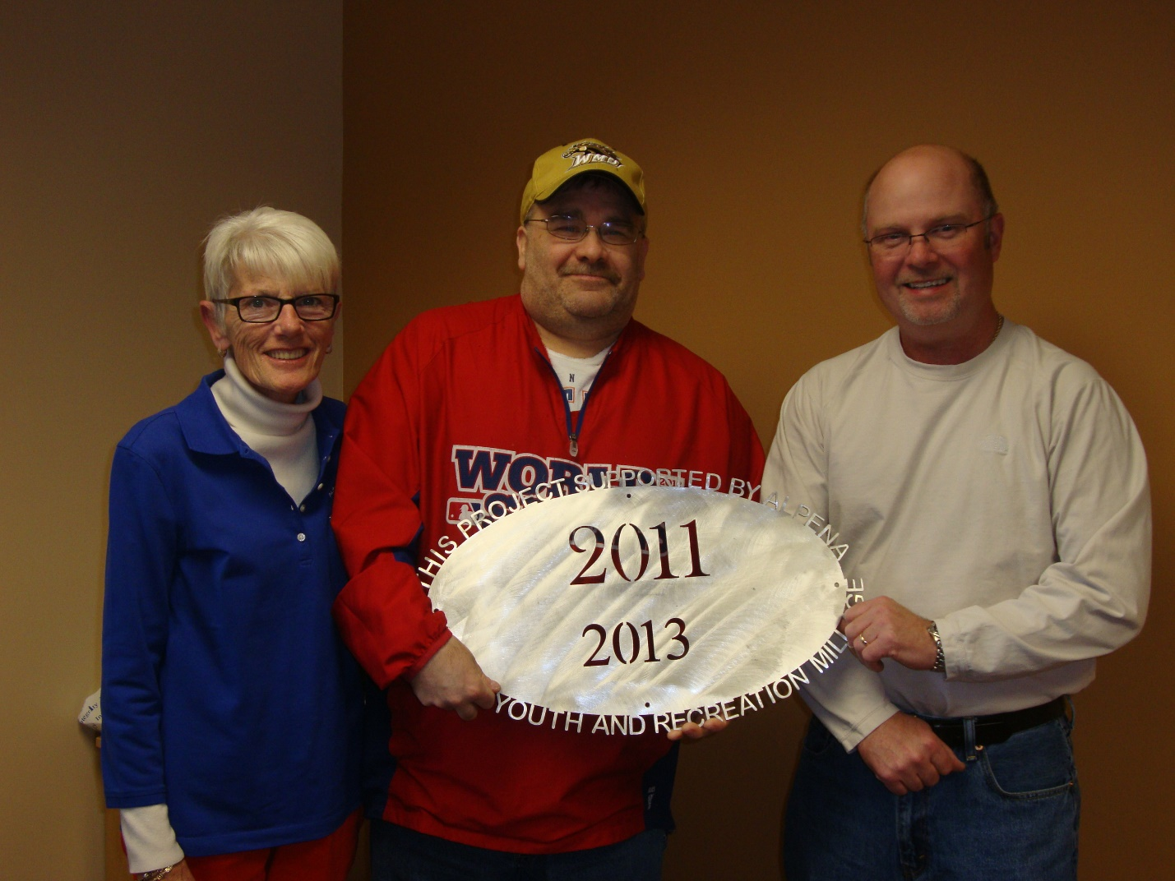
Alpena Tennis Association: ACE Club $10,000
Girls & Boys Varsity Tennis Support

Babe Ruth Baseball $3,500
Operating Support

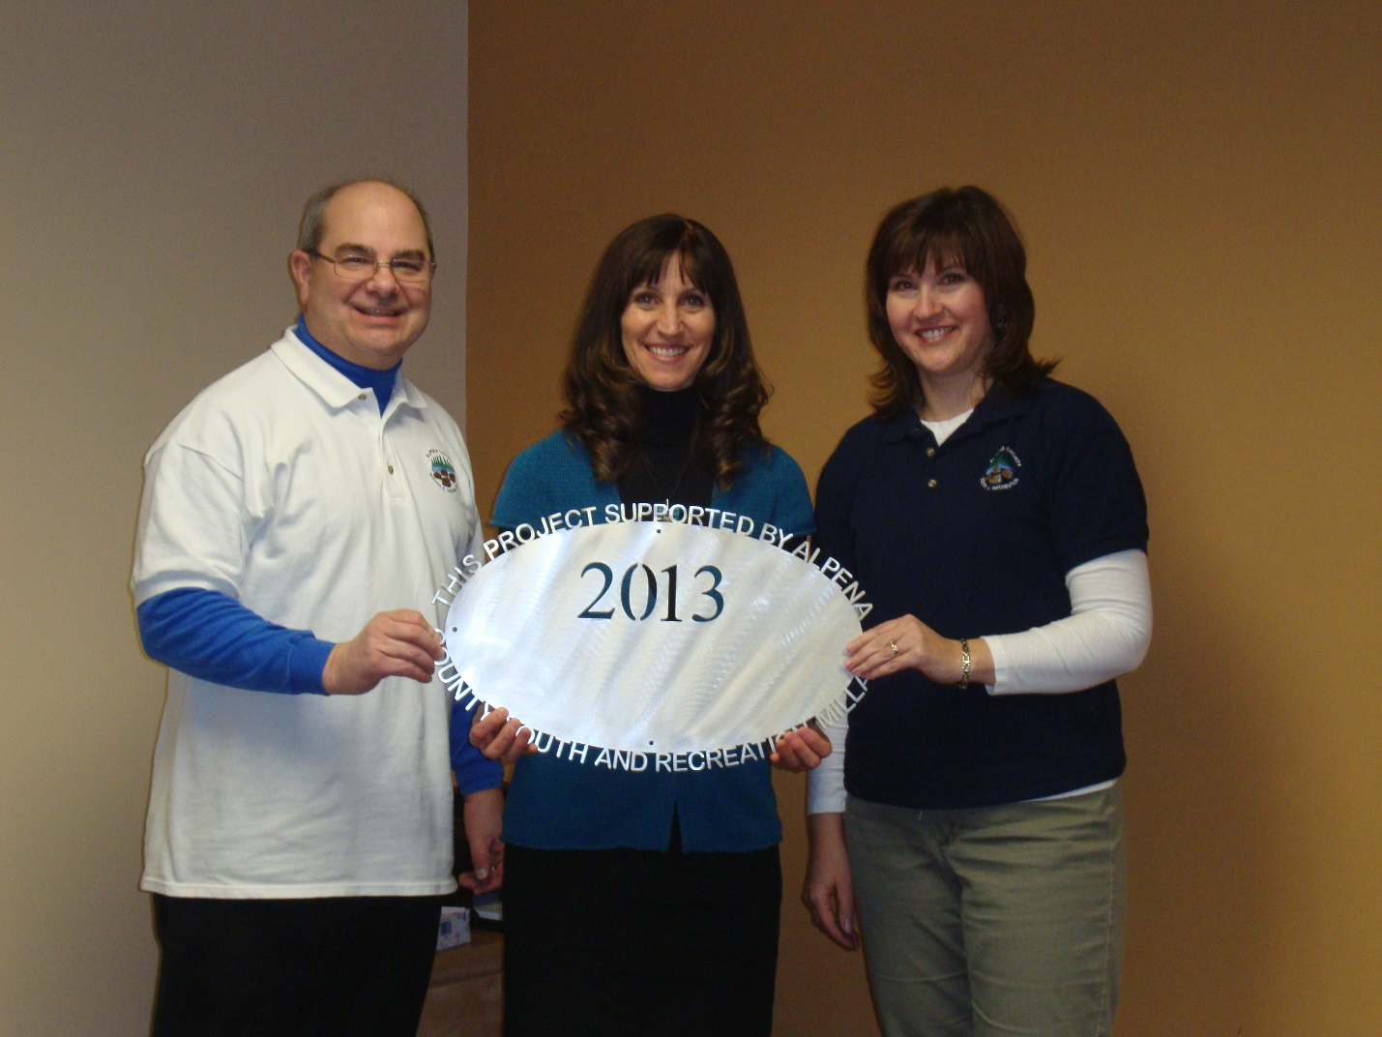
Besser Museum $5,000
Pathway/Ramps to Outdoor Exhibits
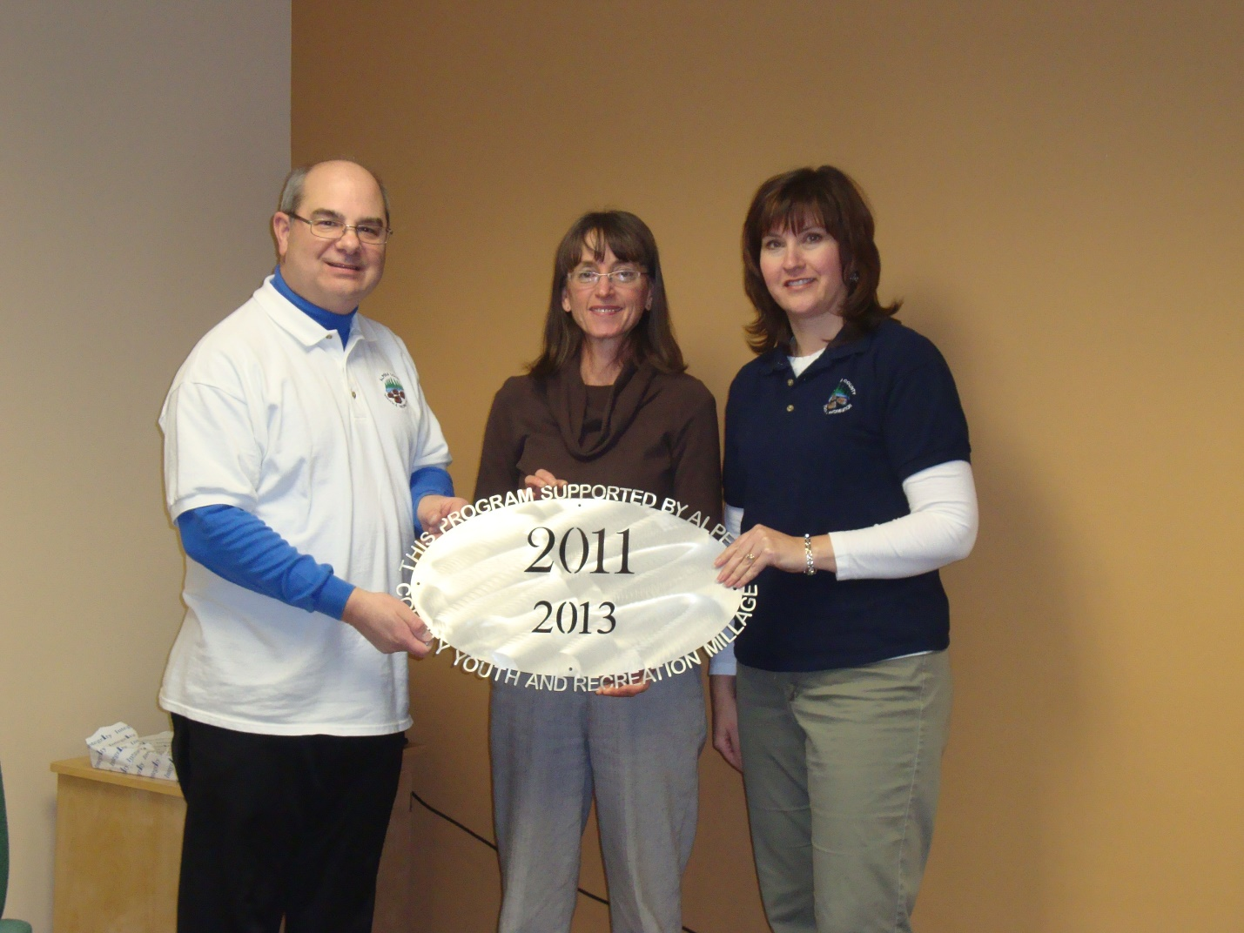
City of Alpena River Rats $1,000
Wildlife Sanctuary programs

City of Alpena: Trail head $40,000 (Carried over to 2014)
Local Match for $245,000 MDNR Grant

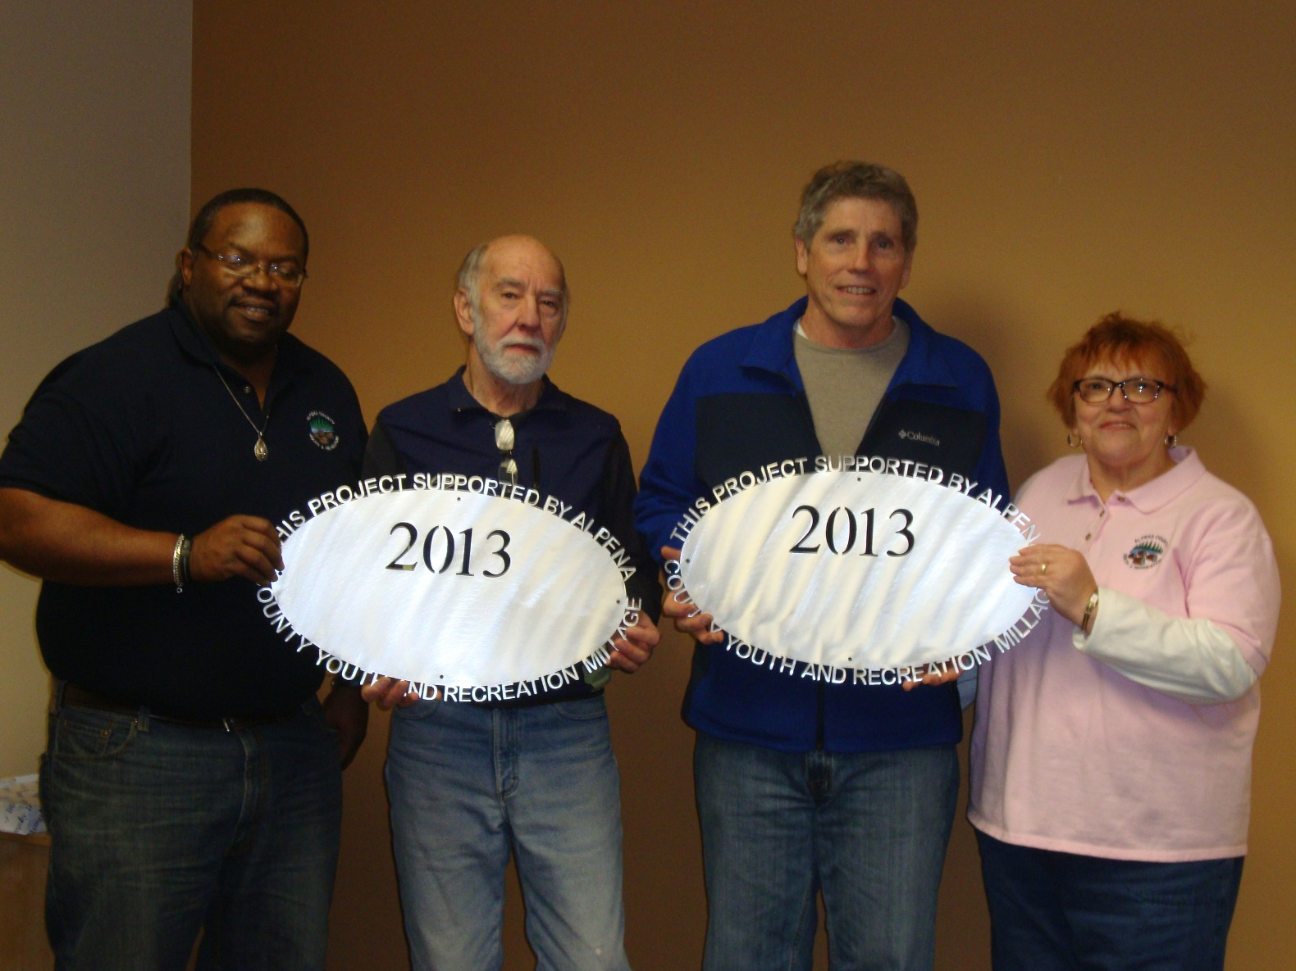Thunder Bay Trails Association $2500
Maintenance – Norway Ridge/Chippewa Hills 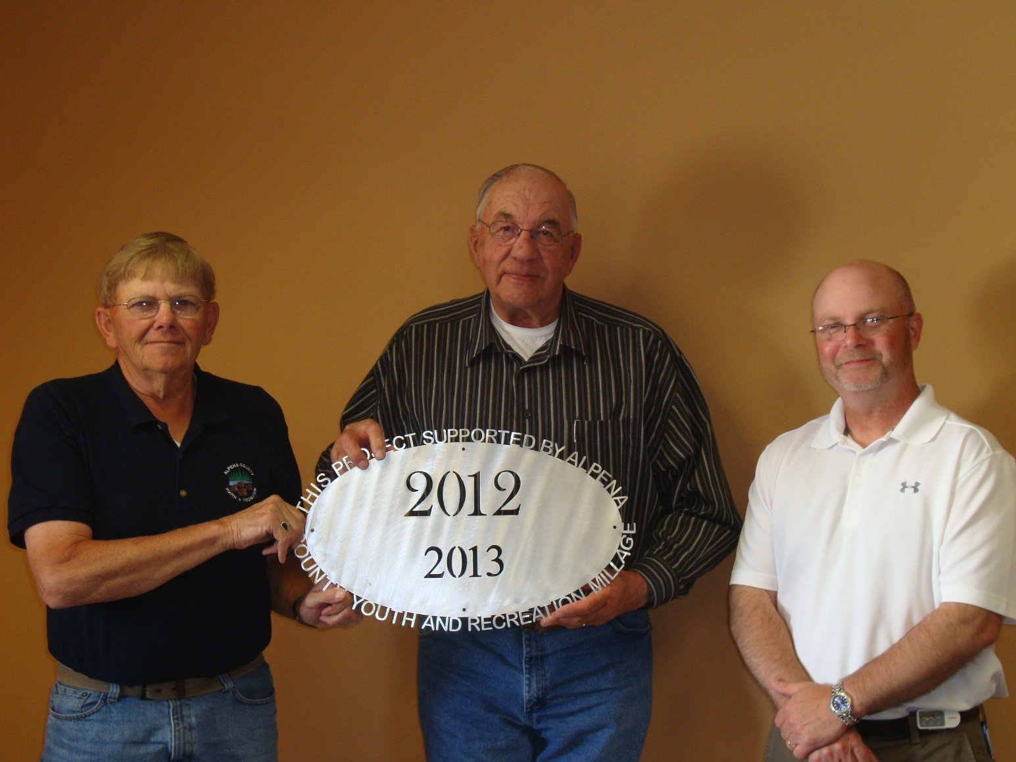Wilson Township $4,000
Concrete Floor – Wolf Creek Pavilion

APS: Cheering leading Club $4,000
Cheer & Tumble Mats 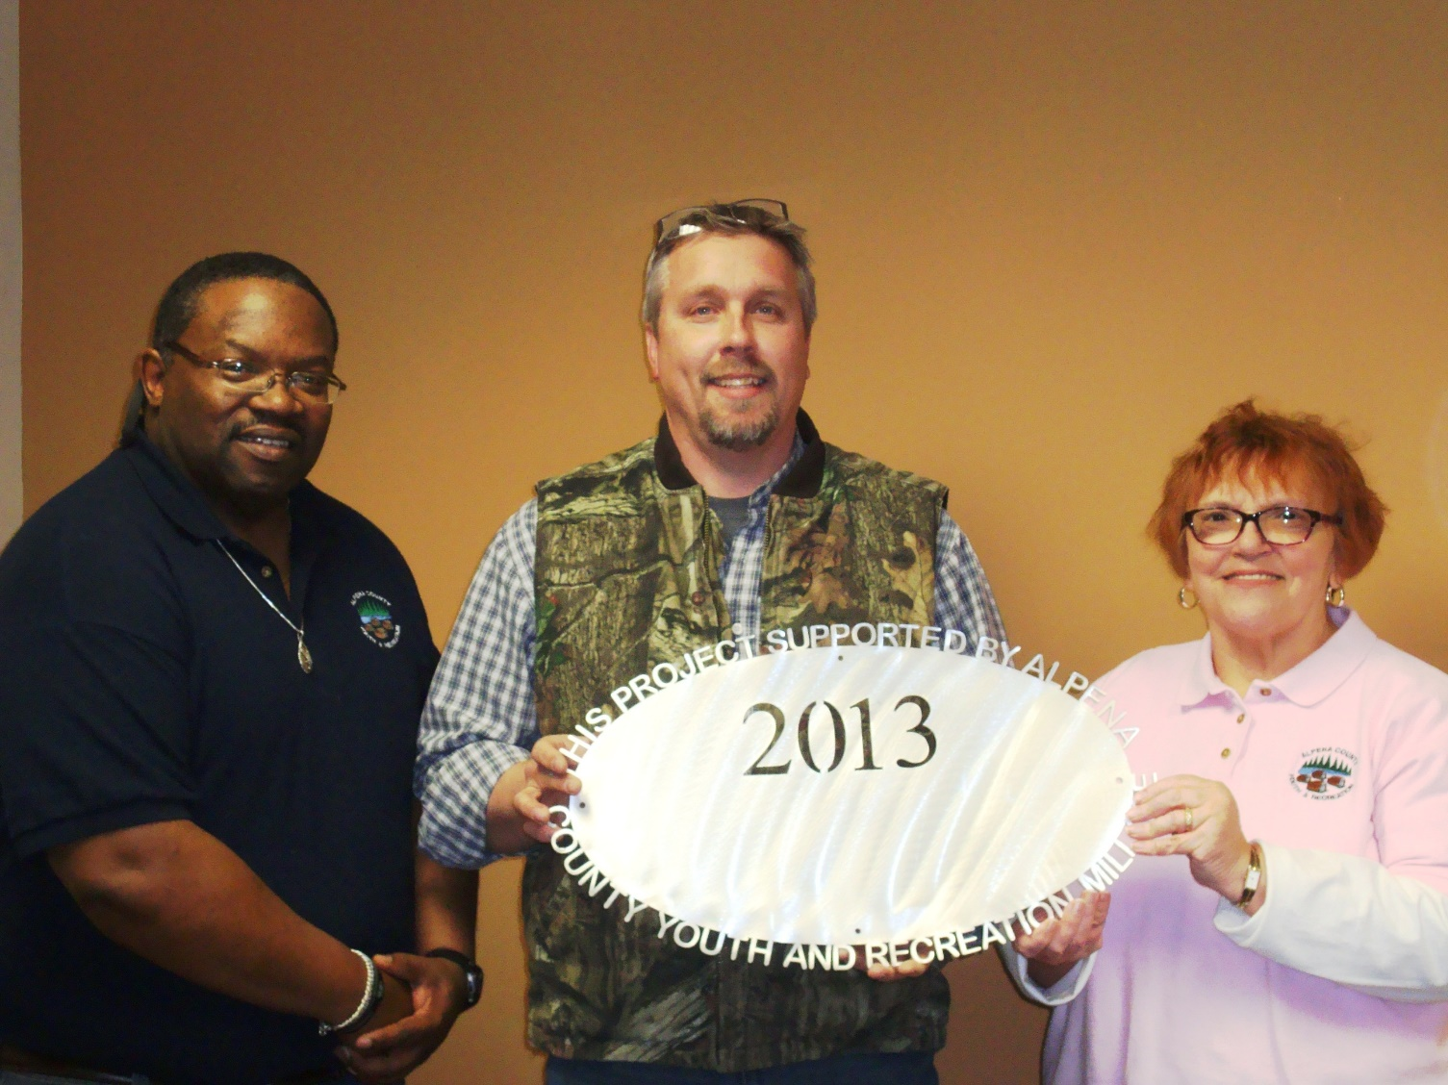Babe Ruth Baseball $3,500
Operating Support 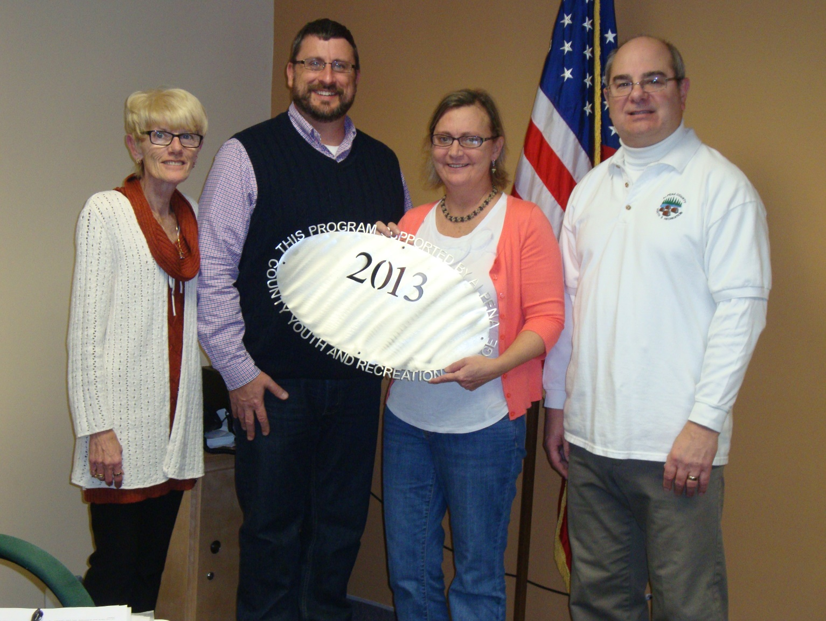Alpena Swim Club/Thunder Bay Schooners
$5,000
Pool Rental, Meet Fees 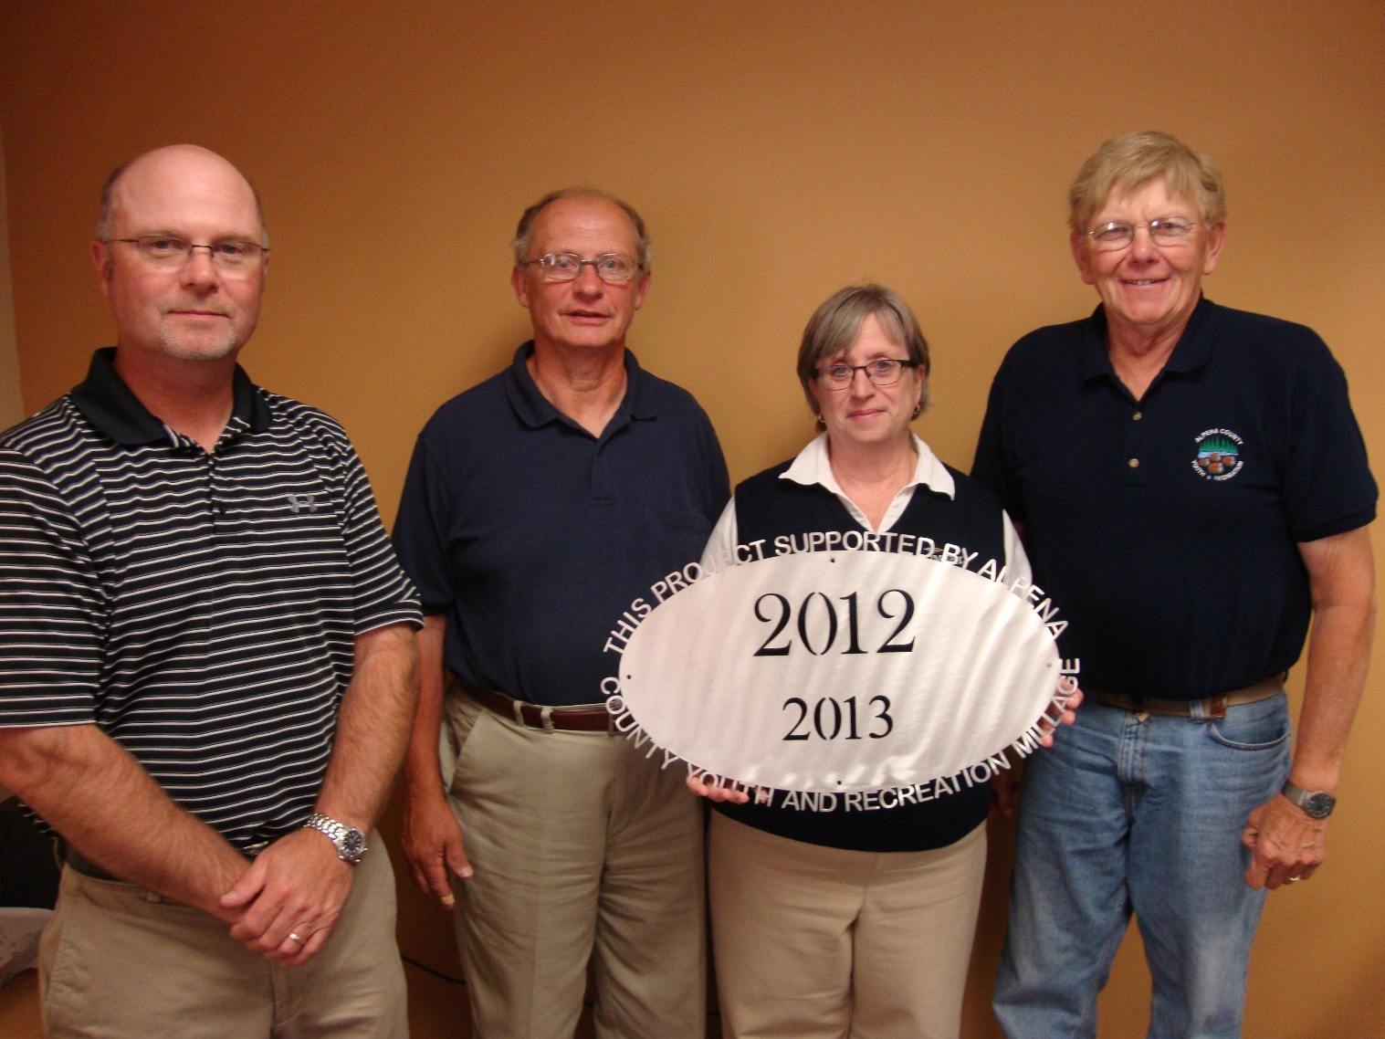Kiwanis Club $4,868
Kiddie Park upgrade 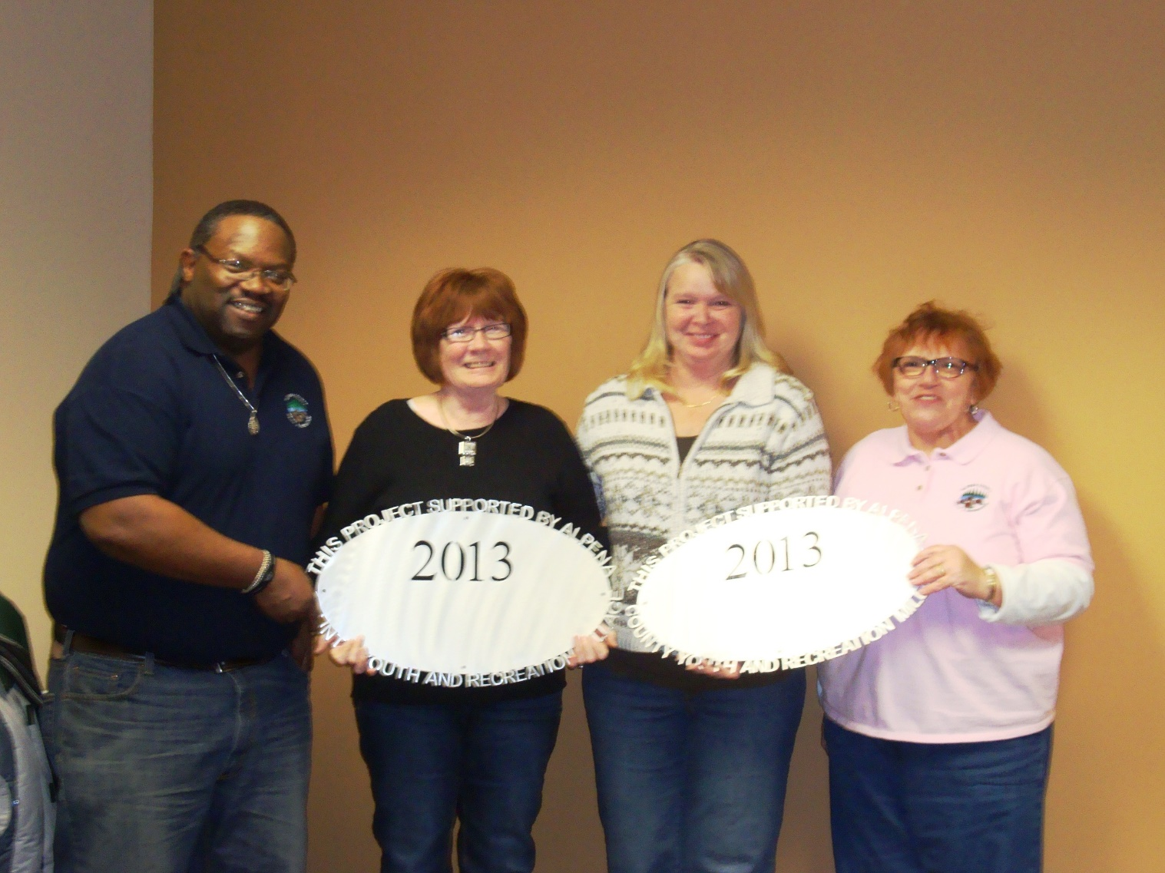Alpena County Parks
Long Lake Park $5,400
Basketball Court 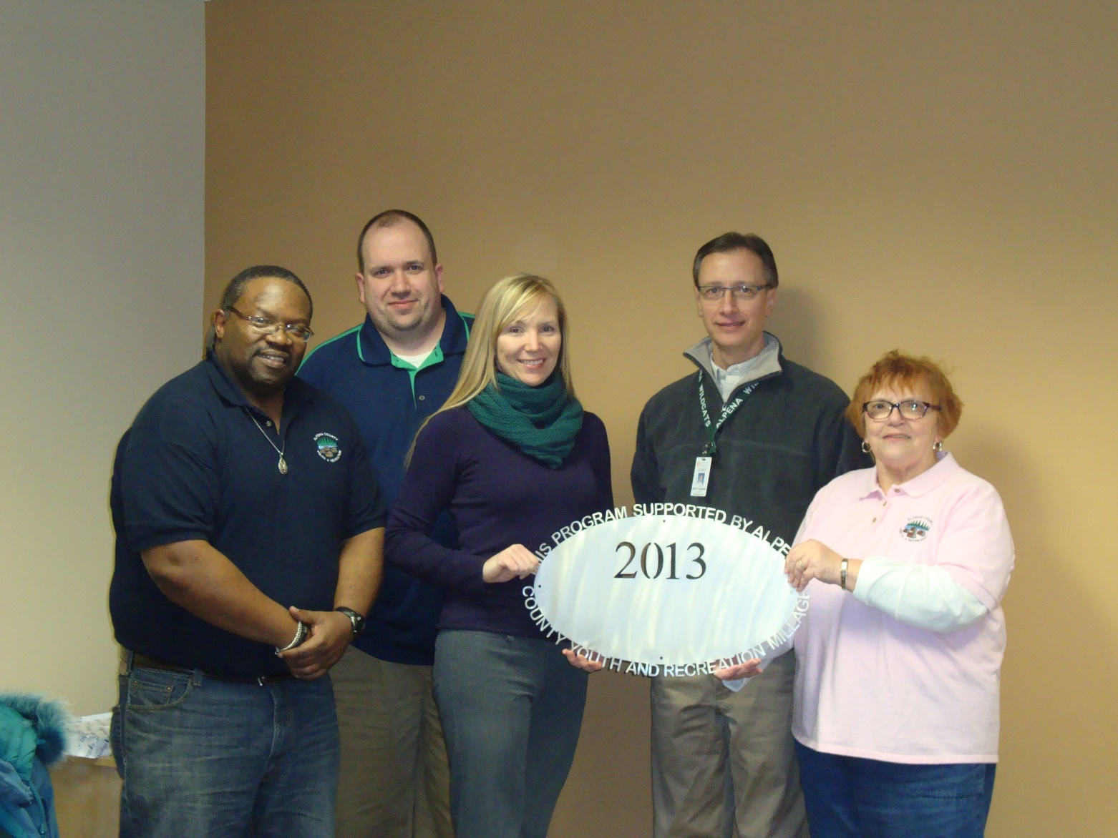APS:TBJHS Athletic Outreach $18,450
6th grade programming, free admission to events 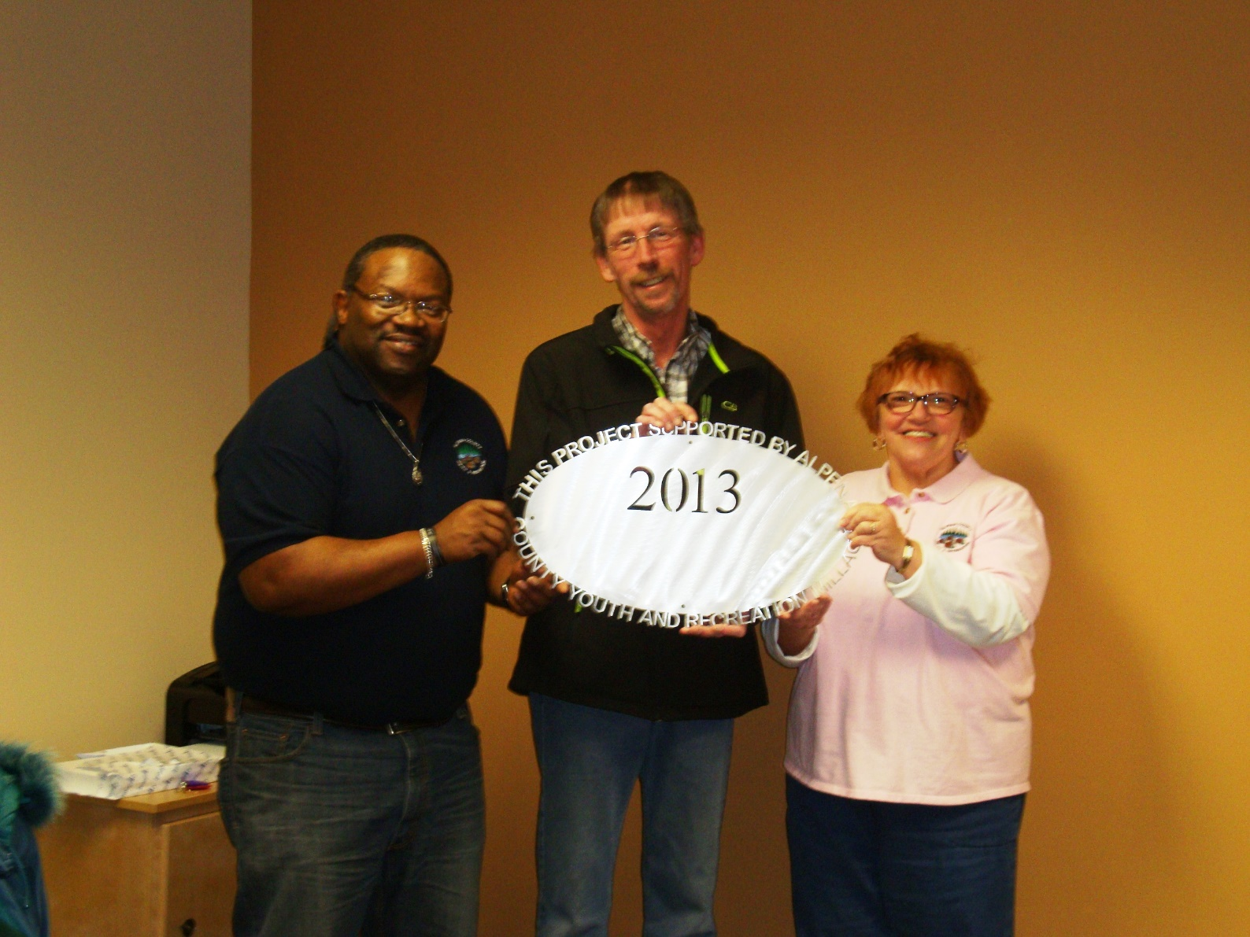County of Alpena Tennis Courts $63,000
Tennis Court Reconstruction Alpena Touchdown Club $10,400
Helmets, shoulder pads, etc. 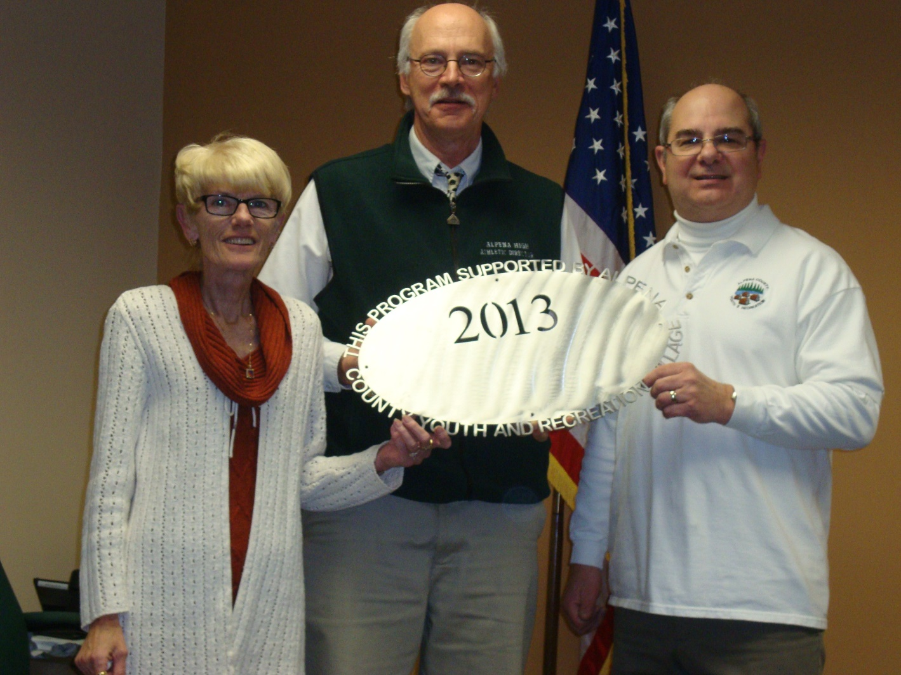APS: Boys Basketball $3,000
New Uniforms County of Alpena Plaza Pool: Capital Outlay
$110,000
Capital Project – HVAC System 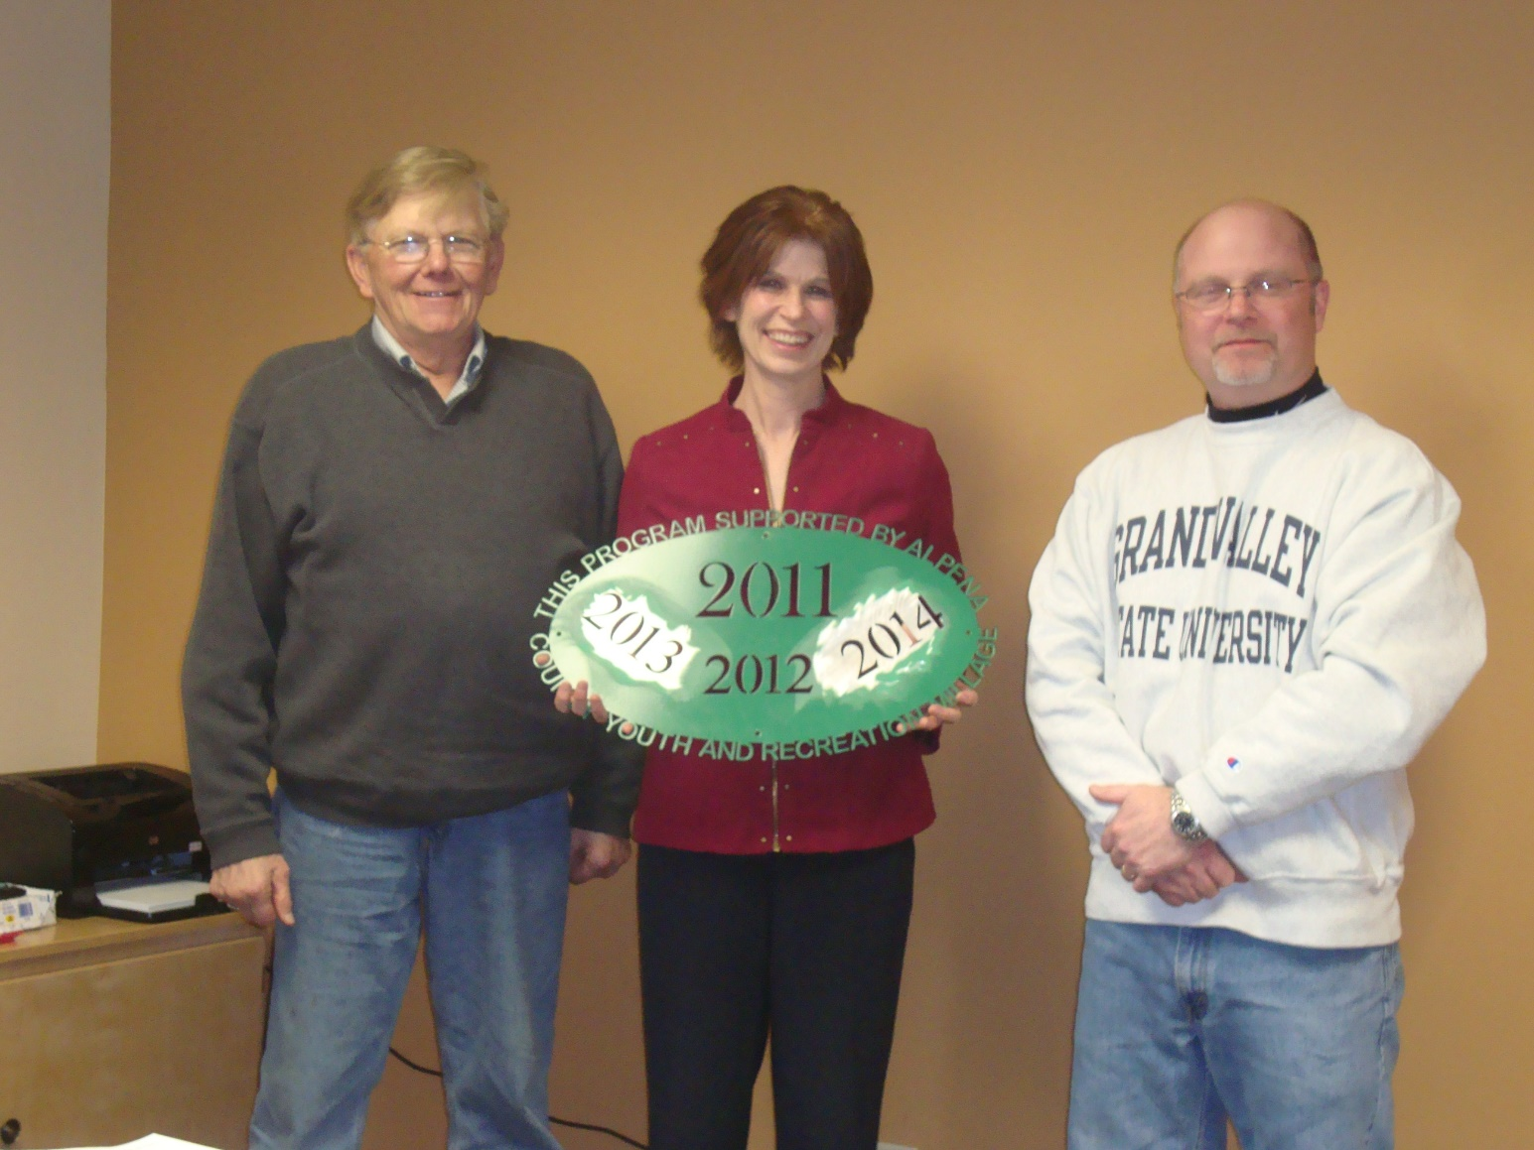MSU EXTENSION – 4H $30,000
4-H Youth Development Program Alpena Figure Skating Club $8,000
Ice time 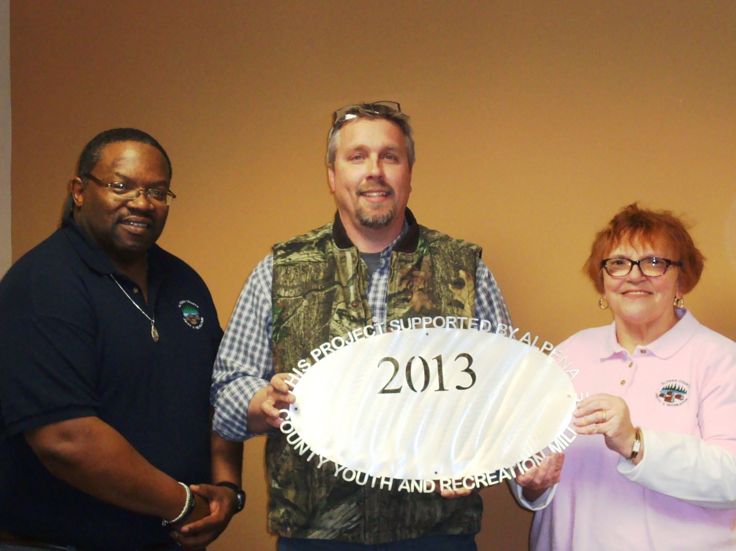Alpena Huron Shore Little League $26,465
Field Improvements/Capital Projects City of Alpena: Trail head $40,000
Local Match for $245,000 MDNR Grant
Carried over to 2014
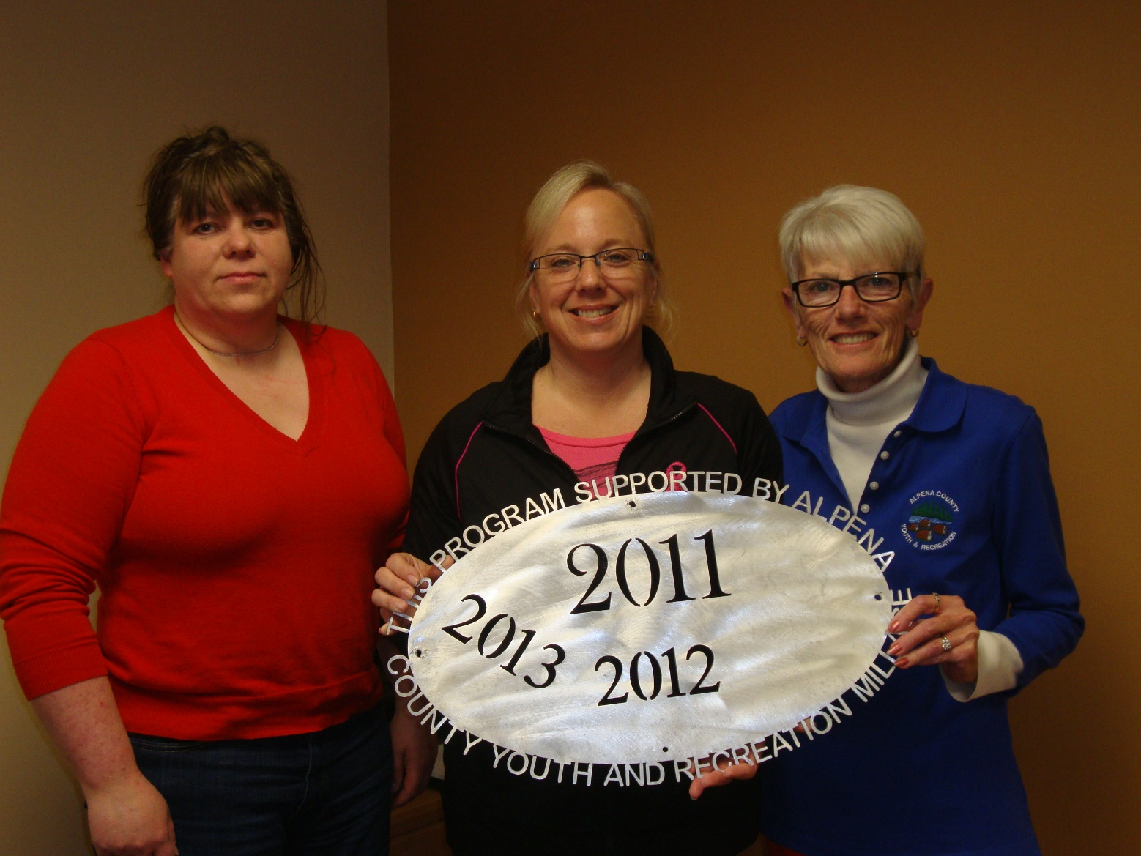Alpena County Plaza Pool Operating $85,000
Aquatic Programming 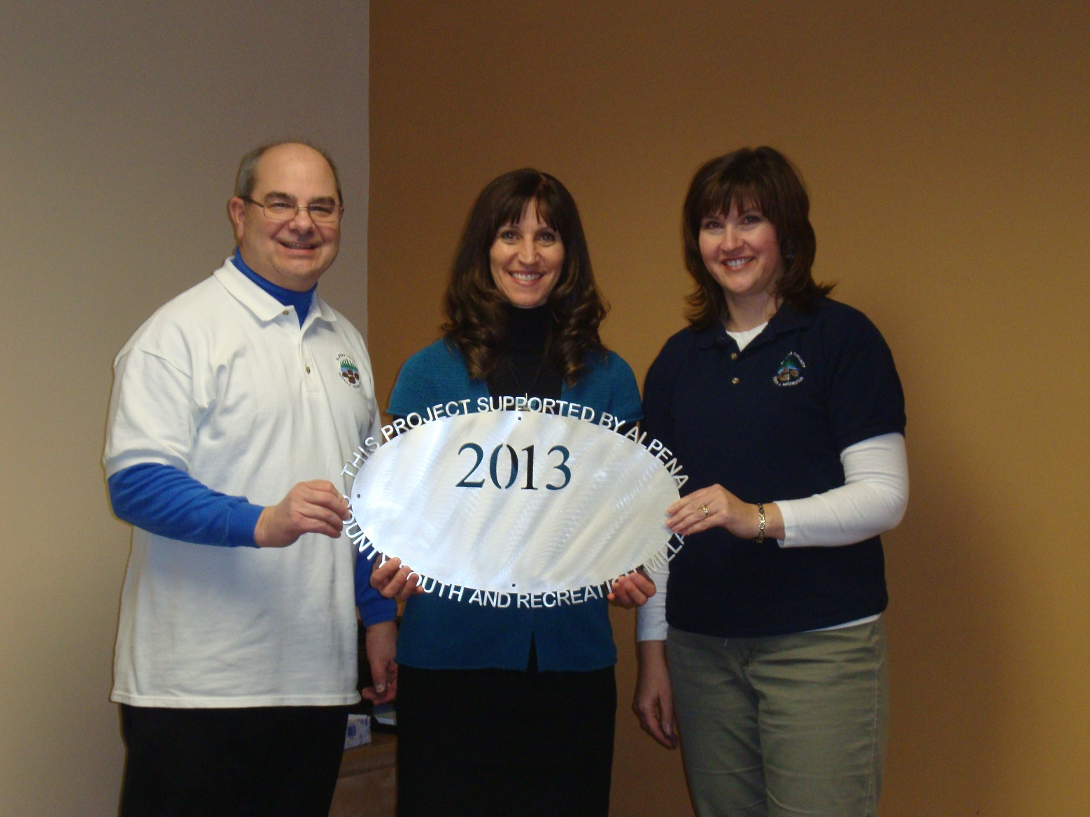Besser Museum $5,000
Pathway/Ramps to Outdoor Exhibits
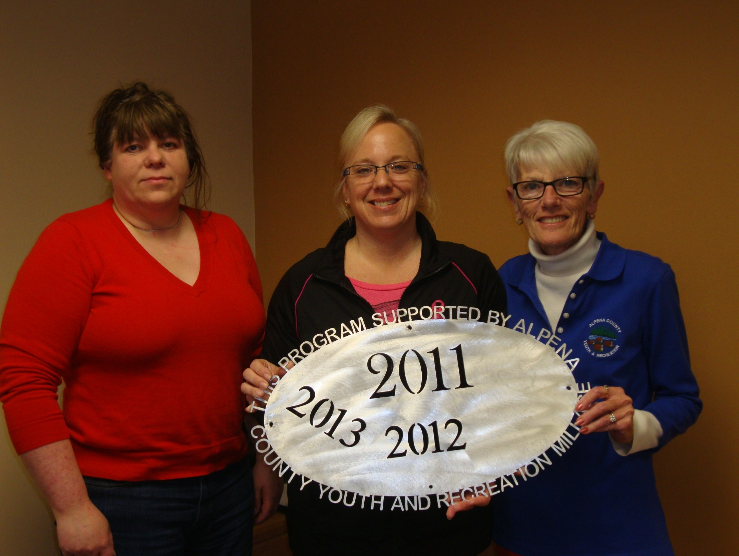Alpena County Plaza Pool: Make a Splash
$5,000 Water Safety – 2nd grade students Friends of Plaza Pool $4,250
Aquatic Support/Expansion projects 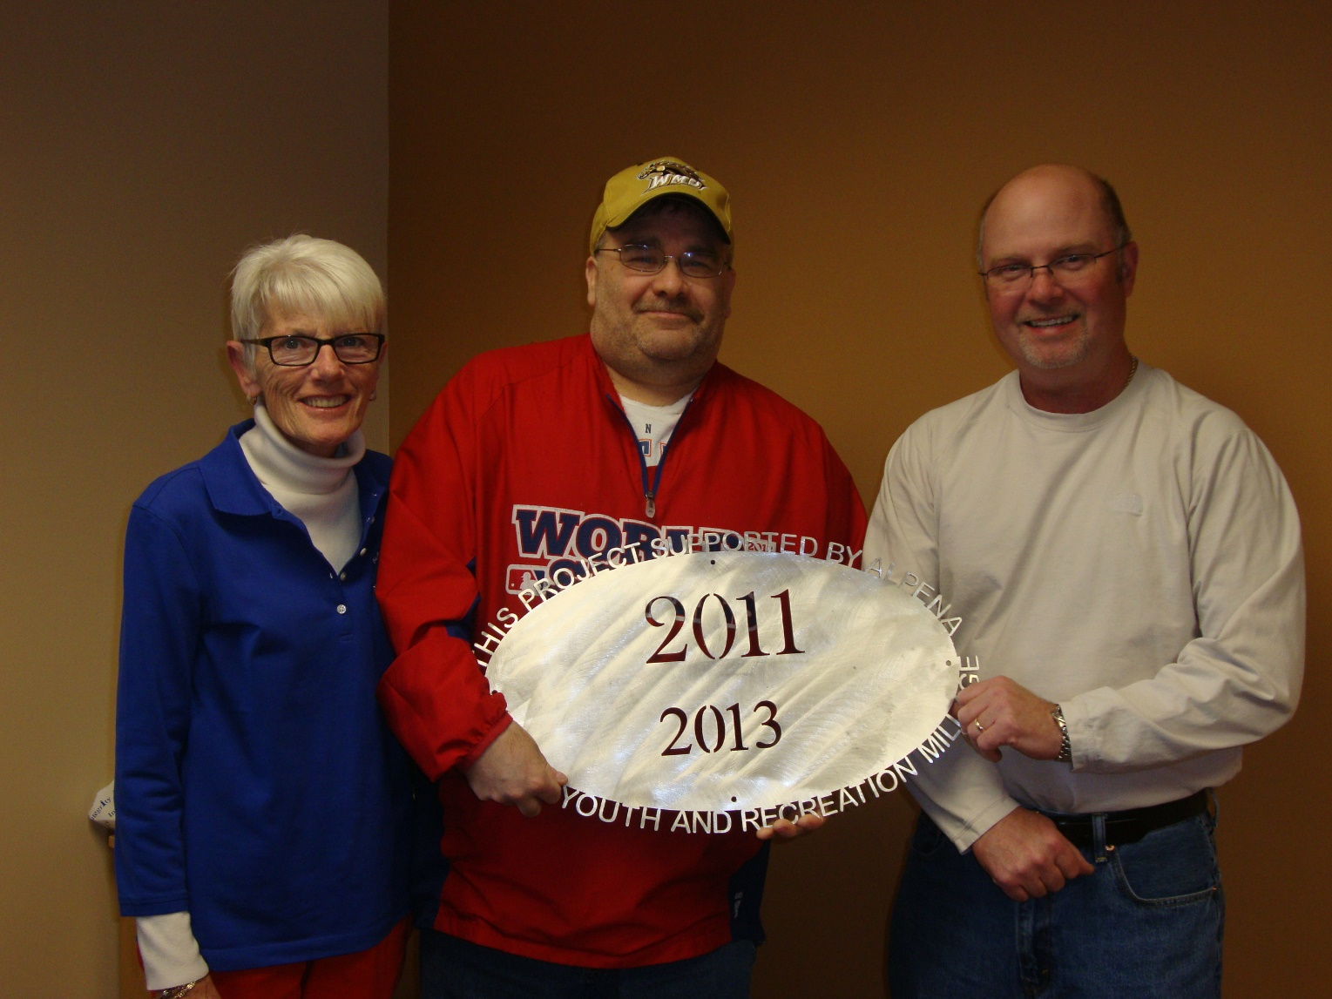Alpena Tennis Association: ACE Club $10,000
Girls & Boys Varsity Tennis Support 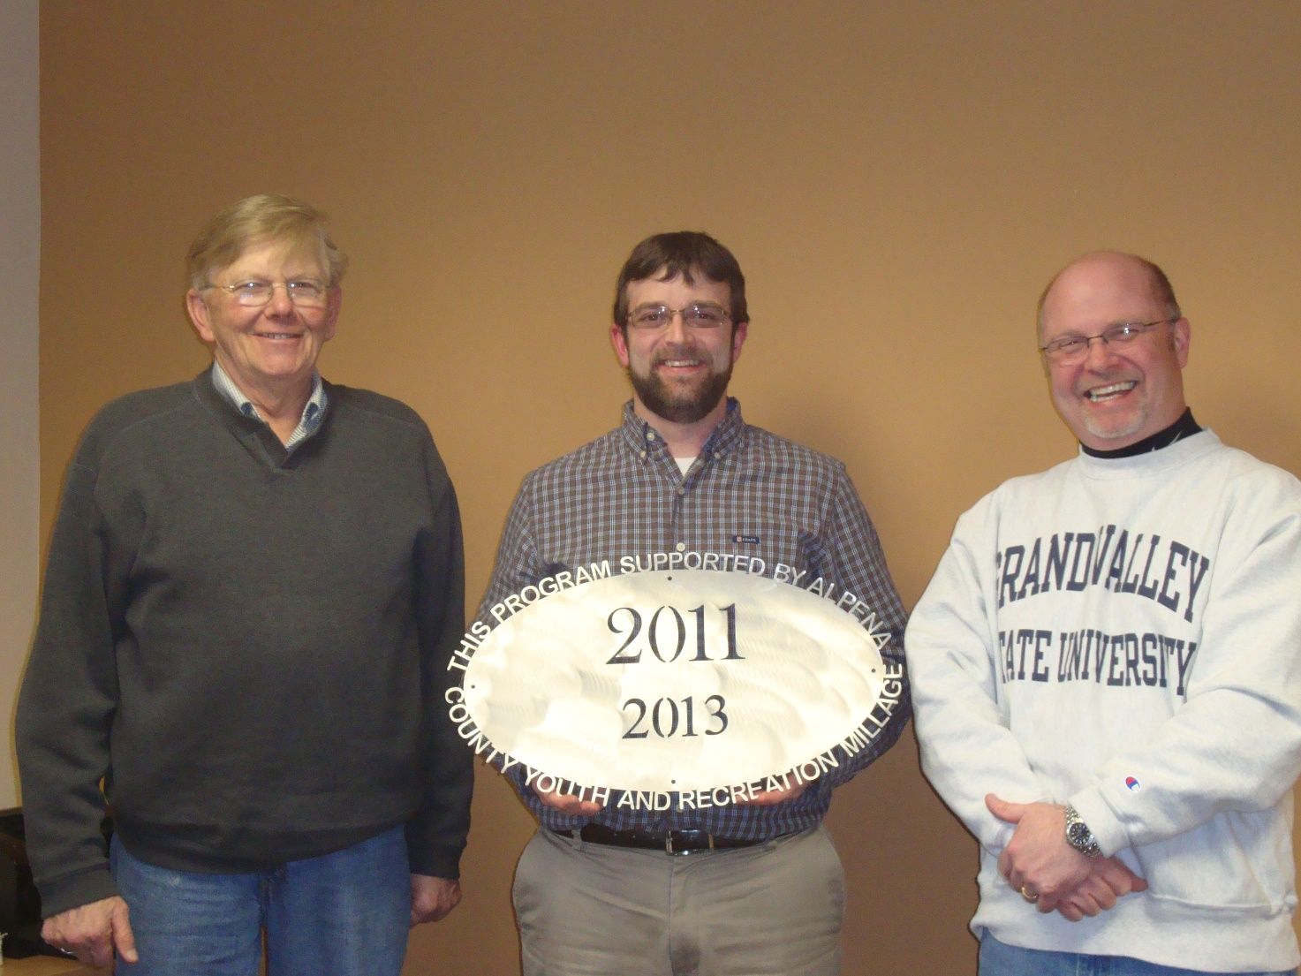Boys and Girls Club $22,682
Heating and Cooling Systems 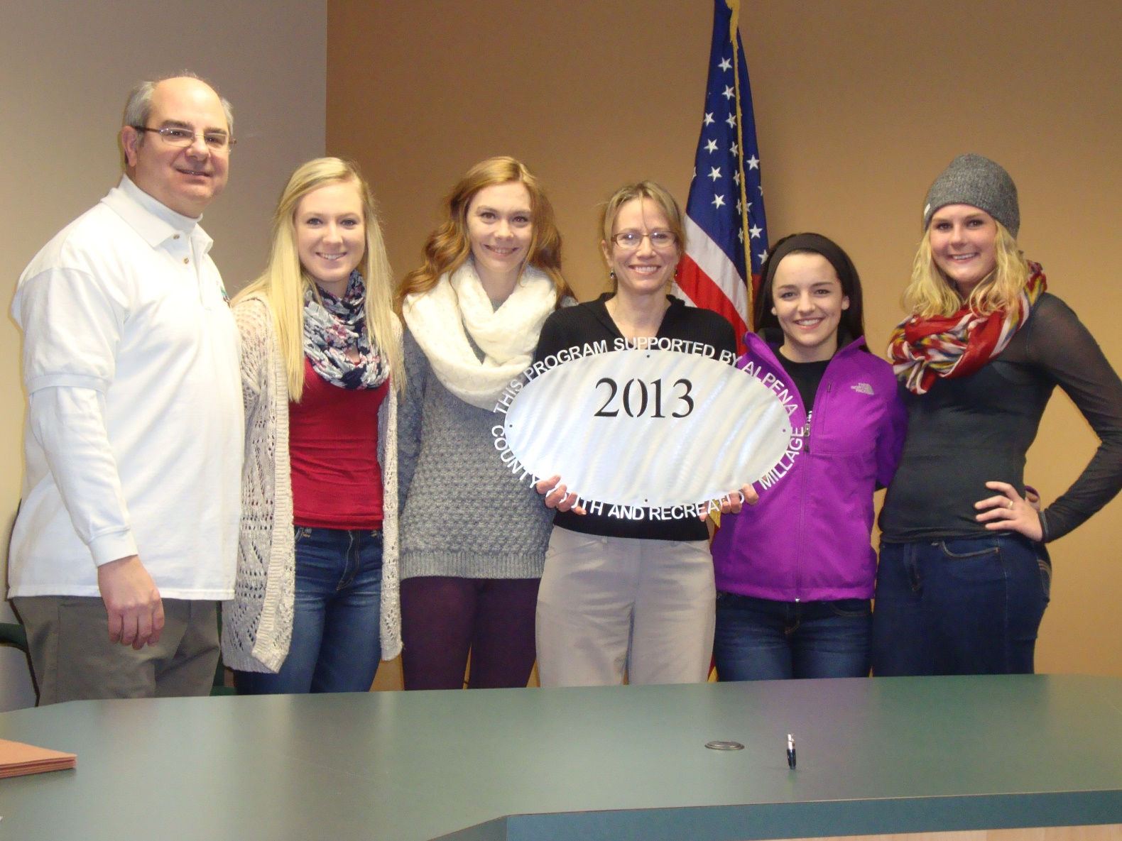APS: Volleyball Club $7,000
Operating Support 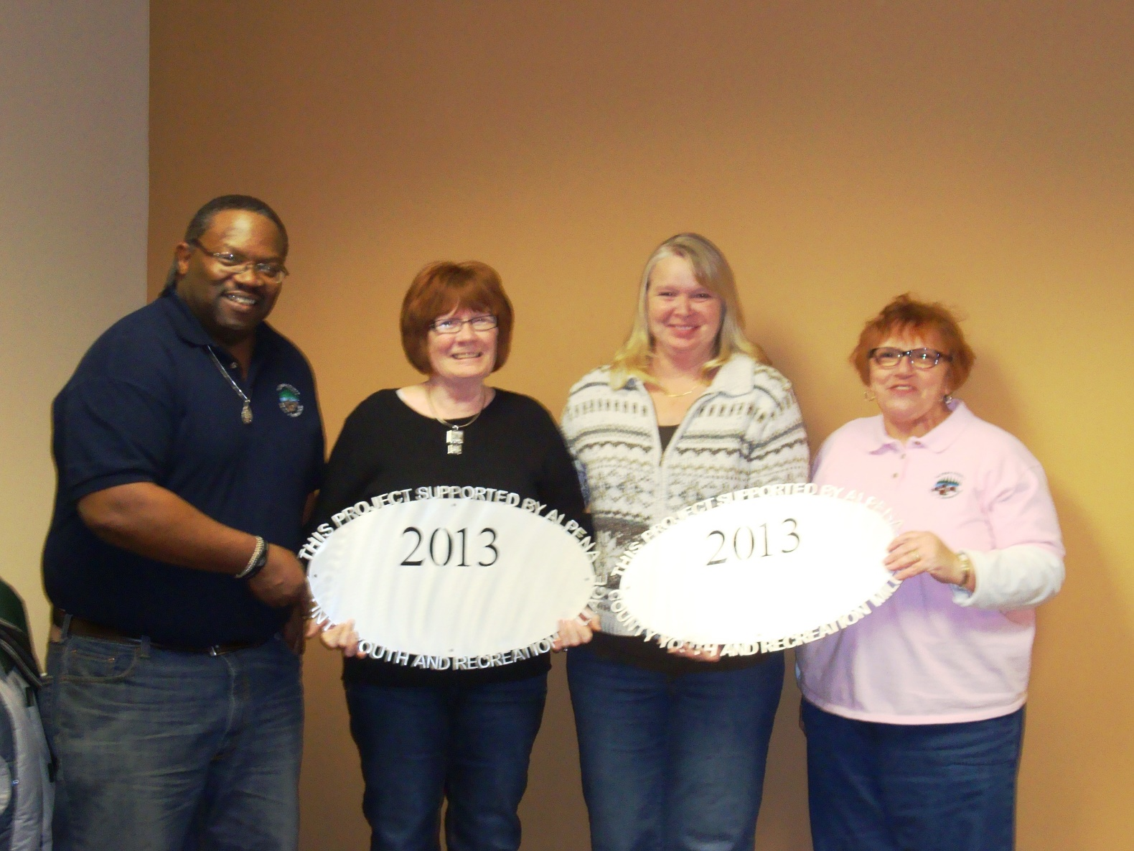Alpena County Parks
Sunken Lake Park $6,000
Playground Equipment M-PAC $6,000
1st Year skating/learn to skate program 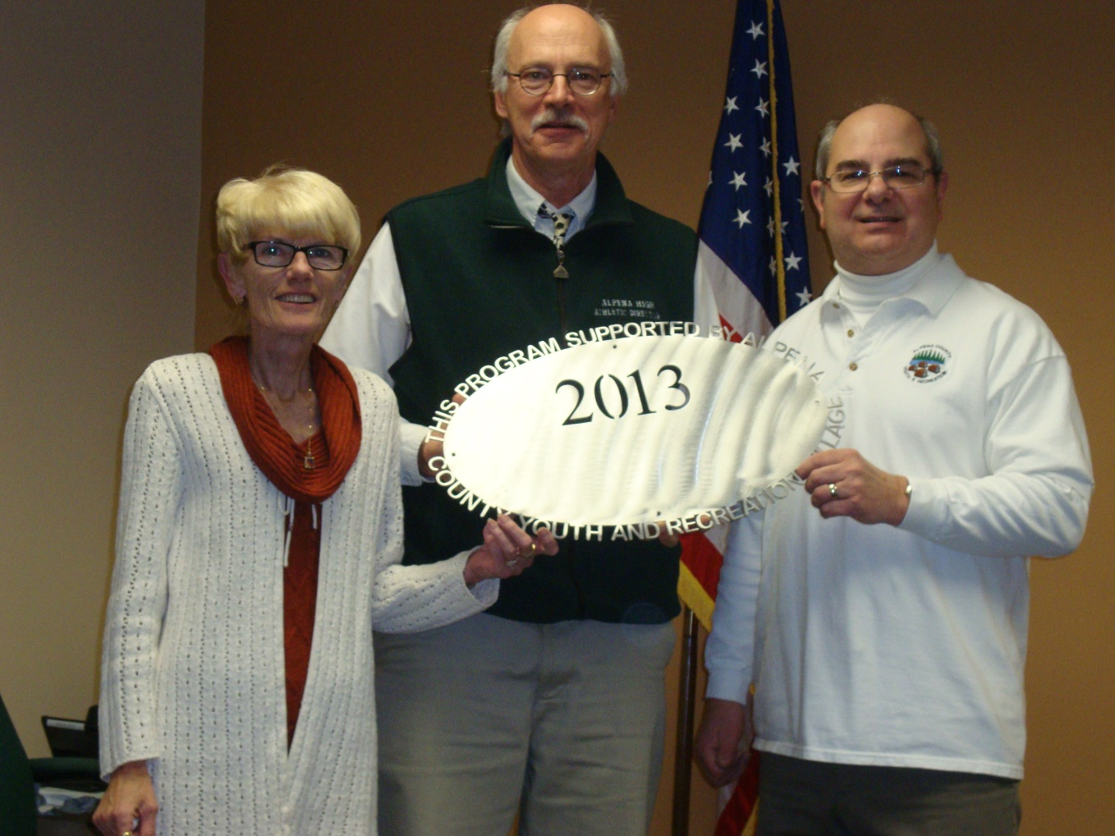AHS Girls Basketball Club $6,200
Operating Support 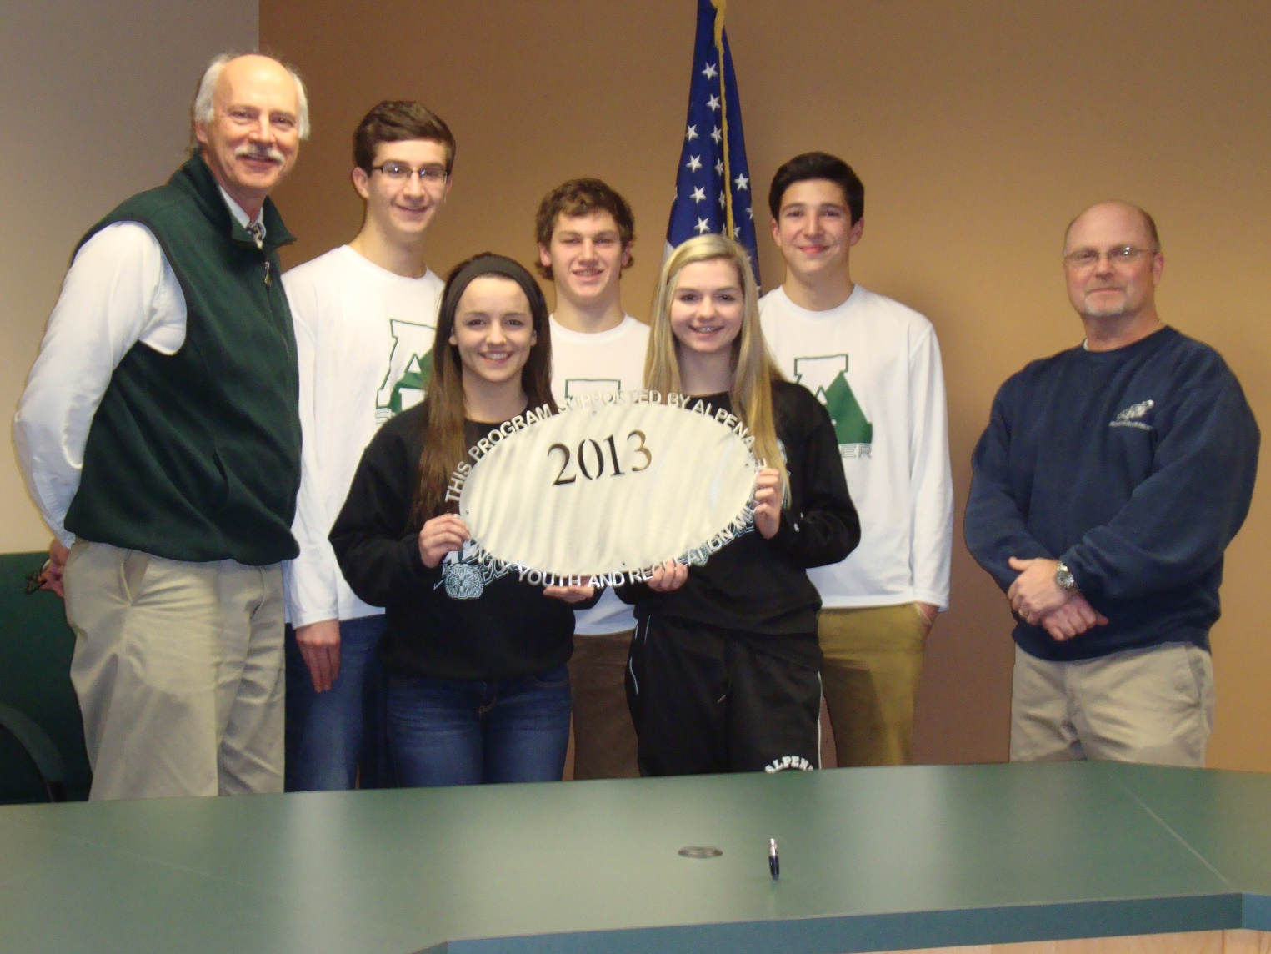APS: Boys & Girls Soccer $7,316
Operating Support 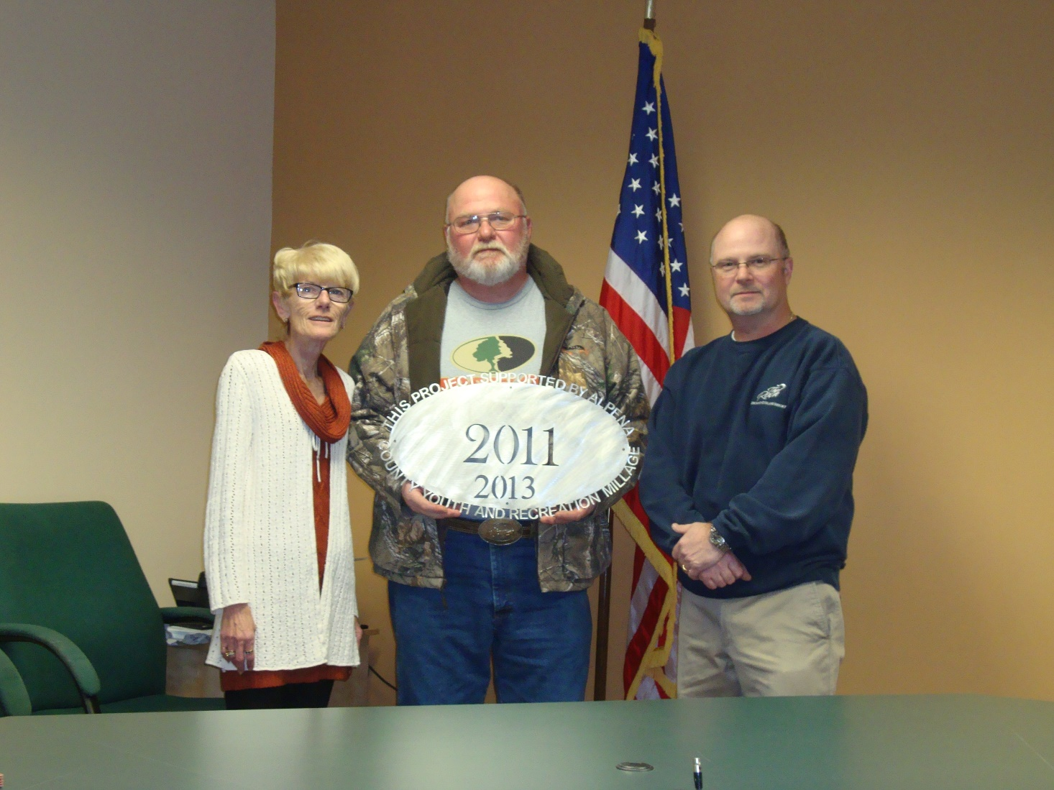Maple Ridge Township $3,000
Cathro Ball Field Improvements 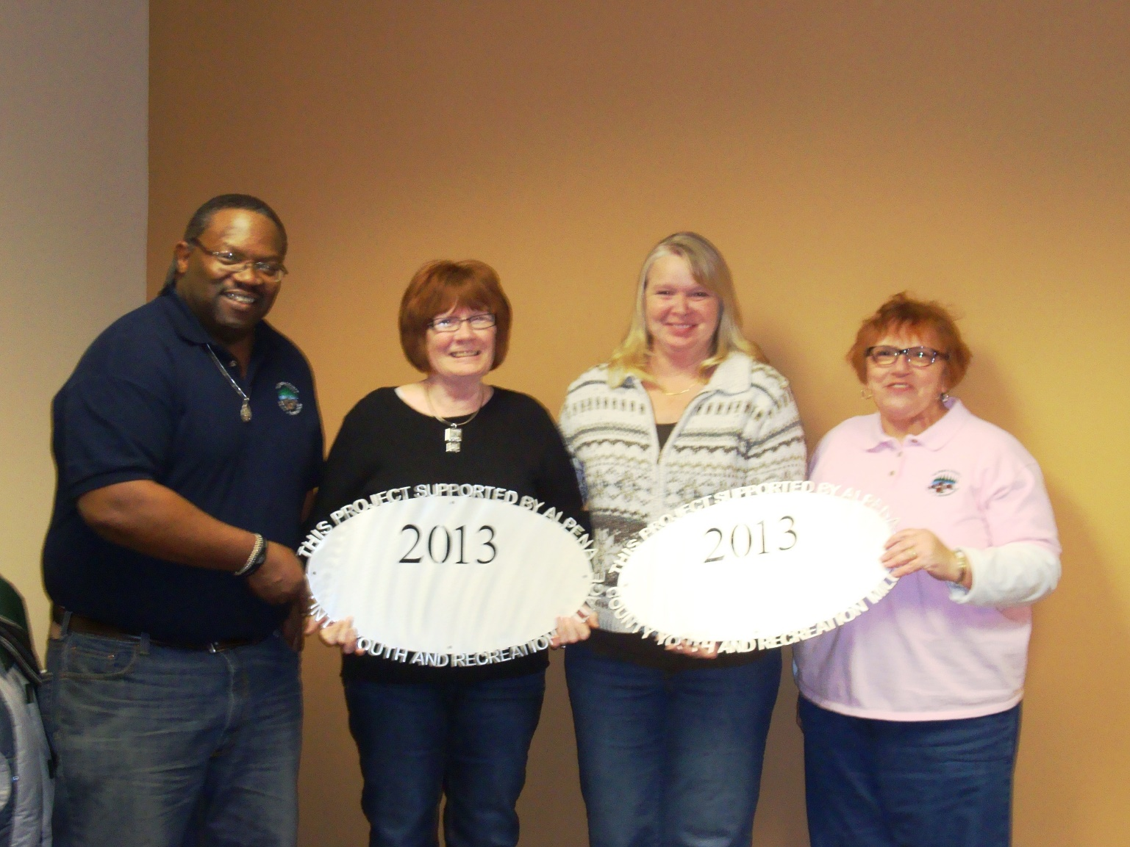Alpena County Parks
Beaver Lake Park $5,400
Basketball Court 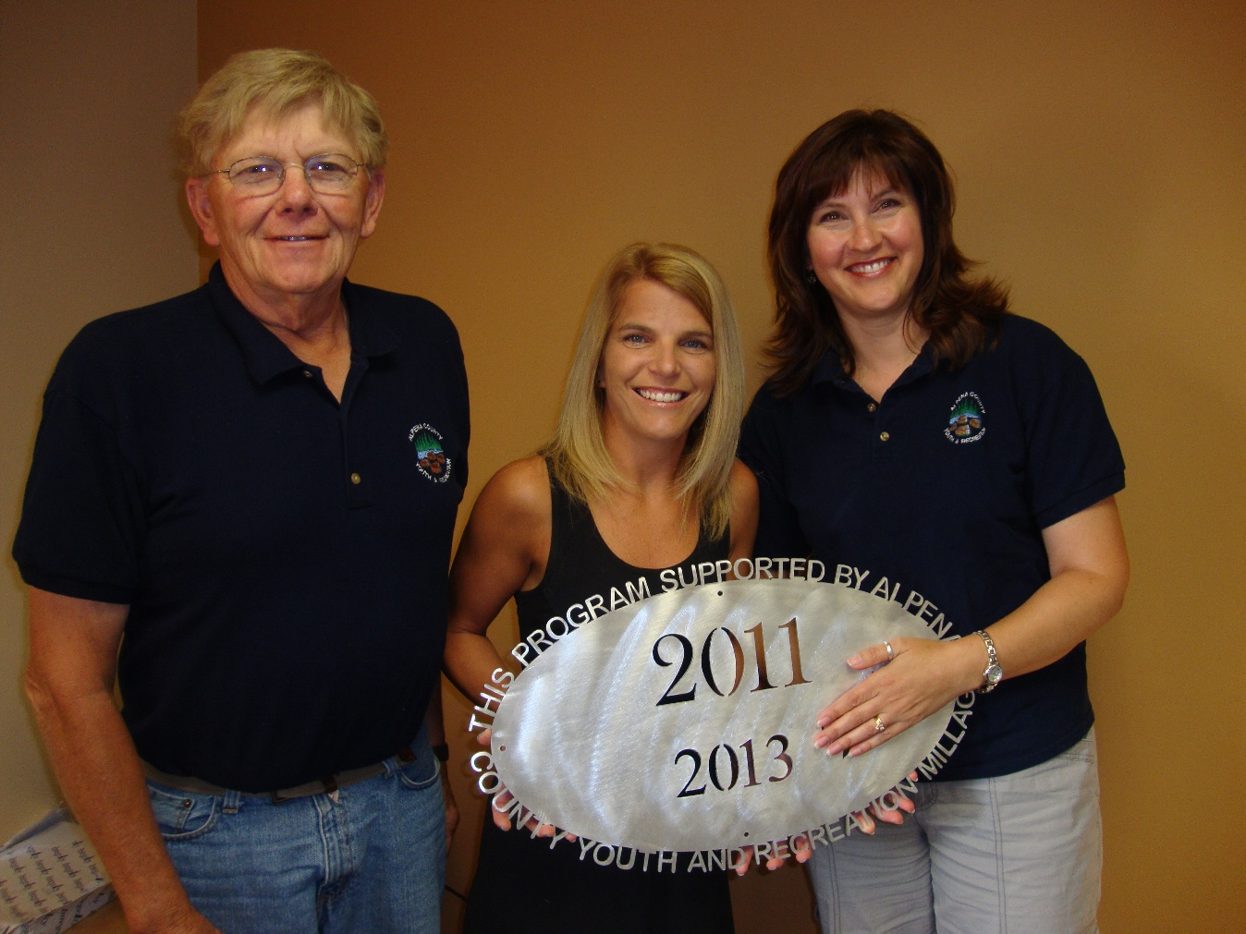NEMCSA $4,400
Staffing for Ropes Course ACC – Ropes Course $900
Maintenance & new components Thunder Bay Soccer Association $12,910
Fencing

Northern Lights Arena – Turf $55,000
Indoor Turf Not Completed APS-Softball Linedrive Club $4,319
AHS Field Improvements
Carried over to 2014

Commissioners & Commissioners Appointees
District 1-COMMISSIONER
Jeff Kowalski
215 Barry Street
Alpena, MI 49707
517.227.0961
jeffkowalski@alpenacounty.org
Linda Canfield
117 Hitchcock Street
Alpena, MI 49707
989.356.2742
lindacanfield1@frontier.com

District 2-COMMISSIONER
Robert Adrian
227 Dawson Street
Alpena, MI 49707
989.354.5732
robertadrian@alpenacounty.org
Calvin L. Howard
329 W. Miller St.
Alpena, MI 49707
989.354.5722
coolbreeze758@hotmail.com

District 3- COMMISSIONER
Tom Mullaney
285 Island View Drive
Alpena, MI 49707
989.356.9781
tommullaney@alpenacounty.org
Camille Nerkowski
3210 S. Third
Alpena, MI 49707
989.356.2909
polishgirl147@hotmail.com
District 4- COMMISSIONER
Lyle VanWormer
4665 Kirchoff Road
Alpena, MI 49707
989.255.5896
lylevanwormer@alpenacounty.org
Tony Suszek
114 Kensington Court
Alpena, MI 49707
989.356.4434
suszektj@charter.net

District 5- COMMISSIONER
Scot McKenzie
2762 Werth Road
Alpena, MI 49707
989.354.3552
scotmckenzie@alpenacounty.org
Tom Heise
3376 Piper Road
Alpena, MI 49707
989.354.2447
htssllc@yahoo.com

District 6-COMMISSIONER
Mark Hall
5005 Long Rapids Road
Alpena, MI 49707
989.354.6023
Kamila Robillard
7361 Haken Road
Alpena, MI 49707
989.657.0600
Kam9431@gmail.com
District 7- COMMISSIONER
Cameron Habermehl
14510 M-32 West
Lachine, MI 49753
989.766.3455
camhabermehl@alpenacounty.org
Fred Wegmeyer
10599 Napper Rd.
Herron, MI 49744
989.379.4034

District 8- COMMISSIONER
Eric Lawson
P.O. Box 73
Ossineke, MI 49766
Phone: 989.255.3762
ericlawson@alpenacounty.org
Lisa Siegert
12700 Hawkins Road
Hubbard Lake, MI 49747
989.727.3089
siegertlne@gmail.com

County Contacts
Kim Ludlow
County Treasurer
989.354.9534
ludlowk@alpenacounty.org

Tammy Sumerix-Bates
Executive Manager
Alpena County Commissioners
989.354.9502
batest@alpenacounty.org

