2012 Youth and Recreation Millage Funds Awarded

(2012 Y&R Pic)

Youth & Recreation
- facebook
- twitter
- linkedin
- email
- pinterest
(Y&R Map)

The Committee is spreading the funds throughout the County, encouraging all the Townships and non-profit organizations, schools, and governmental agencies to apply. The Alpena County Map shown on the left, depicts where the grants were awarded by the red dots for 2011 and the blue dots for 2012 and green dots for 2013. Please click on the image for a larger view.
26 Grant applications were received in 2011 for following year 2012 in the amount of $797,369.00.
Total amount appropriated $421,941.00
Listed below, you can view the organization, amount awarded and the name of project. You can also view or download the 2012 Youth and Recreation Awards Book by clicking here.

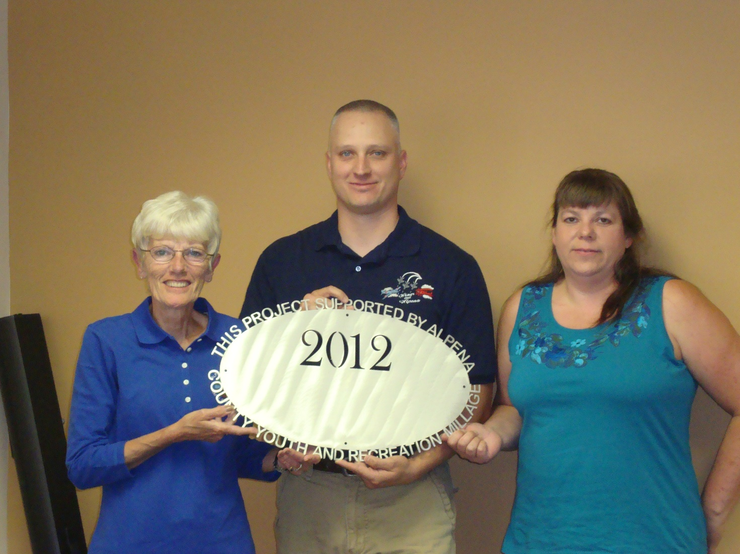Alpena Boosters Club/Wings Over Alpena $10,000.00
Wings Over Alpena 2012 (pdf)

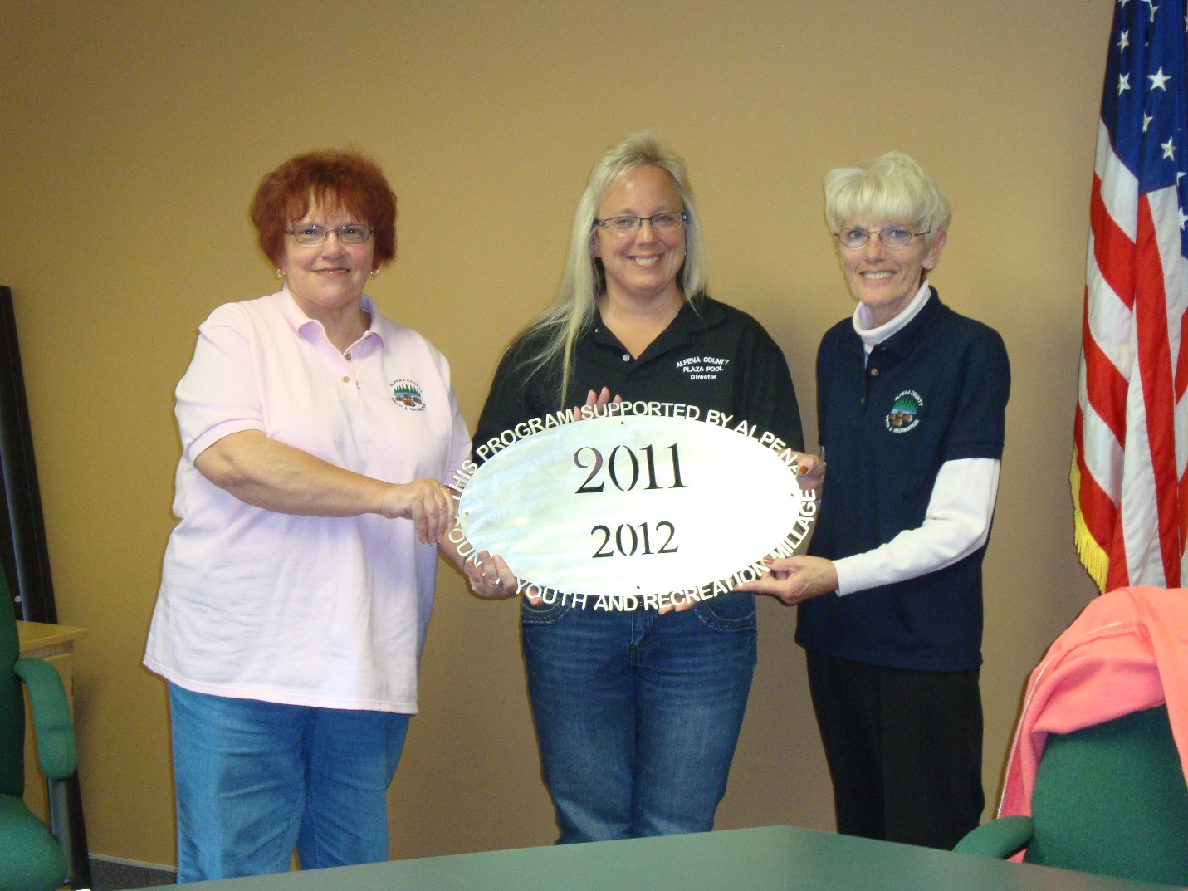Alpena County Plaza Pool (1) $70,000.00
Alpena County Plaza Pool Operational Costs (pdf)

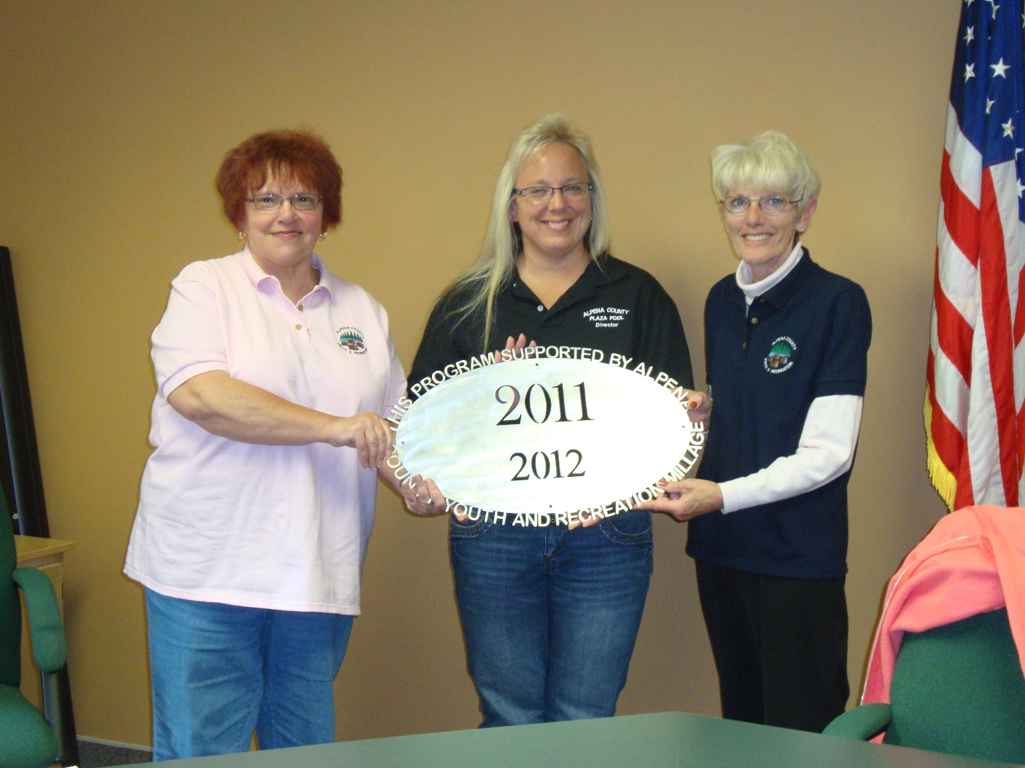Alpena County Plaza Pool (3)
$122,000.00
Alpena County Plaza Pool Outlay Projects-matching grants (pdf)

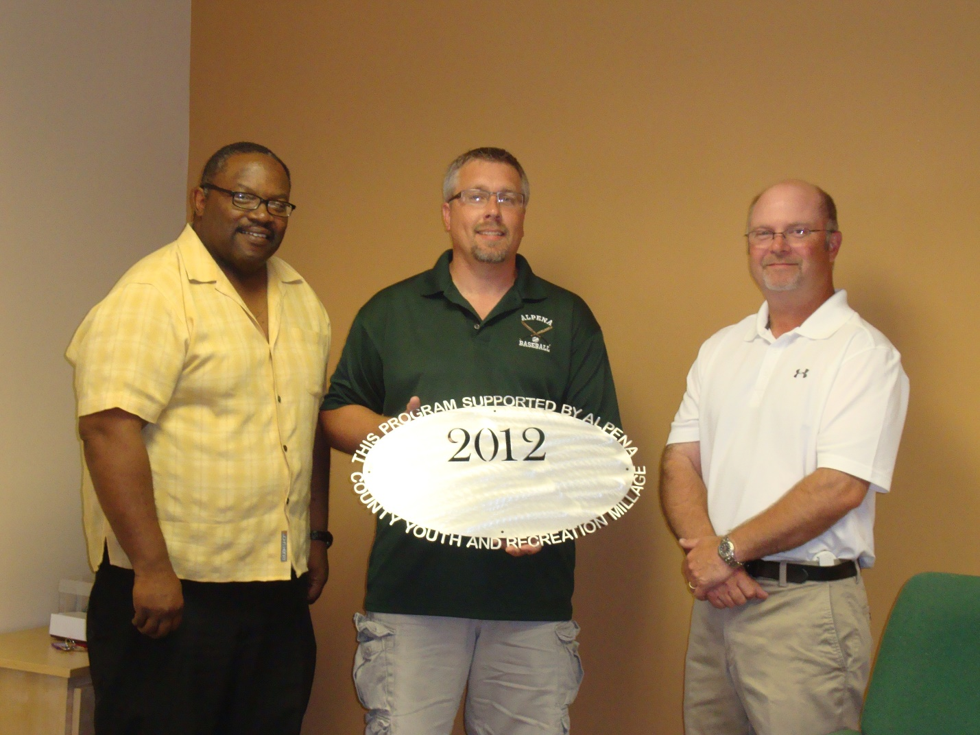Alpena Huron Shore Little League $20,000.00
Alpena Huron Shore Complex Field Renovations (pdf)

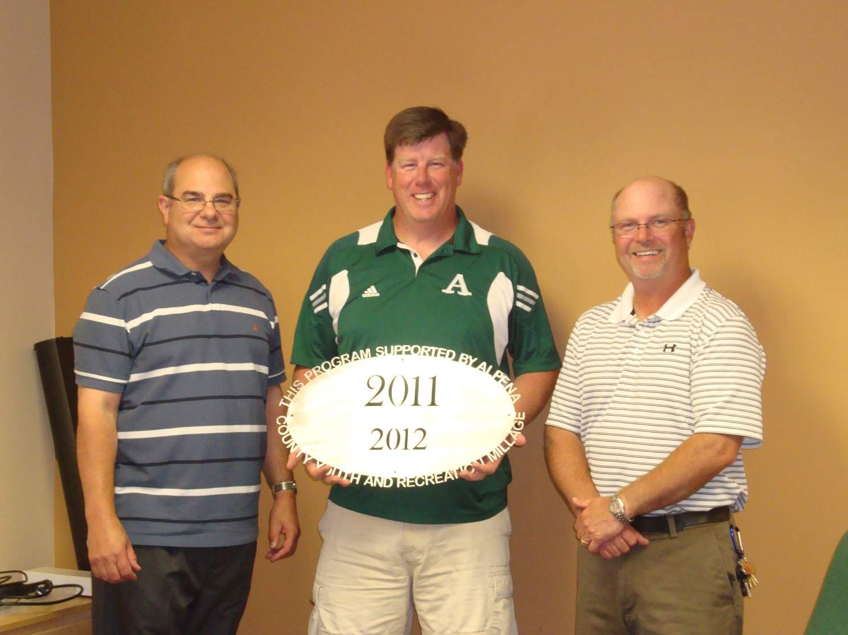Alpena Public Schools $31,500.00
Inter-Scholastic Athletics Fund (pdf)

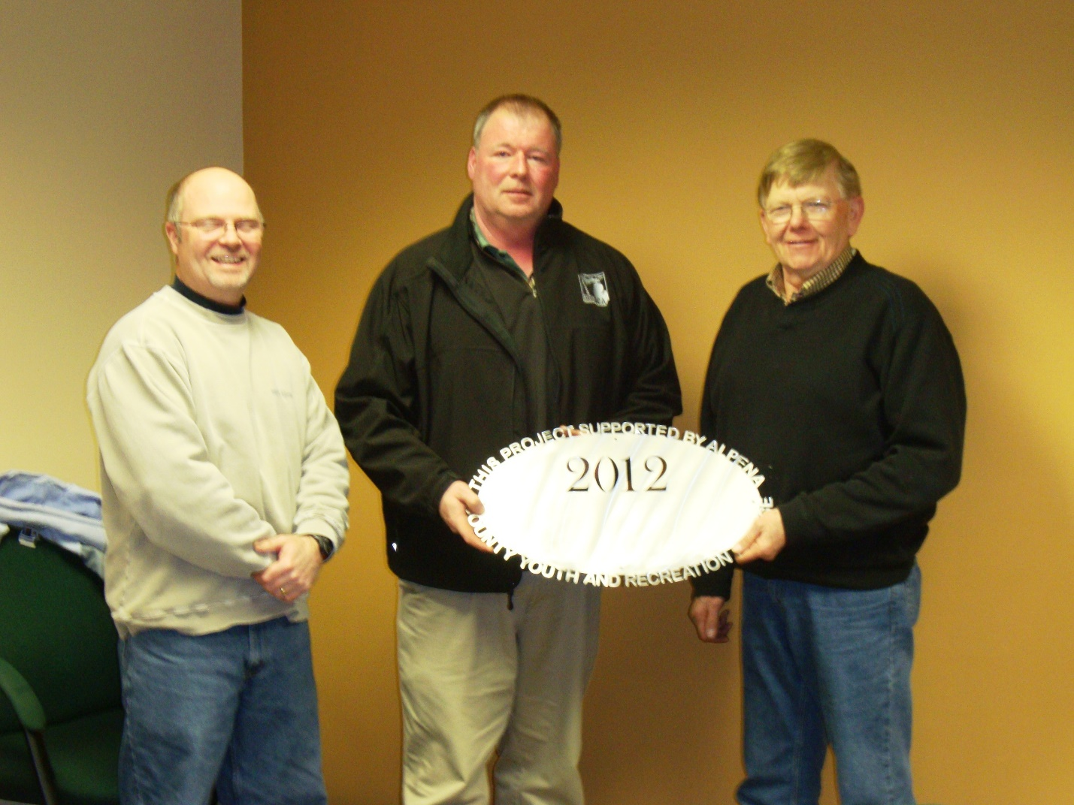Alpena Softball Line Drive Club $4,330.00
Alpena High School Fields Improvement (pdf)
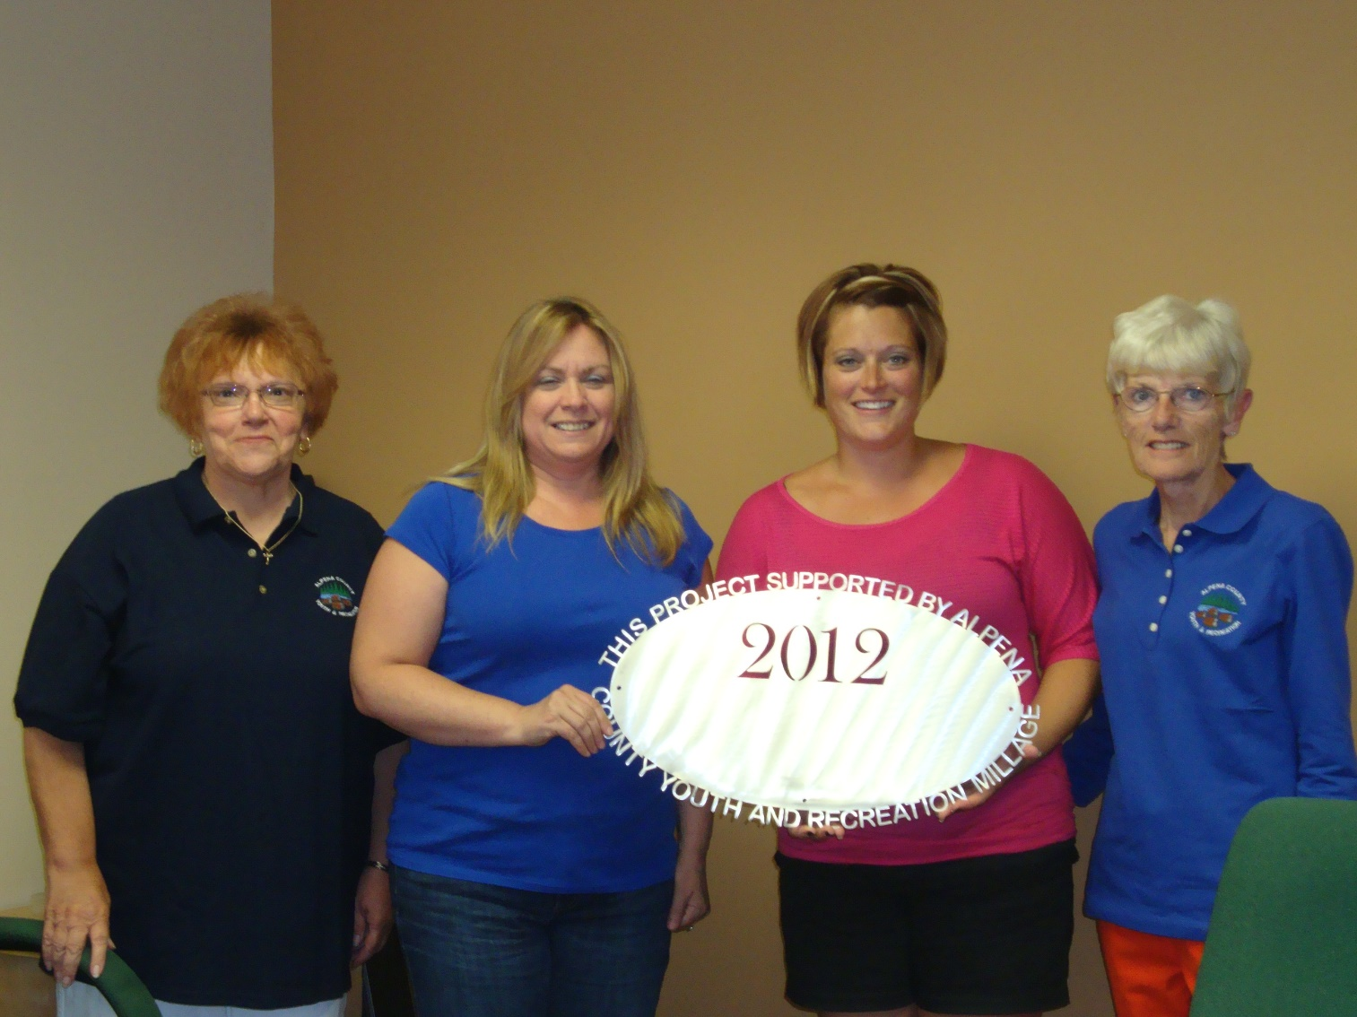Alpena Swim Club Inc. $4,180.00
Equipment Caddy, mats, software upgrades, deck cable and pool time (pdf)

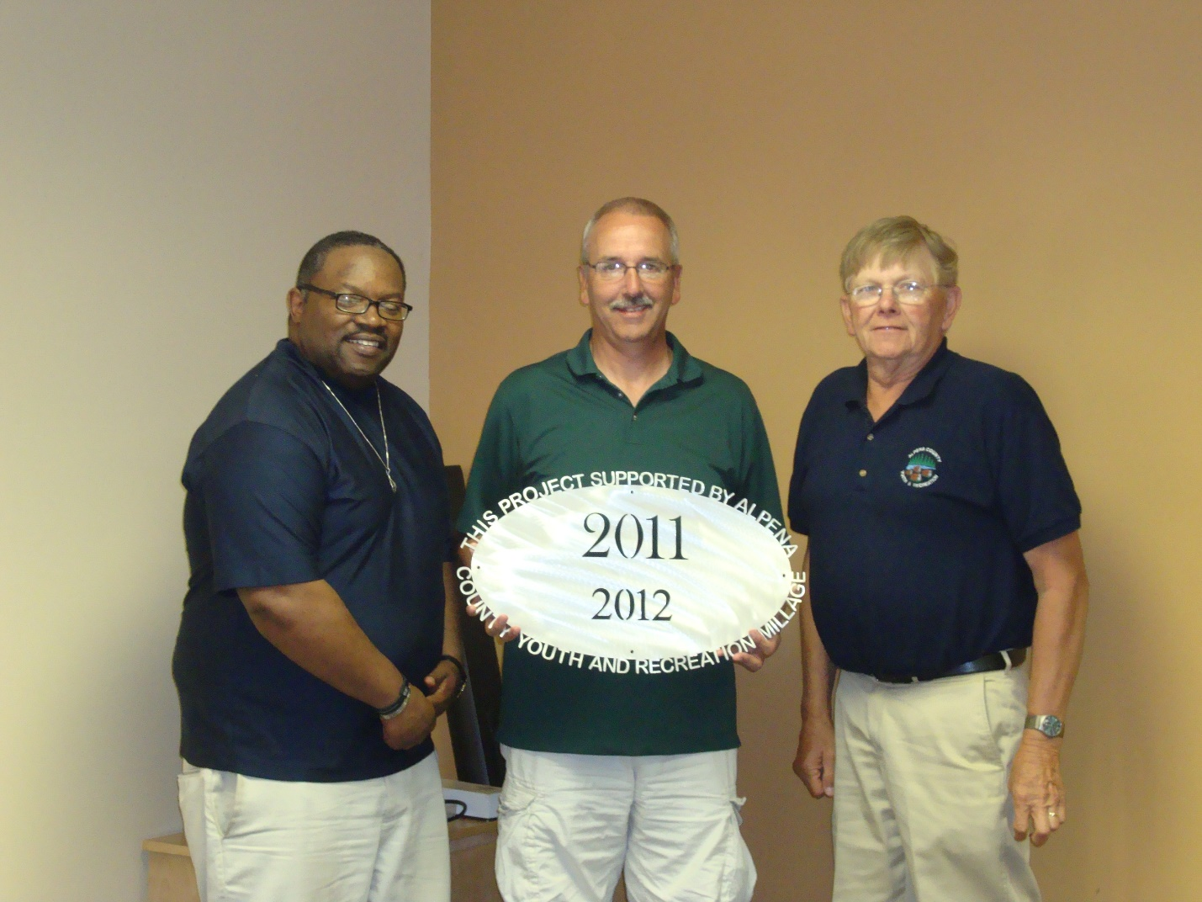Babe Ruth Baseball (1) $3,500.00
Babe Ruth Baseball Operational Project (pdf)
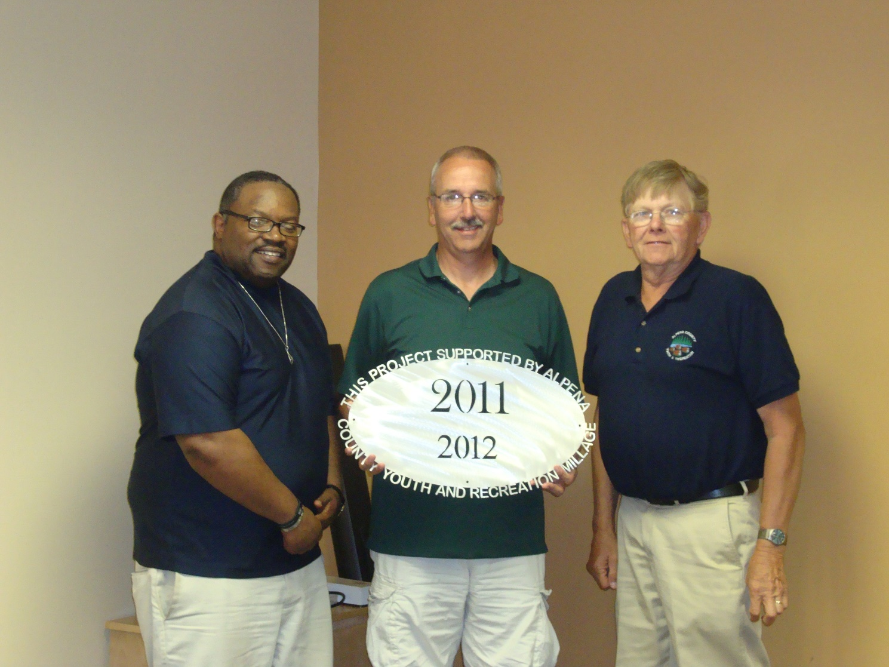Babe Ruth Baseball (2) $17,000.00
Babe Ruth Baseball Field Improvements Project (pdf)

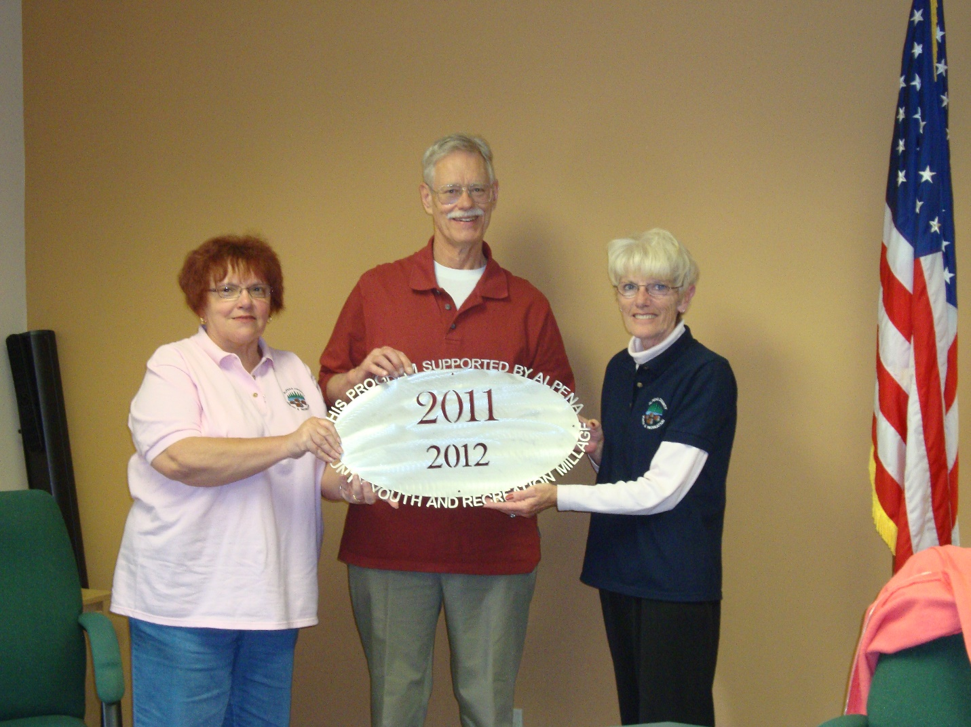

Friends of the Plaza Pool $10,760.00
Plaza Pool Youth and Recreation Enhancement Project
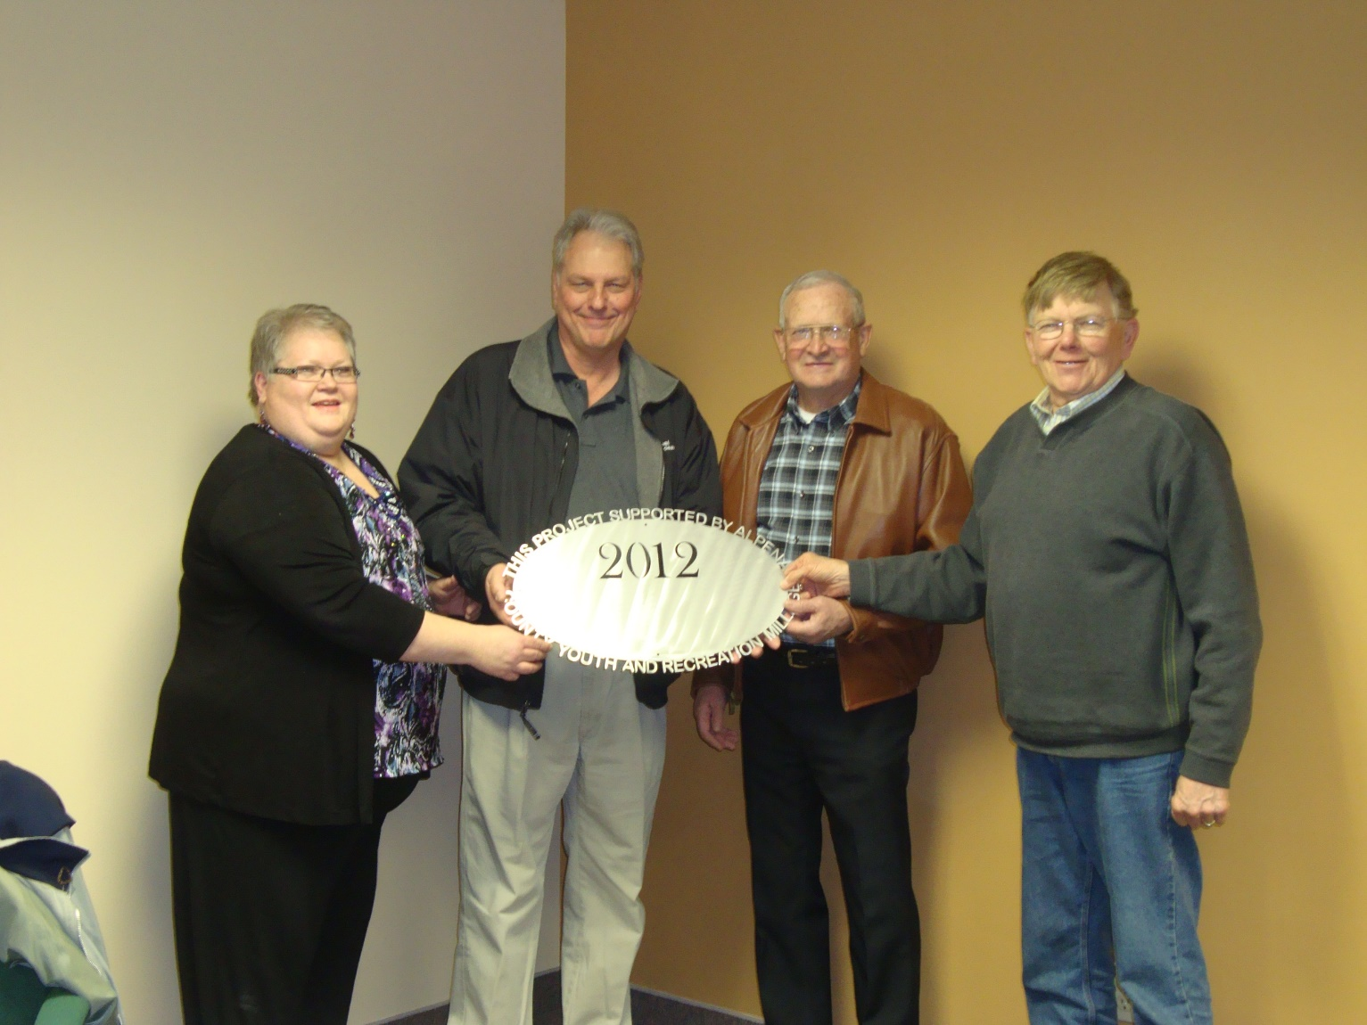Green Township $13,558.00
Green Township Hall and Recreation Facility Upgrade

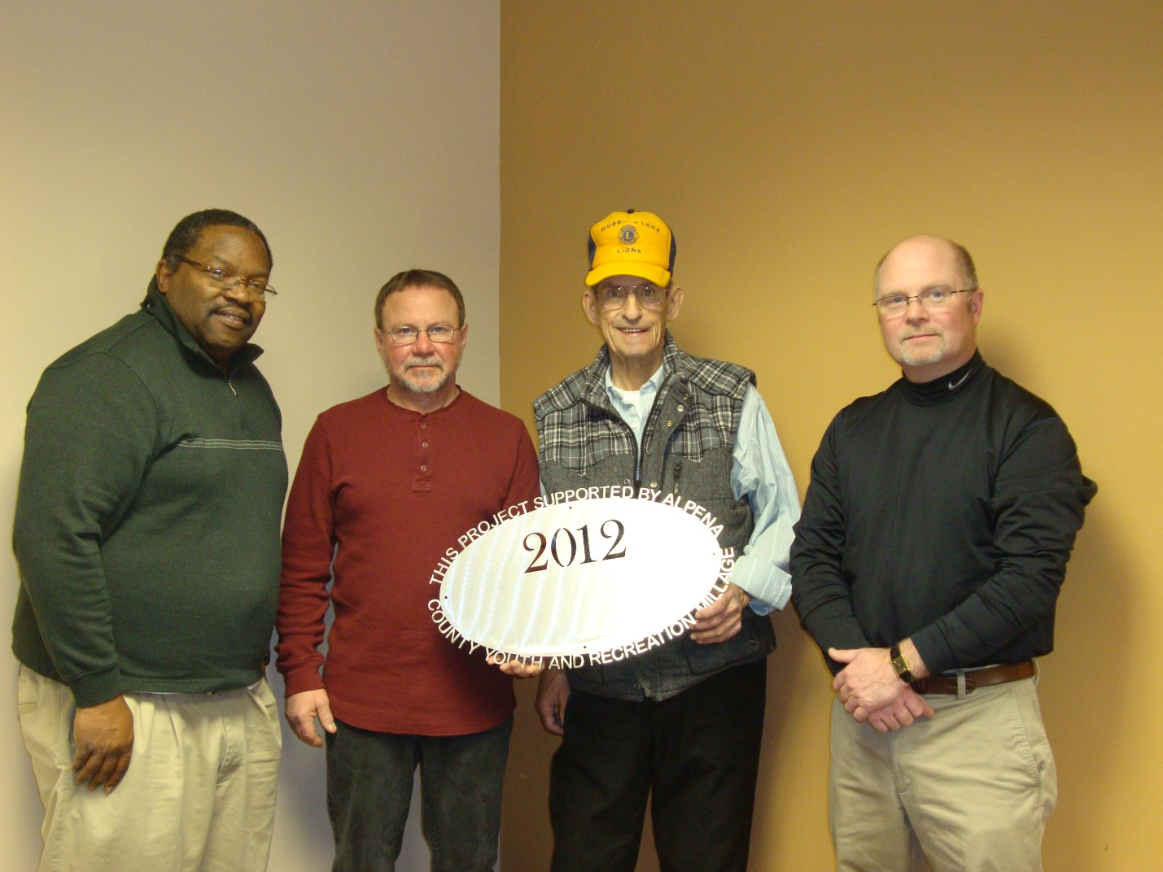
Hubbard Lake Lions Community Foundation $10,000.00
Hubbard Lake Lions Park Improvements – Playground & Pavilion
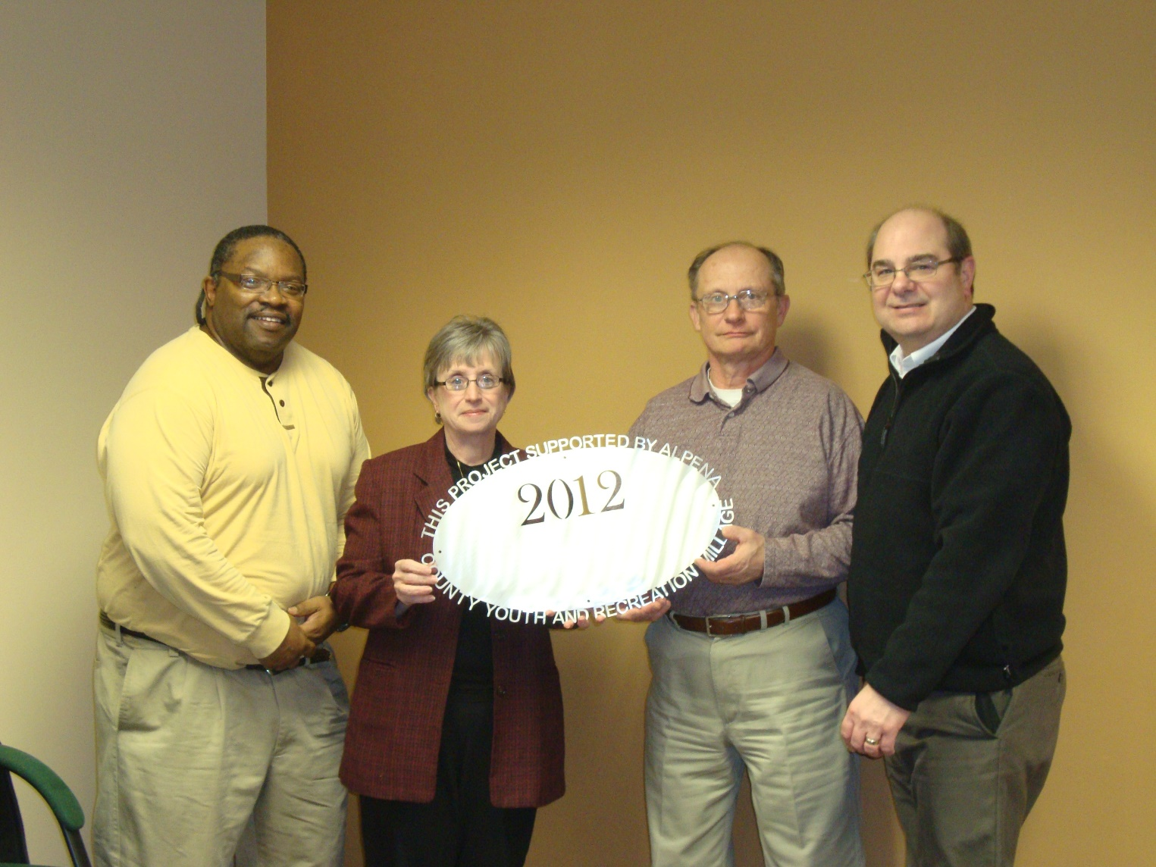Kiwanis Club of Alpena $12,000.00
Improve the facilities at Alpena Kiwanis Kiddie Park (next to the harbor)

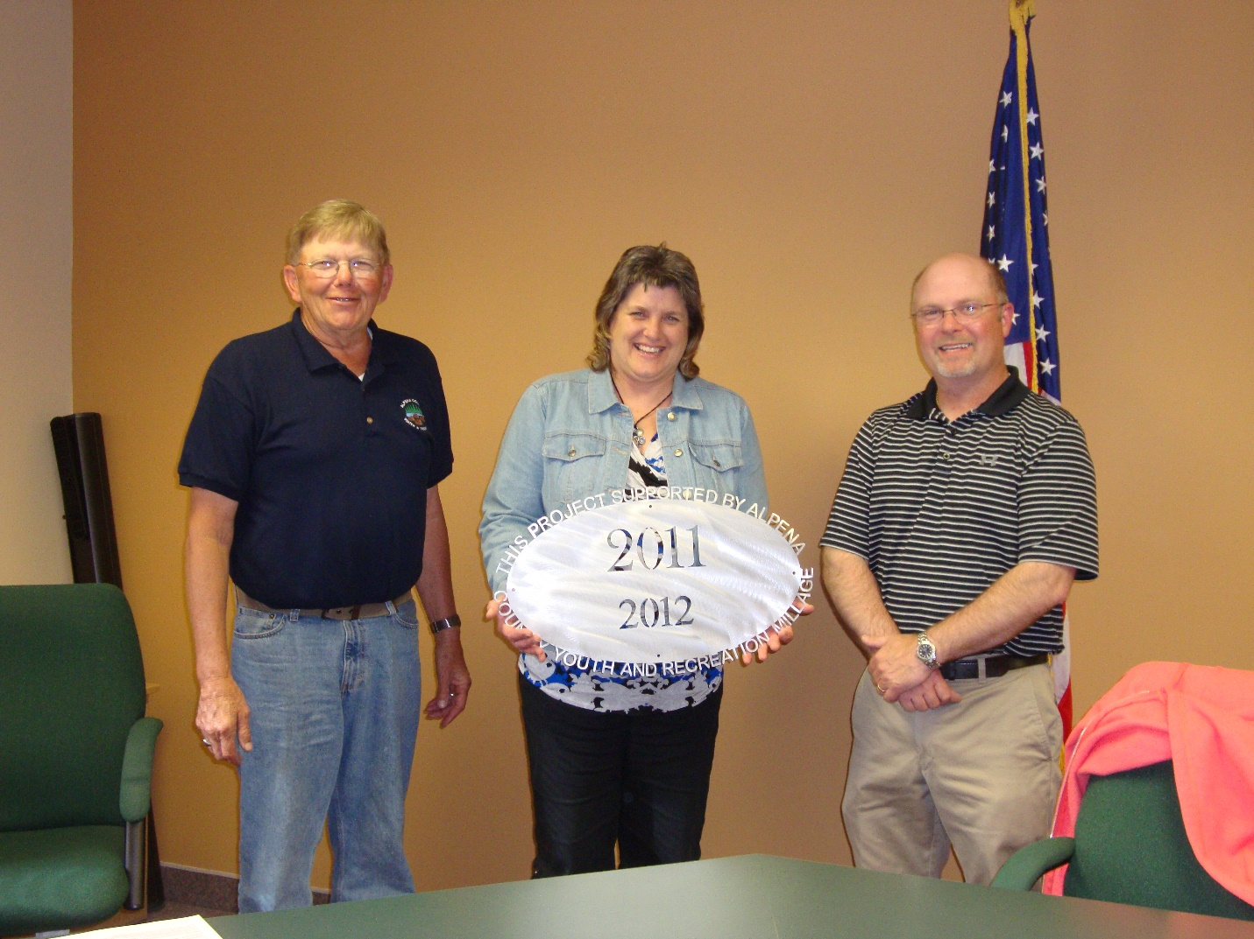
Michigan State University Extension $27,345.00
Alpena County 4-H Youth Development Program
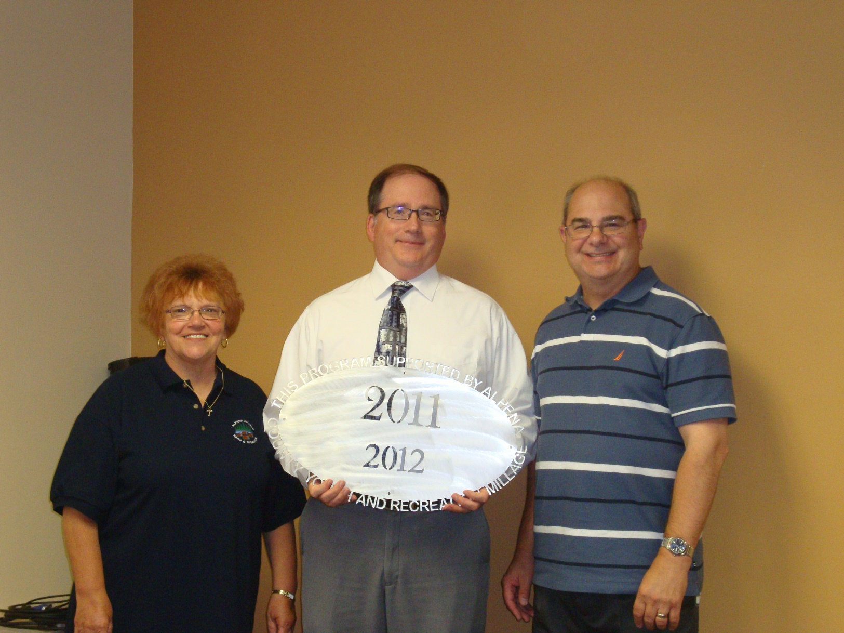Multi-Purpose Arena Coalition $10,425.00
M-PAC First Year Skating Program & NLA Learn to Skate Program

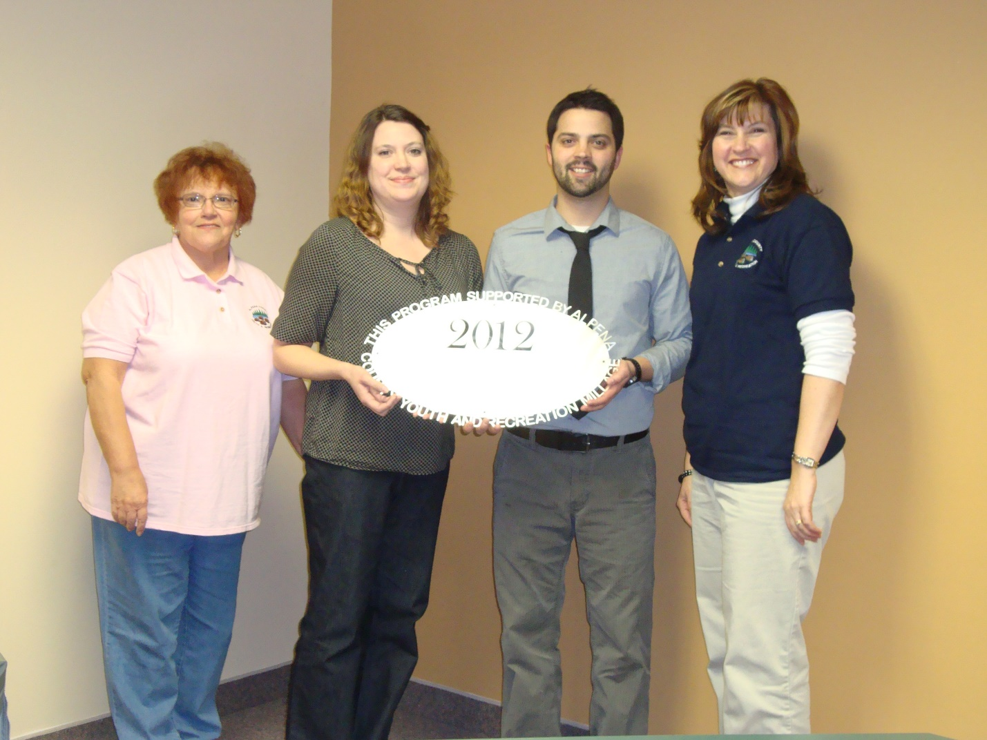
Northeast Michigan Center for Fine Arts, Inc. $15,000.00
Ready, Set…Create! An Arts Cool Workshops
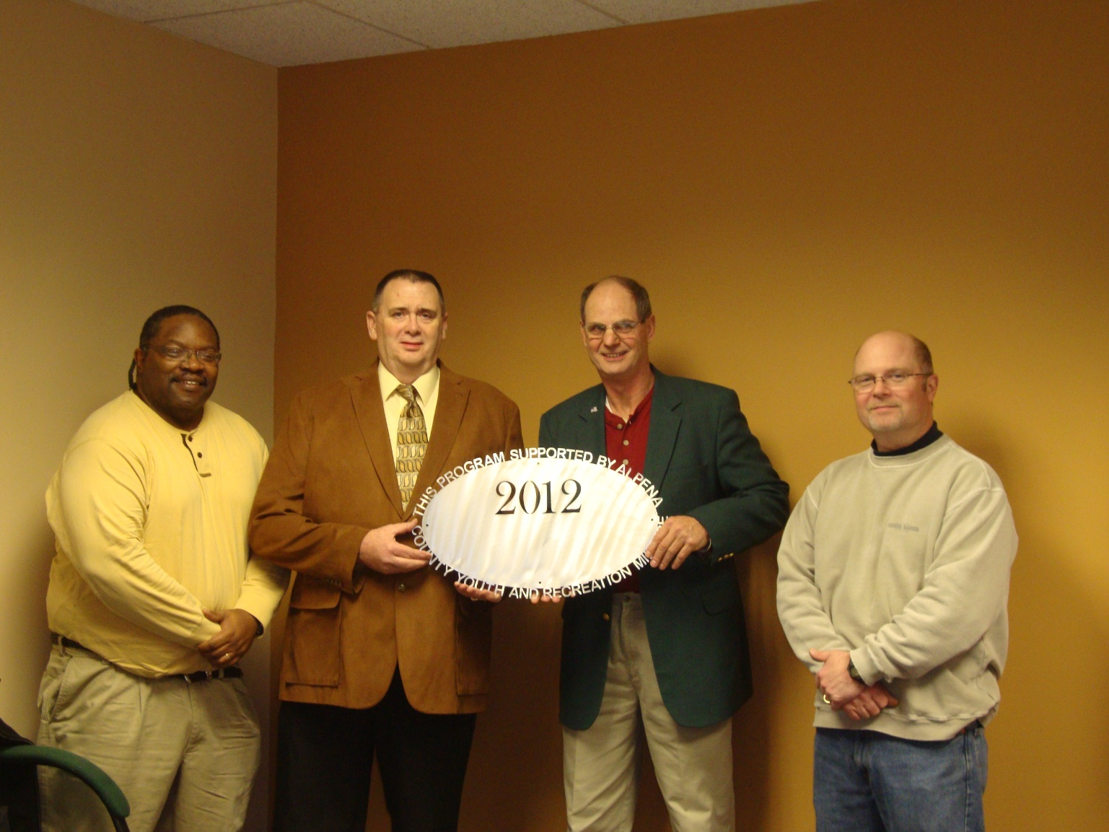Optimist Club of Alpena $4,480.00
Spring Break Fun Day/Kids Fishing

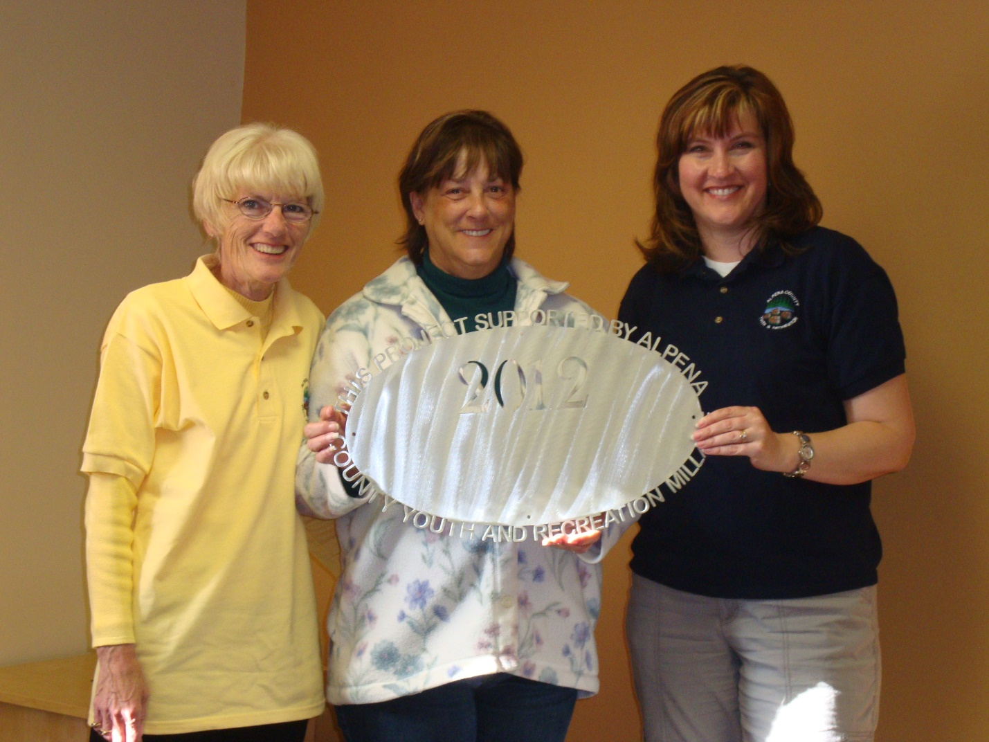
Sanborn Township $8,473.00
Shinga-ba-Shores Playground
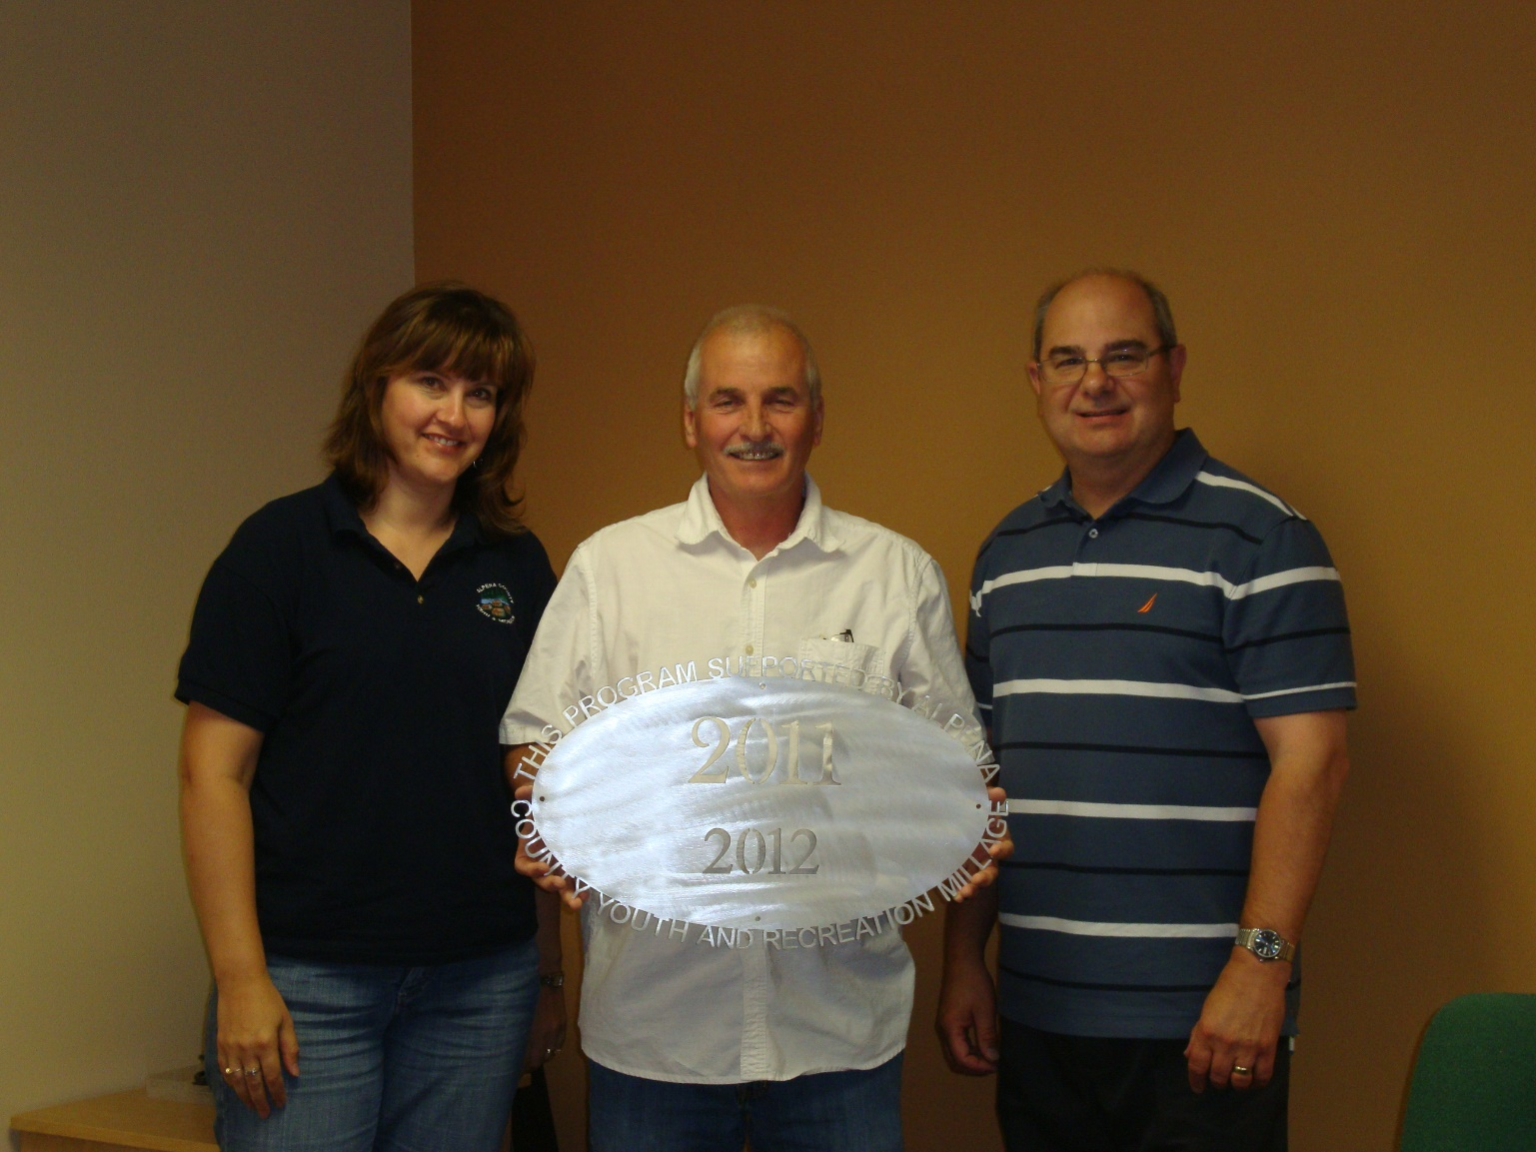Thunder Bay Soccer Association $20,750.00
Thunder Bay Soccer Association Improvement Project

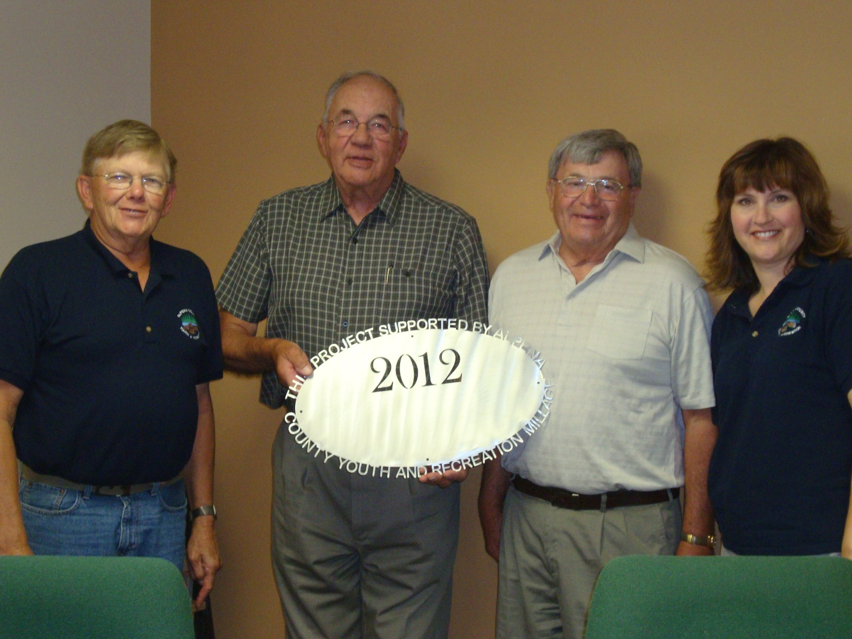
Wilson Township $6,640.00
Wolf Creek Park Pavilion

Commissioners & Commissioners Appointees
District 1- COMMISSIONER
Jeff Kowalski
215 Barry Street
Alpena, MI 49707
517.227.0961
jeffkowalski@alpenacounty.org
Linda Canfield
117 Hitchcock Street
Alpena, MI 49707
989.356.2742
lindacanfield1@frontier.com

District 2 – COMMISSIONER
Robert Adrian
227 Dawson Street
Alpena, MI 49707
989.354.5732
robertadrian@alpenacounty.org
Calvin L. Howard
329 W. Miller St.
Alpena, MI 49707
989.354.5722
coolbreeze758@hotmail.com

District 3 – COMMISSIONER
Tom Mullaney
285 Island View Drive
Alpena, MI 49707
989.356.9781
tommullaney@alpenacounty.org
Camille Nerkowski
3210 S. Third
Alpena, MI 49707
989.356.2909
polishgirl147@hotmail.com

District 4 – COMMISSIONER
Lyle VanWormer
4665 Kirchoff Road
Alpena, MI 49707
989.255.5896
lylevanwormer@alpenacounty.org
Tony Suszek
114 Kensington Court
Alpena, MI 49707
989.356.4434
suszektj@charter.net

District 5 – COMMISSIONER
Scot McKenzie
2762 Werth Road
Alpena, MI 49707
989.354.3552
scotmckenzie@alpenacounty.org
Tom Heise
3376 Piper Road
Alpena, MI 49707
989.354.2447
htssllc@yahoo.com

District 6 – COMMISSIONER
Mark Hall
5005 Long Rapids Road
Alpena, MI 49707
989.354.6023
Kamila Robillard
7361 Haken Road
Alpena, MI 49707
989.657.0600
Kam9431@gmail.com
District 7 – COMMISSIONER
Cameron Habermehl
14510 M-32 West
Lachine, MI 49753
989.766.3455
camhabermehl@alpenacounty.org
Fred Wegmeyer
10599 Napper Rd.
Herron, MI 49744
989.379.4034

District 8 – COMMISSIONER
Eric Lawson
P.O. Box 73
Ossineke, MI 49766
989.255.3762
ericlawson@alpenacounty.org
Lisa Siegert
12700 Hawkins Road
Hubbard Lake, MI 49747
989.727.3089
siegertlne@gmail.com

County Contacts
Kim Ludlow
County Treasurer
989.354.9534
ludlowk@alpenacounty.org

Tammy Sumerix-Bates
Executive Manager
Alpena County Commissioners
989.354.9502
batest@alpenacounty.org

