Friends of the Plaza Pool
Project: Community Education Swim Sessions
Grant: $10,760.00
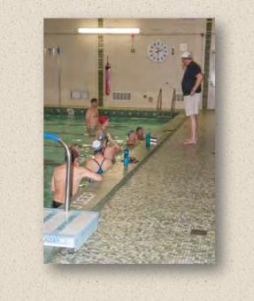
This grant was given to the Friends of the Plaza Pool for community education sessions involving swimming that promotes health and wellness. The Friends of the Plaza Pool also bought a pool vacuum, baby changing table and a PAL pool lift for the handicapped swimmers. Currently, there are over 800 patrons that will benefit from this grant.
