2011 Youth and Recreation Millage Funds Awarded

(2011 Y&R Pic)

Youth & Recreation
- facebook
- twitter
- linkedin
- email
- pinterest
(2011 Y&R Map)

The Committee is spreading the funds throughout the County, encouraging all the Townships and non-profit organizations, schools, and governmental agencies to apply.
The Alpena County Map shown on the left, depicts where the grants were awarded by the red dots for 2011 and the blue dots for 2012 and green dots for 2013. Please click on the image for a larger view.
Total amount appropriated $303,193.00
Listed below, you can view the organization, amount awarded and the name of project. You can also view the 2011 Award Book by clicking here

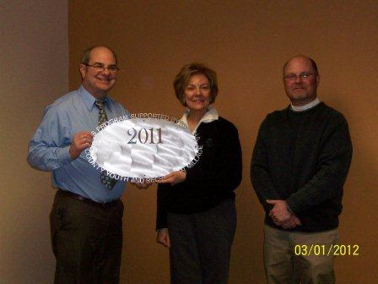
Alpena Boys and Girls Club $5,000.00
Triple Play and Wanna Play (pdf)
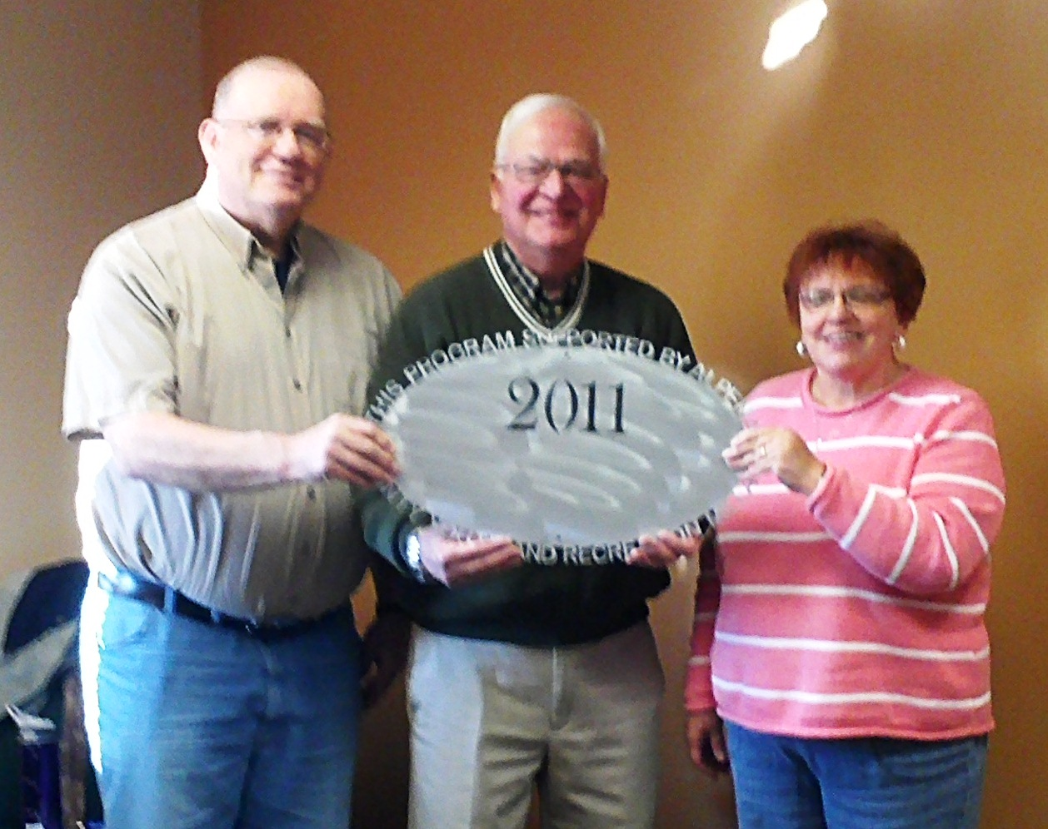Alpena Community College $2,160.00
Lifelong Learners (pdf)

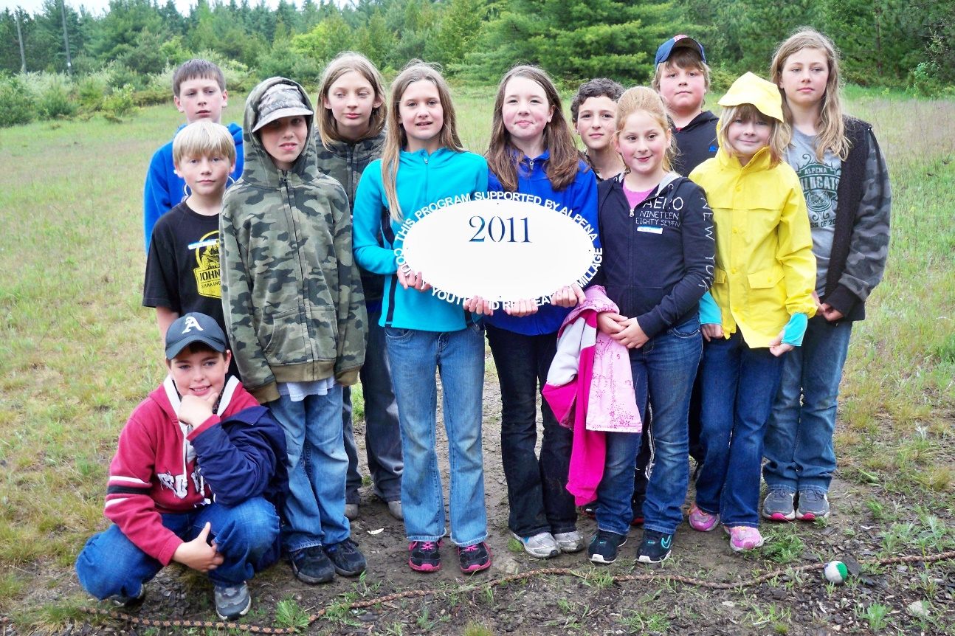
Alpena Community College $1,600.00
Ropes Course (pdf)

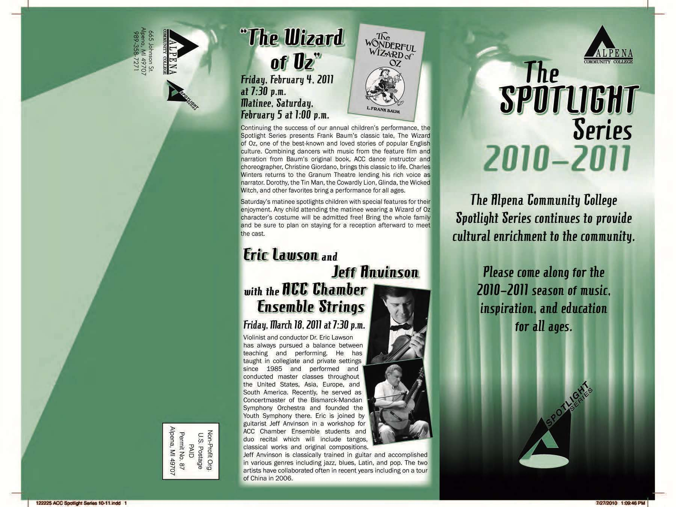
Alpena Community College $1,555.00
Wizard of Oz Production (pdf)

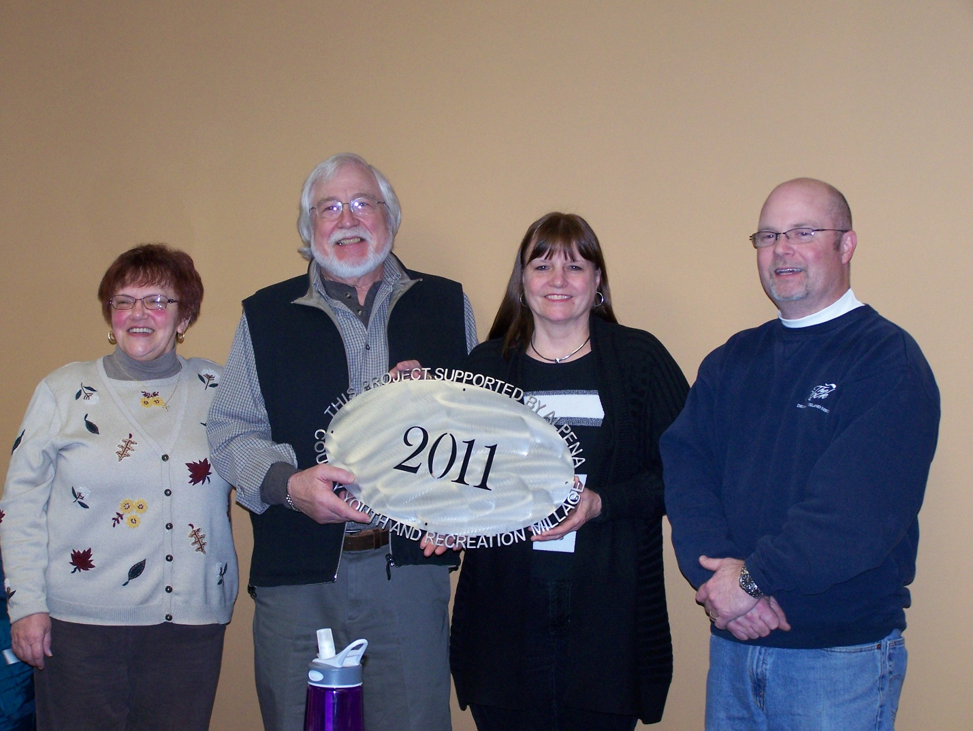
Alpena County Parks (1) $3,750.00
Teen Center (pdf)
Alpena County Parks (2) $20,000.00
Beaver Lake Electrical Project (pdf)

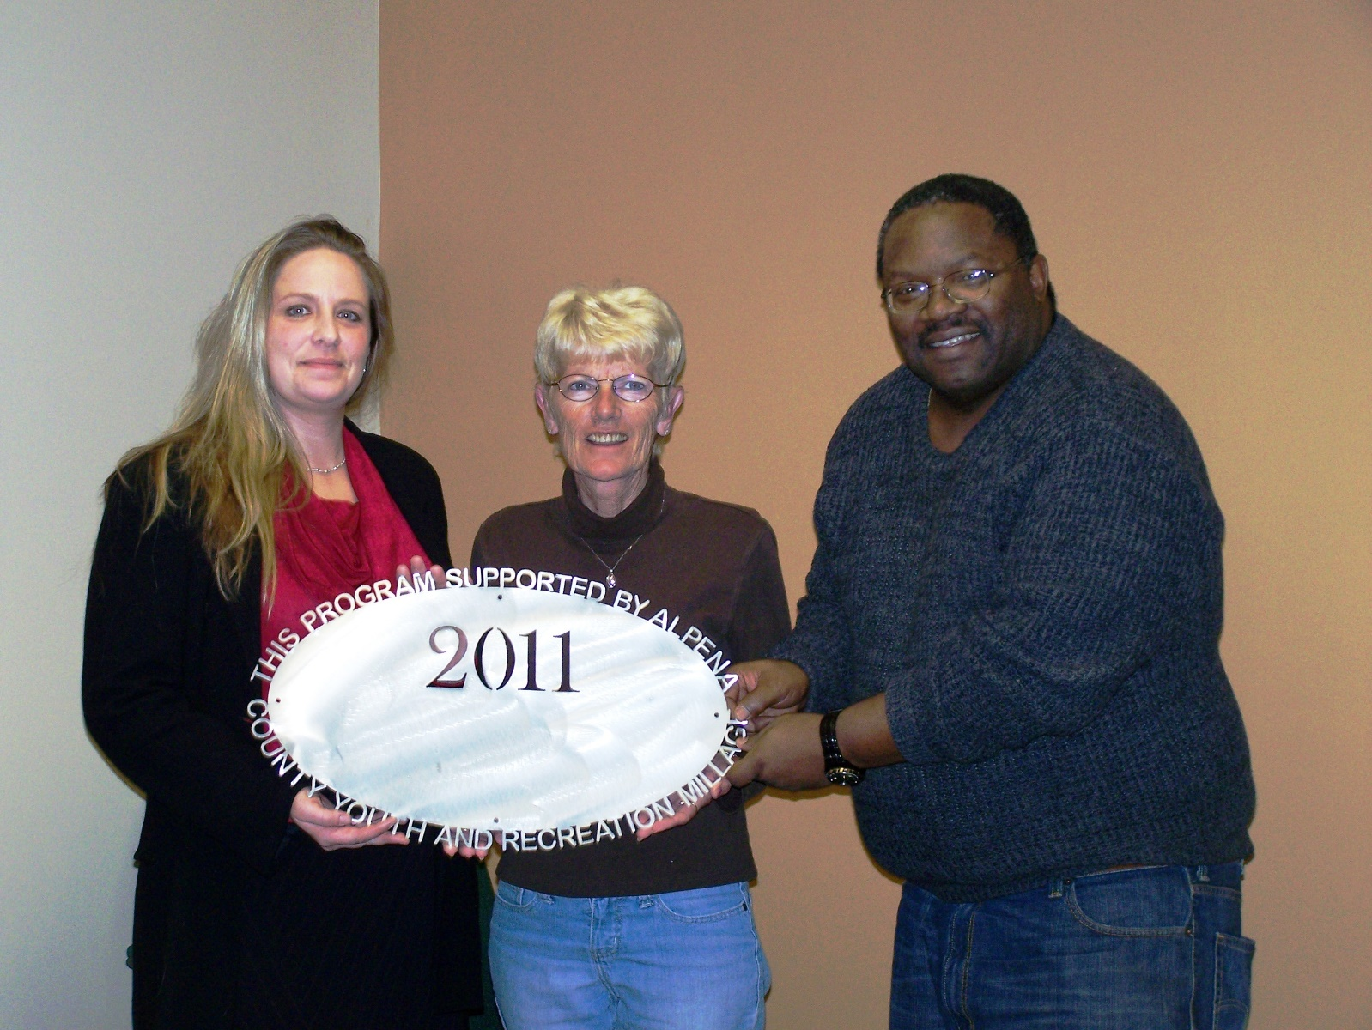Alpena County Plaza Pool (1) $75,925.00
Alpena County Plaza Pool Aquatic Programming (pdf)

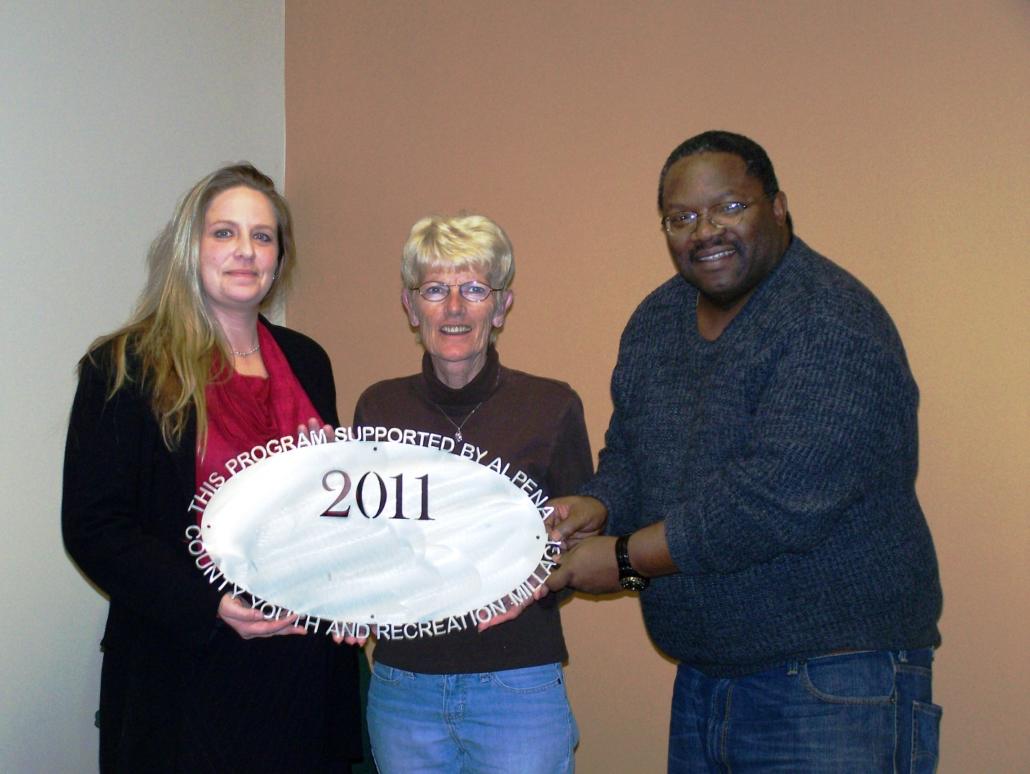Alpena County Plaza Pool (2) $5,000.00
Ready Set Swim Program (pdf)
Alpena County Plaza Pool (3) $6,940.00
Furnace, fill valve, faucet and shower (pdf)

Alpena County Plaza Pool (4) $7,113.00
Inflatable Run (pdf)
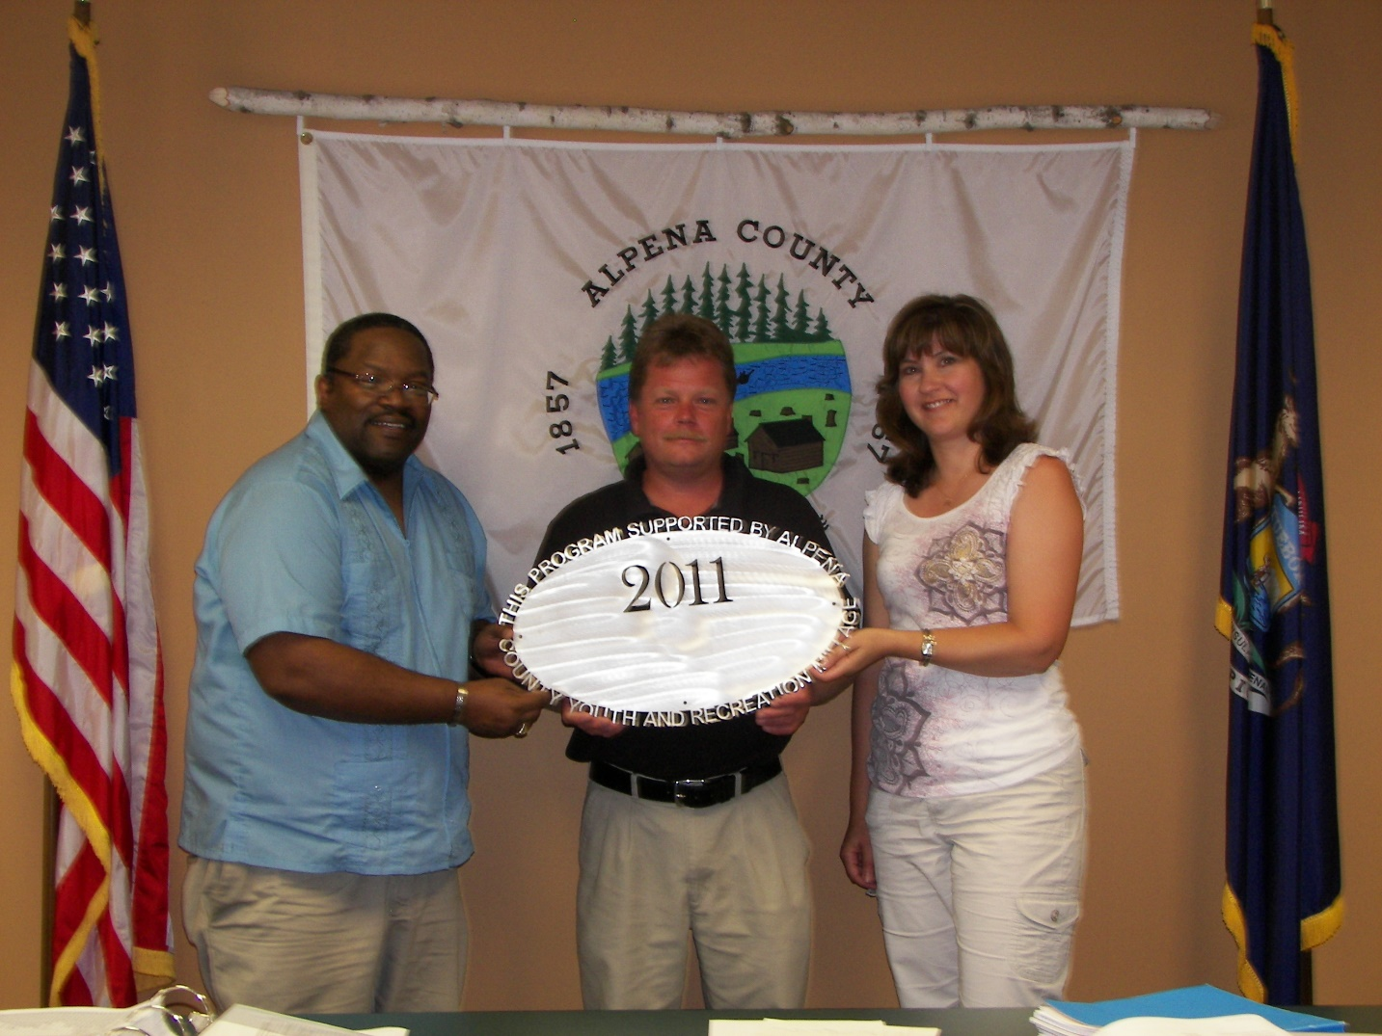Alpena Hockey $7,120.00
Goalie Equipment and Jerseys (pdf)

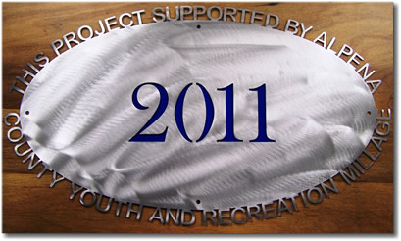
Alpena Independent Hockey $1,000.00
Girls Hockey (pdf)

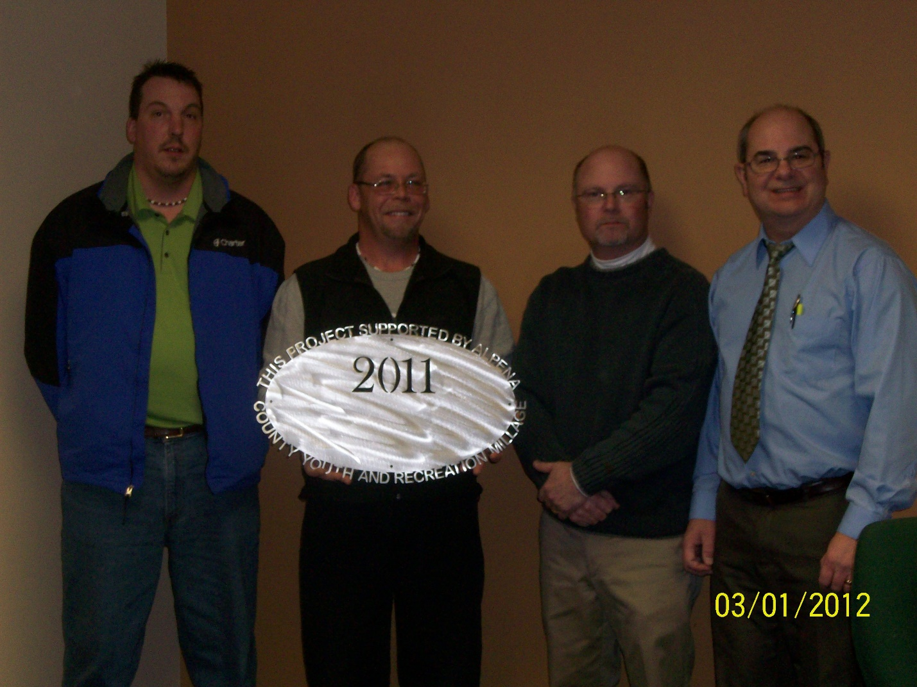
Alpena Huron Shore Little League $5,000.00
Field Repairs (pdf)
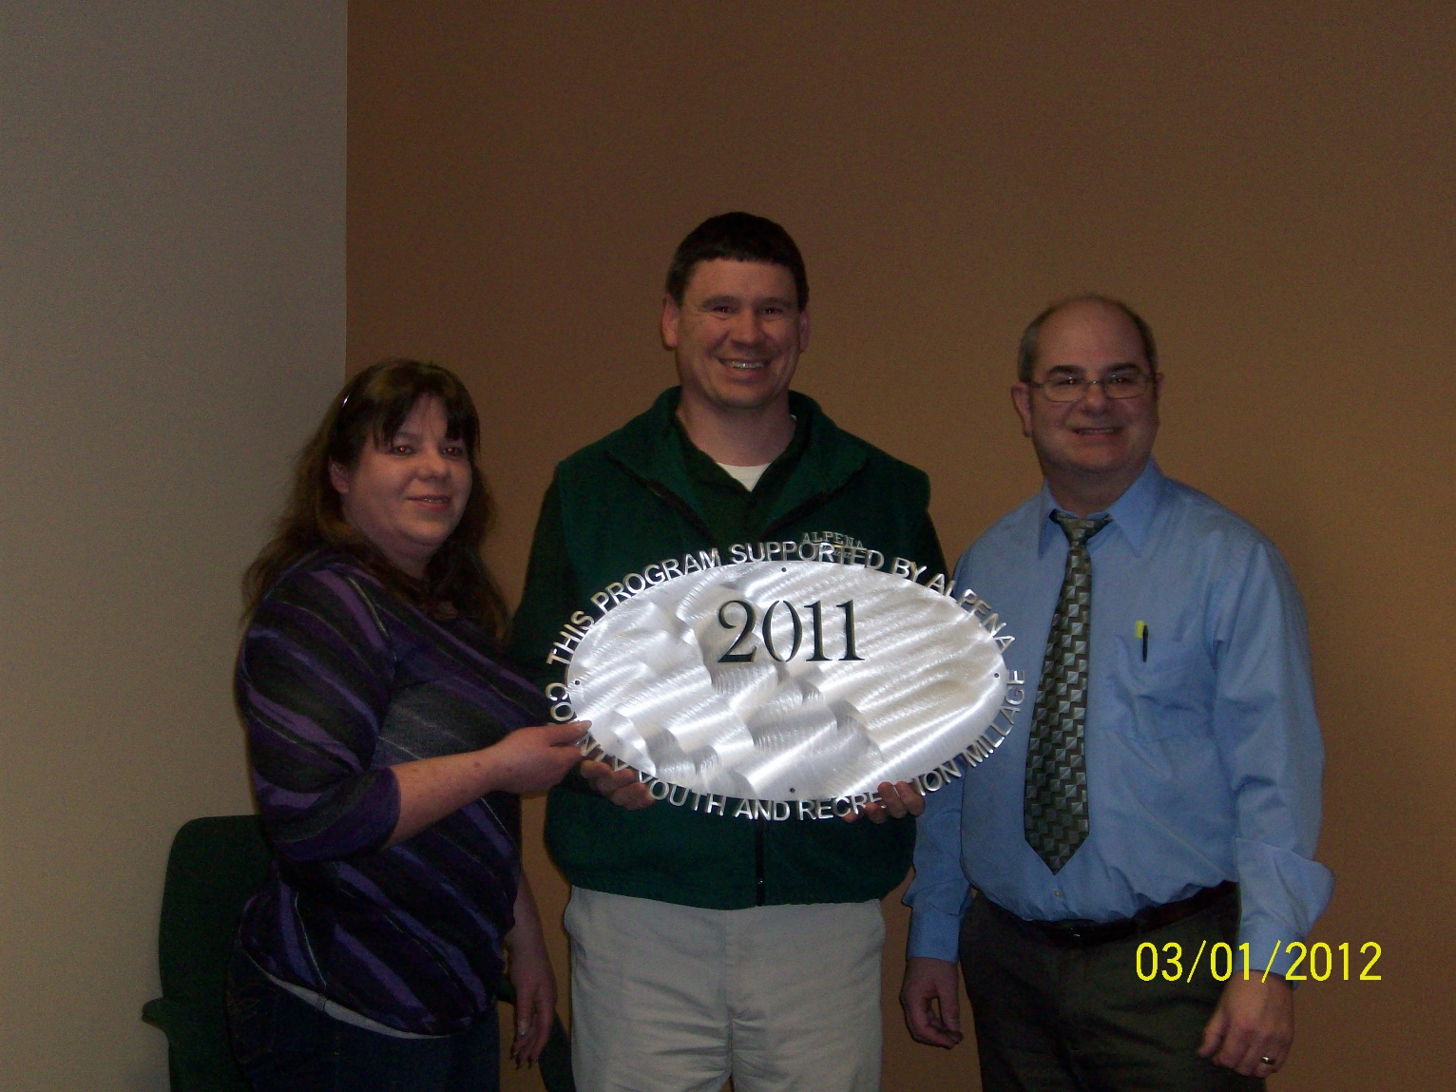Alpena Public Schools $75,000.00
Interscholastic Athletic Fund (pdf)
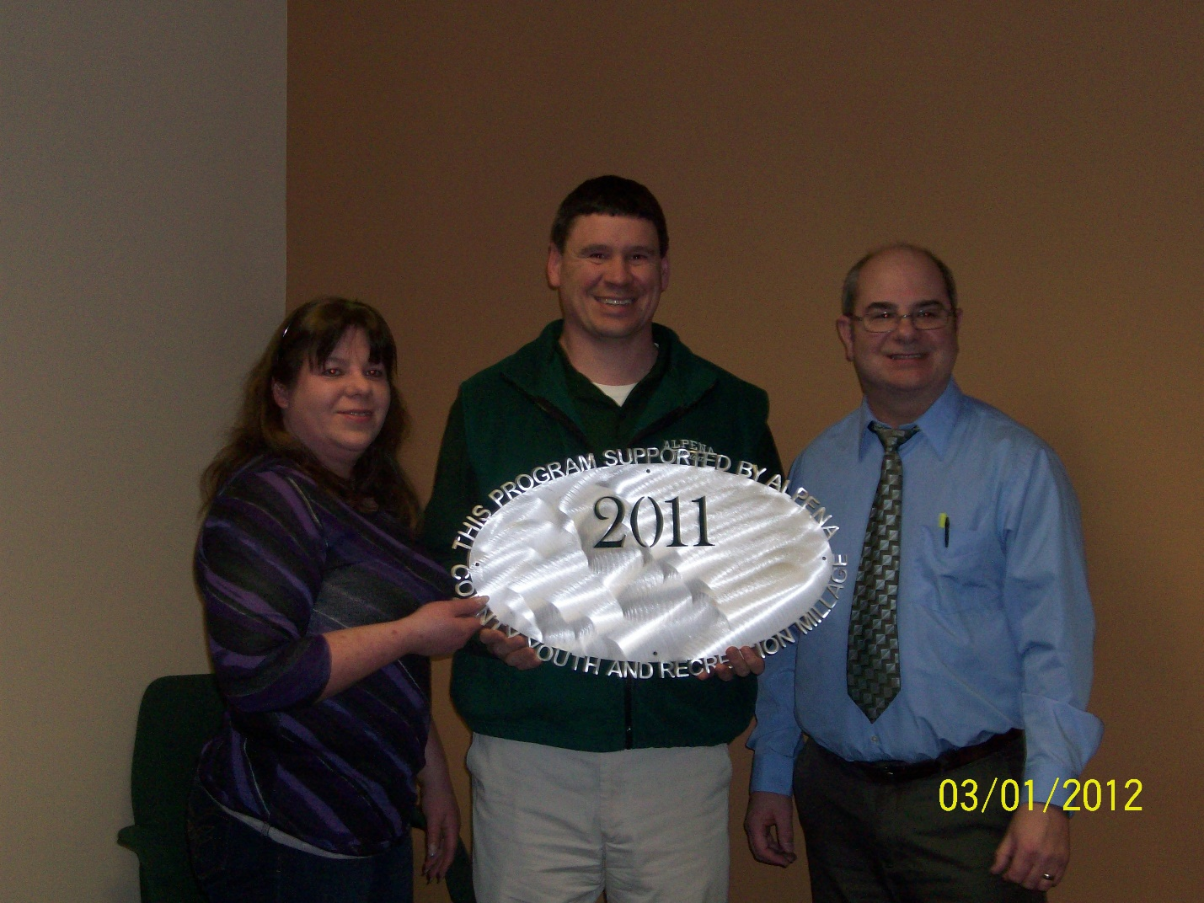Alpena Public Schools $7,500.00
KAPUT Program (pdf)

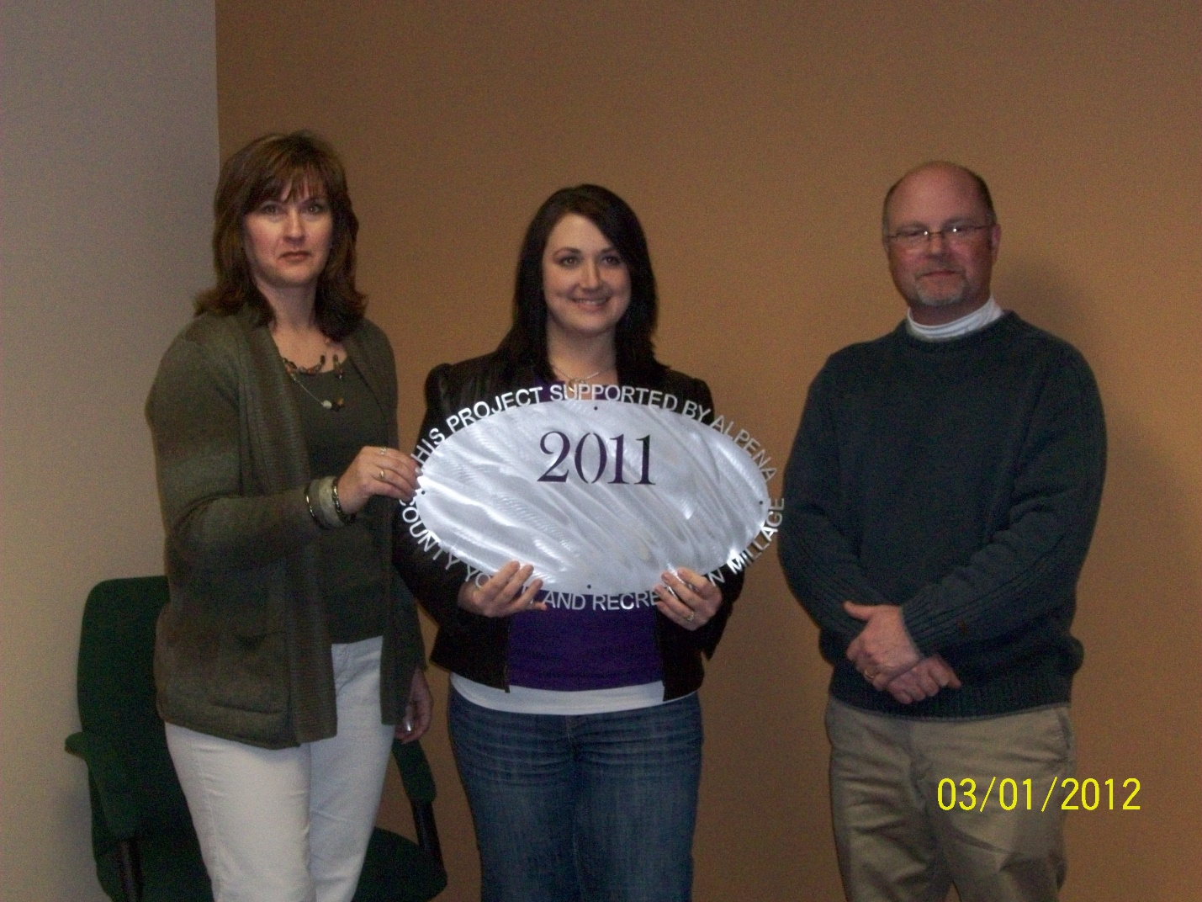Alpena Tennis Association $7,000.00
Ready Set Serve Program (pdf)

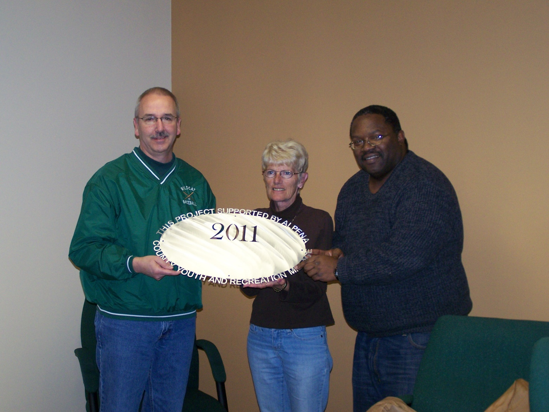Babe Ruth Baseball (1)$ 3,000.00
Babe Ruth Baseball Operational Project (pdf)

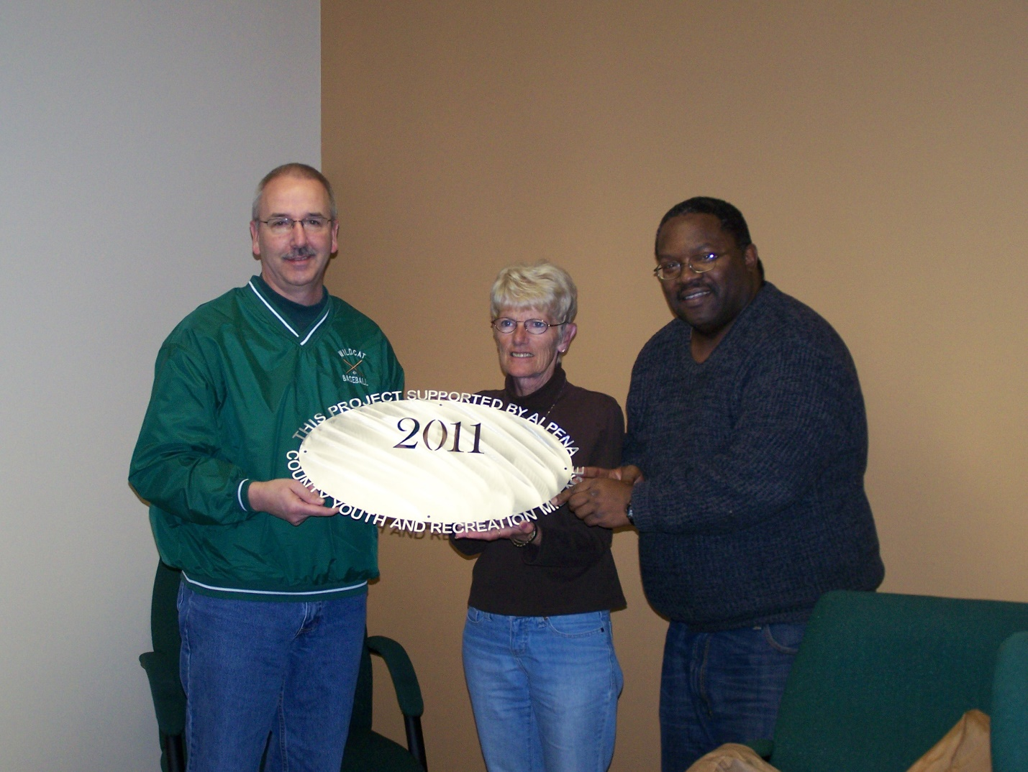Babe Ruth Baseball (2)$ 6,000.00
Babe Ruth Baseball Field Improvements Project (pdf)
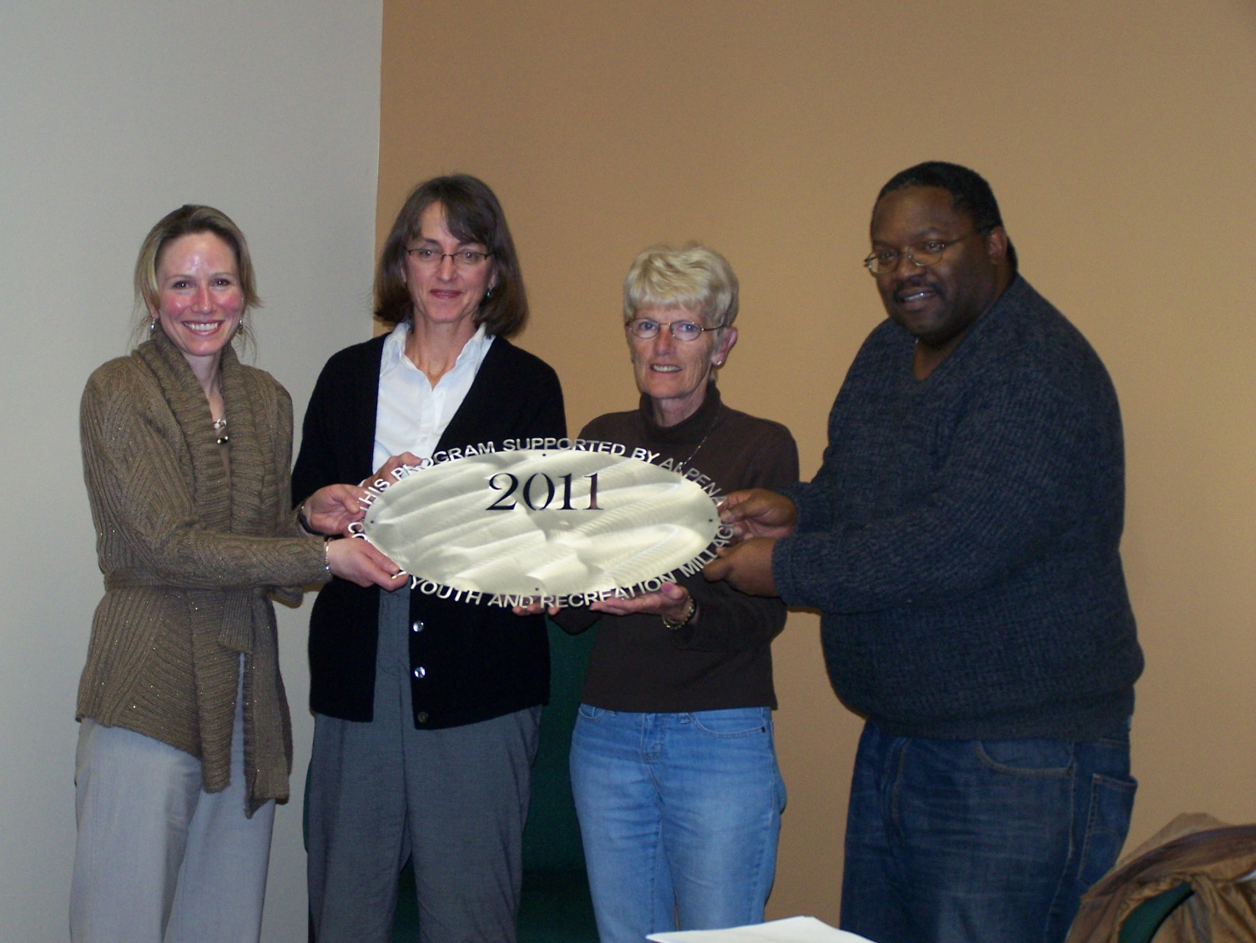City of Alpena $500.00
River Rats (pdf)

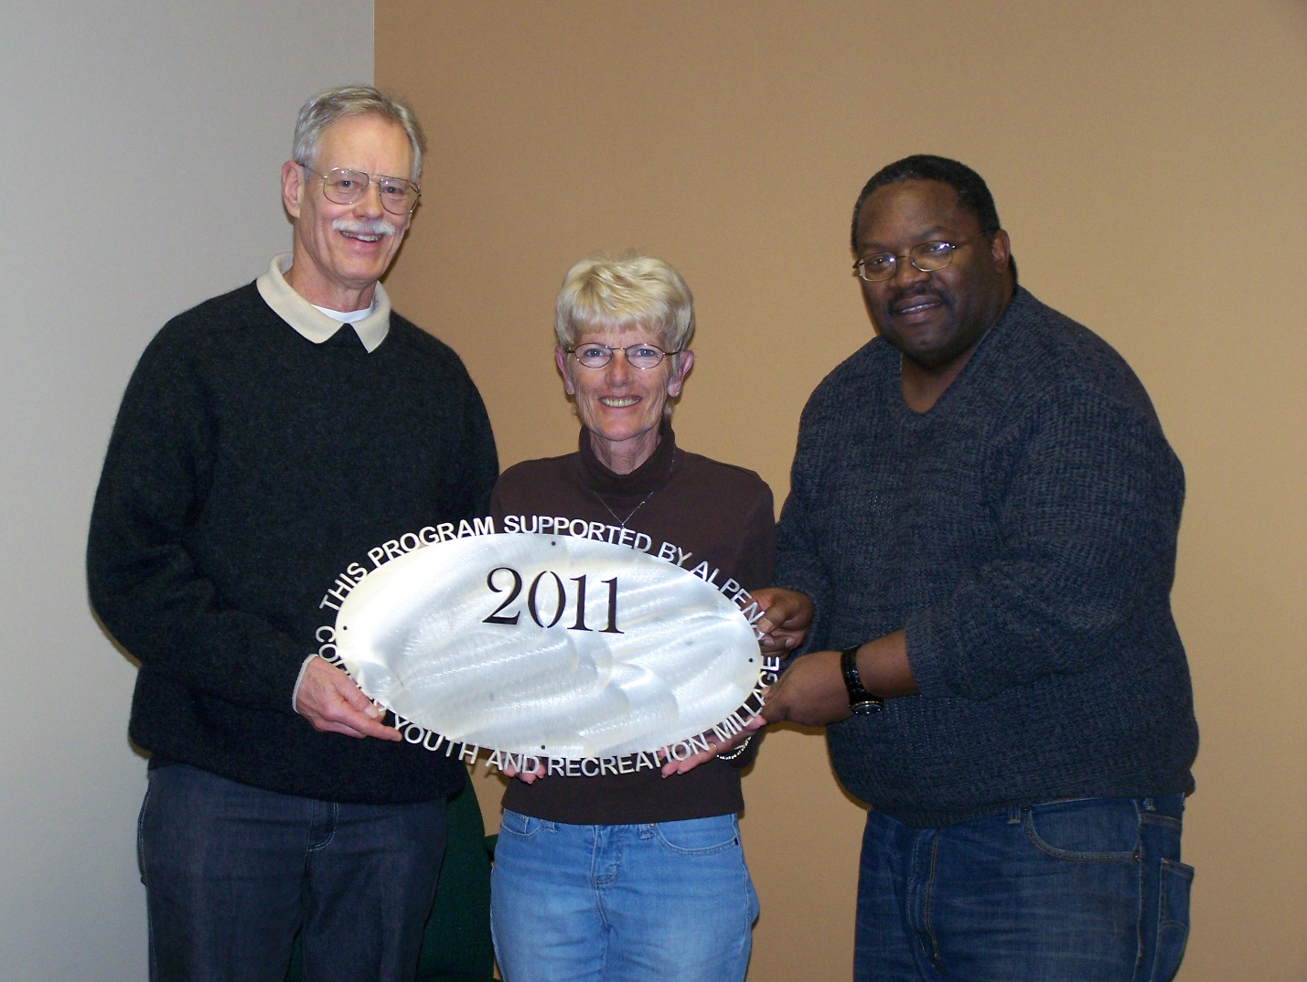
Friends of the Plaza Pool $10,185.00
Workouts, Community Education, Ladder and Chair (pdf)
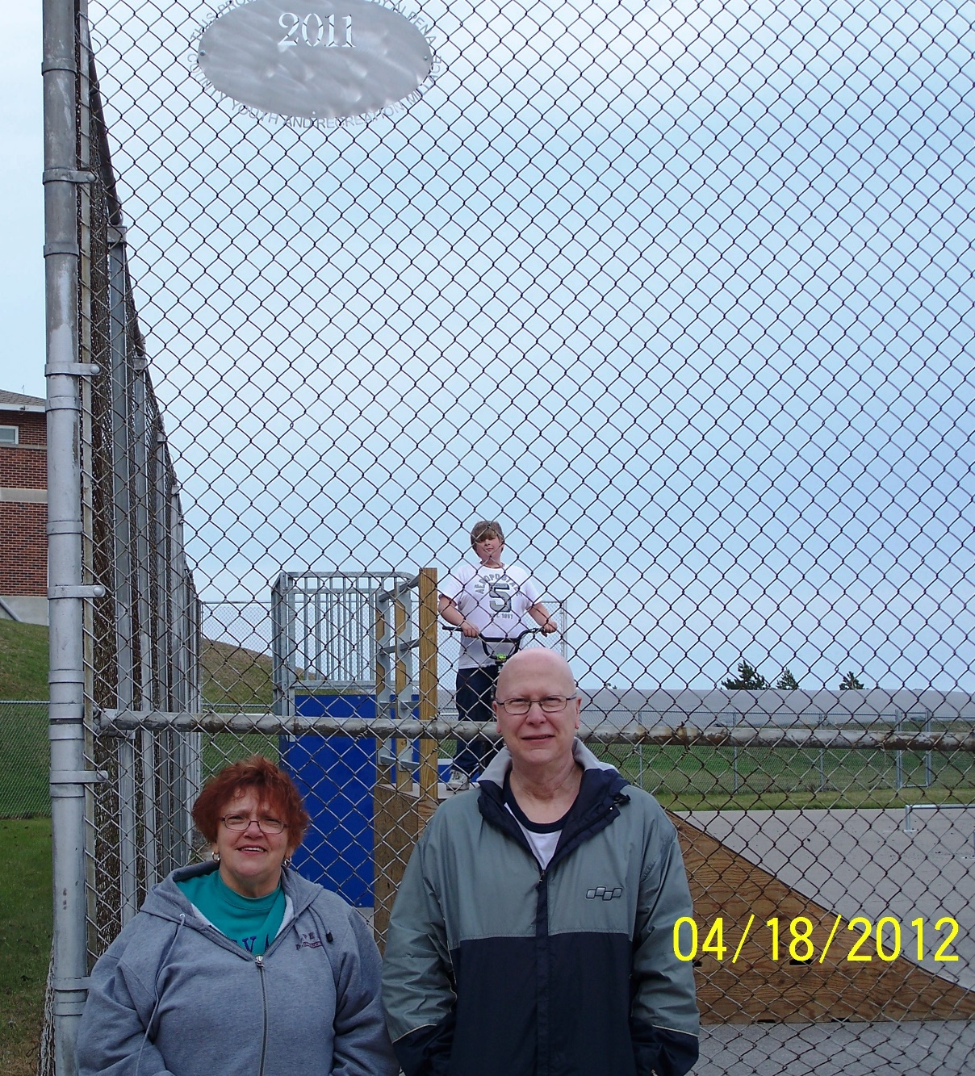
GEAR $10,000.00
Get Excited and Rally (pdf)

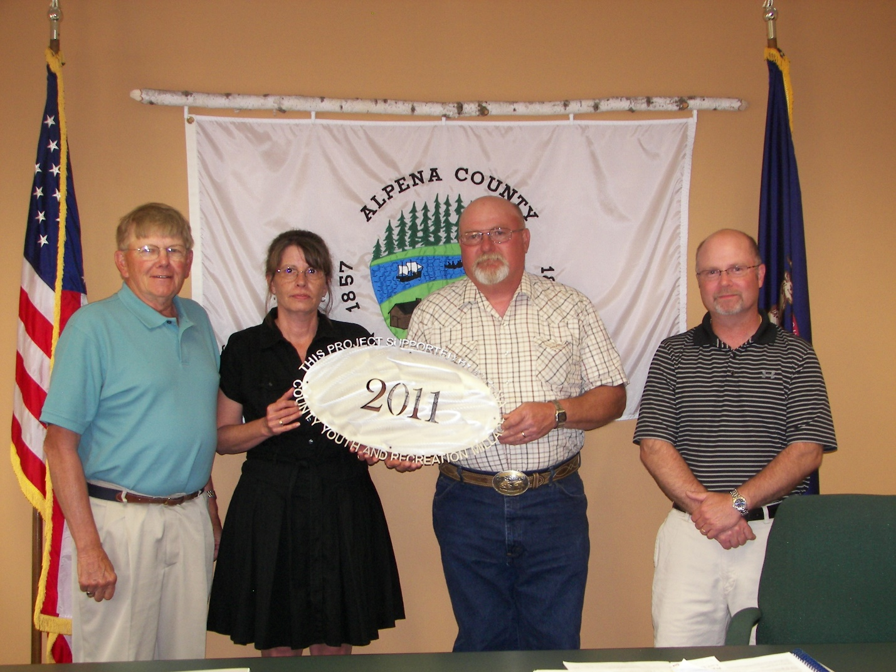Maple Ridge Township $3,500.00
Dugout and Fence (pdf)
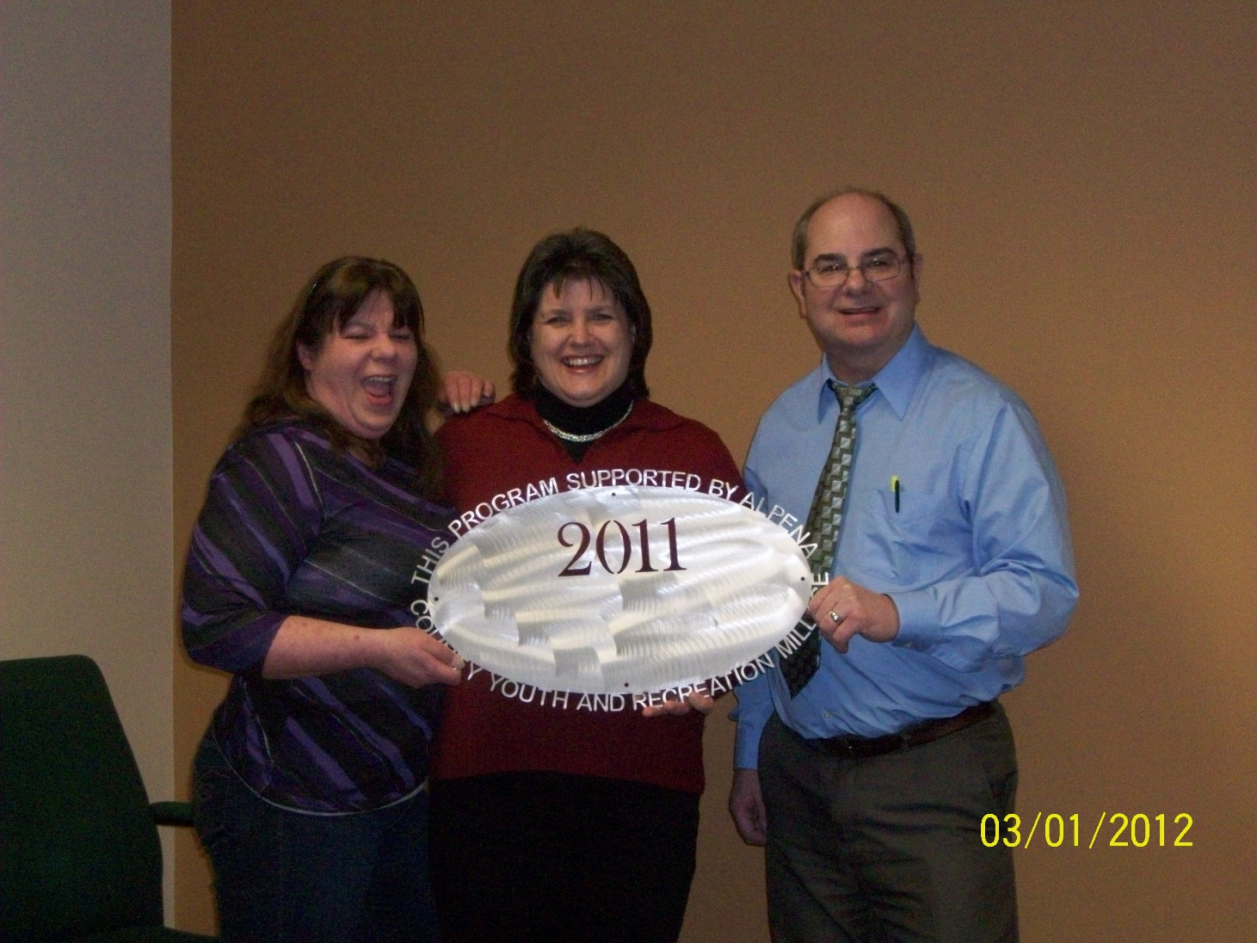Michigan State University Extension $27,345.00
Alpena County 4-H Youth Development Program (pdf)

Special Olympics $6,000.00
Special Olympics (pdf)

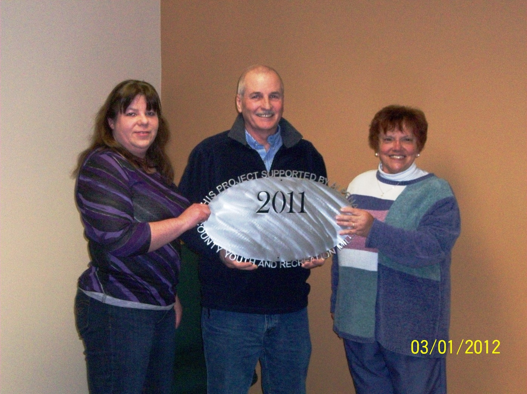Thunder Bay Soccer Association $5,000.00
Mower/Mowing (pdf)

Commissioners & Commissioners Appointees
District 1-COMMISSIONER
Jeff Kowalski
215 Barry Street
Alpena, MI 49707
517.227.0961
jeffkowalski@alpenacounty.org
Linda Canfield
117 Hitchcock Street
Alpena, MI 49707
989.356.2742
lindacanfield1@frontier.com

District 2-COMMISSIONER
Robert Adrian
227 Dawson Street
Alpena, MI 49707
989.354.5732
robertadrian@alpenacounty.org
Calvin L. Howard
329 W. Miller St.
Alpena, MI 49707
989.354.5722
coolbreeze758@hotmail.com

District 3- COMMISSIONER
Tom Mullaney
285 Island View Drive
Alpena, MI 49707
989.356.9781
tommullaney@alpenacounty.org
Camille Nerkowski
3210 S. Third
Alpena, MI 49707
989.356.2909
polishgirl147@hotmail.com

District 4- COMMISSIONER
Lyle VanWormer
4665 Kirchoff Road
Alpena, MI 49707
989.255.5896
lylevanwormer@alpenacounty.org
Tony Suszek
114 Kensington Court
Alpena, MI 49707
989.356.4434
suszektj@charter.net

District 5- COMMISSIONER
Scot McKenzie
2762 Werth Road
Alpena, MI 49707
989.354.3552
scotmckenzie@alpenacounty.org
Tom Heise
3376 Piper Road
Alpena, MI 49707
989.354.2447
htssllc@yahoo.com

District 6-COMMISSIONER
Mark Hall
5005 Long Rapids Road
Alpena, MI 49707
989.354.6023
Kamila Robillard
7361 Haken Road
Alpena, MI 49707
989.657.0600
Kam9431@gmail.com

District 7- COMMISSIONER
Cameron Habermehl
14510 M-32 West
Lachine, MI 49753
989.766.3455
camhabermehl@alpenacounty.org
Fred Wegmeyer
10599 Napper Rd.
Herron, MI 49744
989.379.4034

District 8- COMMISSIONER
Eric Lawson
P.O. Box 73
Ossineke, MI 49766
989.255.3762
ericlawson@alpenacounty.org
Lisa Siegert
12700 Hawkins Road
Hubbard Lake, MI 49747
989.727.3089
siegertlne@gmail.com

County Contacts
Kim Ludlow
County Treasurer
989.354.9534 ludlowk@alpenacounty.org
Tammy Sumerix-Bates
Executive Manager
Alpena County Commissioners
989.354.9502
batest@alpenacounty.org

