ALPENA COUNTY MEDICAL EXAMINER

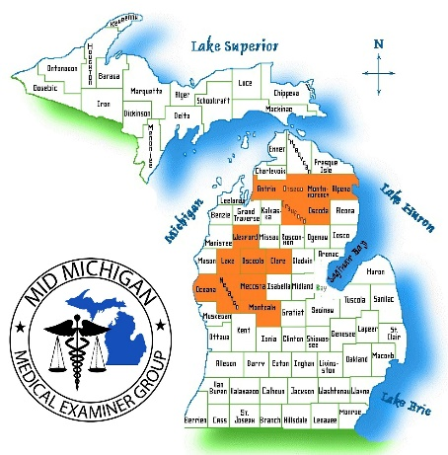

Dr. Paul Wagner, D.O., Chief Medical Examiner
Website: MedicalExaminerGroup.com
Email: main@mmmeg.org

MORE INFORMATION FOR FAMILIES & LOVED ONES:
https://www.medicalexaminergroup.com/funeral-home-information/families

INFORMATION FOR FUNERAL HOMES:
https:www.medicalexaminergroup.com/funeral-home-information/funeral-homes

The Medical Examiner is required by Michigan to investigate deaths that are sudden, suspicious, unexpected, accidental, or violent deaths. The Medical Examiner has the authority to order an autopsy if it is necessary to determine the cause of death.

A family member should choose a funeral home as a first step in the process. Funeral homes and crematoriums are necessary experts in assisting the family with final disposition and vital records for death certificates.

